Year 1 Week 1
Day 1
Phonics

Today you are going to take part in a phonics lesson all about the ‘ay’ sound. Follow the link to watch the phonics lesson.
https://central.espresso.co.uk/espresso/primary_uk/subject/module/video/item63782/grade1/module63425/index.html
You might need to log in to Espresso using the log in below:
Username: student18029
Password: nwi123
Once you have watched the video click the links at the side of the video to take part in two activities.

English
In your English lesson you will be using the traditional tale ‘Jack and The Beanstalk’ as your text. Follow the link and watch episode 1 of ‘What shall we do?’ https://www.bbc.co.uk/teach/class-clips-video/english-ks1-jack-and-the-beanstalk-home/zff42sg

Today you are going to draw and write a list of horrible items that Jack and Ma would keep in their kitchen cupboard. Find worksheet E1 in your workbook and complete the task.
Here are a few ideas to help you:

Smelly socks, mouldy cheese, rotten eggs.

Maths
Today in maths you are going to be sequencing numbers to 50. https://classroom.thenational.academy/lessons/sequencing-numbers-to-50-cmtkjt Click on the link to watch today’s maths lesson.

Once you have watched the lesson, find worksheet M1 in your learning pack.

Reading
Follow the link to the Oxford Owl reading site. https://www.oxfordowl.co.uk/
You will find the class login for Oxford Owl in your online login books which will explain how to access the texts.
Choose a text which matches the coloured book band you are on and then find worksheet R1 in your workbook and complete the task.

Topic- Music
This week we are going to learn a song all about the people who help to keep our communities safe and happy.
Click the link below to:
-Listen to a performance of the song, and a backing track without the words
-Open the lyrics so you can sing along to a backing track
-Open an activities sheet with fun things to do, all related to this song
https://www.singup.org/singupathome/people-who-help-us
Have fun!

Day 2
Phonics
Today you are going to take part in a phonics lesson all about the ‘ee and ey’ sound. Follow the link to watch the phonics lesson.
https://central.espresso.co.uk/espresso/primary_uk/subject/module/video/item90237/grade1/module63425/index.html
You might need to log in to Espresso using the log in below:

Username: student18029
Password: nwi123

Once you have watched the video click the links at the side of the video to take part in two activities.

English
Today you are going to watch episode 2 to help you with your learning. Follow the link and watch episode 2 https://www.bbc.co.uk/teach/class-clips-video/english-ks1-jack-and-the-beanstalk-home/zff42sg

After watching the episode, find worksheet E2 in your workbook and complete the task. You need to look at the pictures from the story and write a sentence to say what is happening in each picture.

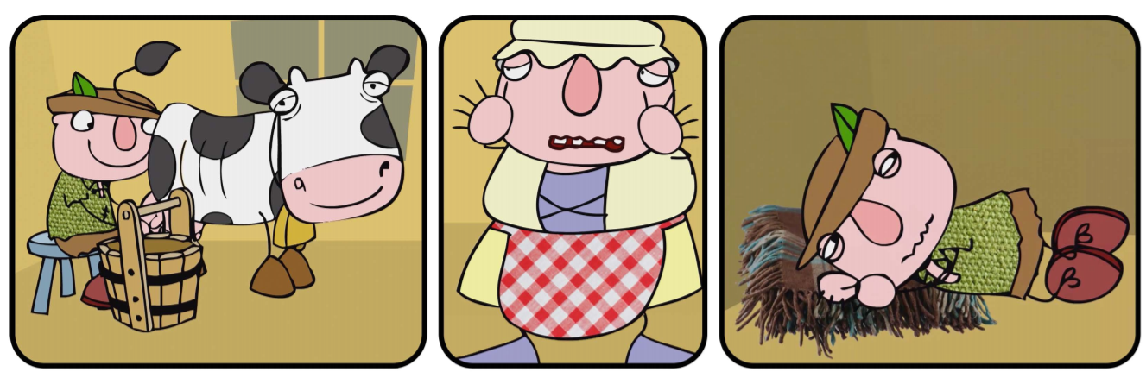

Jack is happily sat on the little wooden stool and milking the spotty cow.

Maths
Today in maths you are going to be grouping and counting in 10s. https://classroom.thenational.academy/lessons/grouping-and-counting-in-tens-60t3ee Click on the link to watch today’s maths lesson.

Once you have watched the lesson, find worksheet M2 in your learning pack.

Reading
Today you are going to listen to Beatrix Potter ‘The Tale of Peter Rabbit’ and then find worksheet R2 in your workbook.

https://www.bbc.co.uk/teach/school-radio/english-ks1--ks2-the-tale-of-peter-rabbit/zkg8f4j
You are going to draw and label a design for your own vegetable garden. What vegetables might you grow?

Topic
We are learning the geographical location of the UK and the countries within the UK. Click on the link below to watch today’s lesson

https://classroom.thenational.academy/lessons/what-is-the-united-kingdom-71k32c

Find worksheet T1 in your workbook and complete the activity labelling the four countries of the UK and use the key to colour them the right colour.

Day 3
Phonics
Today you are going to take part in a phonics lesson all about the ‘ie’ sound. Follow the link to watch the phonics lesson.
https://central.espresso.co.uk/espresso/primary_uk/subject/module/video/item92016/grade1/module63425/index.html
You might need to log in to Espresso using the log in below:

Username: student18029
Password: nwi123

Once you have watched the video click the links at the side of the video to take part in two activities.

English
Today you are going to watch episode 3 and 4 to help you with your learning. Follow the link and watch the episodes https://www.bbc.co.uk/teach/class-clips-video/english-ks1-jack-and-the-beanstalk-home/zff42sg

After watching the episode, find worksheet E3 in your workbook and complete the task. You need to read the sentences and put the correct punctuation at the end of the sentences.

Read them carefully and find the questions and add a question mark and add a full stop to the sentences that are statements. Follow this link to watch a lesson on ‘When to use a question mark.’ https://www.bbc.co.uk/bitesize/articles/z7hc47h before complete the activity.

A question is asked to find out information – ‘What is your name?’

Challenge:
Can you write two of your own questions that Jack might ask the old man at the market?

Maths
Today in maths you are going to be exploring tens and ones. https://classroom.thenational.academy/lessons/exploring-tens-and-ones-cru38d Click on the link to watch today’s maths lesson.

Once you have watched the lesson, find worksheet M3 in your learning pack.

Reading
Follow the link to the Oxford Owl reading site. https://www.oxfordowl.co.uk/
You will find the class login for Oxford Owl in your online login books which will explain how to access the texts.
Choose a text which matches the coloured book band you are on and then find worksheet R3 in your workbook and complete the task. Today you are going to draw a picture of a setting from the story and write a list of nouns you have drawn.

Topic- P.E
Underarm throwing
Click on the link below for a video of simple to follow PE activities to help your child to build on the skills they have been developing in school.
https://www.youtube.com/watch?v=7vuDG6TYWY8&safe=active

Day 4
Phonics
Today you are going to take part in a phonics lesson all about the ‘oe’ sound. Follow the link to watch the phonics lesson.
https://central.espresso.co.uk/espresso/primary_uk/subject/module/video/item92144/grade1/module63425/index.html
You might need to log in to Espresso using the log in below:

Username: student18029
Password: nwi123

Once you have watched the video click the links at the side of the video to take part in two activities.

English
Today you are going to watch episode 5 and 6 to help you with your learning. Follow the link and watch the episodes https://www.bbc.co.uk/teach/class-clips-video/english-ks1-jack-and-the-beanstalk-home/zff42sg

After watching the episode, find worksheet E4 in your workbook and complete the task. Today you are going to think about what Jack dreams about. Draw a picture to show what Jack might dream about and write some sentences about his dream and what is happening.

Here are some useful vocabulary to help you:

dreams | magic | beanstalk
beans | window

Maths
Today in maths you are going to be learning about the value of a number. https://classroom.thenational.academy/lessons/introducing-place-value-ctjkgd Click on the link to watch today’s maths lesson.

Once you have watched the lesson, find worksheet M4 in your learning pack.

Reading
Follow the link to the Oxford Owl reading site. https://www.oxfordowl.co.uk/
You will find the class login for Oxford Owl in your online login books which will explain how to access the texts.
Choose a text which matches the coloured book band you are on and then find worksheet R4 in your workbook and complete the task. Today you are going to draw a picture of the main event from the story and write a sentence to explain what is happening.

Topic- Science
Our topic this half term is ‘materials.’ Click on the link below where you will find a picture that you can click on to find out what the different objects are made from and why.
https://www.bbc.co.uk/bitesize/topics/zrssgk7/articles/z9pgcdm
Have a look around your home and use a post it note to label objects that are made from wood, plastic, glass, fabric and metal.

Day 5
Phonics
Today you are going to take part in a phonics lesson all about the ‘ue and ew’ sound. Follow the link to watch the phonics lesson.
https://central.espresso.co.uk/espresso/primary_uk/subject/module/video/item97598/grade1/module63425/index.html
You might need to log in to Espresso using the log in below:

Username: student18029
Password: nwi123

Once you have watched the video click the links at the side of the video to take part in two activities.

English
Today you are going to watch episode 7 and 8 to help you with your learning. Follow the link and watch the episodes https://www.bbc.co.uk/teach/class-clips-video/english-ks1-jack-and-the-beanstalk-home/zff42sg

After watching the episode, find worksheet E5 in your workbook and complete the task. Today you are going to write a description about what Jack sees when he gets to the top of the beanstalk.

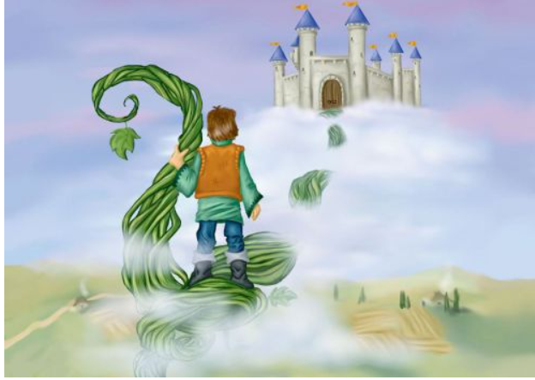
At the top of the towering beanstalk the soft fluffy clouds are floating. The swirling mist is blowing across the sky. In the distance there is a huge brick castle with an old wooden door.

Remember to use adjectives to describe the nouns.
Maths
Today in maths you are going to be learning about the using place value with numbers to 50. https://classroom.thenational.academy/lessons/using-place-value-with-numbers-to-50-6muk4r Click on the link to watch today’s maths lesson.

Once you have watched the lesson, find worksheet M5 in your learning pack.

Reading
Follow the link to the Oxford Owl reading site. https://www.oxfordowl.co.uk/
You will find the class login for Oxford Owl in your online login books which will explain how to access the texts.

Choose a text which matches the coloured book band you are on and then complete the activities from your book.

Topic-

Today we are learning about some of the famous features from the four different countries within the UK. We will learn about both natural features and human features such as capital cities. Click on the link below to begin the session:

https://classroom.thenational.academy/lessons/what-can-you-find-in-the-united-kingdom-60u68d

Year 1 Week 2
Day 1
Phonics
Today you are going to take part in a phonics lesson all about the ‘ir’ sound. Follow the link to watch the phonics lesson.
https://central.espresso.co.uk/espresso/primary_uk/subject/module/video/item94485/grade1/module63425/index.html
You might need to log in to Espresso using the log in below:

Username: student18029
Password: nwi123

Once you have watched the video click the links at the side of the video to take part in two activities.

English
Today you are going to watch episode 9 to help you with your learning. Follow the link and watch the episodes https://www.bbc.co.uk/teach/class-clips-video/english-ks1-jack-and-the-beanstalk-home/zff42sg

After watching the episode, find worksheet E6 in your workbook and complete the task.

Maths
Today in maths you are going to be begin learning about comparing and ordering numbers within 50. Click on the link to watch today’s maths lesson.
https://classroom.thenational.academy/lessons/comparing-and-ordering-numbers-within-50-part-1-60r30t
Once you have watched the lesson, find worksheet M6 in your learning pack. Today you need to sequence the pictures to retell the part of the story when Jack meets the giant. You will then need to write a sentence for each picture.

Reading
Follow the link to the Oxford Owl reading site. https://www.oxfordowl.co.uk/
You will find the class login for Oxford Owl in your online login books which will explain how to access the texts.
Choose a text which matches the coloured book band you are on and then find worksheet R5 in your workbook and complete the task. Today you are going to write a book review about the book you have read.

Topic- Music

Today we are learning about rhythm, vocal and body sounds.
Click on the link below to watch the video and complete the activities afterwards.
https://www.bbc.co.uk/bitesize/topics/zk86qfr/articles/zqtm8hv

Day 2
Phonics
Today you are going to take part in a phonics lesson all about the ‘wh’ sound. Follow the link to watch the phonics lesson.
https://central.espresso.co.uk/espresso/primary_uk/subject/module/video/item97468/grade1/module63425/index.html
You might need to log in to Espresso using the log in below:

Username: student18029
Password: nwi123

Once you have watched the video click the links at the side of the video to take part in two activities.

English
Today you are going to watch episode 10, 11 and 12 to help you with your learning. Follow the link and watch the episodes https://www.bbc.co.uk/teach/class-clips-video/english-ks1-jack-and-the-beanstalk-home/zff42sg

After watching the episode, find worksheet E7 in your workbook and complete the task. Jack brings back a magic hen from the castle, today you are going to create your own magical creature and describe what it does. Think carefully about your creature. What does it look like? Why is it magic? What is special about your creature?

The magical robin has beautiful red and brown feathers. As it soars across the treetops it sprinkles love and kindness to creatures on the ground.

Maths
Today in maths you are going to continue your learning about comparing and ordering numbers within 50. https://classroom.thenational.academy/lessons/comparing-and-ordering-numbers-within-50-part-2-70vkjc Click on the link to watch today’s maths lesson.
Once you have watched the lesson, find worksheet M7 in your learning pack.

Reading
Follow the link to the Oxford Owl reading site. https://www.oxfordowl.co.uk/
You will find the class login for Oxford Owl in your online login books which will explain how to access the texts.
Choose a text which matches the coloured book band you are on and then find worksheet R6 in your workbook and complete the task. Today you are going to draw 2 characters from the book and write what they might say to each other in the speech bubbles.

Topic- Art
This half term we are learning about the life of Gustav Klimt and his famous painting ‘The Tree of Life.’
Take a look at the video below.
https://www.youtube.com/watch?v=CXQ7n0ezr_A&safe=active
The tree had swirling branches, lots of symbols, patterns, shapes, gold paint, and decorations. Complete the tree picture below so that it includes symbols from your own life. Think about using your favourite colours. Is there a colour that means a lot to you? Maybe you could include the colours of your favourite football team. You could add some people or animals that are important to you. What else could you add?

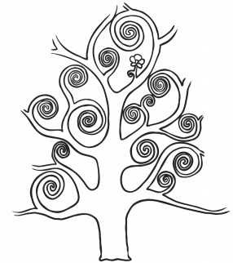

Day 3
Phonics
Today you are going to take part in a phonics lesson all about the ‘ph’ sound. Follow the link to watch the phonics lesson.
https://central.espresso.co.uk/espresso/primary_uk/subject/module/video/item97509/grade1/module63425/index.html
You might need to log in to Espresso using the log in below:

Username: student18029
Password: nwi123

Once you have watched the video click the links at the side of the video to take part in two activities.

English
Today you are going to watch episode 13 and 14 to help you with your learning. Follow the link and watch the episodes https://www.bbc.co.uk/teach/class-clips-video/english-ks1-jack-and-the-beanstalk-home/zff42sg

After watching the episode, find worksheet E8 in your workbook and complete the task. Today you need to draw a picture to show what happens each part of the story and retell the story to an adult. Use the word bank to help you.
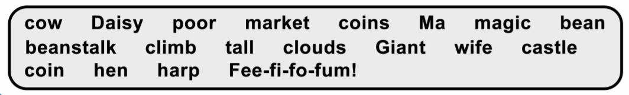
Maths
Today in maths you are going to learning about counting in 5s and 10s. https://classroom.thenational.academy/lessons/counting-in-twos-and-fives-chhkad Click on the link to watch today’s maths lesson.
Once you have watched the lesson, find worksheet M8 in your learning pack.

Reading
Today you are going to listen to Beatrix Potter ‘The Tale of Peter Rabbit’ and then find worksheet R7 in your workbook.
https://www.bbc.co.uk/teach/school-radio/english-ks1--ks2-the-tale-of-two-bad-mice/z73sjhv
Today you will need to read the passage from the text and underline the nouns that are foods. Then you need to write a list of foods you will leave for the mice in the doll’s house.

Topic- P.E
Click on the link below for our second PE session which this week focus on overarm throwing.
https://www.youtube.com/watch?v=o1kpXFfar34&safe=active

Remember to bend your throwing arm at the elbow, hold your ball to your ear and throw over your head, keeping your eyes fixed on your target.

Day 4
Phonics
Today you are going to take part in a phonics lesson all about the ‘au and aw’ sound. Follow the link to watch the phonics lesson. https://central.espresso.co.uk/espresso/primary_uk/subject/module/video/item94485/grade1/module63425/index.html

You might need to log in to Espresso using the log in below:

Username: student18029
Password: nwi123

Once you have watched the video click the links at the side of the video to take part in two activities.

English
Today you are going to use worksheet E8 in your workbook from yesterday. You need to write a sentence for each picture in the story to retell the tradition tale ‘Jack and the Beanstalk.’

Use the word bank to help you:

Once upon a time there was a little boy called Jack. One day his Ma asked him to take Daisy the cow to market and sell her.

Maths
Today in maths you are going to learning about counting in 5s and 10s. https://classroom.thenational.academy/lessons/counting-in-twos-fives-and-tens-65k34d Click on the link to watch today’s maths lesson.

Once you have watched the lesson, find worksheet M9 in your learning pack.

Reading
Follow the link to the Oxford Owl reading site. https://www.oxfordowl.co.uk/
You will find the class login for Oxford Owl in your online login books which will explain how to access the texts.
Choose a text which matches the coloured book band you are on and then complete the activities from your book.

Topic- Science

Today we will be learning about different properties of materials. We will be identifying different objects and describing the properties of the materials they are made from.

Watch the video below and use a pencil and paper to complete the activities.

https://classroom.thenational.academy/lessons/how-can-i-describe-an-object-c9h38c?step=2&activity=video

Click on the link below for further activities http://espresso.education.btlsl.co.uk/espresso/primary_uk/subject/module/activity_index/item1128907/grade1/index.html

Use this log in to access Espresso:

Username: student18029
Password: nwi123

Day 5
Phonics
Today you are going to take part in a phonics lesson all about the ‘ir’ sound. Follow the link to watch the phonics lesson.
https://central.espresso.co.uk/espresso/primary_uk/subject/module/video/item94449/grade1/module63425/index.html
You might need to log in to Espresso using the log in below:

Username: student18029
Password: nwi123

Once you have watched the video click the links at the side of the video to take part in two activities.

English
Today you are going to write a poem. Follow this link and watch the lesson all about poems. https://www.bbc.co.uk/bitesize/articles/z3b6qfr

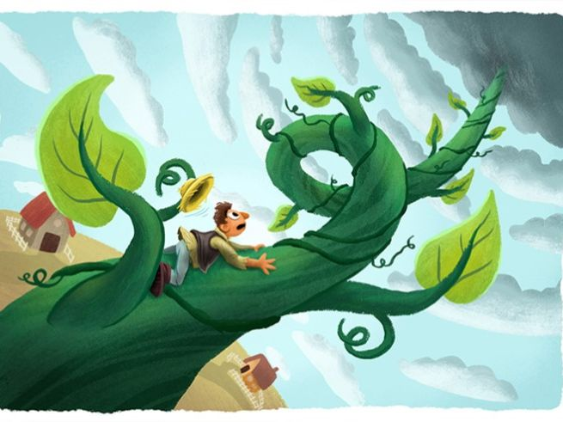
Find worksheet E9 in your workbook and use the image and the word bank to write a list poem.

Climbing up the beanstalk…
I can see fluffy clouds,
I can see twisting vines,
I can see tiny cottages.

Maths
Today in maths you are going to learning to describe and complete number patterns. https://classroom.thenational.academy/lessons/describing-and-completing-number-patterns-6wuk4r Click on the link to watch today’s maths lesson.

Once you have watched the lesson, find worksheet M10 in your learning pack.

Reading
Follow the link to the Oxford Owl reading site. https://www.oxfordowl.co.uk/
You will find the class login for Oxford Owl in your online login books which will explain how to access the texts.
Choose a text which matches the coloured book band you are on and then complete the activities from your book.

Topic- Geography
In today’s session we will be learning about some of the famous landmarks in London. We will have a go at placing them on a map and finish the session by writing a list of tourist attractions for people visiting London.
Click on the link below to begin:
https://classroom.thenational.academy/lessons/what-are-the-landmarks-in-london-71k3cc

Visit https://www.bbc.co.uk/teach/class-clips-video/geography-ks1-ks2-transport-travel-and-landmarks-of-london/zhttscw to follow William Whiskerson and Kulala on their journey on the London Underground to the city centre.

