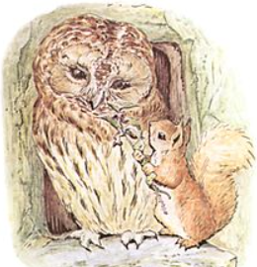

Who are you writing to?
Tell him what you are sorry for (List all the things you did wrong).

Tell him what you will do to say sorry (perhaps help him with a job or take him a present).

Finish the letter (I am very sorry/I will not do it again/love from).

Your name (Squirrel Nutkin).

