ou

Write a label for each picture
out pound cloud mouth count flour

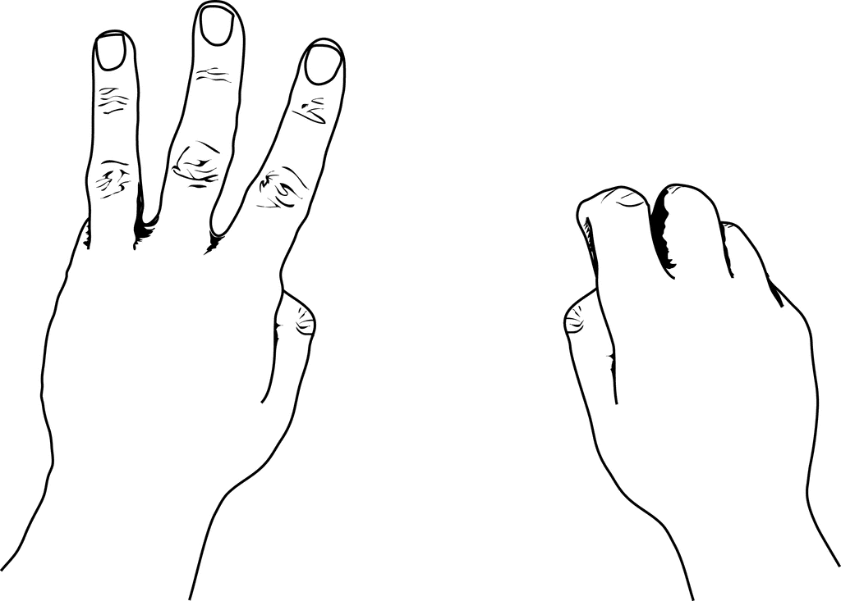
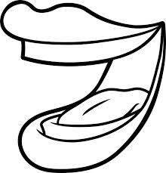
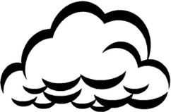

________________________

_______________________ __________________________ ______________________
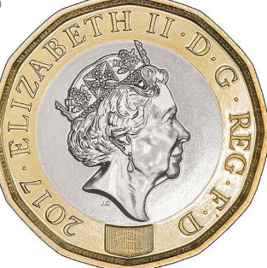

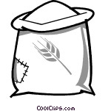

______________________ _________________________ _______________________

Can you think of a sentence to write about the picture below?







