aw
Write a label for each picture
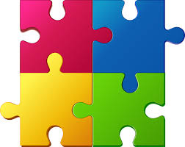
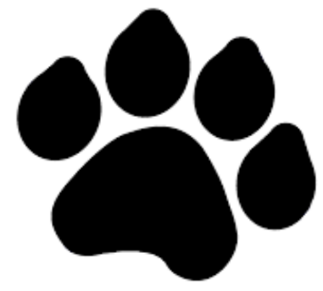

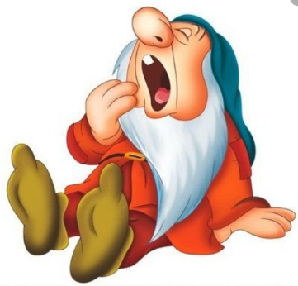
_______________________________ ____________________________
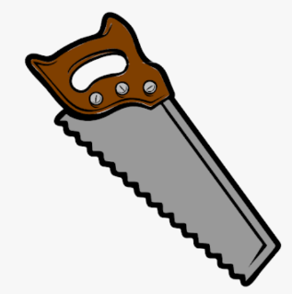

_______________________________ __________________________________

Can you think of a sentence to write about the picture below?







