a-e
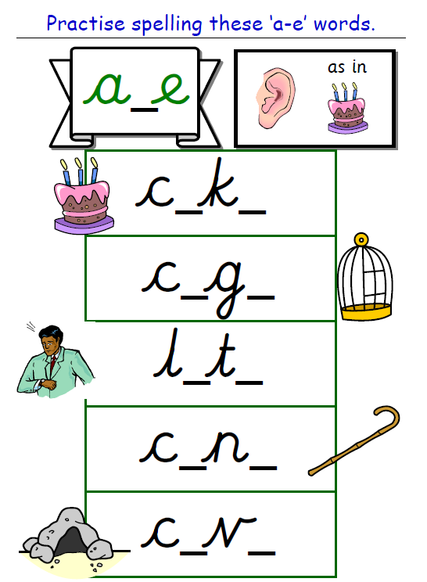
Have a go at writing some sentences using the words above.

