Year 1 Week 1
Day 1
Phonics

Today you are going to take part in a phonics lesson all about the ‘ai’ sound. Follow the link to watch the phonics lesson.
https://central.espresso.co.uk/espresso/primary_uk/subject/module/video/item62926/grade1/module62767/index.html

You might need to log in to Espresso using the log in below:
Username: student18029
Password: nwi123
Once you have watched the video click the links at the side of the video to take part in two activities.

English
In your English lesson you will be using the traditional tale ‘Little Red Riding Hood’

Follow the link to the first part of the story.

https://www.bbc.co.uk/teach/class-clips-video/english-ks1-little-red-riding-hood-pt1/zv8xvk7

Find Worksheet E1 in your learning pack. Can you write a simple sentence about what you like about the story so far?
Maths
Over these next two weeks, we are going to be exploring addition and subtraction within 20.
Today in maths you are going to practise adding 2 quantities together by counting them all.
Click on the link to watch today’s maths lesson. https://classroom.thenational.academy/lessons/combining-2-quantities-to-find-the-totals-6mr3jr

Once you have watched the lesson, find and complete worksheet M1 in your learning pack.

Reading
Watch the video to remind you of the key skills you need to understand texts:

Read a story you have at home.
What is happening in the story? How do you know? What clues can you find in the story that help you to understand what is happening?
Can you answer these questions?
- Is there a good/bad character? Who is it? How can you tell?
- How/where does the story start?

Now draw a picture to show what happened at the beginning/middle/end. Can you label your pictures?

Topic- Music
This afternoon we are going to learn a song that is linked to our topic of Little Red Riding Hood. You will be identifying the long and short notes when you sing the different ‘reds’ in the chorus. Then you will explore the jumpy, fast rhythms and slow rhythms of the words in the verses.

Click the link below to begin the lesson: Watch the very first video Tutorial 1: Learn the song 'I love red!'
https://www.bbc.co.uk/teach/school-radio/music-ks1-little-red-riding-hood-song1/z74txyc
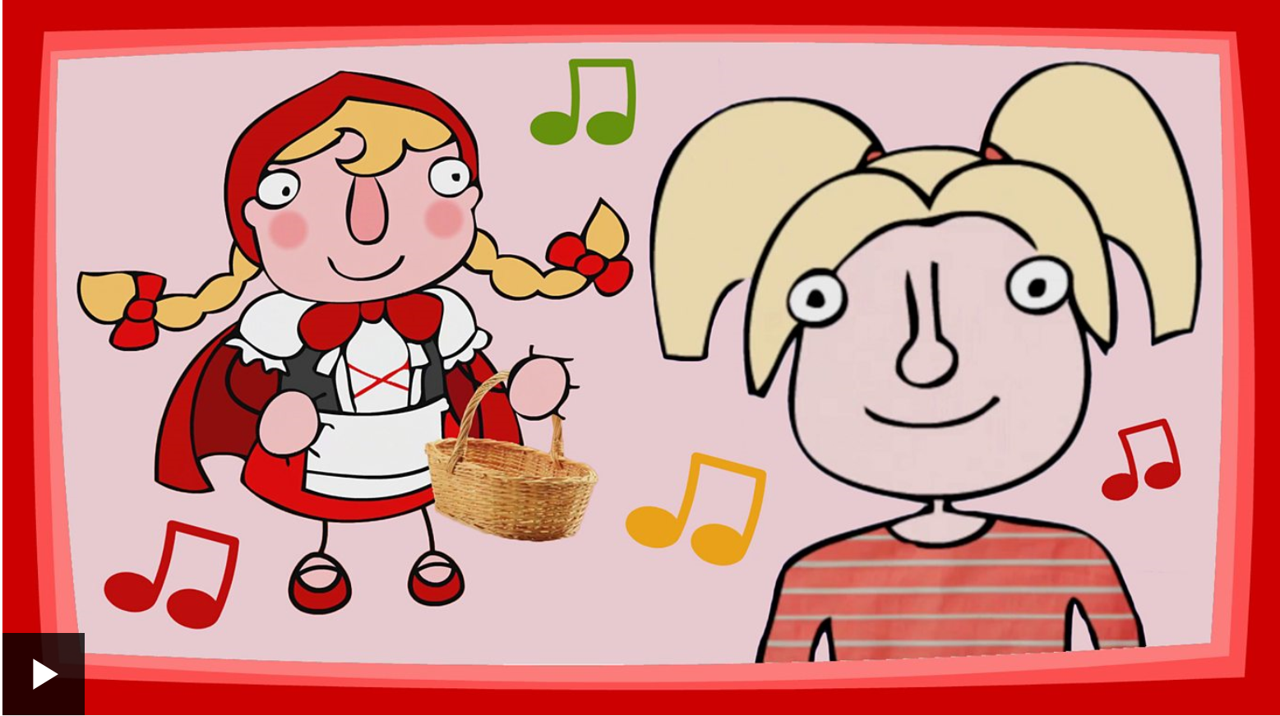
Day 2
Phonics
Today you are going to take part in a phonics lesson all about the ‘ee’ sound. Follow the link to watch the phonics lesson.
https://central.espresso.co.uk/espresso/primary_uk/subject/module/video/item75017/grade1/module62767/index.html

You might need to log in to Espresso using the log in below:
Username: student18029
Password: nwi123

Once you have watched the video click the links at the side of the video to take part in two activities.

English
In your English lesson you will be using the traditional tale ‘Little Red Riding Hood’

Follow the link to watch the video of today’s session. Today you are going to recap the story, adding actions to remember key events.
https://classroom.thenational.academy/lessons/to-speak-and-step-the-story-6dgkae

Maths
Today in maths you are going to practise adding 2 quantities together by counting on. Click on the link to watch today’s maths lesson.
https://classroom.thenational.academy/lessons/exploring-addition-by-adding-on-c8wkgd

Once you have watched the lesson, find worksheet M2 in your learning pack. Can you use your counting on skills to find the answer to each addition number sentence?

Reading
Today you are going to listen to Arnie the Doughnut written by the author Laurie Keller.
https://www.storylineonline.net/books/arnie-the-doughnut/#SchoolTube

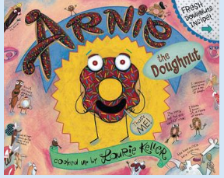

Now find Worksheet R1 in your learning pack.
Arnie is shocked to discover that Mr Bing planned to eat him! Fill in the thought bubble to show what you think Arnie thought was going to happen.
Topic - Geography
We are learning about the history of London and the changes that took place in London over time.

Click on the link below to begin the lesson:
https://classroom.thenational.academy/lessons/what-is-the-history-of-london-6dgp8r
Day 3
Phonics
Today you are going to take part in a phonics lesson all about the ‘igh’ sound. Follow the link to watch the phonics lesson.
https://central.espresso.co.uk/espresso/primary_uk/subject/module/video/item75014/grade1/module62767/index.html

You might need to log in to Espresso using the log in below:

Username: student18029
Password: nwi123

Once you have watched the video click the links at the side of the video to take part in two activities.
English
Follow the link to watch the story of Little Red Riding Hood online. https://www.bbc.co.uk/teach/school-radio/english-ks1--ks2-animated-series-full-versions/z4tdwty

Today you are going to create a story map of the story. Look at the example below for some ideas.

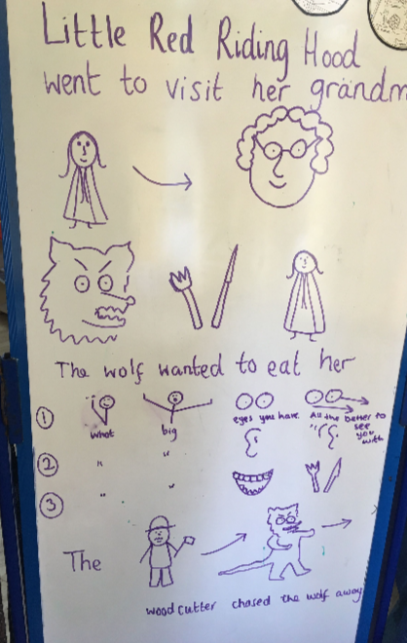
Find worksheet E2 in your learning pack to help you map the story. Can you use your phonic knowledge to label your picture?

Maths
Today in maths you are going to start learning about subtraction. We will look at the part-whole model and think about subtraction as partitioning, taking away a part of the whole and finding out how many are left.
Click on the link to watch today’s maths lesson.
https://classroom.thenational.academy/lessons/exploring-subtraction-as-partitioning-6gv62c

Once you have watched the lesson, find worksheet M3 in your learning pack.
Reading
Follow the link to the Oxford Owl reading site. https://www.oxfordowl.co.uk/
You will find the class login for Oxford Owl in your online login books, which will explain how to access the texts.
Choose a non-fiction text, which matches the coloured book band you are on, then find worksheet R2 in your learning pack, and complete the activity.
Topic- P.E
Together with an adult, join Jaime from Cosmic Kids for some fantastic yoga adventures and activities based on the city of London. Visit the link below:
https://www.youtube.com/watch?v=xROFN9Jh4Wg
Day 4
Phonics
Today you are going to take part in a phonics lesson all about the ‘oa’ sound. Follow the link to watch the phonics lesson.
https://central.espresso.co.uk/espresso/primary_uk/subject/module/video/item75012/grade1/module62767/index.html

You might need to log in to Espresso using the log in below:

Username: student18029
Password: nwi123

Once you have watched the video click the links at the side of the video to take part in two activities.
English

Follow the link to watch a video of Little Red Riding Hood getting her basket ready to take to her Grandma’s house.
https://www.bbc.co.uk/teach/school-radio/english-ks1-ks2-english-little-red-riding-hood/zn9tmfr

Can you write a shopping list of items that Little Red Riding Hood will need? Use Worksheet E3 in your learning pack.
Maths
Today in maths, you are going to explore subtraction as taking away. Click on the link to watch today’s maths lesson.
https://classroom.thenational.academy/lessons/exploring-subtraction-as-takeaway-ctj64r?activity=video&step=1&view=1

Once you have watched the lesson, find worksheet M4 in your learning pack. Look at the pictures and complete the subtraction number sentences underneath.
Reading
Listen to the traditional tale of The Gingerbread Man by clicking on the link below:
https://safeshare.tv/x/ss5c0ed59a0be61
Did you like the story? Why/why not? What did the old lady think when the Gingerbread Man jumped up and ran away? Why do you think all the animals chased the gingerbread man?

Find Worksheet R3 in your learning pack. Can you remember what happened at the end of the story?
Topic- Science
Today we will be thinking about materials and their uses. Click on the link below to watch the video.
https://www.bbc.co.uk/bitesize/clips/zm2jmp3

Think about the material hunt that you did a couple of weeks ago and the properties of the materials.

Find Worksheet S1 in your learning pack. You are now going to decide which materials would be the most suitable to make each object in the pictures.
Day 5
Phonics
Today you are going to take part in a phonics lesson all about the ‘oo’ sound. Follow the link to watch the phonics lesson.
https://central.espresso.co.uk/espresso/primary_uk/subject/module/video/item75009/grade1/module62767/index.html

You might need to log in to Espresso using the log in below:

Username: student18029
Password: nwi123

Once you have watched the video click the links at the side of the video to take part in two activities.
English

Follow the link to watch a video all about the Big Bad Wolf. https://www.bbc.co.uk/teach/school-radio/english-ks1-ks2-english-little-red-riding-hood-2/zr7vscw

Today you are going to label a picture of the Big Bad Wolf. Can you label his ears, eyes, teeth and nose? Find Worksheet E4 in your learning pack to help you to complete the activity.
Maths
Today in maths, you are going to Comparing 2 sets of objects using the language of 'more' or 'fewer'. Click on the link to watch today’s maths lesson.
https://classroom.thenational.academy/lessons/comparing-2-sets-of-objects-using-more-or-fewer-75k62t

Once you have watched the lesson, find worksheet M5 in your learning pack.
Reading
Follow the link to the Oxford Owl reading site. https://www.oxfordowl.co.uk/
You will find the class login for Oxford Owl in your online login books which will explain how to access the texts.

Choose a text which matches the coloured book band you are on and then complete Worksheet R4 in your learning pack.
Topic- Geography

We are going to learn about the different modes of transport used by people in London and will have a go at reading a London Underground map.

Click on the link below to begin the session:

https://classroom.thenational.academy/lessons/how-do-people-move-around-in-london-68wkat

Year 1 Week 2
Day 1
Phonics
Today you are going to take part in a phonics lesson all about the ‘ar’ sound. Follow the link to watch the phonics lesson.
https://central.espresso.co.uk/espresso/primary_uk/subject/module/video/item75001/grade1/module62767/index.html

You might need to log in to Espresso using the log in below:

Username: student18029
Password: nwi123

Once you have watched the video click the links at the side of the video to take part in two activities.

English
For your English learning this week you will be using the traditional tale ‘Jack and the Beanstalk’
Follow the link to watch the story online.
https://learnenglishkids.britishcouncil.org/short-stories/jack-and-the-beanstalk
Can you remember what happened in the beginning, middle and end of the story?
Today you are going to be making a story map of the story. Find Worksheet E5 in your learning pack. Can you order the six pictures from the story correctly? You can either cut out and stick the pictures on to your story map or you can draw your own pictures in the empty boxes.
Maths
Today in maths, you are going to compare quantities using the words 'more' and 'fewer.' Click on the link to watch today’s maths lesson.
https://classroom.thenational.academy/lessons/investigating-quantities-using-more-or-fewer-cmwp6d

Once you have watched the lesson, find worksheet M6 in your learning pack. Write down the numbers to show how many items there are in each box then circle the greatest amount.

Reading
Follow the link to the Oxford Owl reading site. https://www.oxfordowl.co.uk/
You will find the class login for Oxford Owl in your online login books, which will explain how to access the texts.
Choose a text, which matches the coloured book band you are on, then find worksheet R5 in your learning pack and complete the activity. Today you are going to design a new front cover for your book and write about it underneath.
Topic- Music

Today we are learning about timbre.

Timbre is the way our voices sound different. Even our own voice can be used differently at different times.

Watch the video below to find out more and take part in the lesson.

https://classroom.thenational.academy/lessons/exploring-different-ways-to-use-your-voice-6wrk8c
Day 2
Phonics
Today you are going to take part in a phonics lesson all about the ‘or’ sound. Follow the link to watch the phonics lesson.
https://central.espresso.co.uk/espresso/primary_uk/subject/module/video/item75000/grade1/module62767/index.html

You might need to log in to Espresso using the log in below:

Username: student18029
Password: nwi123

Once you have watched the video click the links at the side of the video to take part in two activities.
English
In your English lesson you will be using the traditional tale ‘Jack and the Beanstalk’

Follow the link to watch a video all about some of the things that Jack got up to in the story.

https://www.bbc.co.uk/teach/class-clips-video/english-ks1-jack-and-the-beanstalk-pt10/zvn9mfr

Find worksheet E6 in your learning pack and look at a picture of Jack. What sort of character is he? Is he good or bad? Why? Can you think of some words to describe Jack? Write a list of your words next to Jack’s picture. Here are some ideas that might help.

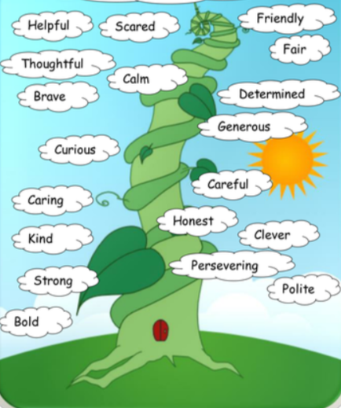
Maths

Today in maths, you are going to explore the concept of doubling. Click on the link to watch today’s maths lesson.

https://classroom.thenational.academy/lessons/exploring-the-concept-of-doubles-cgu3gd
Once you have watched the lesson, find worksheet M7 in your learning pack.

Draw dots on the right side of each ladybird to match the left side. Then add the dots together.
Reading
Follow the link to the Oxford Owl reading site. https://www.oxfordowl.co.uk/
You will find the class login for Oxford Owl in your online login books, which will explain how to access the texts.
Choose a text which matches the coloured book band you are on and then find worksheet R6 in your learning pack and complete the activity. Today you are going to read the beginning of your book and draw a picture of what has happened so far. Then you are going to write a sentence about what you think might happen next. When you have completed the activity, read the rest of your book to see if your prediction was correct!
Topic- Art
Drawing – Creating different pencil tones
Different tones are created when shading by adding more/less pressure on paper with your pencil.
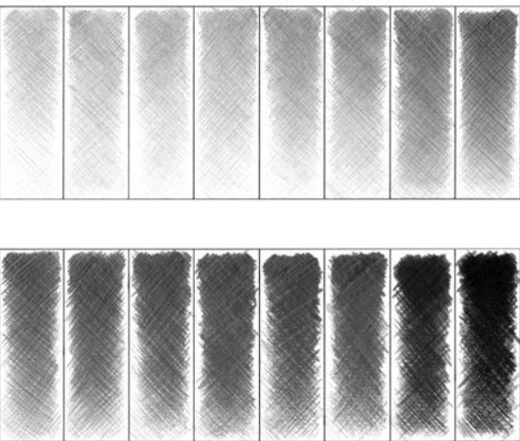
Activity 1: Practise creating different tones with your pencil by applying different pressures using your pencil. What happens when you apply a lot of pressure? What about when you apply lighter pressure?
Activity 2: Draw some of the patterns below using different tones. You may wish to draw your own patterns!
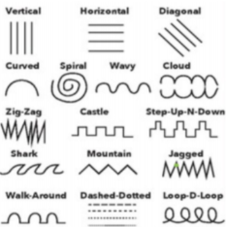
Day 3
Phonics
Today you are going to take part in a phonics lesson all about the ‘ur’ sound. Follow the link to watch the phonics lesson.
https://central.espresso.co.uk/espresso/primary_uk/subject/module/video/item76756/grade1/module62767/index.html

You might need to log in to Espresso using the log in below:

Username: student18029
Password: nwi123

Once you have watched the video click the links at the side of the video to take part in two activities.

English
Follow the link to watch a video of the beanstalk from our story.
https://classroom.thenational.academy/lessons/to-write-the-opening-to-a-recycled-story-6rwkct

When Jack climbed to the top of the beanstalk, he found a Giant’s castle. Imagine a beanstalk has grown outside your window. What would you like to discover at the top of your beanstalk? Find Worksheet E7 in your learning pack. Draw a picture of what you would like to find inside the cloud and write a sentence about your picture underneath.
Maths

Today in maths, you are going to practise finding half of numbers to 20. Click on the link to watch today’s maths lesson.

https://classroom.thenational.academy/lessons/finding-half-of-numbers-to-20-74v34t
Once you have watched the lesson, find worksheet M8 in your learning pack.

Reading
Today you are going to listen to The Elves and the Shoemaker’. Click on the link below to listen to the story:
https://www.storylineonline.net/books/the-elves-and-the-shoemaker/#SchoolTube

Now complete worksheet R7 in your learning pack. Can you draw and label the main characters and setting from the story?
Topic- P.E
This afternoon we are going to be practising our gymnastic skills. Click on the link below:
https://central.espresso.co.uk/espresso/modules/t1_gym/video_files/index.html
Watch both videos on evaluation performance 1 and 2. Have a go. Make sure there is an adult to support you.
You might need to log in to Espresso using the log in below:
Username: student18029
Password: nwi123
Day 4
Phonics
Today you are going to take part in a phonics lesson all about the ‘ow’ sound. Follow the link to watch the phonics lesson.

https://central.espresso.co.uk/espresso/primary_uk/subject/module/video/item76763/grade1/module62767/index.html

You might need to log in to Espresso using the log in below:
Username: student18029

Password: nwi123

Once you have watched the video click the links at the side of the video to take part in two activities.
English
Visit the link to watch a video of the part where the beanstalk grew in our story.
https://www.bbc.co.uk/teach/class-clips-video/english-ks1-jack-and-the-beanstalk-pt6/zn63d6f

Jack accidentally grew a beanstalk when he threw the magic beans out of the window. How do you grow a beanstalk? Talk about steps to grow a bean.
First put soil in a pot.
Next put the seed in the soil,
Then put water on it.
Finally you need to put it in the sun.
Find Worksheet E8 in your learning pack and have a go at writing some instructions for growing a beanstalk.
Maths

Today in maths, you are going to practise estimating and counting different quantities. Click on the link to watch today’s maths lesson.

https://classroom.thenational.academy/lessons/estimating-and-counting-chjkad
Once you have watched the lesson, find worksheet M9 in your learning pack. Estimate how many pictures you think are in each set and then count them to see how close your estimate is.
Reading
Follow the link to the Oxford Owl reading site. https://www.oxfordowl.co.uk/
You will find the class login for Oxford Owl in your online login books which will explain how to access the texts.
Choose a text which matches the coloured book band you are on and then complete the activities from your book.
Topic- Science
We are going to think about how the shape of some materials can be changed.
Watch the video below to find out about how materials can change.

https://www.bbc.co.uk/bitesize/clips/zrkc87h

Find Worksheet S2 in your learning pack. Now you are going to explore how materials can be changed by squashing, bending, twisting or stretching.
Day 5
Phonics
Today you are going to take part in a phonics lesson all about the ‘oi’ sound. Follow the link to watch the phonics lesson.
https://central.espresso.co.uk/espresso/primary_uk/subject/module/video/item76738/grade1/module62767/index.html

You might need to log in to Espresso using the log in below:

Username: student18029
Password: nwi123
Once you have watched the video click the links at the side of the video to take part in two activities.

English
Follow the link to watch the video for today’s session.
https://www.bbc.co.uk/teach/class-clips-video/english-ks1-jack-and-the-beanstalk-pt14/zdwncqt

Jack stole the golden hen from the Giant. Was that the right thing to do? Why? Jack is feeling bad about what he did and he wants to say sorry but he is too scared to see the Giant. What could he do? He could write a sorry letter. What could he write in the letter? Find Worksheet E9 in your learning pack to help Jack write a letter to the giant to say sorry.
Maths
Today in maths, you are going to recap everything you have learnt about addition and subtraction these past two weeks.

Click on the link to watch today’s maths lesson.
https://classroom.thenational.academy/lessons/reviewing-addition-and-subtraction-6dhk8d

Reading
Follow the link to the Oxford Owl reading site. https://www.oxfordowl.co.uk/
You will find the class login for Oxford Owl in your online login books which will explain how to access the texts.
Choose a text which matches the coloured book band you are on and then complete the activities from your book.

Topic- SMSC
Kindness is what the world needs. Click on the link below to watch a short story about kindness.
https://www.youtube.com/watch?v=8Wi0UWLeT9I

Can you create a song, role-play, story or poster showing or explaining the importance of kindness?

