Anansi
E2
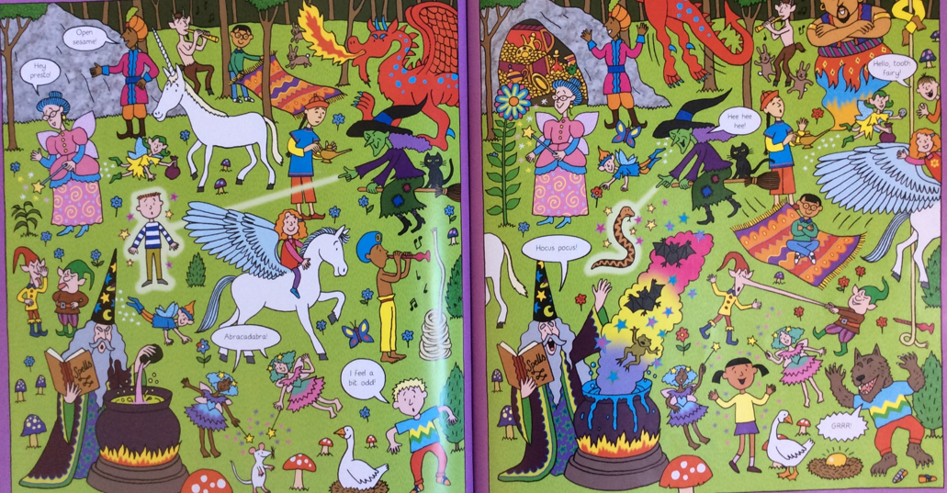
Anansi found a moss covered rock that had the power to make you fall asleep. If you fall asleep, what do you dream about? Use the picture to help you think of ideas.
E.g., I dream that I will fly on a fire-breathing dragon.
_________________________________________________________________________________________________________________________________________________________________________________________________________________________________________________________________________________

