Anansi and the Moss Covered Rock
E4
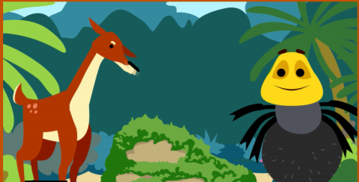
How did the deer manage to trick Anansi? What did he do? Did her clever plan work? Can you use ‘and’ in your sentences to extend them?
__________________________________________________________________________________________
__________________________________________________________________________________________
_______________________________________________________________________________________
_______________________________________________________________________________________

