Tiddalik Character Description
Word Bank
greedy
selfish
rude
slimy
green
enormous

E8
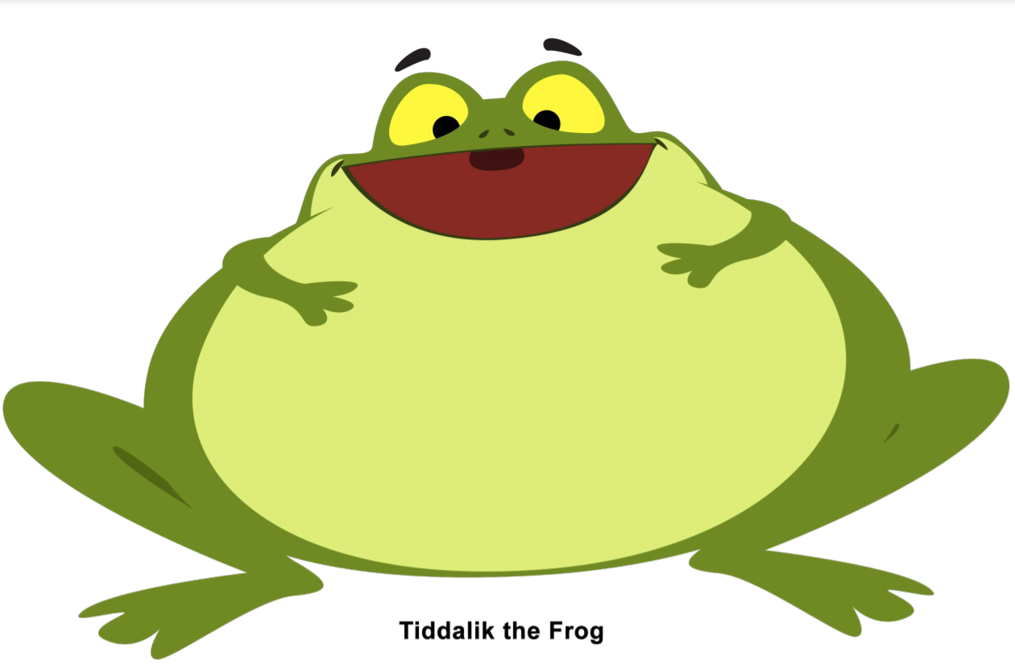

Create a character description using the word bank to help you.
____________________________________________________________________________________________________________________________________________________________________________________________________________________________________________________________________________________________________________________

