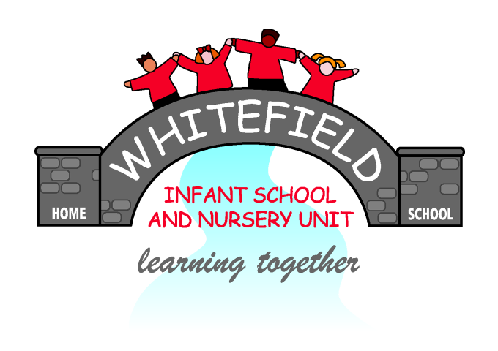
Whitefield Infant School

PSHE Scheme of Work Overview

(With Health Education and Relationships Education/RSE)

PSHE, Health Education and Relationships Education (RSE) at Whitefield Infant School
The Programme of Study for personal, social, health and economic (PSHE) education has three strands;
- Health & Wellbeing (covering Healthy Lifestyles, Mental health, Ourselves Growing and Changing, Keeping Safe, Safety)
- Relationships (covering Families and close positive relationships, Friendships, Managing hurtful behaviour and bullying, Safe Relationships, Respecting Self and others)
- Living in the Wider World (covering Shared Responsibilities, Communities, Media Literacy and digital resilience, Economic well-being (Money), Economic wellbeing: Aspirations, work and career)

At Whitefield Infant School, we cover all three of these stands and although PSHE is taught as a discreet subject, there are many cross-curricular links across our wider curriculum.

From 2020, it has been made mandatory for all schools to deliver Health Education and Relationships and Sex Education/RSE (or ‘Relationships Education’ in primaries). Statutory guidance for Relationships Education (RSE) and Health Education sets out what schools will be required to cover. Please the themes listed below;

Relationships Education (RSE)  The focus in primary school should be on teaching the fundamental building blocks and characteristics of positive relationships, with particular reference to friendships, family relationships, and relationships with other children and with adults. | Physical Health and Mental Wellbeing  The focus in primary school should be on teaching the characteristics of good physical health and mental wellbeing. Mental wellbeing is a normal part of daily life, in the same way as physical health.
- Families and people who care for me  - Caring friendships  - Respectful relationships  - Online relationships  - Being safe | - Mental wellbeing  - Internet safety and harms  - Physical health and fitness  - Healthy eating  - Drugs, alcohol and tobacco  - Health and prevention  - Basic first aid  - Changing adolescent body

This scheme of work outlines how the Programme of Study for PSHE education will be covered at Whitefield Infant School, alongside the new Statutory Guidelines for Relationship Education (RSE) and Health Education. (Physical Health and Mental Wellbeing).
EYFS
Assessments linked to Development Matters/ ELG
PD  PSHE -Health and Well-being | 4+ years  -Revise and refine the fundamental movement skills they have already acquired: - rolling - crawling - walking - jumping - running - hopping - skipping – climbing  -Further develop and refine a range of ball skills including: throwing, catching, kicking, passing, batting, and aiming.  -Progress towards a more fluent style of moving, with developing control and grace  -Develop the overall body strength, co-ordination, balance and agility needed to engage successfully with future physical education sessions and other physical  disciplines including dance, gymnastics, sport and swimming.  -Use their core muscle strength to achieve a good posture when sitting at a table or sitting on the floor.  - Combine different movements with ease and fluency.  -Confidently and safely use a range of large and small  apparatus indoors and outside, alone and in a group. Develop overall body-strength, balance, co-ordination and  agility  - Develop confidence, competence, precision and accuracy when engaging in activities that involve a ball.  - Know and talk about the different factors that support  their overall health and wellbeing:  - regular physical activity  - healthy eating  - toothbrushing  - sensible amounts of  ‘screen time’  - having a good sleep  routine  - being a safe pedestrian  -Further develop the skills they  need to manage the school day successfully:  - lining up and queuing  - mealtimes  - personal hygiene  Gross Motor Skills ELG 6  Children at the expected level of development will:  Negotiate space and obstacles safely, with consideration for themselves and others;  Demonstrate strength, balance and coordination when playing;  Move energetically, such as running, jumping, dancing, hopping, skipping and climbing.
PSHE/ PSED – Self Regulation | 4+ years  -See themselves as a valuable individual.  --Identify and moderate their own feelings socially and emotionally.  Self-Regulation ELG 3  Children at the expected level of development will:  Show an understanding of their own feelings and those of others, and begin to regulate their behaviour accordingly;  Set and work towards simple goals, being able to wait for what they want and control their immediate impulses when appropriate;  Give focused attention to what the teacher says, responding appropriately even when engaged in activity, and show an ability to follow instructions involving several ideas or actions.
PSED – Managing Self  Relationships | 4+ years  -Manage their own needs.  -Express their feelings and consider the feelings of others  - Show resilience and perseverance in the face of challenge.  Managing Self ELG 4  Children at the expected level of development will:  Be confident to try new activities and show independence, resilience and perseverance in the face of challenge;  Explain the reasons for rules, know right from wrong and try to behave accordingly;  Manage their own basic hygiene and personal needs, including dressing, going to the toilet and understanding the importance of healthy food choices.
PSED – Building Relationships | 4+ years  -Build constructive and respectful relationships.  -Think about the perspectives of others.  Building Relationships ELG 5  Children at the expected level of development will:  Work and play cooperatively and take turns with others;  Form positive attachments to adults and friendships with peers;  Show sensitivity to their own and to others’ needs.
UW – People, culture and communities  PSHE - Living in the wider World | 4+ years  -Talk about members of their immediate family and community.  -Understand that some places are special to members of their community  - Name and describe people who are familiar to them.  - Draw information from a simple map.  - Recognise that people have different beliefs and celebrate special times in different ways  - Recognise some similarities and differences between life in this country and life in other countries.  People Culture and Communities ELG 14  Children at the expected level of development will:  Describe their immediate environment using knowledge from observation, discussion, stories, non-fiction texts and maps;  Know some similarities and differences between different religious and cultural communities in this country, drawing on their experiences and what has been read in class;  Explain some similarities and differences between life in this country and life in other countries, drawing on knowledge from stories, non-fiction texts and – when appropriate – maps.
UW – The Natural World | 4+ years  -Describe what they see, hear and feel whilst outside.  -Understand the effect of changing seasons on the natural world around them.  - Explore the natural world around them. (Observe and interact with natural processes, such as ice melting, a sound causing a vibration, light travelling through transparent material, an object casting a shadow, a magnet attracting an object and a boat floating on water.)  - Recognise some environments that are different to the one in which they live.  - Understand the effect of changing seasons on the  natural world around them.  The Natural World ELG 15  Children at the expected level of development will:  Explore the natural world around them, making observations and drawing pictures of animals and plants;  Know some similarities and differences between the natural world around them and contrasting environments, drawing on their experiences and what has been read in class;  Understand some important processes and changes in the natural world around them, including the seasons and changing states of matter.
 | Autumn 1 | Autumn 2 | Spring 1 | Spring 2 | Summer 1 | Summer 2
Topic | Ourselves (Me and my family) | Sparkle and Shine (Celebrations) | Hot and Cold  (Senses) | Journeys (Where are we going?) | Spring and Growth  (Life Cycles) | Whole School Theme
Health & Wellbeing | RSE focus - Mental well-being  Physical health and fitness  General end points –  During this half term:  - the children will be settling into school, getting to know the staff, the environment and routines.  - They will begin to form friendships and learn to play alongside other children.  - They will develop rules for their classroom and learn to share.  - They will take part in simple celebrations and start to learn about different religions and the special people and artefacts that are associated with them. | RSE focus - Mental well-being  Families and people who care for me  General end points- During this half term:  - the children will be developing friendships, learning to be more co-operative and begin to reflect on how their actions affect others.  - They will take part in simple celebrations.  - They will talk about different religious and family celebrations.  - They will be finding out about other cultures/ religions and celebrations.  - They will begin to will be developing their understanding of what it means to make a choice and how some choices are better than others. | RSE focus - Being Safe  Mental well-being  Health and prevention/ Online Safety  General end points - During this half term:  - the children will be continuing to develop friendships and learn to help others.  - They will take part in simple celebrations and develop their knowledge of different religions e.g Chinese New Year  - They will look at similarities and differences between different cultures.  - They will begin to understand what a choice is and how to make choices.  - They will develop an understanding of values and reflect on how their actions can affect others. | RSE focus - Being Safe/ Health and Prevention  General end points - During this half term:  - the children will be given more responsibility within the classroom and outside areas..  - They will be developing their sense of right and wrong resulting in development of simple morals.  - Become aware of things they are good at and how to improve their abilities.  - They will talk about family customs. They will take part in simple celebrations and develop their knowledge of different religions and festivals e.g Easter | - RSE Focus - Caring Friendships/  General end points - During this half term:  - the children will be further developing their understanding of what it means to make a choice and how some choices are better than others.  - They will be also be developing ‘staying power’ alongside concentration and determination.  - They will be given more opportunities to express and talk about their feelings.  - They will learn about the importance of caring for living things e.g growing plants.  - They will have chances to talk about and develop their own sense of self-worth.  - They will take part in simple celebrations and start to learn about different religions and the special people and artefacts that are associated with them e.g Eid | RSE Focus - Caring Friendships/ Mental Well-being  General end points - During this half term:  the children will be encouraged to concentrate on tasks for longer and to be more independent in and out of the classroom in preparation for Year 1  They will have opportunities to become sensitive to differences between themselves and others, their likes and dislikes, things they can do or can’t do and how we can celebrate these differences. They will meet their new class teacher and build relationships with the staff team. In class the children will be encouraged to work as a team and stick together in order to progress in their new class.
Relationships | RSE focus - Families and people who care for me  - Explore new environment  - Learn new rules and routines  - Play alongside others  - Learn to share  - Separate from carer with support.  - Discuss families and people who care for me | RSE focus - Families and people who care for me/ Respectful relationships  - Daily collective worship  - Celebrations topic  - Personal celebrations e.g; birthdays  - Kindness and Diversity  Building friendships through kindness, respecting everyone’s differences. | RSE focus - Being Safe/ Respectful relationships  - Learn about other cultures – in particular Chinese New Year  - Learn about friendships based on the Penguin books – use the characters to emphasise the need for friendships and respectful relationships. | RSE focus - Being Safe/ Respectful relationships/ Caring Friendships  Focus on Core Text – Goldilocks and the Three Bears  Discuss Goldilocks actions and talk about the the three bears feelings/ Mums feelings when Goldilocks disappeared• Understands that own actions affect other people, for example, becomes upset or tries to comfort another child when they realise they have upset them.  • Aware of the boundaries set, and of behavioural expectations in the setting. | RSE Focus - Caring Friendships/ Mental wellbeing  - They will learn about the importance of caring for living things e.g growing plants. | RSE Focus Caring Friendships/ Mental well-being  - Daily collective worship  - Reflection of achievement, looking ahead, transition to new classes.
Living in the Wider World. | RSE focus - Families and people who care for me  - Build relationships with key worker/ adults and peers.  PSED /RE/Festivals/Events  - Daily collective worship  - Eid al-Adha  Personal celebrations e.g; birthdays British Values  - New beginnings  - Assembly focus –Families and homes  - Respect and Responsibility  - Good behaviour, polite manners, responsibility within our community | RSE focus - Families and people who care for me  Health and Prevention  Understanding the world  - Ask questions about the world  - Talk about own experiences  - Daily collective worship  - Harvest.  - Halloween 31st Oct,  - Bonfire Night 5th Nov, Diwali  - Remembrance Sunday  - Christmas 25th Dec.  - Learn about different cultures  - Diwali  - Christmas  Personal celebrations e.g; birthdays | RSE focus - Respectful relationships  Health and prevention  - Learn about friendships via the characters in the Penguin stories  - Learn about what it is like to live in other countries with different climates – link to appropriate items of clothing  UW – mapping skills – where are we in relation to other landmarks? | RSE focus - Respectful relationships  UW – mapping skills – where are we in relation to other landmarks?  Growth – planting seeds ready for the Summer term.  RE/Festivals/Events  - Daily collective worship  - World book day, Mothering Sunday,  Easter Sunday  . | RSE Focus - Caring Friendships/  Understanding the world  - Show care for living things.  Talk about past and present events in own lives  Plant seeds and observe them growing in the Summer term.  - Life cycles of butterfly/ chick/ frog | RSE focus - Respectful relationships/ Mental well being  Understanding the world  - Be sensitive to differences.  Reflect on all the celebrations covered this year and compare them to their own  Transition to Year 1.

Relationships Education/RSE | 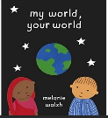  Families and people who care for me  Text –  My World your World  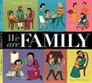  We are family | Families and people who care for me  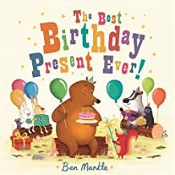  The best birthday present ever! | Respectful Relationships  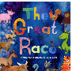  The great race – Chinese New Year | Caring Friendships  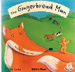  The Gingerbread Man | Caring Friendships  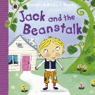  Jack and the Beanstalk | Respectful Relationships
Relationships Education/RSE | 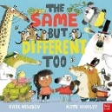  Caring Friendships  Same but different | Being Safe  Link to bonfire night safety |  | 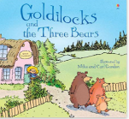  Respectful Relationships  Goldilocks and the 3 Bears | Respectful Relationships | Caring Friendships
Relationships Education/RSE | Respectful Relationships  My World your World  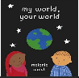 | Respectful Relationships  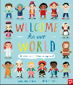  Text – Welcome to our World  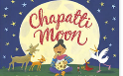  The Chapatti Moon | Respectful Relationships  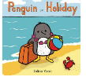  Penguin on Holiday | Being Safe  The Gingerbread Man
Physical Health and Mental Wellbeing | Mental wellbeing  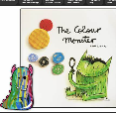  Texts – The colour Monster  Silly Billy | Mental wellbeing  Collective worship, discussion time and general day to day classroom life ensures that children feel they can talk to an adult if something is worrying them. We have an open door policy for parents and carers to discuss any worries they may have about their child. We offer times during the day for quiet reflection and all adults use positive behaviour management strategies.  Texts shared during weekly assemblies:  The Elephant who was Scared- Elliot  The Hippo who was Happy- Elliot  The Zebra who was Sad- Elliot  The Somethingosaur- Mitton  The Cloud- Browne  How Full is your Bucket?- Reckmeyer  Hug- Alborough  Albert Le Blanc to the Rescue- Butterworth  The Huge Bag of Worries- Ironside  Everyone- Neal  Jack’s Worry- Zuppardi  When Sadness Comes to Call- Eland  The Day you Begin- Woodson
Physical Health and Mental Wellbeing | Physical health and fitness  Teach through weekly PE sessions/daily lunch choices  Health and prevention / Basic First Aid /Healthy eating  Daily lunch choices/ incidental learning e.g falling over at play times


