Year 1 Week 1
Day 1
Phonics

Today you are going to take part in a phonics lesson all about the ‘ea’ sound. Follow the link to Mr Thorne does phonics’ youtube channel to watch today’s phonics lesson.

https://www.youtube.com/watch?v=U5KZNjV37Mo

Once you have watched the video, find worksheet P1 in your learning pack and complete the activities.
English
This week our learning in English will be linked to the traditional tale ‘Little Red Riding Hood’
Follow the link to watch the story online.
https://learnenglishkids.britishcouncil.org/short-stories/little-red-riding-hood

Draw a picture of something that happens at the beginning of the story, something that happens during the middle and something that happens at the end. Can you write a sentence underneath each of your pictures to explain what is happening?
Find worksheet E1 in your learning pack and complete the activity.
Maths
This week in Maths, we will be exploring fractions. 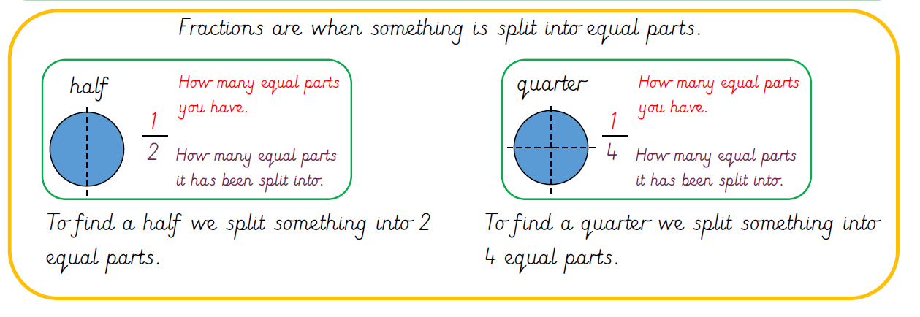
Today in maths, you are going to be exploring halves practically.
https://classroom.thenational.academy/lessons/to-find-half-of-a-quantity-6nhpct

Click on the link to watch today’s maths lesson.

Can you explore finding halves by folding and cutting a piece of paper? Have a go with different shapes, pieces of fruit or a slice of bread!

Once you have completed this activity, ask your grown up to take some photographs and email them to us to share your learning
Reading
Watch the video to remind you of the key skills you need to understand texts:

Read a story you have at home.
What is happening in the story? How do you know? What clues can you find in the story that help you to understand what is happening?
Can you answer these questions?
- Is there a good/bad character? Who is it? How can you tell?
- How/where does the story start?
- Is there anything you have just read that reminds you of something that has happened to you or someone you know? Why? How?

Now draw a picture to show what happened at the beginning/middle/end. Can you write a sentence for each picture?

Topic- Music
This afternoon we are going to learn a song that is linked to our topic of Little Red Riding Hood. You will be identifying the long and short notes when you sing the different ‘reds’ in the chorus. Then you will explore the jumpy, fast rhythms and slow rhythms of the words in the verses.

Click the link below to begin the lesson: Watch the very first video Tutorial 1: Learn the song 'I love red!'
https://www.bbc.co.uk/teach/school-radio/music-ks1-little-red-riding-hood-song1/z74txyc

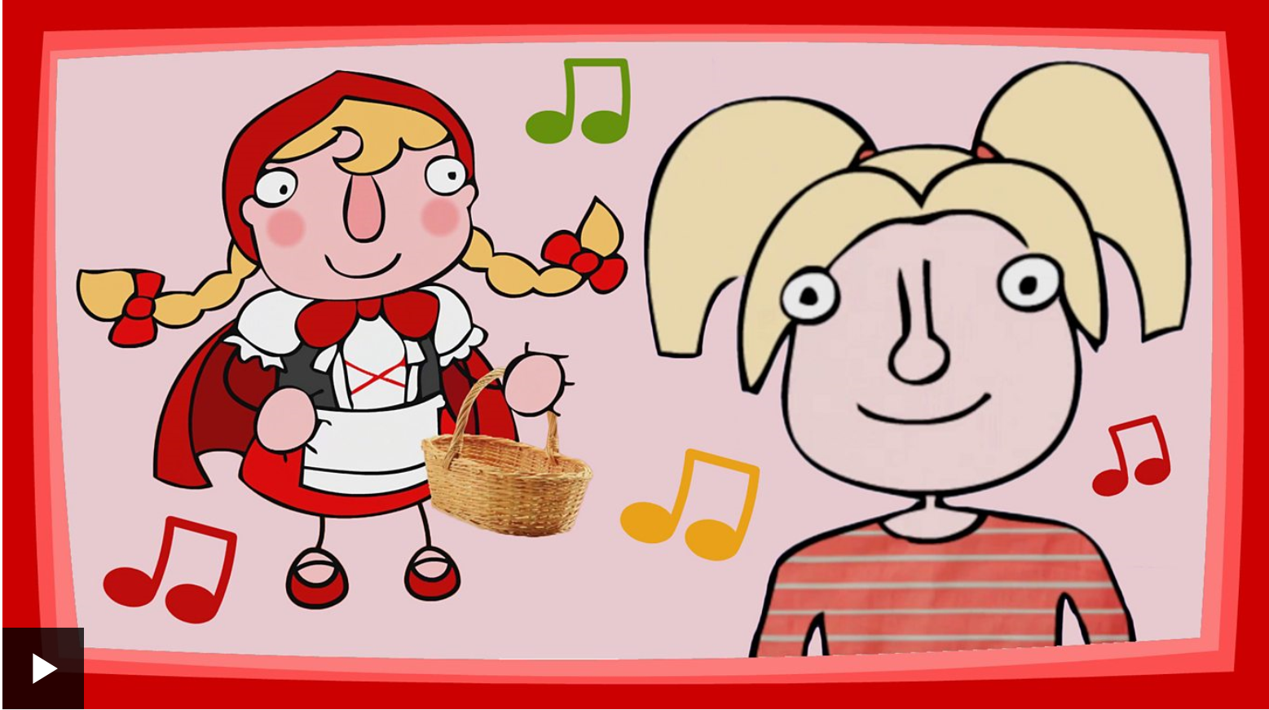
Day 2
Phonics

Today you are going to take part in a phonics lesson all about the ‘oy’ sound. Follow the link to Mr Thorne does phonics’ youtube channel to watch today’s phonics lesson.
https://www.youtube.com/watch?v=aodJQr-WJLk

Once you have watched the video, find worksheet P2 in your learning pack and complete the activities.

English
Watch the video below and join in with the story of Little Red Riding Hood that we began learning about yesterday.
https://classroom.thenational.academy/lessons/to-listen-and-join-in-with-a-story-6muk6c?activity=video&step=1

After watching the video see you if can think of some adjectives to describe the characters of Little Red Riding Hood, the wolf, Grandma and the woodcutter. Find worksheet E2 in your learning pack and complete the activity.

Use the word bank below to help you.

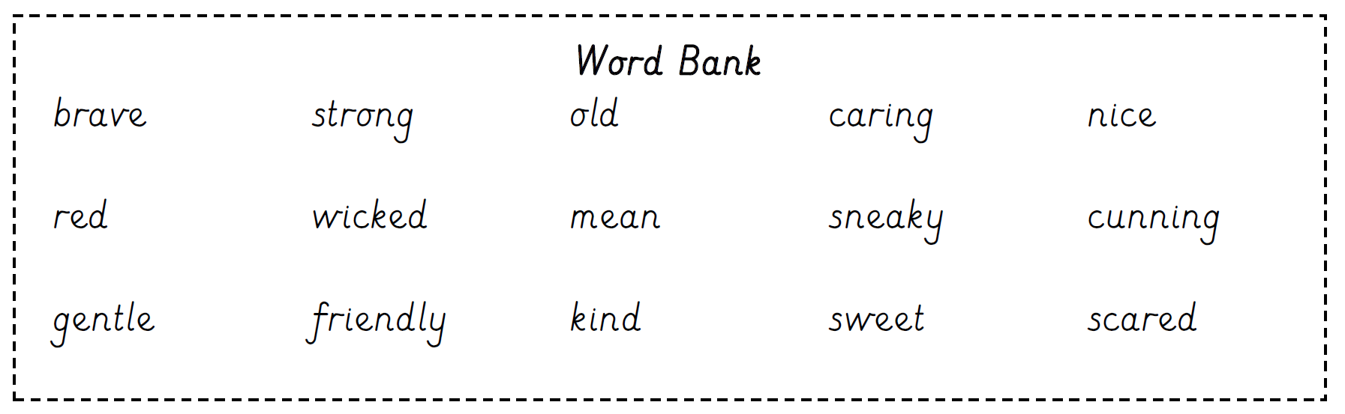
Maths
Visit the following links for today’s session:
https://classroom.thenational.academy/lessons/to-identify-one-half-of-a-shape-60up2c
https://classroom.thenational.academy/lessons/to-find-one-quarter-of-a-shape-c8r66c

Find Worksheet M1 in your learning pack. The shapes have been split into equal parts. Can you show halves and quarters by colouring in the correct amount of the shape? Make sure you look carefully at how many halves or quarters you need to colour!
Reading
Today you are going to listen to Arnie the Doughnut written by the author Laurie Keller.
https://www.storylineonline.net/books/arnie-the-doughnut/#SchoolTube

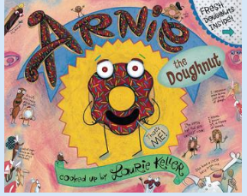

Now find Worksheet R1 in your learning pack.
Arnie is shocked to discover that Mr Bing planned to eat him! Fill in the thought bubble to show what you think Arnie thought was going to happen.

Topic - Geography
We are learning about the history of London and the changes that took place in London over time.

Click on the link below to begin the lesson:
https://classroom.thenational.academy/lessons/what-is-the-history-of-london-6dgp8r
Day 3
Phonics

Today you are going to take part in a phonics lesson all about the ‘ou’ sound. Follow the link to Mr Thorne does phonics’ youtube channel to watch today’s phonics lesson.

https://www.youtube.com/watch?v=DezS9N7el5Y

Once you have watched the video, find worksheet P3 in your learning pack and complete the activities.
English
Watch episode 3 (Cake for Grandma) to help you with your learning today. Follow the link below
https://www.bbc.co.uk/teach/class-clips-video/english-ks1-little-red-riding-hood-pt3/zkpgjhv

After watching the episode, find worksheet E3 in your learning pack. Can you think of some other items to pack in the basket for Grandma? Write some sentences underneath to explain what you will pack and use the word ‘because’ to explain why. For example, I will put flowers in because they will cheer Grandma up. I will put some apples in because she might be hungry.

Maths
Today in maths you are going to be using a ruler to carefully split shapes into halves and quarters. Visit the link below to watch the video of today’s session.
https://www.bbc.co.uk/bitesize/topics/z3rbg82/articles/zq2yfrd

Once you have watched the lesson, find worksheet M2 in your learning pack.
Have a look at the shapes. Can you draw a straight line to split the shape in half and quarters. (Have a go at using a ruler or anything else you have at home that will help you to draw straight lines!)
Reading
Follow the link to the Oxford Owl reading site. https://www.oxfordowl.co.uk/
You will find the class login for Oxford Owl in your online login books, which will explain how to access the texts.
Choose a non-fiction text, which matches the coloured book band you are on, then find worksheet R2 in your learning pack, and complete the activity.
Topic- P.E
Together with an adult, join Jaime from Cosmic Kids for some fantastic yoga adventures and activities based on the city of London. Visit the link below:
https://www.youtube.com/watch?v=xROFN9Jh4Wg

Day 4
Phonics

Today you are going to take part in a phonics lesson all about the ‘aw’ sound. Follow the link to Mr Thorne does phonics’ youtube channel to watch today’s phonics lesson.

https://www.youtube.com/watch?v=finOGW5MCCs
Once you have watched the video, find worksheet P4 in your learning pack and complete the activities.
English
Today we are going to be creating a wanted poster for the big bad wolf! Watch episode 6 (What big eyes you’ve got!) to help you with your learning. Follow the link below
https://www.bbc.co.uk/teach/class-clips-video/english-ks1-little-red-riding-hood-index/zmnrqp3

After watching the episode, find worksheet E4 in your learning pack to make your wanted poster. Use the word bank on the following page to help you
Maths
Today we are going to find halves and quarters of an amount that we will be sharing into equal parts.
Click on the link below for the video of today’s lesson.
https://classroom.thenational.academy/lessons/to-find-one-quarter-of-a-quantity-6xjkad
Once you have watched the lesson, find worksheet M3 in your learning pack.
Can you share the amount into the equal parts by drawing dots in the shape? How many dots do you have in one half or quarter of the shape?
Reading
Listen to the traditional tale of The Gingerbread Man by clicking on the link below:
https://safeshare.tv/x/ss5c0ed59a0be61
Did you like the story? Why/why not? What did the old lady think when the Gingerbread Man jumped up and ran away? Why do you think all the animals chased the gingerbread man?

Find Worksheet R3 in your learning pack. Can you retell the main events from the Gingerbread Man story?
Topic- Science
Today we will be thinking about materials and their uses. Click on the link below to watch the video.
https://www.bbc.co.uk/bitesize/clips/zm2jmp3

Think about the material hunt that you did a couple of weeks ago and the properties of the materials.

Find Worksheet S1 in your learning pack. You are now going to decide which materials would be the most suitable to make each object in the pictures.
Day 5
Phonics
Today you are going to take part in a phonics lesson all about the ‘ey’ sound. Follow the link to Mr Thorne does phonics’ youtube channel to watch today’s phonics lesson.
https://www.youtube.com/watch?v=jua0OODatow
Once you have watched the video, find worksheet P5 in your learning pack and complete the activities.
English
Today we are going to be going into role as the characters from the story and writing speech bubbles. Follow the link and watch the lesson
https://classroom.thenational.academy/lessons/to-write-speech-and-thought-bubbles-to-show-how-a-character-is-feeling-c8rp6c

Find worksheet E5 in your learning pack and complete the activity by writing a sentence inside each speech bubble to show what each character might be saying.
Maths
Today in maths you are going to continue to practise identifying halves and quarters.
Visit the link below:
https://www.bbc.co.uk/teach/class-clips-video/maths-ks1-fractions-titch-and-ted-do-maths-part-six/zkf2t39
Once you have watched the video, find worksheet M4 in your learning pack.
Have a look at the halves and quarters. Are they all correct? Can you tick the correct statements and correct the mistakes?
Reading
Follow the link to the Oxford Owl reading site. https://www.oxfordowl.co.uk/
You will find the class login for Oxford Owl in your online login books which will explain how to access the texts.

Choose a text which matches the coloured book band you are on and then complete Worksheet R4 in your learning pack.
Topic- Geography

We are going to learn about the different modes of transport used by people in London and will have a go at reading a London Underground map.

Click on the link below to begin the session:

https://classroom.thenational.academy/lessons/how-do-people-move-around-in-london-68wkat

Year 1 Week 2
Day 1
Phonics
Today you are going to take part in a phonics lesson all about the ‘a-e split digraph’. Follow the link to Mr Thorne does phonics’ youtube channel to watch today’s phonics lesson.

https://www.youtube.com/watch?v=W1xqLjHF53A

Once you have watched the video, find worksheet P6 in your learning pack and complete the activities.
English
A couple of weeks ago you enjoyed listening to the story of Peter Rabbit by Beatrix Potter. This week we are going to listen to some more stories by the same author and our learning in English will be linked to these texts.
Today our story is called The Tale of Squirrel Nutkin. The story is about Old Brown, a wise old owl who allows the squirrels to collect nuts from the tree where he lives. Squirrel Nutkin can’t resist teasing him and causes all sorts of trouble when he just won’t behave properly. Old Brown is patient for a long time, but eventually his patience with Squirrel Nutkin runs out. Click on the link below to listen to the Tale of Squirrel Nutkin online.
https://www.bbc.co.uk/teach/school-radio/english-ks1--ks2-the-tale-of-squirrel-nutkin/z769nrd

Now think about what Squirrel Nutkin did wrong in the story. What do you think of Squirrel Nutkin’s behaviour? What do you think he should do now? Find worksheet E6 in your learning pack and help Squirrel Nutkin write a letter to give to Old Brown to say sorry.

Maths
This week we are going to be exploring multiplication
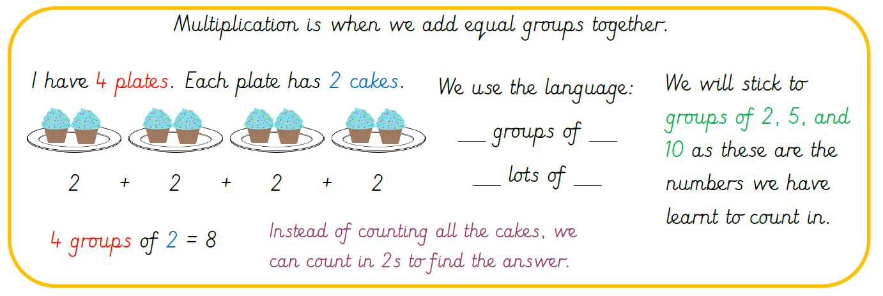

Watch the video below and sing along to the doubles song:
https://www.youtube.com/watch?v=At0quRa90rs
Find worksheet M5 in your learning pack.
Have a look at the pictures. Are they showing doubles or not? Can you write the word ‘double’ or ‘not double’ below each picture.
Reading
Follow the link to the Oxford Owl reading site. https://www.oxfordowl.co.uk/
You will find the class login for Oxford Owl in your online login books, which will explain how to access the texts.
Choose a text, which matches the coloured book band you are on, then find worksheet R5 in your learning pack and complete the activity. Today you are going to design a new front cover for your book and write about it underneath.
Topic- Music

Today we are learning about timbre.

Timbre is the way our voices sound different. Even our own voice can be used differently at different times.

Watch the video below to find out more and take part in the lesson.

https://classroom.thenational.academy/lessons/exploring-different-ways-to-use-your-voice-6wrk8c
Day 2
Phonics
Today you are going to take part in a phonics lesson all about the ‘e-e split digraph’. Follow the link to Mr Thorne does phonics’ youtube channel to watch today’s phonics lesson.

https://www.youtube.com/watch?v=kFuETDoqVnA

Once you have watched the video, find worksheet P7 in your learning pack and complete the activities.
English
Today our story is called The Tale of Benjamin Bunny. In the story, Benjamin is with his cousin Peter Rabbit as he tries to find his clothes in Mr McGregor’s garden. Benjamin wants to stay and helps himself to some onions, but Peter is worried. When they try to get out of the garden to go home they find themselves trapped by the cat. Luckily, help is on hand from Benjamin’s dad.

Click on the link below to listen to the Tale of Benjamin Bunny online.
https://www.bbc.co.uk/teach/school-radio/english-ks1--ks2-the-tale-of-benjamin-bunny/z7rv2sg
How does Mr McGregor know that the bunnies have been in his garden? What clues does he find? As well as their shoe prints, his wife also finds the cat in the greenhouse. Can you remember how she got there? Can you think of something else Mr McGregor might notice, such as the onions being dug up and Peter’s clothes missing from the scarecrow. Use worksheet E7 in your learning pack to write down the clues that Mr McGregor finds.
Maths
Today in maths you are going to continue your learning about mulitiplication. Click on the link to watch today’s maths lesson.
https://www.youtube.com/watch?v=CEKeDditk3g&feature=youtu.be

Once you have watched the lesson, find worksheet M6 in your learning pack.
Each picture shows a group of objects. Count how many groups you have. Count how many objects are in each group. Count in 10s to find the total number of objects and complete the sentences.
Reading
Follow the link to the Oxford Owl reading site. https://www.oxfordowl.co.uk/
You will find the class login for Oxford Owl in your online login books, which will explain how to access the texts.
Choose a text which matches the coloured book band you are on and then find worksheet R6 in your learning pack and complete the activity. Today you are going to read the beginning of your book and draw a picture of what has happened so far. Then you are going to write a sentence about what you think might happen next. When you have completed the activity, read the rest of your book to see if your prediction was correct!
Topic- Art
Drawing – Creating different pencil tones
Different tones are created when shading by adding more/less pressure on paper with your pencil.
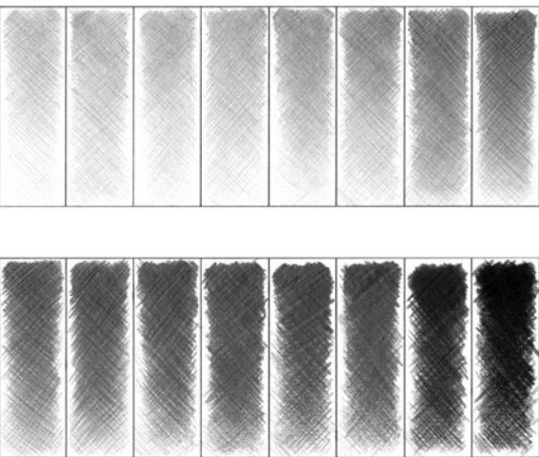
Activity 1: Practise creating different tones with your pencil by applying different pressures using your pencil. What happens when you apply a lot of pressure? What about when you apply lighter pressure?
Activity 2: Draw some of the patterns below using different tones. You may wish to draw your own patterns!
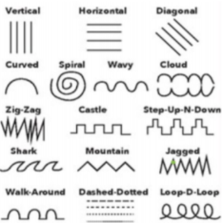
Day 3
Phonics
Today you are going to take part in a phonics lesson all about the ‘i-e split digraph’. Follow the link to Mr Thorne does phonics’ youtube channel to watch today’s phonics lesson.

https://www.youtube.com/watch?v=4-swf3Gy_40

Once you have watched the video, find worksheet P8 in your learning pack and complete the activities.

English
Today our story is called The Tale of Mr Jeremy Fisher. Jeremy Fisher is the frog who goes fishing to catch something for him and his friends for tea. Unfortunately, it turns into a day of disasters...

Click on the link below to listen to the Tale of Mr Jeremy Fisher online.
https://www.bbc.co.uk/teach/school-radio/english-ks1--ks2-the-tale-of-jeremy-fisher/zdkrt39

Now you are going to help write a menu for Jeremy Fisher’s visitors. You can use the foods from the story such as roasted grasshopper and add some more strange ‘foods’, using your imagination. Use the word bank below and worksheet E8 in your learning pack to write your menu.
Roasted boiled toasted fried chopped

baked crispy crunchy spicy stew soup sauce

Maths
Today in maths you are going to identify equal groups. https://www.youtube.com/watch?v=SFz3Dg4jwZ8&feature=youtu.be
Click on the link to watch today’s maths lesson.
Once you have watched the lesson, find worksheet M7 in your learning pack.
Have a look at the pictures. Are the groups the same or different? Label the pictures with the words equal, or not equal.
Have a look at the equal groups. How many groups are in the picture? How many objects does each group have? Complete the sentence with the correct number.
Have a look at the pictures. Complete the pictures to make the groups equal. How many more strawberries do you need in each group?

Reading
Today you are going to listen to The Elves and the Shoemaker’. Click on the link below to listen to the story:
https://www.storylineonline.net/books/the-elves-and-the-shoemaker/#SchoolTube

Now complete worksheet R7 in your learning pack.
Topic- P.E
This afternoon we are going to be practising our gymnastic skills. Click on the link below:
https://central.espresso.co.uk/espresso/modules/t1_gym/video_files/index.html
Watch both videos on evaluation performance 1 and 2. Have a go. Make sure there is an adult to support you.
You might need to log in to Espresso using the log in below:
Username: student18029
Password: nwi123
Day 4
Phonics
Today you are going to take part in a phonics lesson all about the ‘o-e split digraph’. Follow the link to Mr Thorne does phonics’ youtube channel to watch today’s phonics lesson.

https://www.youtube.com/watch?v=VpTIpkgU1fY

Once you have watched the video, find worksheet P9 in your learning pack and complete the activities.
English
Our story today is called The Tale of Tom Kitten. Tom Kitten is in his best clothes for visitors. He just needs to keep them clean...but that proves to be harder than it sounds! When his mother sees him she is not happy.
Click on the link below to listen to the Tale of Tom Kitten online.
https://www.bbc.co.uk/teach/school-radio/english-ks1--ks2-the-tale-of-tom-kitten/zkkrt39

Can you retell what happens in this story? Think about five main things that happen. Use Worksheet E9 to create a storyboard. Write a sentence or two for each part of the story to tell your own version.
Maths
Today in maths you are going to be adding equal groups.
https://www.youtube.com/watch?v=8_FpS6lrzAg&feature=youtu.be
Click on the link to watch today’s maths lesson.

Once you have watched the lesson, find worksheet M8 in your learning pack.
Each picture shows equal groups. Count how many groups you have and how many are in each group. Complete the sentence and find the total amount.
Reading
Follow the link to the Oxford Owl reading site. https://www.oxfordowl.co.uk/
You will find the class login for Oxford Owl in your online login books which will explain how to access the texts.
Choose a text which matches the coloured book band you are on and then complete the activities from your book.
Topic- Science
We are going to think about how the shape of some materials can be changed.
Watch the video below to find out about how materials can change.

https://www.bbc.co.uk/bitesize/clips/zrkc87h

Find Worksheet S2 in your learning pack. Now you are going to explore how materials can be changed by squashing, bending, twisting or stretching.
Day 5
Phonics
Today you are going to take part in a phonics lesson all about the ‘u-e split digraph’. Follow the link to Mr Thorne does phonics’ youtube channel to watch today’s phonics lesson.

https://www.youtube.com/watch?v=CQXnqp8g9WM
Once you have watched the video, find worksheet P10 in your learning pack and complete the activities.
English
Our story today is called The Tailor of Gloucester. In this story, a group of mice decide to help finish making a coat for the Mayor when the tailor is too old and worn out to finish it. The tailor’s cat has other ideas. However, when the cat realises what the mice are doing, he feels ashamed. From that day on, the tailor’s luck changes.

Click on the link below to listen to The Tailor of Gloucester online.
https://www.bbc.co.uk/teach/school-radio/english-ks1--ks2-the-tailor-of-gloucester/zrnx47h

Can you remember what happened in this story? What did Simpkin the cat do? Why was he cross when the tailor set the mice free? How did he feel when he realised that the mice were helping to make clothes for the tailor?

Complete Worksheet E10 in your learning pack by drawing the things that Simpkin does in this story and writing a sentence about each one underneath.
Maths
Today in maths, you are going to multiply by adding equal groups. https://www.youtube.com/watch?v=dpFOvoiYDaQ
Click on the link to watch today’s maths lesson.

Once you have watched the lesson, find worksheet M9 in your learning pack.
Complete the sentences by filling in the number of groups and how many objects are in each group. Write an addition number sentence to match your groups. Make sure you have the correct number of groups in your number sentence.
Reading
Follow the link to the Oxford Owl reading site. https://www.oxfordowl.co.uk/
You will find the class login for Oxford Owl in your online login books which will explain how to access the texts.
Choose a text which matches the coloured book band you are on and then complete the activities from your book.

Topic- SMSC
Kindness is what the world needs. Click on the link below to watch a short story about kindness.
https://www.youtube.com/watch?v=8Wi0UWLeT9I

Can you create a song, role-play, story or poster showing or explaining the importance of kindness?

