Whitefield Infant School


Year 2
Remote Learning Pack

Week 3
(Week beginning 18th January 2021)
Year 2
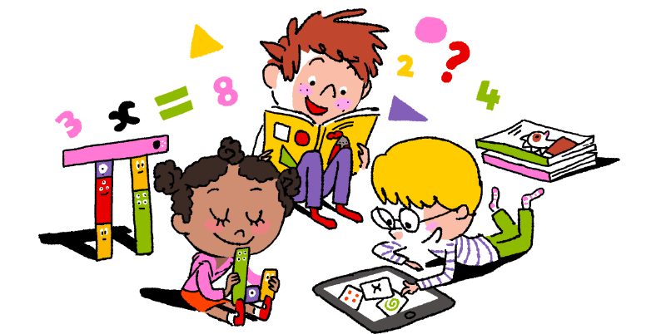
Maths Learning

Week 3

This week in Maths you will be learning about money.
You will need to ask your family if you can see some real coins. How many of them can you recognise? What is the value of each coin and note?
Order the coins you have. Start with the coin of the least value.
This week you will need: 2 worksheets for each day, real coins, a pencil, some coloured pencils, some tins from the cupboard

Day 1 | Draw more coins to make the total 20p  Add jottings to show the value of each coin. This will help you find your answers. You could use real coins as well.
Day 2 | Draw coins to make a total of 14p  Add jottings to show the value of each coin. This will help you find your answers. You could use real coins as well.
Day 3 | Stationary shopping.  Try to find the total by counting on in your head. If this is hard, use jottings. This will help you.  What can I buy for 10p?  This worksheet is asking you to find lots of possibilities. Don’t give up. Find lots of stamina. How many different possibilities can you find?
Day 4 | Investigate which coins make amounts up to 50p  Look at the amounts written in the left column. Use real coins or jottings to answer the question, Can you make it with 2p and 5p coins? Next show the coins that you could use. For example, 3p can be made only with 1p+1p+1p or 2p+1p
Day 5 | Change from £1 (Multiples of 5p)  Draw jottings to show £1. Remember there are 10 ,10ps in £1.  ////////// You will have to exchange 1 ten for 10 ones. If the price is near to £1 you can count on from that number to 100.

Challenge.

I paid for the baked beans using 3 silver coins. How much might they have cost? Show all the possibilities.
First write down all the silver coins you could use. This will help you get started

Year 2
English Learning
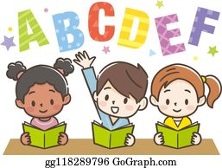

Week 3
This week in English you will be using the key text ‘Mr Wolf and the Three Bears’.
Before you start your learning you will need to read the story Mr Wolf and the Three Bears. You can watch the story in one of the following ways:
- Watch the story on Youtube following this link https://www.youtube.com/watch?v=290FAQRhYR0
- Listen to Miss Stott read the story on the remote learning section of your class page
- Open the powerpoint of the story which is saved on the remote learning section of your class page and read the story
This week you will need: the worksheets in this pack, a pencil, to listen/ watch/ read the story following the options above.

Day 1 | Write a description of Mr Wolf and his Grandma  The main character in the story is Mr Wolf, he is a kind, friendly character who is preparing for his best friend’s birthday party. Use the word bank on the sheet titled ‘Day 1’ to help you write a description.  Key skill: Today you will be using nouns and adjectives in your writing.  A noun- is the name of a person, place or thing  Eg. Aisha Nelson table chair coat  An adjective- is a word that describes the noun  Eg. bright soft kind friendly warm
Day 2 | Make a list of jobs  Make a list of all the things Mr Wolf and Grandma need to do to prepare for the party, before their guests arrive. Use ideas from the story like, clean, cook, bake, decorate etc. Use the sheet titled ‘Day 2’ to write your list.  Key skill: Today you will be using verbs in your writing.  A verb- a verb is a ‘doing’ word  Eg. clean cook run play tidy
Day 3 | Write a description of the party food  Using the sheet titled ‘Day 3’ write a description of the delicious party food Mr Wolf and Grandma have made. There is a word mat on this sheet which will help you with your writing.  Key skill: Today try to use a ‘joining word’ to extend your sentences.  Eg. and with that  (See your word mat for some ideas using these joining words)
Day 4 | Instructions for how to make huff puff cakes  Watch the following video https://www.youtube.com/watch?v=LX_VHvjunFM on how to make chocolate huff puff cakes (or even better- make them with an adult at home!) then write a set of instructions using the sheet titled ‘Day 4’.  Key skill: Today you will be using verbs in your writing. Here are some examples of some verbs you might use today.  get stir mix break melt put eat
Day 5 | Follow the instructions to make a party hat  Today this is a reading task, you must carefully read and follow the set of instructions to make your own party hat. You can then decorate it, take a photo and send it to your class teacher!  Key skill: Use your phonics and reading skills today to carefully read the instructions.

English- Day 1
Write a description

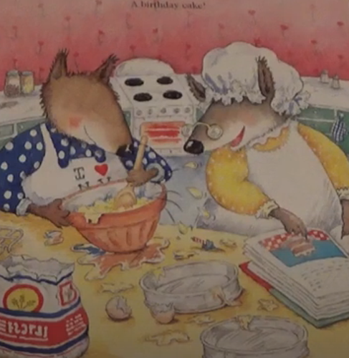
Nouns
Mr Wolf
Grandma
shirt
hat
apron
bowl
spoon
recipe book
Adjectives
messy
smiley
friendly
kind
helpful
blue
yellow
spotty

__________________________________________________________________________________

__________________________________________________________________________________

__________________________________________________________________________________

__________________________________________________________________________________

__________________________________________________________________________________

__________________________________________________________________________________

__________________________________________________________________________________

__________________________________________________________________________________

English- Day 2

Jobs List

___________________________________________

___________________________________________

___________________________________________

___________________________________________

___________________________________________

___________________________________________

___________________________________________

___________________________________________
This page from the story will help you with some ideas for your writing if you are unsure.

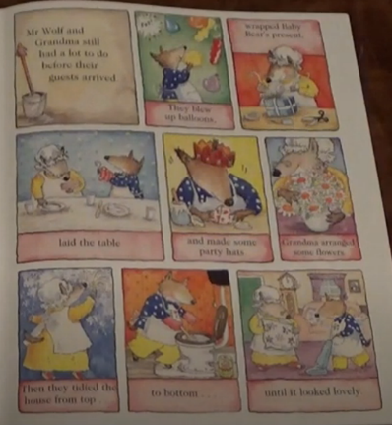

English- Day 3
Write a description of the party food

Use this word mat to help you.
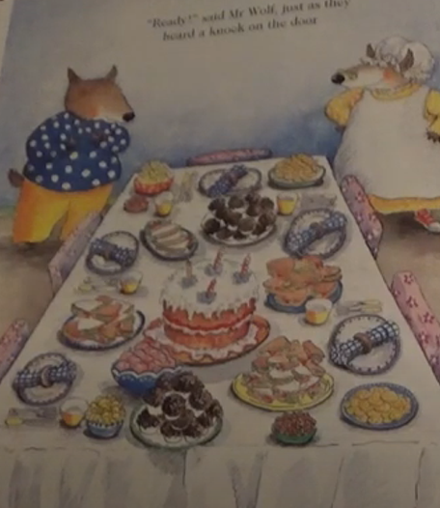
burger
ice cream
juice
milkshake
biscuits
kebab
popcorn

birthday cake
sandwiches
cupcakes
jelly
pizza
chips
sweets

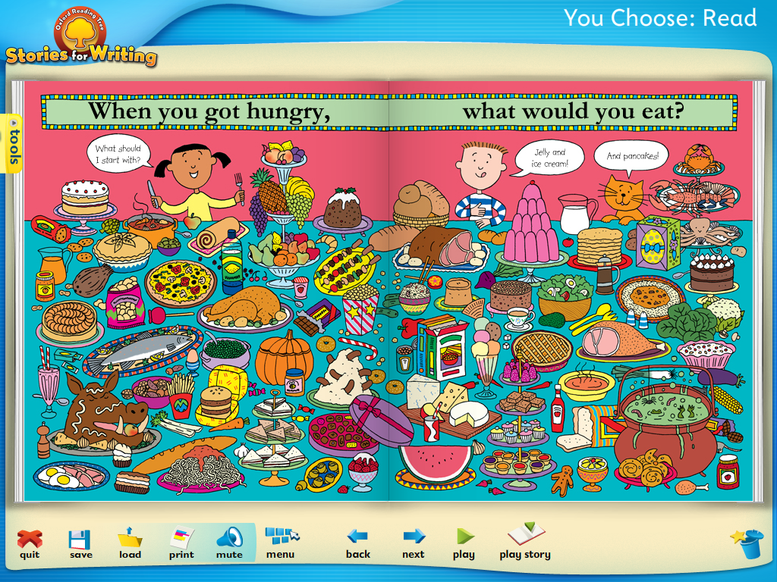
delicious
tasty
yummy
crunchy
soft
sweet
wobbly
juicy

Examples of using joining words:
There is wobbly jelly and tasty sweets.
There is a huge, creamy birthday cake with cherries on top.
There is a juicy watermelon that will melt in your mouth.

English- Day 3
Write a description of the party food

__________________________________________________________________________________

__________________________________________________________________________________

__________________________________________________________________________________

__________________________________________________________________________________

__________________________________________________________________________________

__________________________________________________________________________________

__________________________________________________________________________________

__________________________________________________________________________________

__________________________________________________________________________________

Draw a picture of your favourite party food here:

English- Day 4
Instructions

How to make delicious huff puff cakes

What you need:

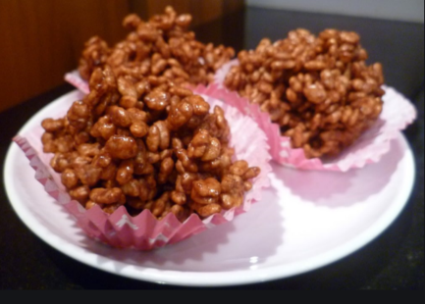
- _____________________
- _____________________
- _____________________
- _____________________
- _____________________
What you do:

- First ______________________________________________________
___________________________________________________________
- Next ______________________________________________________
___________________________________________________________________________

- Then ______________________________________________________
___________________________________________________________
- Finally _____________________________________________________
___________________________________________________________________________

English- Day 5
Follow these instructions for how to make a party hat

How to make a birthday party hat

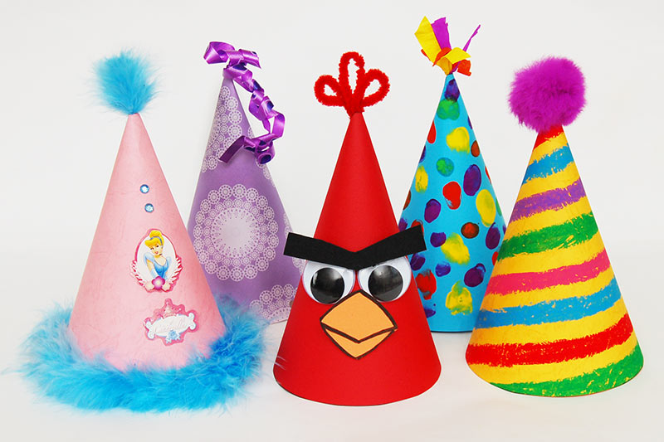
What you need:

- Template (in your pack)
- Scissors
- Sellotape
- crayons

What you do:

- First find the template in your pack

- Next carefully cut around the template using a pair of scissors. Ask an adult for help if needed.

- Then bend the template to make a cone shape and sellotape or glue along the line to hold it together.

- After that decorate your party hat using coloured crayons or any craft materials you have at home.

- Finally wear your hat and enjoy!

Year 2
Science and Topic Learning


Week 3

Science Learning

In our Science learning this week we are learning about things that are living and things that have never been alive.
https://www.bbc.co.uk/bitesize/topics/z6882hv/articles/zs73r82
- If you have a computer you can click on this link and watch a short video. If you don’t have a computer look outside your window and see how many living things you can spot. How many objects can you see outside that have never been alive. You could also watch a TV programme and make a list of things that are alive in the programme (people, pets, plants and trees), and things that have never been alive (settee, chair, window, door)
- Make a list of living things and non-living things.

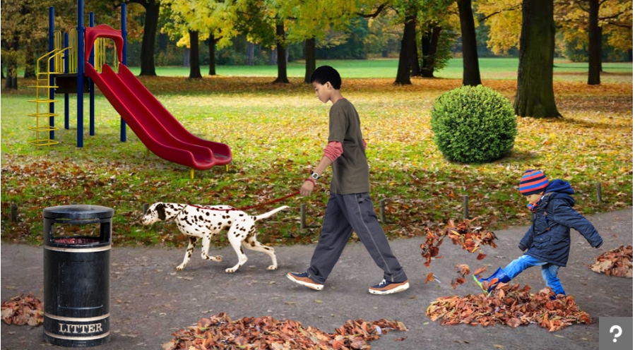

- Now look at the picture. Make a list of all the living things you can see. Fill in the worksheet S1. Explain how you know it is a living thing.

S1

Living thing | I know it is living because…………………………………

Topic Learning
Computing – Create own monster
What would your monster look like if you were making your own traditional tale?
Purple Mash by 2Simple
https://www.purplemash.com/#app/pap/fairy_stories/monster
Follow the link, sign in with your login details and click on My Monster.
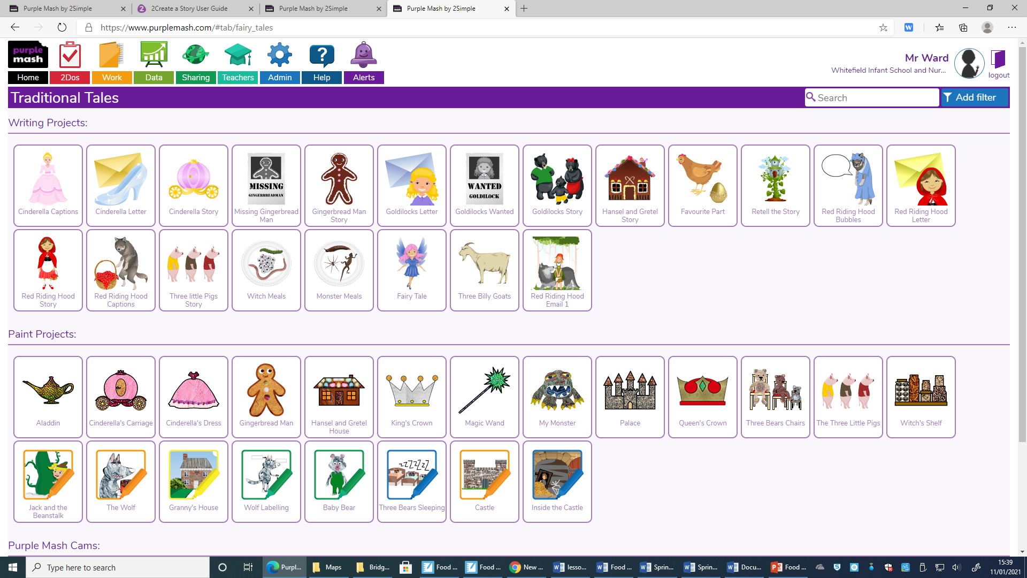

Music – Low pitch sounds
Lesson: Low sounds | Teacher Hub | Oak National Academy (thenational.academy)

Geography – Different perspectives.
This half-term, we are learning about maps. Maps show how an area looks from above. Have a go at this quiz to see if you are good at spotting things in different perspectives (the way they are shown to you).
http://espresso.education.btlsl.co.uk/espresso/primary_uk/standalone/activity_html/item258825/index.html?referrer=http%3A%2F%2Fespresso.education.btlsl.co.uk%2Fespresso%2Fmodules%2Ft1_mapping%2Factivities%2Findex.html&bgcolor=8cc3cd

