Whitefield Infant School


Year 2
Remote Learning Pack

Week 4
(Week beginning 25th January 2021)
Year 2
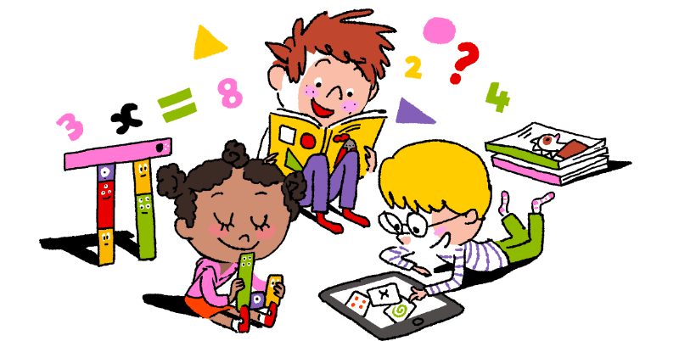
Maths Learning

Week 4

This week in Maths you will be learning about statistics. Statistics means collecting and representing information.
Ask your family if you can have some objects to sort in different ways. This could be buttons, shoes, toy cars, money or any collection of objects that are different colours, sizes or shapes.

Day 1 | Tally Charts (under the sea)    When you want to count a collection of objects, people, plants and animals, you might like to use a tally chart.  l =1 ll =2 lll =3 llll =4 =5  Count the sea creatures and record the total for each as a tally. When the tally chart is finished remember to write the numeral at the end of the row.  Complete the bar chart on the next page. Each square has a value of 2. So if there are 13 fish you should colour 6 squares and half of one more.
Day 2 | Letters of the Alphabet  Look at the letters carefully. Sort them using the criteria shown. The letters may have curved lines, straight lines, be capital letters, not capital letters. Sort them in to the correct box. It might help to write each one on a piece of paper and put each letter in the correct box. P will have to go in more than 1 box. Do you know why?  Multiples of Five  All of the numbers are multiples of 5 but some are even, some are odd, some are greater than 25 and some less than 25, some are even and some are odd. Sort the numbers in to the correct boxes. Check your answers.
Day 3 | Are Names with 5 Letters The Most Popular?  Count the number of letters in each name. Write the total on top of each name. Complete the table to find the answer.
Day 4 | Weather Pictograms  Look at the pictogram. Write the total for each month at the top of each column. Use the information to answer the questions.
Day 5 | Draw Pictograms 2,5,10  Count each tally and write the total at the end of the row. Draw a pictogram using to represent 2 flowers and using to represent 5 flowers in the second pictogram. The second worksheet will give you a chance for more practise.
Challenge
There is a little test for you to complete. You will answer questions about tally charts, bar charts and pictograms. Good luck! Read the questions carefully!

Year 2
English Learning
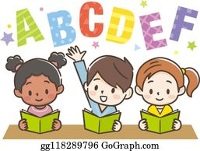

Week 4

This week in English you will continue to use the key text ‘Mr Wolf and the Three Bears’.
Just like last week, you can watch the story in one of the following ways:
- Watch the story on Youtube following this link https://www.youtube.com/watch?v=290FAQRhYR0
- Listen to Miss Stott read the story on the remote learning section of your class page
- Open the powerpoint of the story which is saved on the remote learning section of your class page and read the story or ask an adult to help you read the story
This week you will need: the worksheets in this pack, a pencil, to listen/ watch/ read the story following the options above

Day 1 | Write a description of Goldilocks  Goldilocks causes a lot of trouble at Mr Wolf’s party! Write a description of Goldilocks using the word mat on the sheet titled ‘Day 1’.  Key skill: Today you will be using nouns and adjectives in your writing.  A noun- is the name of a person, place or thing  Eg. Goldilocks coat hair bow Mr Wolf  An adjective- is a word that describes the noun  Eg. mean red soft nasty kind
Day 2 | Create a poster to warn other people about Goldilocks  Would you want Goldilocks to come to your party? Why or why not?  Create a poster to warn other people NOT to let Goldilocks in their house!  Key skill: Today you will use the joining word ‘because’ to give reasons.  Practice spelling that word here then make sure you spell it correctly in your writing.  because ___________ ____________ ____________
Day 3 | Write instructions for your favourite party game  Mr Wolf played musical statues and pass the parcel at his party. What games do you like playing at home or when you go to a party? Write instructions to explain to someone else how to play your favourite game.  Key skill: Today you will use verbs in your writing.  A verb- is a ‘doing’ word. Here are some examples of verbs you might use today.  stand sit move walk play dance sing
Day 4 | Write a thank you card from Baby bear to Mr Wolf  Mr Wolf has been such a good friend to Baby Bear by organising a party for him. Baby Bear needs your help to write a thank you card to Mr Wolf. Here are some ideas of what you might thank him for: baking a birthday cake, decorating the house, organising the party games, buying some presents.  Key skill: When you write a card to someone you must use your very best handwriting, really concentrate on your handwriting today.
Day 5 | Sorry letter from Goldilocks to Baby Bear  Goldilocks has realised she has not been a very good friend to Baby Bear and would like to say sorry! Help Goldilocks to write a letter to Baby Bear using the template on the sheet titled ‘Day 5’.  Key skill: Today try to use a variety of joining words such as,  and but so because

English- Day 1
Write a description

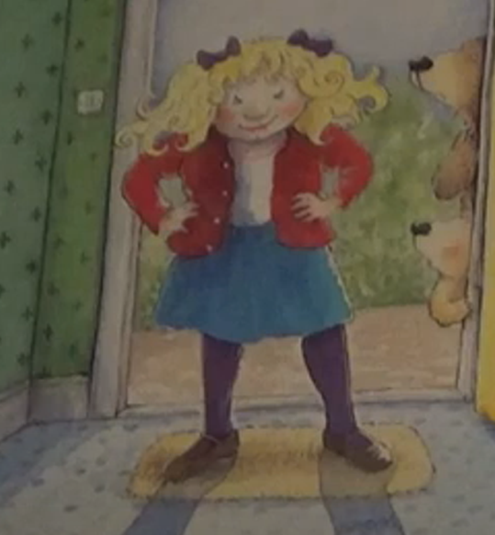
Nouns
Goldilocks
cardigan
skirt
shoes
hair
bows
tights
hands
hips

Adjectives
red
blue
purple
blonde
frown
cross
sneaky
nasty

__________________________________________________________________________________

__________________________________________________________________________________

__________________________________________________________________________________

__________________________________________________________________________________

__________________________________________________________________________________

__________________________________________________________________________________

__________________________________________________________________________________

__________________________________________________________________________________

English- Day 2
Create a poster
WARNING!

Drawing of Goldilocks here:

Do not let Goldilocks to your party because she will ___________________________________________________________
________________________________________________________________
________________________________________________________________________________

________________________________________________________________
________________________________________________________________
________________________________________________________________
________________________________________________________________________________

________________________________________________________________
English- Day 3
Instructions

How to play_______________________

What you need:

- _____________________
- _____________________
- _____________________
- _____________________
- _____________________
What you do:

- First ______________________________________________________
___________________________________________________________
- Next ______________________________________________________
___________________________________________________________________________

- Then ______________________________________________________
___________________________________________________________
- Finally _____________________________________________________
___________________________________________________________________________

English- Day 4
Thank you card

Dear Mr Wolf,

I am writing to thank you for organising a birthday party for me. Thank you for ______________________________________
______________________________________________________________
______________________________________________________________
______________________________________________________________
______________________________________________________________
______________________________________________________________
______________________________________________________________
Love from Baby Bear xxx

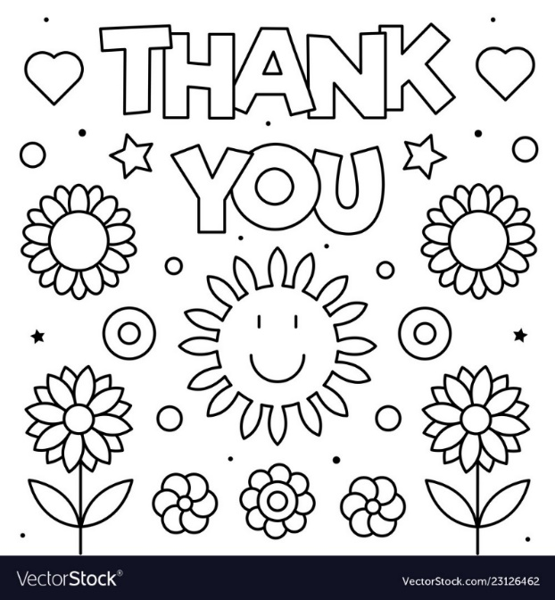

English- Day 5
Letter

Dear Baby Bear,

I am writing you a letter to say sorry because I ruined your birthday party. I am sorry for ____________________________
______________________________________________________________
______________________________________________________________
______________________________________________________________
______________________________________________________________
______________________________________________________________
______________________________________________________________
Love from Goldilocks xxx

Discuss with an adult:
Do you trust Goldilocks?
Do you think she really is sorry?
Do you think she would do it again?
Why do you think she behaved like that at the party?
What does it mean to be a good friend?
How can you show someone you are a good friend?

Year 2
Science and Topic Learning


Week 4

Science Learning

Draw the pet that you would most like to have. Think about what your pet would need to stay happy, safe and healthy.

When you write down your ideas remember to include some of these scientific words.
diet exercise rest good hygiene excrete warmth shelter grow love

Pets

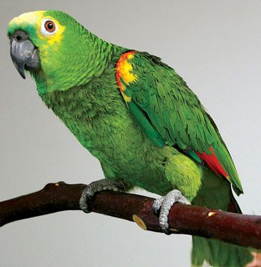

cat
parrot
hamster


guinea pig

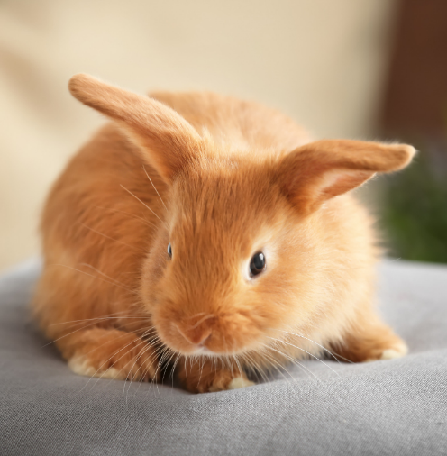
dog

rabbit
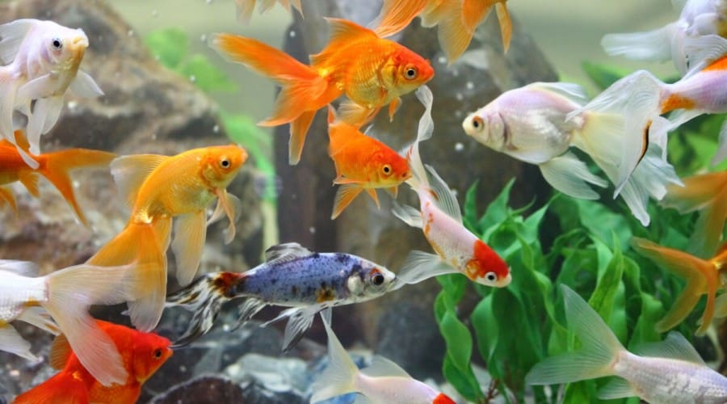
fish

Topic Learning
RE – Passover
Watch the video https://www.bbc.co.uk/programmes/p05x425v to learn about the story of Passover. Once you have watched it, complete the story sequence. Some of it has been done for you. Fill in the empty boxes using the text on the right hand side.
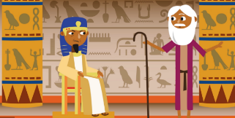 | Moses asked the Pharaoh to let the Jewish people go free but he said no.
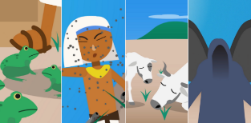
 | Jewish people painted lamb’s blood on their doorways so the Angel of Death would pass over them.
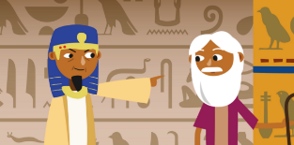

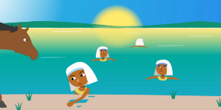
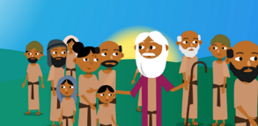 | Moses finally led the Jewish people to safety.

God parted the Red Sea so the Jewish people could escape.
The sea fell back onto the Pharaoh’s army.
Pharaoh finally let the Jews go free but he quickly changed his mind and sent his army after them.
God sent ten plagues to make the Pharaoh change his mind.

PSHE – Fairness
Today, I want you to think about fairness and what it means. Talk to a grown up about your ideas. I want you to think of one example of fairness and one example of when something isn’t fair. Write one sentence or draw a picture for each example.

Computing – Typing skills
Today, I want you to practise your typing skills. Follow the link and have a go at some of the games. See if you can improve your score!
https://www.purplemash.com/#tab/pm-home/computing/2type2/home_keys

