Whitefield Infant School
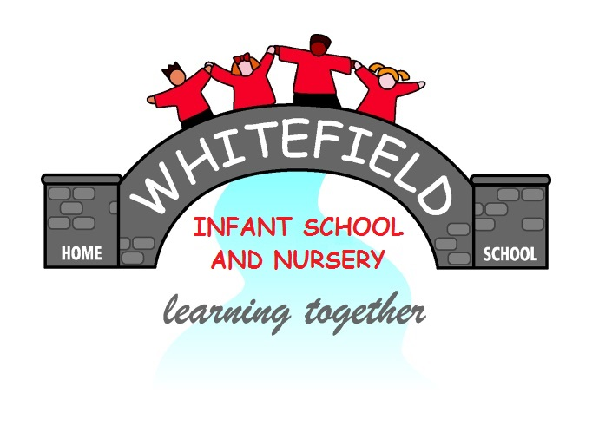

Year 2
Remote Learning Pack

Week 3
(Week beginning 18th January 2021)
Year 2
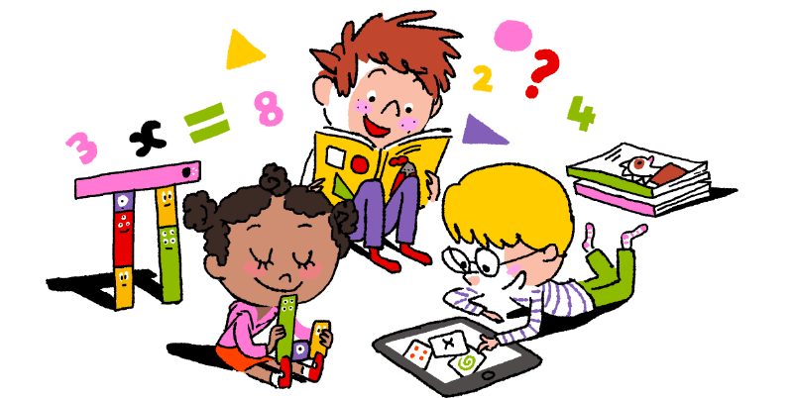
Maths Learning

Week 3

This week in Maths you will be learning about money.
You will need to ask your family if you can see some real coins. How many of them can you recognise? What is the value of each coin and note?
Order the coins you have. Start with the coin of the least value.
This week you will need: 2 worksheets for each day, real coins, a pencil, some coloured pencils, some tins from the cupboard

Day 1 | Counting Money (1p and 2p)  Add jottings to show the value of each coin. This will help you find your answers.
Day 2 | Counting Money (1p and 10p)  Add jottings to show the value of each coin. This will help you find your answers.  On page 2, it will help if you draw 20 and 17 as jottings.
Day 3 | Combinations of coins (1p, 2p and 10p)  Ask a grown up if you can use real coins to make the totals. You will need 10ps, 2ps and 1ps. Jottings will help you but remember you can only use 1ps, 2ps and 10ps.
Day 4 | The school shop  Draw jottings for 10s and 1s. This will help you.  / is a jotting for 10 and is a jotting for 1.  There is only 1 worksheet today.
Day 5 | Adding 10p  When you add 10 to a number the ones don’t change. The 10s digit increases by 1 more. Use jottings to help you.

Challenge.
Ask your family if you can get some tins of food and put a price tag on each. Ask them to buy your food. They have to pay you the correct money. Now you be the shopper and go to the shop to buy the food. Draw what you have bought. Write the price next to it. Show the amount using jottings.

30p ///

Year 2
English Learning
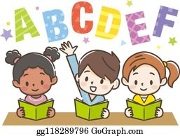

Week 3

This week in English you will be using the key text ‘Mr Wolf and the Three Bears’.
Before you start your learning you will need to read the story Mr Wolf and the Three Bears. You can watch the story in one of the following ways:
- Watch the story on Youtube following this link https://www.youtube.com/watch?v=290FAQRhYR0
- Listen to Miss Stott read the story on the remote learning section of your class page
- Open the powerpoint of the story which is saved on the remote learning section of your class page and read the story
This week you will need: the worksheets in this pack, a pencil, to listen/ watch/ read the story following the options above.

Day 1 | Write a description of Mr Wolf  The main character in the story is Mr Wolf, he is a kind, friendly character who is preparing for his best friend’s birthday party. Use the word bank on the sheet titled ‘Day 1’ to help you write a description.  Key skill: Today you will be using nouns in your writing.  A noun- is the name of a person, place or thing  Eg. Mr Wolf fur shirt hat
Day 2 | Make a list of jobs  Make a list of all the things Mr Wolf and Grandma need to do to prepare for the party, before their guests arrive. Use ideas from the story like, clean, cook, bake, decorate etc. Use the sheet titled ‘Day 2’ to write your list.  Key skill: Today you will be using verbs in your writing.  A verb- a verb is a ‘doing’ word  Eg. clean cook run play tidy
Day 3 | Label and describe the party food  Using the sheet titled ‘Day 3’ label the different party food then write your own sentence using an adjective.  Key skill: Today try to use an adjective in your writing.  An adjective- is a word that describes the noun  Eg. tasty yummy crunchy sweet
Day 4 | Label and describe a room in Mr Wolf’s house  Use the sheet titled ‘Day 4’ to label a room in Mr Wolf’s house. Then use your labels to write a sentence to describe the room.  Key skill: Today you will be using nouns and adjectives in your writing.  Remember:  A noun- is the name of a person, place or thing  An adjective- is a word that describes the noun
Day 5 | Follow the instructions to make a party hat  Today this is a reading task, you must carefully read and follow the set of instructions to make your own party hat. You can then decorate it, take a photo and send it to your class teacher!  Key skill: Use your phonics and reading skills today to carefully read the instructions.

English- Day 1
Write a description

Adjectives
spotty
yellow
blue
yummy
kind
friendly

Nouns
Mr Wolf
shirt
hat
fur
cake
smile
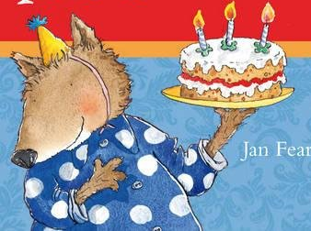

Mr Wolf is wearing a ____________________________________
_________________________________________________________________
Mr Wolf has ______________________________________________
_________________________________________________________________
Mr Wolf is _________________________________________________
_________________________________________________________________

Now think of your own sentence, say it out loud and write it down.
________________________________________________________________
________________________________________________________________
________________________________________________________________
English- Day 2
Jobs List

___________________________________________

___________________________________________

___________________________________________

___________________________________________

___________________________________________

___________________________________________

___________________________________________

___________________________________________
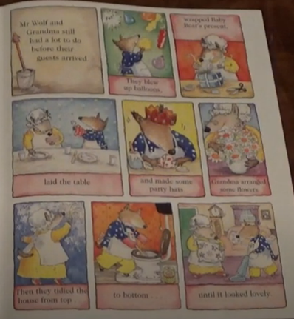
This page in the story might give you some ideas if you are unsure.

This page from the story will help you with some ideas for your writing if you are unsure.

English- Day 3
Label and describe

Use your phonics to label these foods

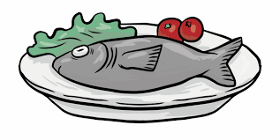


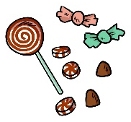
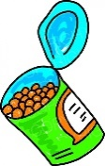

Describe your favourite food to me. Try to use an adjective using the word bank below.
tasty soft crunchy hot
cold sweet fresh crispy

__________________________________________________________________________________

__________________________________________________________________________________

__________________________________________________________________________________

__________________________________________________________________________________

English- Day 4
Label and describe
h _ _
f __ _
c _ _ __

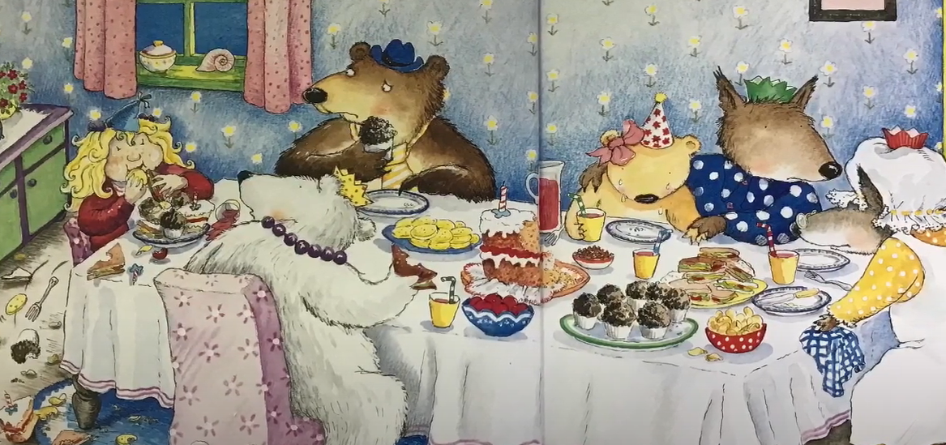

ch ___
j _ _
c _ _

__________________________________________________________________________________

__________________________________________________________________________________

__________________________________________________________________________________

__________________________________________________________________________________

__________________________________________________________________________________

English- Day 5
Follow these instructions for how to make a party hat

How to make a birthday party hat

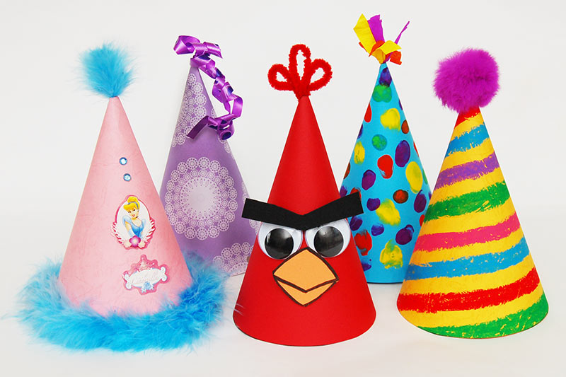
What you need:

- Template (in your pack)
- Scissors
- Sellotape
- crayons

What you do:

- First find the template in your pack

- Next carefully cut around the template using a pair of scissors. Ask an adult for help if needed.

- Then bend the template to make a cone shape and sellotape or glue along the line to hold it together.

- After that decorate your party hat using coloured crayons or any craft materials you have at home.

- Finally wear your hat and enjoy!

Year 2
Science and Topic Learning
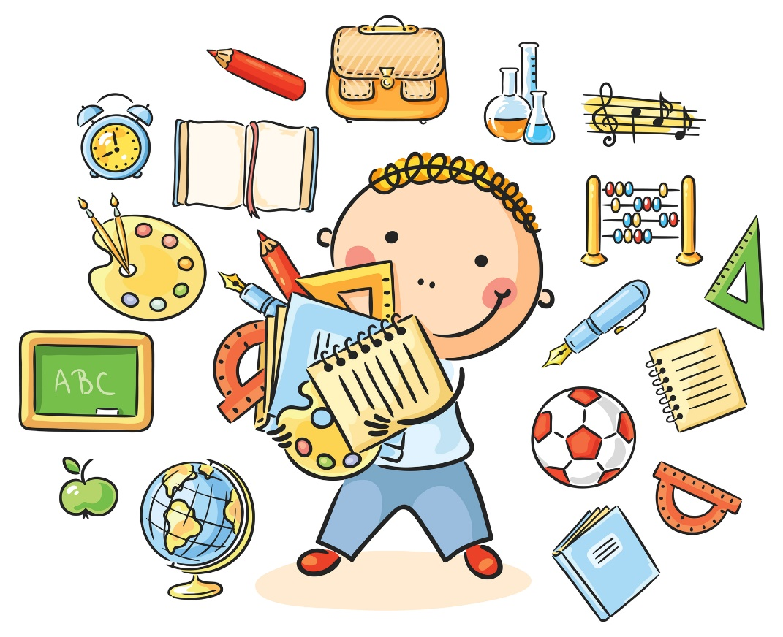

Week 3

Science Learning

In our Science learning this week we are learning about things that are living and things that have never been alive.
https://www.bbc.co.uk/bitesize/topics/z6882hv/articles/zs73r82
- If you have a computer you can click on this link and watch a short video. If you don’t have a computer look outside your window and see how many living things you can spot. How many objects can you see outside that have never been alive. You could also watch a TV programme and make a list of things that are alive in the programme (people, pets, plants and trees), and things that have never been alive (settee, chair, window, door)
- Make a list of living things and non-living things.

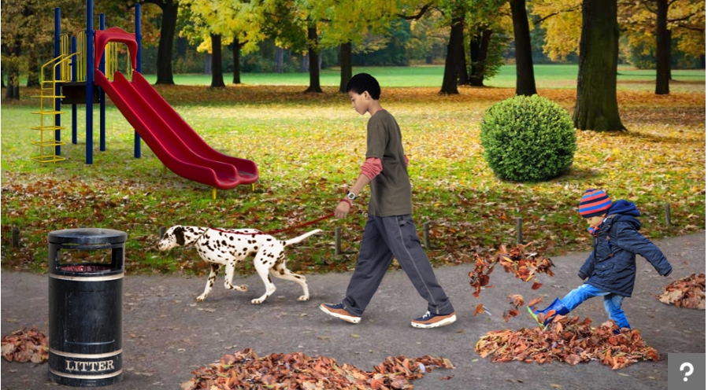

- Now look at the picture. Make a list of all the living things you can see. Fill in the worksheet S1. Explain how you know it is a living thing.

S1

Living thing | I know it is living because…………………………………

Topic Learning
Computing – Create own monster
What would your monster look like if you were making your own traditional tale?
Purple Mash by 2Simple
https://www.purplemash.com/#app/pap/fairy_stories/monster
Follow the link, sign in with your login details and click on My Monster.
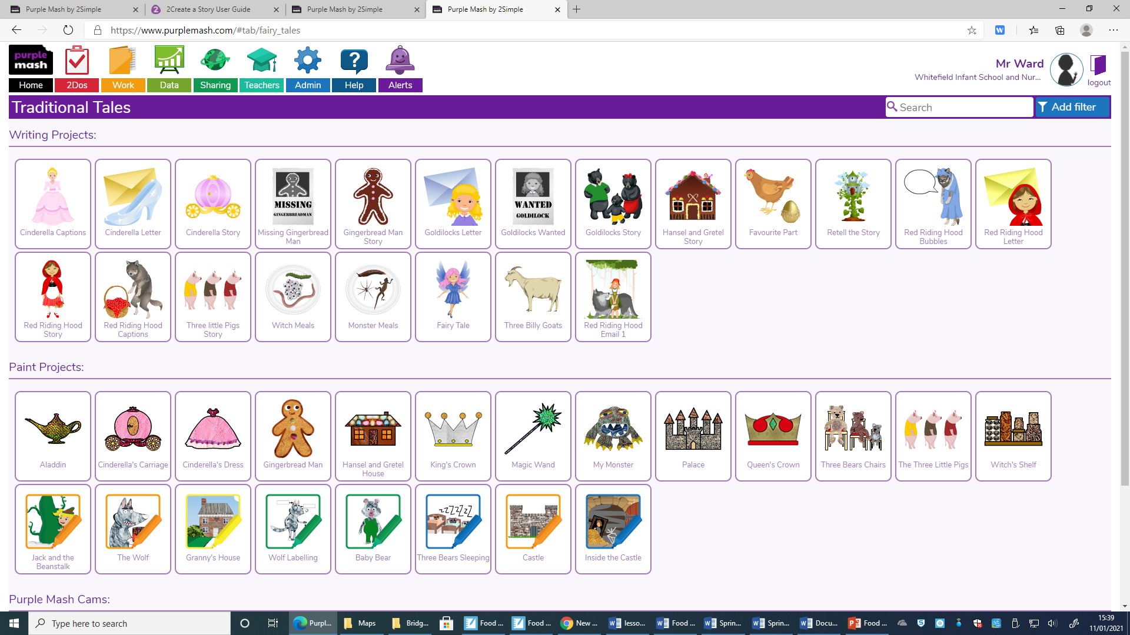

Music – Low pitch sounds
Lesson: Low sounds | Teacher Hub | Oak National Academy (thenational.academy)

Geography – Different perspectives.
This half-term, we are learning about maps. Maps show how an area looks from above. Have a go at this quiz to see if you are good at spotting things in different perspectives (the way they are shown to you).
http://espresso.education.btlsl.co.uk/espresso/primary_uk/standalone/activity_html/item258825/index.html?referrer=http%3A%2F%2Fespresso.education.btlsl.co.uk%2Fespresso%2Fmodules%2Ft1_mapping%2Factivities%2Findex.html&bgcolor=8cc3cd

