Whitefield Infant School


Year 2
Remote Learning Pack

Week 4
(Week beginning 25th January 2021)
Year 2
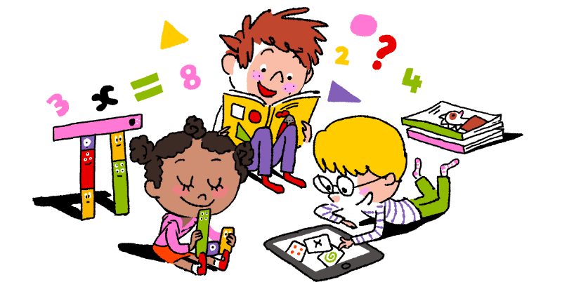
Maths Learning

Week 4

This week in Maths you will be learning about statistics. Statistics means collecting and representing information.
Ask your family if you can have some objects to sort in different ways. This could be buttons, shoes, toy cars, money or any collection of objects that are different colours, sizes or shapes.

Day 1 | Tally Charts  When you want to count a collection of objects, people, plants and animals, you might like to use a tally chart.  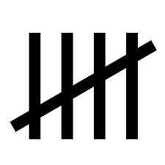  l =1 ll =2 lll=3 llll=4 =5  Count the tally carefully and remember to write the numeral correctly.
Day 2 | Tally Charts  Count the birds carefully. It might be a good idea to put a mark on each one as you count it. Show the tally and write the total at the end of the line.
Day 3 | Sorting Tally Charts  This tally is called a single tally. Count each tally stick and write the total at the end of the line. When you have done that complete the correct tally on the worksheet on the other side.
Day 4 | Ice Cream Graph Favourite Snack Pictogram  1 brick represents 1 count. Count each column of bricks and write the total at the top of each. Answer the questions by looking at each total.  Look at the pictogram of the snacks that were eaten in school. Write the total of each at the top of each column. Use this to help you answer the questions on the other sheet.
Day 5 | List of First Names  Look at all the names on the worksheet and count how many letters in each. Write the total on top of each name. Write the names in the correct column.  Ask your family to write their names on a piece of paper. Count how many letters are in each one. Add each name to the correct table.
Challenge
Ask your family how old they are. Show this information as a tally chart. Write each age at the end of each tally.

Year 2
English Learning
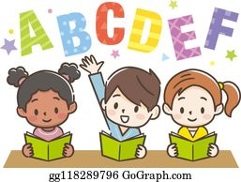

Week 4

This week in English you will continue to use the key text ‘Mr Wolf and the Three Bears’.
Just like last week, you can watch the story in one of the following ways:
- Watch the story on Youtube following this link https://www.youtube.com/watch?v=290FAQRhYR0
- Listen to Miss Stott read the story on the remote learning section of your class page
- Open the powerpoint of the story which is saved on the remote learning section of your class page and read the story or ask an adult to help you read the story
This week you will need: the worksheets in this pack, a pencil, to listen/ watch/ read the story following the options above

Day 1 | Write a description of Goldilocks  Goldilocks causes a lot of trouble at Mr Wolf’s party! Write a description of Goldilocks using the word mat on the sheet titled ‘Day 1’.  Key skill: Today you will be using nouns and adjectives in your writing.  A noun- is the name of a person, place or thing  Eg. Goldilocks coat hair bow Mr Wolf  An adjective- is a word that describes the noun  Eg. mean red soft nasty kind
Day 2 | Create a poster to warn other people about Goldilocks  Would you want Goldilocks to come to your party? Why or why not?  Create a poster to warn other people NOT to let Goldilocks in their house!  Key skill: Today you will use the joining word ‘and’ to extend your sentence.  Practice spelling that word here then make sure you spell it correctly in your writing.  and ___________ ____________ ____________
Day 3 | Write instructions for how to play musical statues.  Mr Wolf played musical statues and pass the parcel at his party. What games do you like playing at home or when you go to a party? Read the statements and write them in the correct order to make a set of instructions.  Key skill: Today you will use verbs in your writing, the verbs will be highlighted in bold.  A verb- is a ‘doing’ word. Here are some examples of verbs you might use today.  stand sit move walk play dance sing
Day 4 | Write a thank you card from Baby bear to Mr Wolf  Mr Wolf has been such a good friend to Baby Bear by organising a party for him. Baby Bear needs your help to write a thank you card to Mr Wolf. Here are some ideas of what you might thank him for: baking a birthday cake, decorating the house, organising the party games, buying some presents.  Key skill: When you write a card to someone you must use your very best handwriting, really concentrate on your handwriting today.
Day 5 | Sorry letter from Goldilocks to Baby Bear  Goldilocks has realised she has not been a very good friend to Baby Bear and would like to say sorry! Help Goldilocks to write a letter to Baby Bear using the template on the sheet titled ‘Day 5’.  Key skill: Today try to use the joining word ‘and’ in your writing to extend your sentences.  and

English- Day 1
Write a description

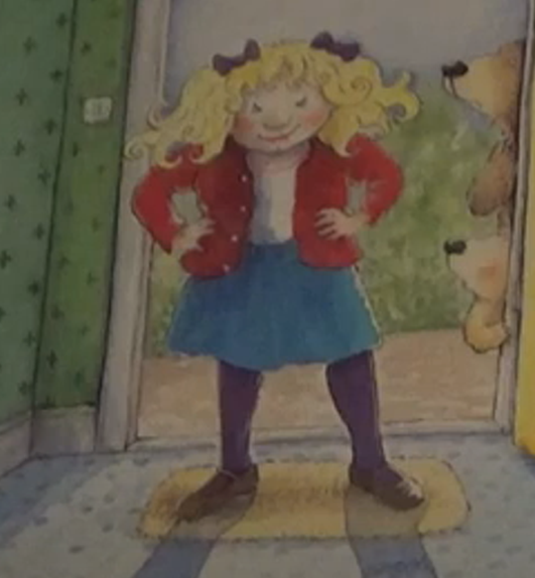
Nouns
Goldilocks
skirt
hair
bows
hands
hips

Adjectives
red
blue
blonde
cross
sneaky
nasty
Goldilocks is wearing a __________________________________
_________________________________________________________________
Goldilocks has _____________________________________________
_________________________________________________________________
Goldilocks is _______________________________________________
_________________________________________________________________
Now think of your own sentence, say it out loud and write it down.
________________________________________________________________
________________________________________________________________
________________________________________________________________
English- Day 2
Create a poster
WARNING!

Drawing of Goldilocks here:

Do not let Goldilocks to your party because she will ___________________________________________________________
and she will _______________________________________________.

If you let Goldilocks to your party she will _______
_________________________________________________________________
and she will ________________________________________________.
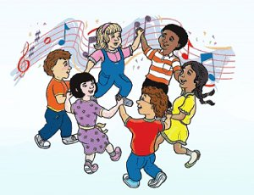
English- Day 3
Instructions

How to play musical statues

Put these instructions in the correct order and write them out below.
Next everyone should start dancing.
First one person must play the music.
Then when the music stops everyone must freeze.
Finally if anyone moves they are out of the game.

What you do:

- First____________________________________________________
___________________________________________________________
- Next ______________________________________________________
___________________________________________________________________________

- Then ______________________________________________________
___________________________________________________________
- Finally _____________________________________________________
___________________________________________________________________________

English- Day 4
Thank you card

Dear Mr Wolf,

Thank you for _____________________________________________
______________________________________________________________
Thank you for ______________________________________________
______________________________________________________________
Thank you for ______________________________________________
______________________________________________________________
Love from Baby Bear xxx
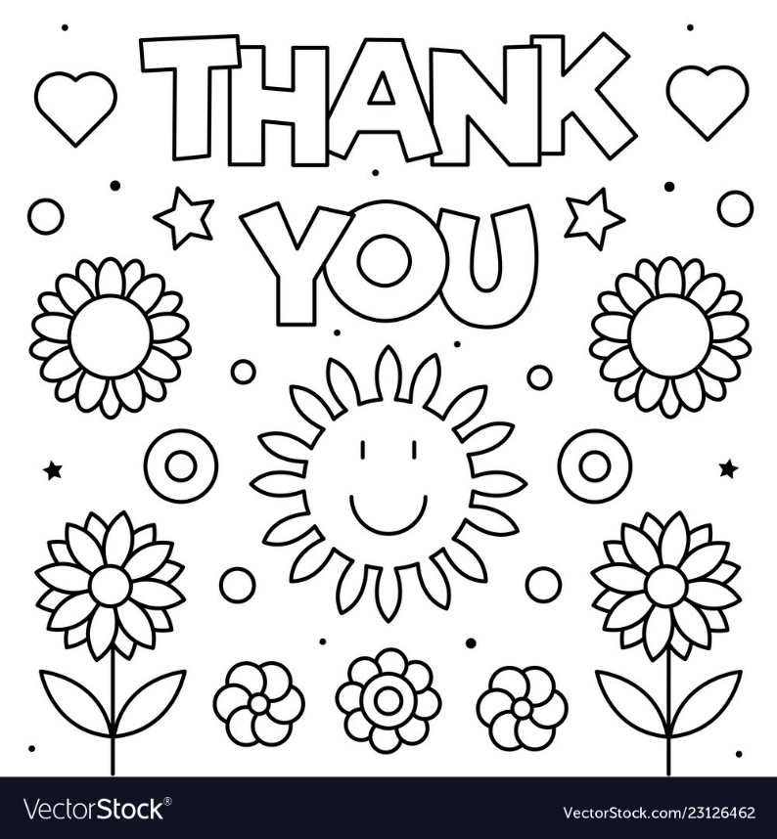

English- Day 5
Letter

Dear Baby Bear,

I am sorry for _____________________________________________
______________________________________________________________
______________________________________________________________
I am sorry for _____________________________________________
______________________________________________________________
______________________________________________________________
Love from Goldilocks xxx

Year 2
Science and Topic Learning
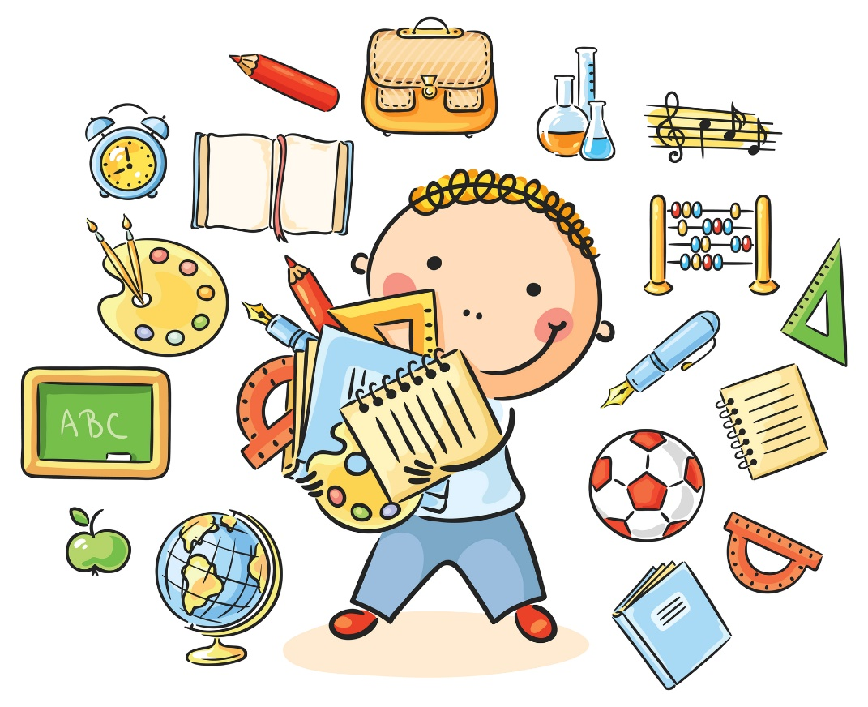

Week 4

Science Learning

Draw the pet that you would most like to have. Think about what your pet would need to stay happy, safe and healthy.

When you write down your ideas remember to include some of these scientific words.
diet exercise rest good hygiene excrete warmth shelter grow love

Pets

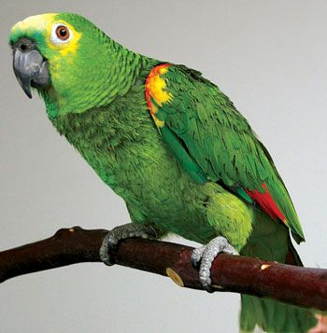
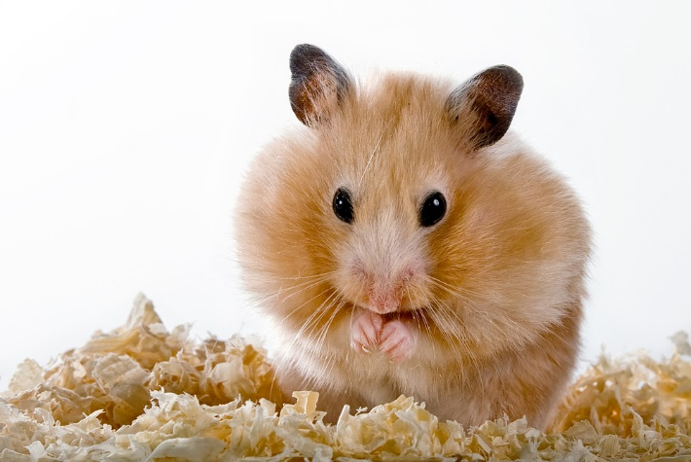
cat
parrot
hamster


guinea pig

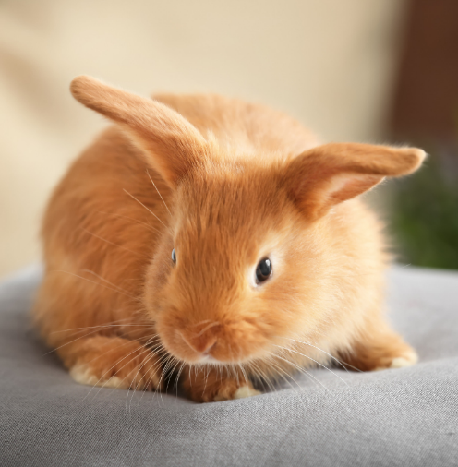
dog

rabbit
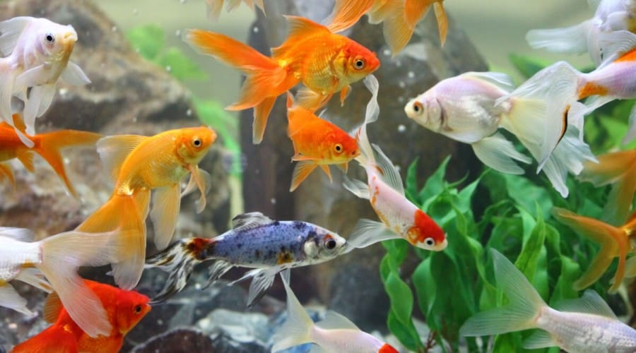
fish

Topic Learning
RE – Passover
Watch the video https://www.bbc.co.uk/programmes/p05x425v to learn about the story of Passover. Once you have watched it, complete the story sequence. Some of it has been done for you. Fill in the empty boxes using the text on the right hand side.
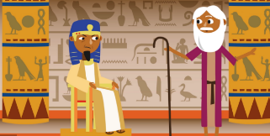 | Moses asked the Pharaoh to let the Jewish people go free but he said no.
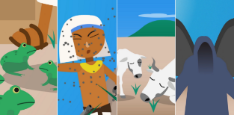
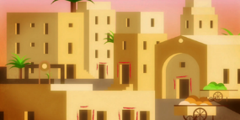 | Jewish people painted lamb’s blood on their doorways so the Angel of Death would pass over them.
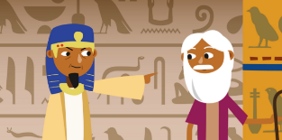

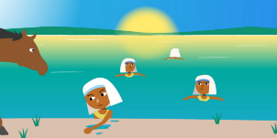
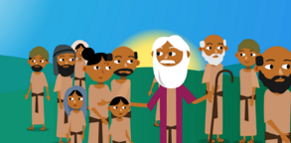 | Moses finally led the Jewish people to safety.

God parted the Red Sea so the Jewish people could escape.
The sea fell back onto the Pharaoh’s army.
Pharaoh finally let the Jews go free but he quickly changed his mind and sent his army after them.
God sent ten plagues to make the Pharaoh change his mind.

PSHE – Fairness
Today, I want you to think about fairness and what it means. Talk to a grown up about your ideas. I want you to think of one example of fairness and one example of when something isn’t fair. Write one sentence or draw a picture for each example.

Computing – Typing skills
Today, I want you to practise your typing skills. Follow the link and have a go at some of the games. See if you can improve your score!
https://www.purplemash.com/#tab/pm-home/computing/2type2/home_keys

