Whitefield Infant School
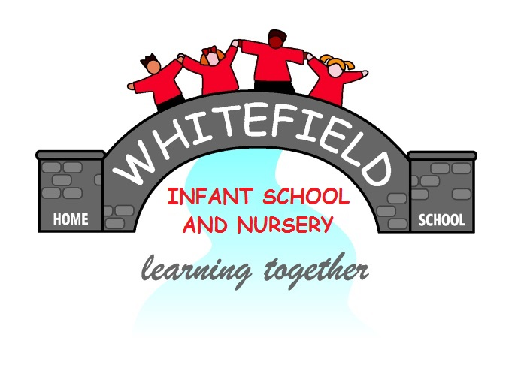

Year 2
Remote Learning Pack

Week 5
(Week beginning 1st February 2021)
Year 2
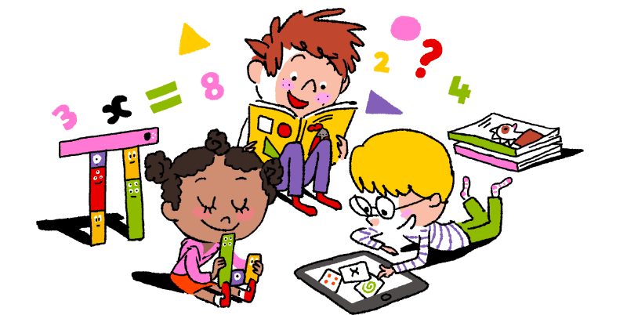
Maths Learning

Week 5

This week in Maths you will be learning to solve problems using the maths skills that you have learned already. It is important that you keep trying. Don’t give up. All of the problems are easy, once you have worked out what strategies you will need to use.
If you want to do some practical learning you will need: buttons, pennies, paper and coloured pencils.
Day 1 | How many ways?  You could do this practically first. Get 20 buttons, beads or pennies. Share them out in to 3 different groups. Record on the columns on the worksheet. On the back of the worksheet record as addition sentences.  + + =20
Day 2 | How many ways to colour 2 balloons?  You need 2 coloured pencils. How many ways can you colour the balloons, using only the 2 pencils you have got?  How many ways to colour 3 balloons?  You will need 3 coloured pencils. Colour the balloons so that each set of 3 are different. Don’t be tempted to give up!
Day 3 | How many number questions?  It will be easier if you write the numbers and symbols on small pieces of paper. You can choose different numbers and symbols to make a number sentence. Read the number sentence and then write it down. Do as many as you can. Don’t give up after a few! Keep going!
Day 4 | Make 2 digit numbers  Copy the numbers on to small pieces of paper. Move them around to make different 2 digit numbers. Write them down, starting with the number with the lowest value. Do this with the 2 digit numbers you make.
Day 5 | Reasoning. Shopping for 2 of a kind  These problems need you to have lots of stamina. Don’t give up! Try all the possibilities. If the total is 30p, draw jottings or get 30 pennies. How much might each fruit cost? When you have your answer you can check it by seeing if it still works when the total is 40p for 3 fruits. These problems are tricky but I know you can do them. Don’t give up easily. Your family will help you if you really need it.
Challenge Give it a try. Don’t give up!

Year 2
English Learning
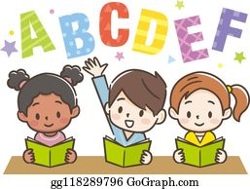

Week 5

This week in English you will be using the key text ‘Mr Wolf’s Pancakes’ By Jan Fearnley.
Before you start your learning you will need to read the story Mr Wolf’s Pancakes. You can watch the story in one of the following ways:
- Watch the story on Youtube following this link https://www.youtube.com/watch?v=CXQDiqHp-xM&safe=active
- Listen to Miss Stott read the story on the remote learning section of your class page
- Open the document of the story which is saved on the remote learning section of your class page and read the story
This week you will need: the worksheets in this pack, a pencil, to listen/ watch/ read the story following the options above.

Day 1 | Write a speech bubble for Mr Wolf and Chicken Licken  Mr Wolf needs help reading his recipe book but his neighbour Chicken Licken is not very kind! Think about the conversation they might have. You could act out the conversation with someone at home, then use the sheet titled ‘Day 1’ to write the speech down.  Key skill: Today you will be using a question mark when Mr Wolf asks Chicken Licken for help.  A question mark comes at the end of a question.  Eg. What is the weather like today? How are you feeling? When is it your birthday?
Day 2 | Help Mr Wolf write a shopping list  Poor Mr Wolf needs help and Wee Willy Winky will not help him write his shopping list. Please can you help him? Research the ingredients you need to make pancakes and write them on the shopping list. You could add extra yummy things to your list like fruit, syrup, chocolate sprinkles!  Key skill: Today you will be using your phonics to spell the ingredients on your list correctly.  Sound out each word carefully before you write it on your shopping list.
Day 3 | Instructions for how to make pancakes  Mr Wolf has all his ingredients so now he needs to make his pancakes. Can you write some instructions to help him make them correctly? Watch the following video for how to make pancakes https://www.youtube.com/watch?v=1G9PxUVQLxg or even better make them with an adult at home!  Key skill: Today you will be using verbs to write your instructions.  A verb- is a ‘doing word’. Here are some examples of verbs you might use in your writing today- mix, stir, flip, shake, eat, taste
Day 4 | Write a description of the town  Even though Mr Wolf has unhelpful neighbours, he lives in a beautiful village! Use the image from the story titled ‘Day 4’ to write your own description of the village where Mr Wolf lives.  Key skill: Today you will be using adjectives to describe the village.  An adjective- is a describing word.  Eg. tall, clean, tidy, lovely, kind
Day 5 | What would you do?  Look at the image from the text, on the sheet titled ‘Day 4’. Mr Wolf’s neighbours have been very unkind to him and now they want to share his pancakes! What would you do? What would you say to the neighbours? You could act it out with someone at home then try to write your ideas down.  Key skill: Today you will be using the joining word because to give reasons for your answers.  Eg. I would not let them in because _________  I would share my pancakes with them because __________

English- Day 1
Write a speech bubble

English- Day 2
Shopping List

English- Day 3
Instructions

How to make pancakes

What you need:


- _____________________
- _____________________
- _____________________
- _____________________
- _____________________
What you do:

- First ______________________________________________________
___________________________________________________________
- Next ______________________________________________________
___________________________________________________________________________

- Then ______________________________________________________
___________________________________________________________
- Finally _____________________________________________________
___________________________________________________________________________

English- Day 4
Description of the town
Use this word mat to help you, then write your description on the next page

Nouns
houses field doors castle hill river bridge apple tree well path gate

Adjectives
tall bright colourful busy tidy clean
beautiful welcoming lovely

Some ideas for sentence starters
There are…
There is…
In the distance there is…
Over the bridge…
At the top of the hill…
English- Day 4
Description of the town

__________________________________________________________________________________
__________________________________________________________________________________

__________________________________________________________________________________
__________________________________________________________________________________
__________________________________________________________________________________
__________________________________________________________________________________
__________________________________________________________________________________
__________________________________________________________________________________
__________________________________________________________________________________
Draw your own picture of Mr Wolf’s town here

English- Day 5
What would you do?

__________________________________________________________________________________
__________________________________________________________________________________

__________________________________________________________________________________
__________________________________________________________________________________
__________________________________________________________________________________
Some ideas for sentence starters
I would let them in because…
I would not let them in because…

Year 2
Science and Topic Learning
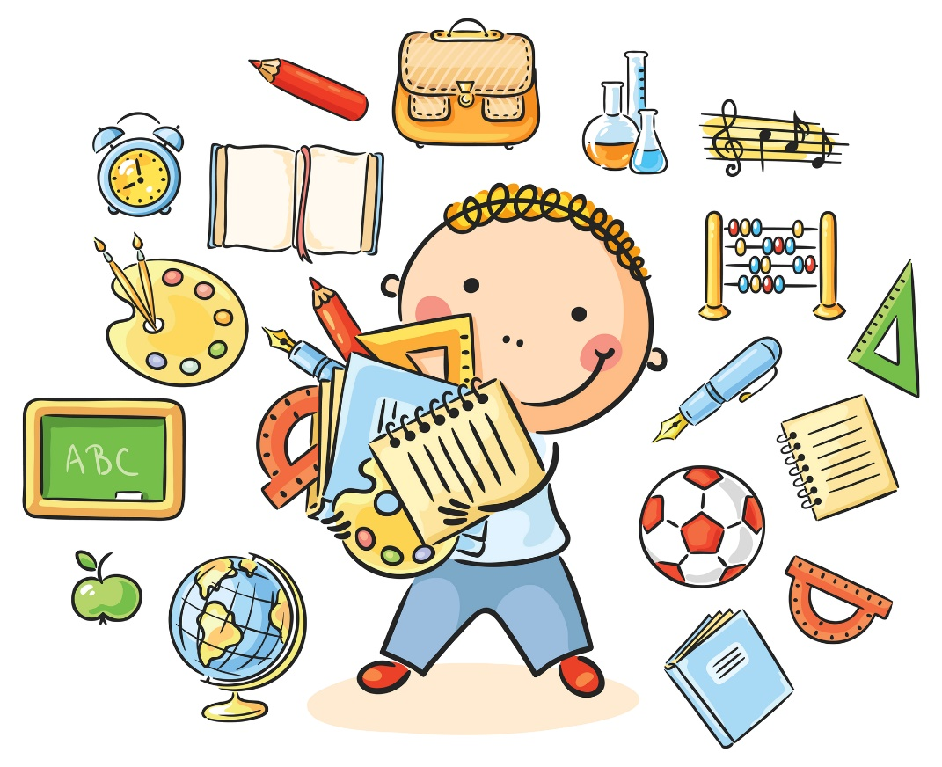

Week 5

Science Learning
Food Chains

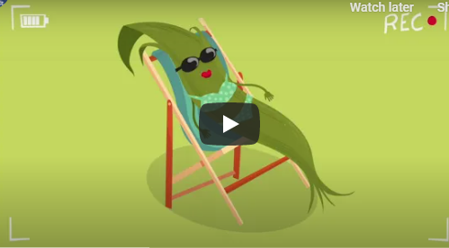
If you have a computer have a look at BBC Bitesize – food chains.
There are some good video clips that are fairly short.
https://www.bbc.co.uk/bitesize/topics/zx882hv/articles/z3c2xnb
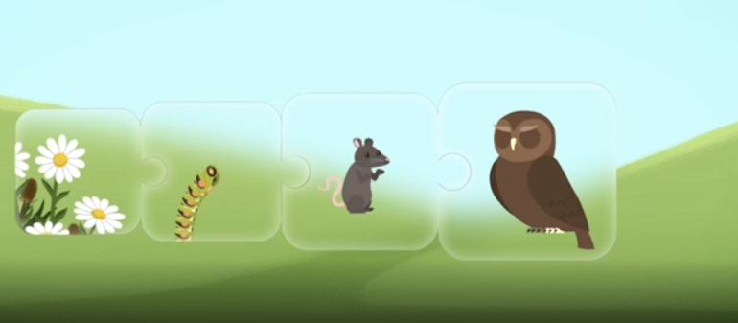
Look at the picture carefully. All living things, including plants, animals and humans, need energy to live. All living things get their energy from food. Animals and humans need to eat to get energy. Think about where animals get their food from. Animals depend on each other to get food.
A caterpillar eats plants. A mouse eats caterpillars. Owls eat mice. An owl’s poo helps the ground to be rich with nutrients so that plants will grow.

https://www.bbc.co.uk/bitesize/topics/zx882hv/articles/z3c2xnb
This is a game where you can test your knowledge of food chains.
Draw pictures to show this food chain. Label your pictures.
Topic Learning
RE
Last week, we looked at Judaism and the story of Passover. Jewish people celebrate Passover with a special meal. Think about how you use food to celebrate a special event. I want to know which food you would include if you were planning a celebration. Think about the foods that are your favourite or are special to you. Draw and label them on the plate. You could also think about the drinks that you would have at your party.


PE
We love Joe Wicks at Whitefield. Get yourself active by completing one of his PE sessions on his YouTube channel here https://www.youtube.com/channel/UCAxW1XT0iEJo0TYlRfn6rYQ
Try to get the rest of your family involved!

Geography
This half term is all about maps. Talk to an adult about what Today, I would like you to follow the link https://www.bbc.co.uk/bitesize/articles/zfv9bqt to find out about maps. Watch the video and complete the quizzes to test your knowledge!

Computing
Today, I would like you to practice your typing skills. Follow the link https://www.purplemash.com/#tab/pm-home/computing/2type2/home_keys and have a go at the challenges. See if you can beat your high score and challenge the other people in your house!

