Whitefield Infant School


Year 2
Remote Learning Pack

Week 6
(Week beginning 8th February 2021)
Year 2
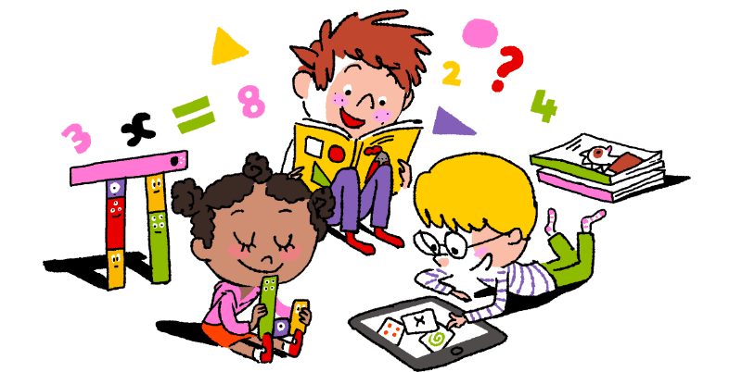
Maths Learning

Week 6

This week in Maths you will be learning about 2D and 3D shapes.
Look around your house. How many things can you find that are cubes, cuboids, spheres? How many things can you find with circle, triangle, square and oblong faces?
Draw all the 2D shapes you can remember. Name them. Ask a grown up to check that they are right.

Day 1 | Making 4 sided shapes  Use the dotted paper to draw shapes with 4 sides. Don’t draw the same shape twice. Some of the shapes you draw will be irregular shapes. All the shapes you draw will be quadrilaterals because they have 4 sides.
Day 2 | Identify 2D shapes on the surface of 3D shapes  Look at the drawings of the 3D shapes. Remember you can’t see all of the shape, just a part. Read the sentences and write the letter of the shape along the dotted line.
Day 3 | Recognise right angles  If you don’t want to cut out the right angle corner you can use the edge of a piece of paper or a book because these are right angles. A right angle is a quarter turn.  Look around your house to find right angles. Add the things you find to your list.  There are 2 more worksheets for you to use. Find the shapes with right angles.
Day 4 | Sorting shapes Pentagons and hexagons  Read the description of a pentagon. Use a ruler to draw your own. Irregular pentagons are fine. Count the number of sides you have drawn, just to be sure they are pentagons. Do the same with hexagons.
Day 5 | What shape? Pentagons and hexagons  Read the clues that match to the shapes. A rectangle is a shape with 4 straight sides. This is a rectangle called an oblong.
Challenge
Use the correct mathematical vocabulary when you explain your answer.

Year 2
English Learning
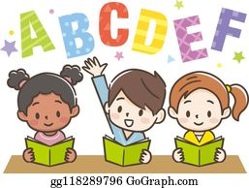

Week 6

This week in English you will continue to use the key text ‘Mr Wolf’s Pancakes’
Before you start your learning this week re-read the story Mr Wolf’s Pancakes. You can watch the story in one of the following ways:
- Watch the story on Youtube following this link https://www.youtube.com/watch?v=CXQDiqHp-xM&safe=active
- Listen to Miss Stott read the story on the remote learning section of your class page
- Open the document of the story which is saved on the remote learning section of your class page and read the story
This week you will need: the worksheets in this pack, a pencil, to listen/ watch/ read the story following the options above.

Day 1 | Story map of Mr Wolf’s Pancakes  Today you are going to create a story map of Mr Wolf’s Pancakes. Draw pictures to add the main events in the story. Make sure your story map has a beginning, a middle and an ending. Use the sheet titled ‘Day 1’ to help you create your story map. Once you have created your story map re-tell the story to someone at home in your own words.  Key skill: Today you will be sequencing events in a story.  Make sure your story is in the correct order with a beginning, a middle and an ending.
Day 2 | Create your own story  Now you are going to use the planning sheet titled ‘Day 2’ to create your own version of Mr Wolf’s Pancakes. Use your imagination and make it as exciting, interesting and funny as you can!  Key skill: Today you will be sequencing events in a story.  Make sure your story has a beginning, a middle and an ending.
Day 3 | Write your own story  Today you are going to use your story plan that you created yesterday to write your own version of Mr Wolf’s Pancakes. On the sheet titles ‘Day 3’ there is a word bank that might help you when writing your story. Try to make your story interesting for the reader.  Key skill: When writing your story remember to use the correct punctuation.  A capital letter comes at the start of a sentence.  A full stop comes at the end of a sentences.  A comma is used to separate items in a list. Eg. Mr Wolf made his tasty, delicious pancakes all by himself.
Day 4 | Perform your story  Today you are going to perform the story you have written. You could read it aloud to an adult, sibling or relative at home or you could ask an adult at home to video you reading your story aloud and send it to your class teacher. Your teachers would love to listen to your stories!  Key skill: Try to use expression and change your voice for the different characters when reading aloud, to make it interesting for the listener.
Day 5 | Mr Wolf’s Pancakes Comprehension  Now that you have read the story and learnt lots about the characters, setting and plot, answer the questions on the sheet titled ‘Day 5’ to show your understanding of the story.

English- Day 1
Story map of Mr Wolf’s Pancakes

Draw pictures to create your story map
Who is the main character in the story? What does he want to make?
Who does he ask to help him read his recipe book?
What happens at the end of the story?
Who knocks on the door when the pancakes are ready?
Mr Wolf goes to the shops then goes home to make his pancakes.
Who does he ask to help him write his shopping list?

English- Day 2
Create your own version of the story

Mr Wolf’s __________________
(Write your own title- what do you want Mr Wolf to make in your story?)
Who is the main character in the story? What does he want to make?
Who does he ask for help? (You can think of a new character for your story)
What happens at the end of the story? Does Mr Wolf share his food?
Who knocks on the door when the ________ are ready?
Mr Wolf makes his _________

Who does he ask for help? (You can think of a new character for your story)

English- Day 3
Write your own version of the story

Use your own story map from Day 2 to write your own version of the story. Below is a word bank with some of the phrases you might use to start your sentences.

One sunny day Just then The next day
Later that day After that In the end

__________________________________________________________________________________
__________________________________________________________________________________

__________________________________________________________________________________
__________________________________________________________________________________
__________________________________________________________________________________
__________________________________________________________________________________
__________________________________________________________________________________
__________________________________________________________________________________
__________________________________________________________________________________
__________________________________________________________________________________
__________________________________________________________________________________
__________________________________________________________________________________
__________________________________________________________________________________
__________________________________________________________________________________
__________________________________________________________________________________
__________________________________________________________________________________
__________________________________________________________________________________
__________________________________________________________________________________
__________________________________________________________________________________
__________________________________________________________________________________
__________________________________________________________________________________
__________________________________________________________________________________
__________________________________________________________________________________
__________________________________________________________________________________
__________________________________________________________________________________
__________________________________________________________________________________
__________________________________________________________________________________
__________________________________________________________________________________
English- Day 5
Comprehension

You will need to have the story that is on the remote learning section of your class page to help you answer the questions.

- Who did Mr Wolf as for help to count his money?

__________________________

- What did Mr Wolf want to borrow from Little Red Riding Hood?

___________________________________
- List three things that are sold at Old Mother Hubbard’s General Store? (Look at the illustration of the shop to find the answer)
____________________
____________________
____________________
- How did Mr Wolf feel when the three little pigs slammed their doors?

_____________________________________________________
- What adjective is used to describe the Mr Wolf’s pancakes?

_______________________
- What made all Mr Wolf’s neighbours feel hungry and made them go to his house?

____________________________________________________

- What did Mr Wolf’s neighbours do? Underline the verbs in this sentence.

His greedy neighbours rudely pushed him aside and dashed down the hall.
Year 2
Science and Topic Learning
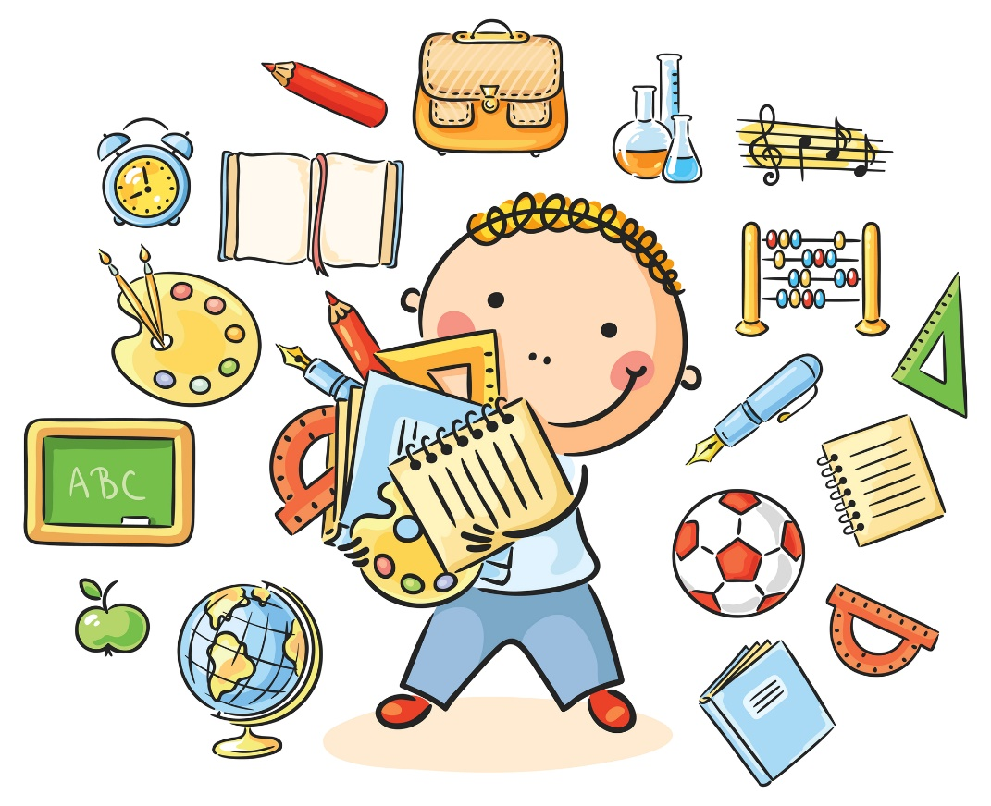

Week 6

Science Learning
Food Chains
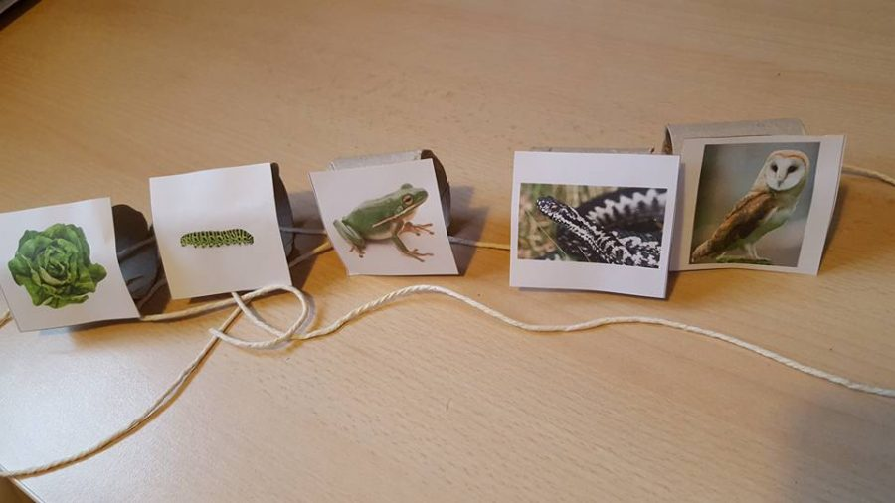
You will need:
- A set of picture cards
- A cardboard tube
- A glue stick
- Scissors
- Some string
What to do
- Cut out the labelled pictures
- Start with the title card
- Put the other cards in order. Remember what you learnt last week
- Cut your tube so you have one part for each of your card pictures
- Stick each card picture on to a part of your tube
- Thread string or wool through each part to show the correct sequence
- Use your string to explain to your family what a food chain is
- Think of other food chains that you can make to show your family
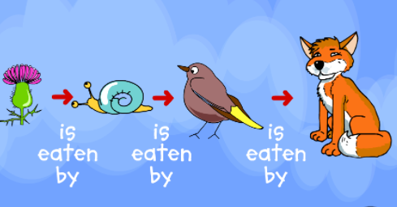
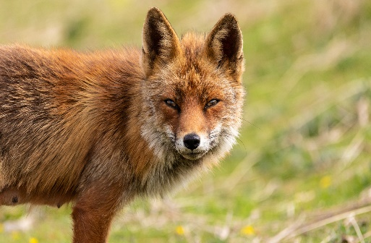
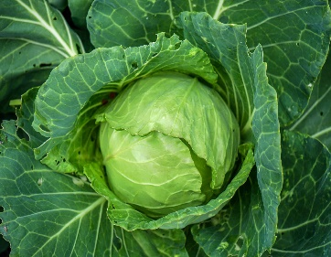
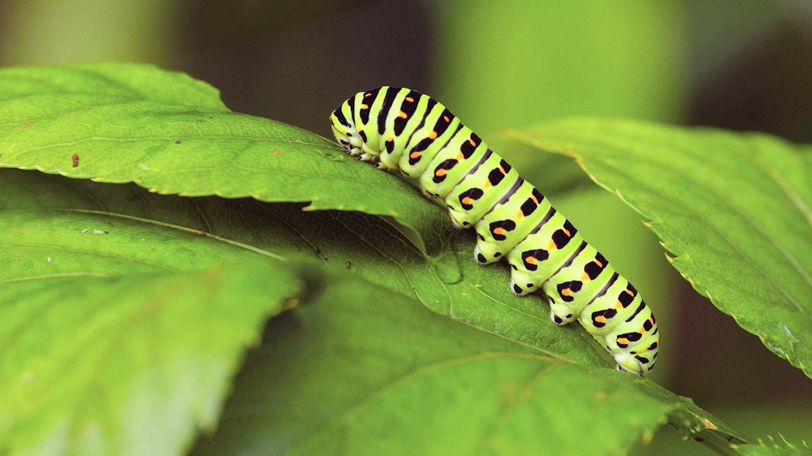

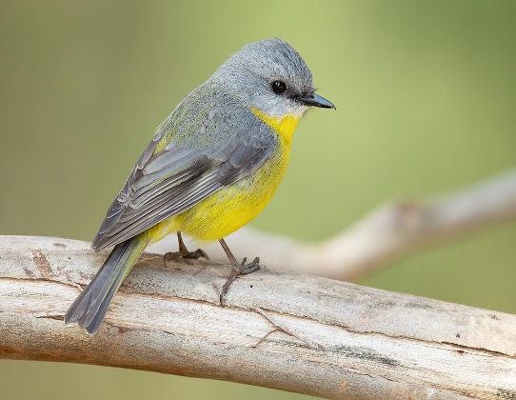

My
Food Chain

fox
cabbage
caterpillar
3
sun

bird

Topic Learning
Art
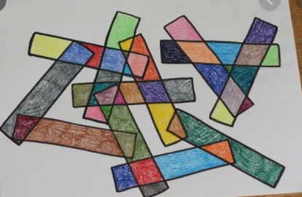
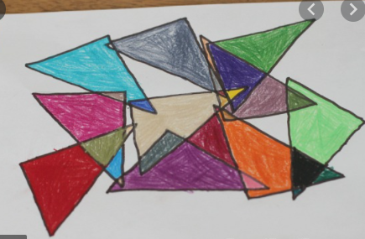
Today I would like you to use your knowledge of 2D shapes to create some shape art. Use the pictures as inspiration to help you create your own designs.
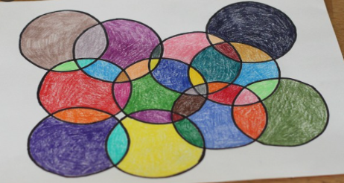


PE
Time to get moving again! Get yourself active by completing another of Joe’s PE sessions on his YouTube channel here https://www.youtube.com/channel/UCAxW1XT0iEJo0TYlRfn6rYQ
Remember to get the rest of your family involved!

Computing
Today, I would like you to practice your coding skills. Follow the link https://www.purplemash.com/app/code/chimp/airtrafficcontrol to Purple Mash and see if you can complete the challenges to make the planes take off. When you have finished, you could try to beat your score from last week’s typing challenge here https://www.purplemash.com/#tab/pm-home/computing/2type2/home_keys

