Whitefield Infant School
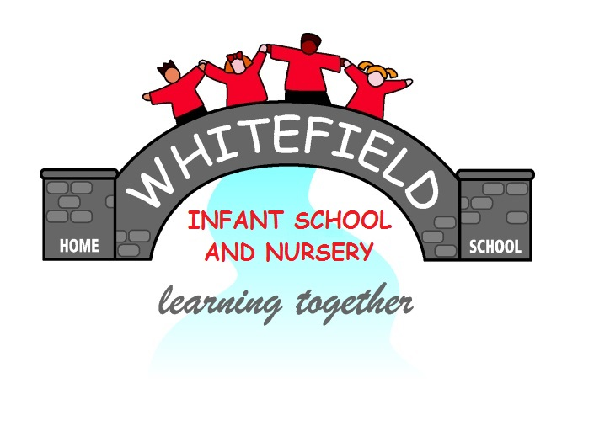

Year 2
Remote Learning Pack

Week 5
(Week beginning 1st February 2021)
Year 2
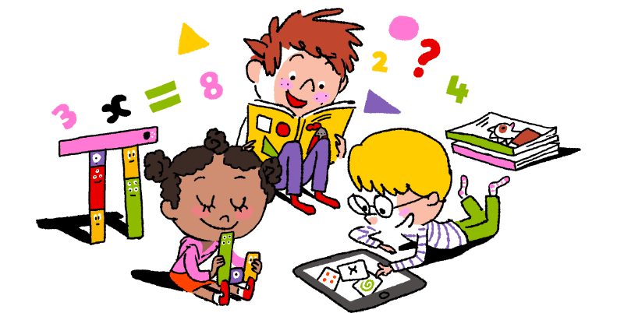
Maths Learning

Week 5

This week in Maths you will be learning to solve problems using the maths skills that you have learned already

Day 1 | How many ways? 7  Get 7 buttons, counters or pennies. Share the 7 objects in to 2 different groups. Write down how many are in each group. Write an addition sentence for each.  + =7
Day 2 | How many ways? 9  Get 9 buttons, counters or pennies. Share the 7 objects in to 2 different groups. Write down how many are in each group. Write an addition sentence for each.  + = 9
Day 3 | Challenge Ice lollies  This asks you to colour the ice lollies in, using just 2 colours. Don’t worry if you don’t have the yellow and blue colours it says. Any 2 colours will do. Remember, each lolly has to look different. How many ways can you do this?
Day 4 | Challenge Make 8  Copy the numbers ad symbols from the sheet on to Post it notes or small pieces of paper. You can use the numbers as many times as you like. You can also use + and – as many times as you like. Only use = once for each number sentence.
Day 5 | Sorting in to groups  Look at the ladybirds carefully, Sort them in to groups. You could draw them in your workbook or cut them out and stick them in, if that would help you. If you find it hard to write an explanation sentence, ask a grown up to write down what you tell them.  Sorting Objects  Look at the fruit carefully. Sort the fruit by drawing them in the sorting boxes. Explain how you have sorted the fruit. Ask a grown up to write down your ideas.
Challenge
How many numbers can you write down that are greater than 23 and less than 61?
Write the numbers down in your workbook.

Year 2
English Learning
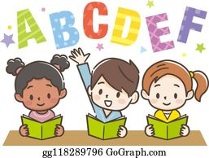

Week 5
This week in English you will be using the key text ‘Mr Wolf’s Pancakes’ By Jan Fearnley.
Before you start your learning you will need to read the story Mr Wolf’s Pancakes. You can watch the story in one of the following ways:
- Watch the story on Youtube following this link https://www.youtube.com/watch?v=CXQDiqHp-xM&safe=active
- Listen to Miss Stott read the story on the remote learning section of your class page
- Open the document of the story which is saved on the remote learning section of your class page and read the story
This week you will need: the worksheets in this pack, a pencil, to listen/ watch/ read the story following the options above.

Day 1 | Write a speech bubble for Mr Wolf and Chicken Licken  Mr Wolf needs help reading his recipe book but his neighbour Chicken Licken is not very kind! Think about the conversation they might have. You could act out the conversation with someone at home, then use the sheet titled ‘Day 1’ to write the speech down.  Key skill: Use a capital letter and a full stop correctly.  A capital letter comes at the start of a sentence.  A full stop comes at the end of a sentence.
Day 2 | Help Mr Wolf write a shopping list  Poor Mr Wolf needs help and Wee Willy Winky will not help him write his shopping list. Please can you help him? Research the ingredients you need to make pancakes and write them on the shopping list. You could add extra yummy things to your list like fruit, syrup, chocolate sprinkles!  Key skill: Today you will be using your phonics to spell the ingredients on your list correctly.  Sound out each word carefully before you write it on your shopping list.
Day 3 | Instructions for how to make pancakes  Mr Wolf has all his ingredients so now he needs to make his pancakes. Can you order the instructions to help him make them correctly? Watch the following video for how to make pancakes https://www.youtube.com/watch?v=1G9PxUVQLxg or even better make them with an adult at home!  Key skill: Today you will be using verbs to write your instructions.  A verb- is a ‘doing word’. Here are some examples of verbs you might read today-  put, mix, cook, add, eat
Day 4 | Write a description of the town  Even though Mr Wolf has unhelpful neighbours, he lives in a beautiful village! Use the image from the story titled ‘Day 4’ and the sentence starters given to write your own description of the village where Mr Wolf lives.  Key skill: Today try to use adjectives to describe the village.  An adjective- is a describing word.  Eg. tall, clean, tidy, lovely, kind
Day 5 | What would you do?  Look at the image from the text, on the sheet titled ‘Day 4’. Mr Wolf’s neighbours have been very unkind to him and now they want to share his pancakes! What would you do? What would you say to the neighbours? You could act it out with someone at home then try to write your ideas down.  Key skill: Today you will be using the joining word and to extend your sentences.  Eg. Yes you can come in and…  No you cannot come in and…

English- Day 1
Write a speech bubble

English- Day 2
Shopping List

English- Day 3
Instructions

How to make pancakes

Put these instructions in the correct order and write them out below.
Next put a pan on the hob and add some butter.
First mix the ingredients in a bowl.
Then cook the pancakes on both sides for 1 minute.
Finally add your toppings and eat them!

What you do:

- First ______________________________________________________
___________________________________________________________
- Next ______________________________________________________
___________________________________________________________________________

- Then ______________________________________________________
___________________________________________________________
- Finally _____________________________________________________
___________________________________________________________________________

English- Day 4
Description of the town

Use the sentences starters to help you with your writing

In the town there is _____________________________________________________
__________________________________________________________________________________
There are ___________________________________________________________________
__________________________________________________________________________________
Over the bridge there is _______________________________________________
__________________________________________________________________________________
At the top of the hill there is ________________________________________
__________________________________________________________________________________

English- Day 5
What would you do?

__________________________________________________________________________________
__________________________________________________________________________________

__________________________________________________________________________________
__________________________________________________________________________________
__________________________________________________________________________________
__________________________________________________________________________________
Some ideas for sentence starters
Yes you can come in and….
No you cannot come in and…

Year 2
Science and Topic Learning


Week 5

Science Learning
Food Chains
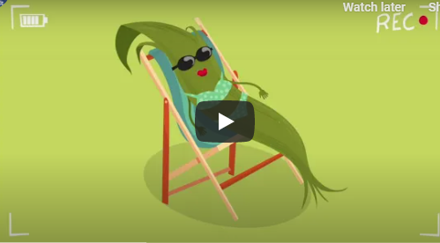
If you have a computer have a look at BBC Bitesize – food chains.
There are some good video clips that are fairly short.
https://www.bbc.co.uk/bitesize/topics/zx882hv/articles/z3c2xnb
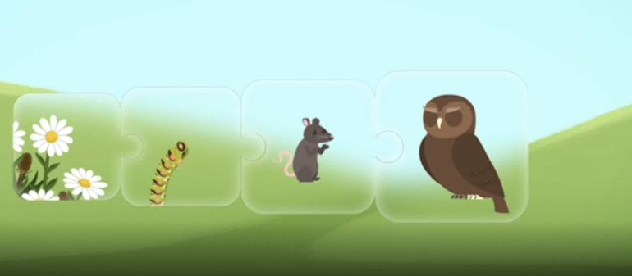
Look at the picture carefully. All living things, including plants, animals and humans, need energy to live. All living things get their energy from food. Animals and humans need to eat to get energy. Think about where animals get their food from. Animals depend on each other to get food.
A caterpillar eats plants. A mouse eats caterpillars. Owls eat mice. An owl’s poo helps the ground to be rich with nutrients so that plants will grow.

https://www.bbc.co.uk/bitesize/topics/zx882hv/articles/z3c2xnb
This is a game where you can test your knowledge of food chains.
Draw pictures to show this food chain. Label your pictures.

Topic Learning
RE
Last week, we looked at Judaism and the story of Passover. Jewish people celebrate Passover with a special meal. Think about how you use food to celebrate a special event. I want to know which food you would include if you were planning a celebration. Think about the foods that are your favourite or are special to you. Draw and label them on the plate. You could also think about the drinks that you would have at your party.


PE
We love Joe Wicks at Whitefield. Get yourself active by completing one of his PE sessions on his YouTube channel here https://www.youtube.com/channel/UCAxW1XT0iEJo0TYlRfn6rYQ
Try to get the rest of your family involved!

Geography
This half term is all about maps. Talk to an adult about what Today, I would like you to follow the link https://www.bbc.co.uk/bitesize/articles/zfv9bqt to find out about maps. Watch the video and complete the quizzes to test your knowledge!

Computing
Today, I would like you to practice your typing skills. Follow the link https://www.purplemash.com/#tab/pm-home/computing/2type2/home_keys and have a go at the challenges. See if you can beat your high score and challenge the other people in your house!

