Whitefield Infant School
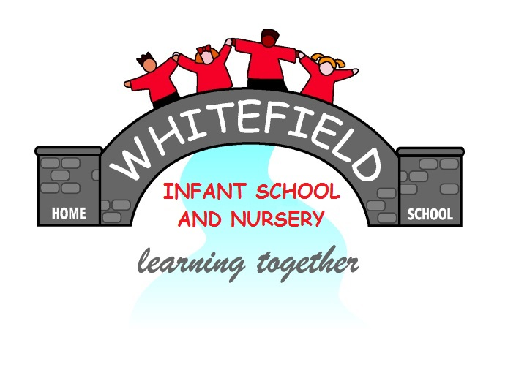

Year 2
Remote Learning Pack

Week 6
(Week beginning 8th February 2021)
Year 2
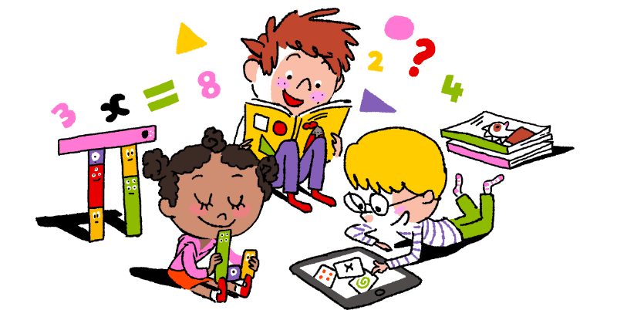
Maths Learning

Week 6

This week in Maths you will be learning about 2D and 3D shapes.
Look around your house. How many things can you find that are cubes, cuboids, spheres? How many things can you find with circle, triangle, square and oblong faces?
The first 2 worksheets are just to remind you of the names of 3D shapes. Read the words and match them to the correct shape.

Day 1 | 3D shapes The odd one out  Look carefully at the pyramids. What are the properties of a pyramid? Do all the shapes have the same properties? Put a circle around the odd one out. Think about the properties of cubes, spheres and cuboids. If you know the properties of each 3D shape, you will be able to find the odd one out.
Day 2 | Are the 3D shapes sorted correctly?  Look at the pictures very carefully and check that they have been sorted correctly. Use the correct mathematical words when you explain your answers.
Day 3 | 2D shapes Sorting in to groups  Use a coloured pencil to colour the correct shapes. You could draw some more of your own.
Day 4 | 2D shapes The odd one out  Look carefully at the 2D shapes. There is an odd one out in each. Colour the one that is the odd one out.
Day 5 | Using 2D shapes  Colour the picture using the correct colours. There are 2 for you to do. When you have finished draw a picture of your own using 2D shapes. Colour it in.
Challenge
Go on a shape hunt around your house. Find 6 things that are cuboid shape. Draw and label them. Find 6 things that are cylinder shape. Draw and label them.

Year 2
English Learning
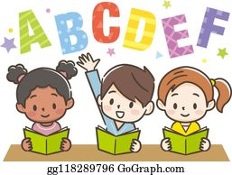

Week 6
This week in English you will continue to use the key text ‘Mr Wolf’s Pancakes’
Before you start your learning this week re-read the story Mr Wolf’s Pancakes. You can watch the story in one of the following ways:
- Watch the story on Youtube following this link https://www.youtube.com/watch?v=CXQDiqHp-xM&safe=active
- Listen to Miss Stott read the story on the remote learning section of your class page
- Open the document of the story which is saved on the remote learning section of your class page and read the story
This week you will need: the worksheets in this pack, a pencil, to listen/ watch/ read the story following the options above.

Day 1 | Story plan of Mr Wolf’s Pancakes  Today you are going to draw pictures to show the main events in the story. Use the boxes on the sheet titled ‘Day 1’ to show the beginning, middle and ending of the story. Once you have filled in each box re-tell the story to someone at home in your own words.  Key skill: Today you will be sequencing events in a story.  Make sure your story is in the correct order with a beginning, a middle and an ending.
Day 2 | Write the story in your own words  Today and tomorrow you are going to use your story plan that you created yesterday to write re-tell the story of Mr Wolf’s Pancakes. On the sheet titled ‘Day 2’ there are some images from the story. Write a sentence next to each image to re-tell the story in your own words.  Key skill: When writing your story remember to use the correct punctuation.  A capital letter comes at the start of a sentence.  A full stop comes at the end of a sentences.
Day 3 | Write the story in your own words  Today you are going to continue re-telling the story. Find the sheet titled ‘Day 4’ and similarly to yesterday write a sentence next to each image to re-tell the story in your own words.  Key skill: Today try to use an adjective in your writing to make your story interesting for the reader.  An adjective- describes a noun.
Day 4 | Perform your story  Today you are going to perform the story you have written. You could read it aloud to an adult, sibling or relative at home or you could ask an adult at home to video you reading your story aloud and send it to your class teacher. Your teachers would love to listen to your stories!  Key skill: Try to use expression and change your voice for the different characters when reading aloud, to make it interesting for the listener.
Day 5 | Mr Wolf’s Pancakes Comprehension  Now that you have read the story and learnt lots about the characters, setting and plot, answer the questions on the sheet titled ‘Day 5’ to show your understanding of the story.

English- Day 1
Story plan of Mr Wolf’s Pancakes

Draw a picture in each box to show the main events in the story.

Beginning
Middle
Ending

Now use your drawings to re-tell the story to someone at home in your own words.

English- Day 2
Re-tell the story in your own words

______________________________
______________________________
______________________________
______________________________
______________________________
______________________________
______________________________
______________________________
______________________________
______________________________
______________________________
______________________________
English- Day 3
Continue to re-tell the story in your own words

______________________________
______________________________
______________________________
______________________________
______________________________
______________________________
______________________________
______________________________
______________________________
______________________________
______________________________
______________________________
English- Day 5
Comprehension

You will need to have the story that is on the remote learning section of your class page to help you answer the questions.

- What colour is Mr Wolf’s shirt?

__________________________

- Tick the correct answer.
Mr Wolf asked Little Red Riding Hood to borrow her…

jacket basket shoes

- Name something that is sold at Old Mother Hubbard’s General Store? (Look at the illustration of the shop to find the answer)
_________________________

- How did Mr Wolf feel when the three little pigs slammed their doors?

_____________________________________________________

- Put a circle around the adjective in this sentence.

Soon there was a huge pile of delicious pancakes.

- What was your favourite part of the story?

_____________________________________________________
_____________________________________________________

Year 2
Science and Topic Learning
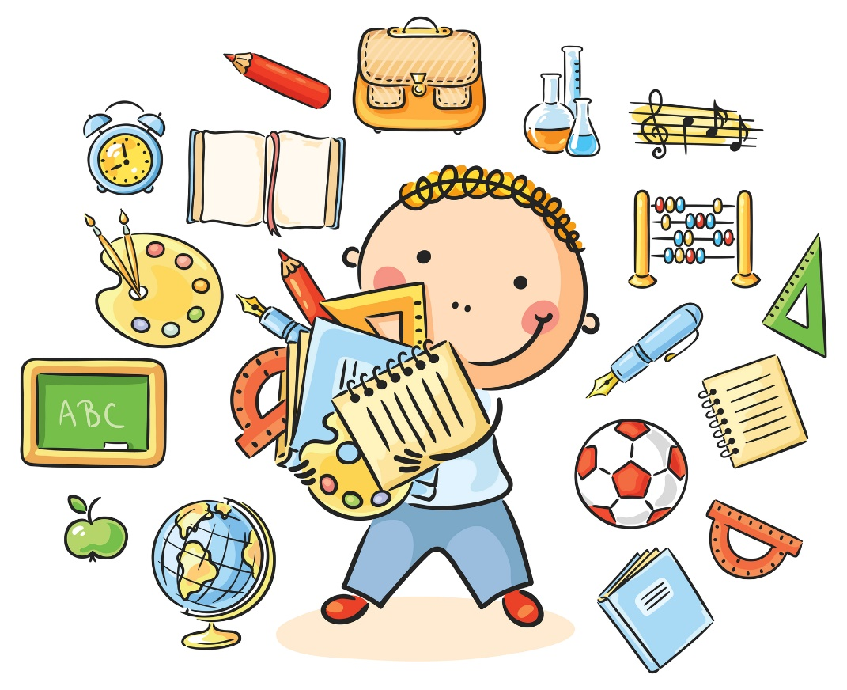

Week 6

Science Learning
Food Chains
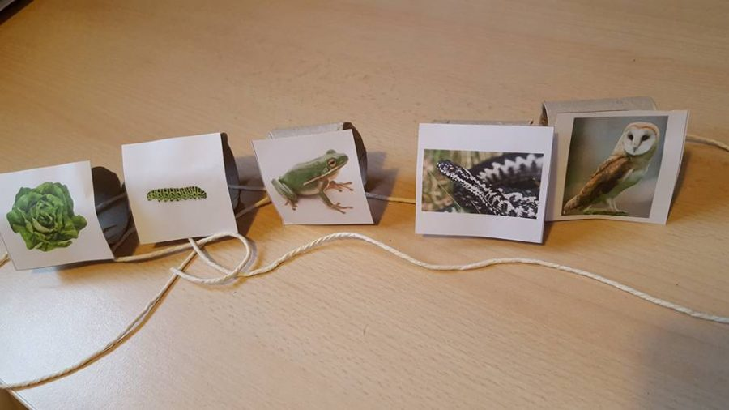
You will need:
- A set of picture cards
- A cardboard tube
- A glue stick
- Scissors
- Some string
What to do
- Cut out the labelled pictures
- Start with the title card
- Put the other cards in order. Remember what you learnt last week
- Cut your tube so you have one part for each of your card pictures
- Stick each card picture on to a part of your tube
- Thread string or wool through each part to show the correct sequence
- Use your string to explain to your family what a food chain is
- Think of other food chains that you can make to show your family
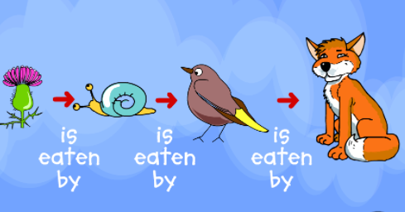
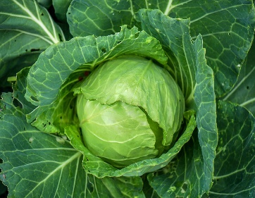
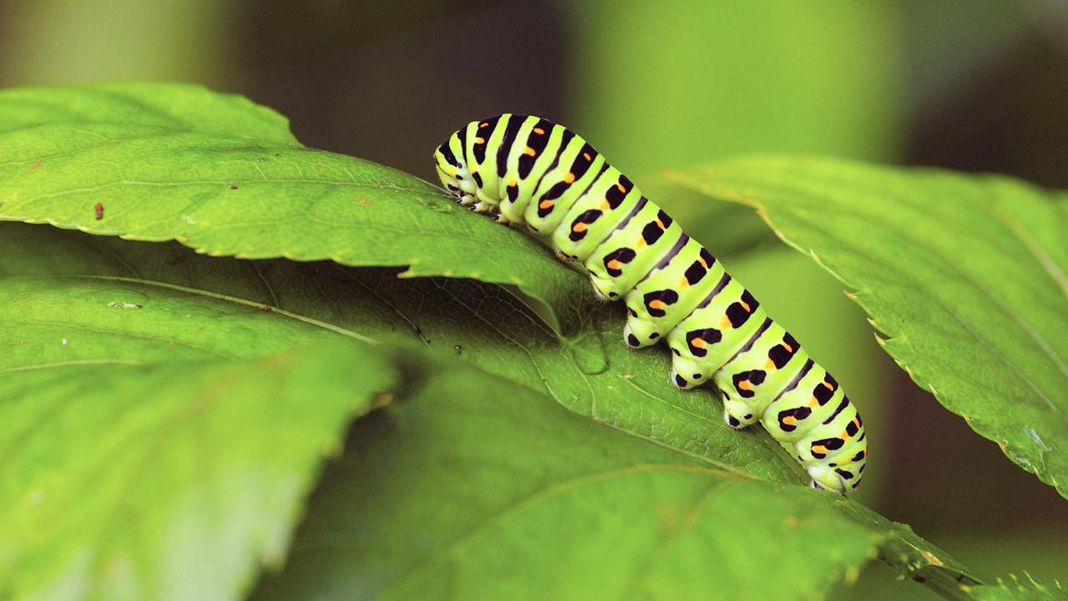

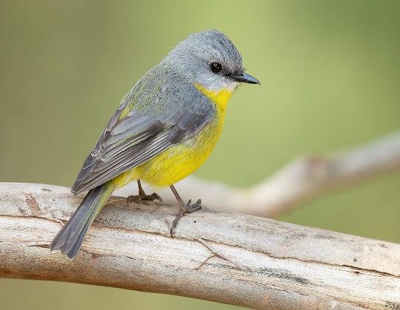
My
Food Chain

cabbage
caterpillar 3
sun

bird



Topic Learning
Art
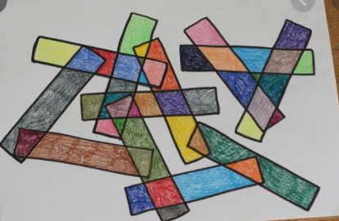
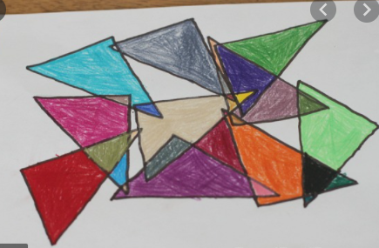
Today I would like you to use your knowledge of 2D shapes to create some shape art. Use the pictures as inspiration to help you create your own designs.
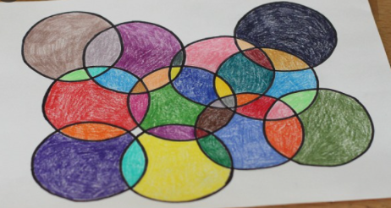
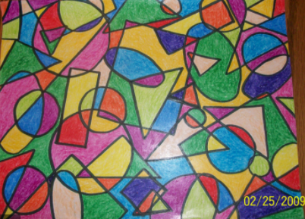

PE
Time to get moving again! Get yourself active by completing another of Joe’s PE sessions on his YouTube channel here https://www.youtube.com/channel/UCAxW1XT0iEJo0TYlRfn6rYQ
Remember to get the rest of your family involved!

Computing
Today, I would like you to practice your coding skills. Follow the link https://www.purplemash.com/app/code/chimp/airtrafficcontrol to Purple Mash and see if you can complete the challenges to make the planes take off. When you have finished, you could try to beat your score from last week’s typing challenge here https://www.purplemash.com/#tab/pm-home/computing/2type2/home_keys

