Year 2 Week 1
Day 1
Phonics

Follow the link to take part in today’s phonics lesson all about different ways to make a ‘ch’ sound. https://central.espresso.co.uk/espresso/primary_uk/subject/module/video/item63791/grade1/module63429/index.html You will need to log in to Espresso using the log on details that you have been given. Once you have watched the video, use the links at the side and complete the activities.
English- Grammar task

In this lesson you will learn to use different joining words to extend your sentence.
Find worksheet E1 and complete the activity.

Maths

Today in maths you are going to be adding a multiple of 10 to a 2-digit number. Follow the link to our school website and find the video in the year 2 section on adding multiples of 10. https://www.whitefield-inf.lancs.sch.uk/addition/
Once you have watched the video find worksheet M1 in your learning pack. Complete the activity about adding multiples of 10. Choose which strategy from the video you will use to answer the questions.

Reading

For today’s task, watch this video of the story ‘Tadpole’s Promise’. https://central.espresso.co.uk/espresso/primary_uk/subject/module/video/item1217572/grade1/module1217337/index.html
Once you have watched the video, follow this link to take part in a comprehension activity about what you have read. https://central.espresso.co.uk/espresso/primary_uk/subject/module/activity/item1217776/grade1/module1217337/index.html

Topic- Music

Follow the link to take part in today’s music lesson all about changes in tempo, which is the speed of the music. https://classroom.thenational.academy/lessons/identifying-tempo-changes-in-tempo-cru64t

Day 2
Phonics
Follow the link to take part in today’s phonics lesson all about the ‘dge’ sound. https://central.espresso.co.uk/espresso/primary_uk/subject/module/video/item108355/grade1/module63429/index.html You will need to log in to Espresso using the log on details that you have been given. Once you have watched the video ask an adult to read these words for you to spell. Once you have written the words put them into a sentence.
judge | edge | bridge | hedgehog
badge | fridge | smudge | nudge

English
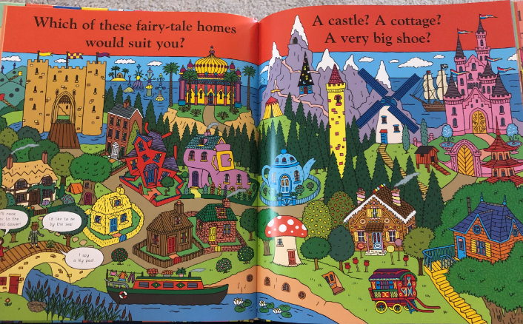
Find worksheet E2 in your learning pack. Today you are going to think about different fairytale homes. I want you to write about which homes you would like to live in. In your sentences make sure you include adjectives and connectives to extend your sentences. Write these in your exercise book.
Here is an example of what you might write.

I would live in the appetising gingerbread house with a stripy marshmellow chimney and sweet, hardboiled lollypop trees. This would be the perfect home for me because I could snack on delicious treats.
Maths
Today in maths you are going to be subtracting a multiple of 10 from a 2-digit number. Follow the link to our school website and find the video in the year 2 section on subtracting multiples of 10. https://www.whitefield-inf.lancs.sch.uk/subtraction/
Once you have watched the video find worksheet M2 in your learning pack. Complete the activity about subtracting multiples of 10. Choose which strategy from the video you will use to answer the questions.

Reading
Find worksheet R1 in your learning pack, this is the story of ‘The Princess and the Pea.’ Read the story carefully and ask an adult if you need help. Once you have read the story answer these questions in your exercise book. Remember to answer in a full sentence.
1. What was the prince trying to find?
2. What was wrong with the princesses he found?
3. How did the prince feel when he couldn’t find what he was looking for?
4. What was the weather like when the princess arrived at the castle?
5. Why did the Queen put a pea in the girl’s bed?

Topic- Science
Follow the link to watch today’s science lesson all about food chains. https://www.bbc.co.uk/teach/class-clips-video/science-ks1-the-food-chain/zbr8d6f
Once you have watched the video find worksheet T1 in your learning pack. Complete the activities all about food chains.

Day 3
Phonics
Follow the link to take part in today’s phonics lesson all about the ‘mb’ sound. https://central.espresso.co.uk/espresso/primary_uk/subject/module/video/item108347/grade1/module63429/index.html
You will need to log in to Espresso using the log on details that you have been given. Once you have watched the video, use the links at the side and complete the activities.
English
This week in English you are going to be reading the story of ‘The Kiss That Missed.’ You can find the story on the school website on the ‘Teacher Story Time’ page. Teacher Story-Time | Whitefield Infant School and Nursery (secure-primarysite.net) The story will also be on your class page with the remote learning resources.
Read the story with an adult. Today you are going to be describing the setting of the forest in the story. Find worksheet E3, which is a word mat to give you some ideas of what you might write. Here is an example of one of my sentences.
In the heart of the misty forest there are sharp, prickly bushes and an immense, flowing river. The knight trembled because he could hear fierce, cunning wolves with terrifying claws and enormous bears with monstrous jaws.
Maths
Today in maths you are going to be adding 2-digit numbers. Follow the link to our school website and find the video in the year 2 section on adding 2-digit numbers. https://www.whitefield-inf.lancs.sch.uk/addition/
Once you have watched the video find worksheet M3 in your learning pack. Complete the activity about adding 2-digit numbers. Choose which strategy from the video you will use to answer the questions.

Reading
Find worksheet R1 in your learning pack, read the story of ‘The Princess and the Pea’ again.
Once you have read the story again answer these questions in your exercise book. Remember to answer in a full sentence.
1. What did the princess have all over her when she woke up?
2. Why was this proof she was a real princess?
3. What did the prince do next?
4. What did they do with the pea?
5. Retell the story to someone in your house!
Topic- P.E
Get moving this afternoon by watching this PE video and joining in. Try and encourage the people in your house to join in too.
https://www.youtube.com/watch?v=E5cmJpSFZB8&list=PLyCLoPd4VxBvPHOpzoEk5onAEbq40g2-k&index=20

Day 4
Phonics

Follow the link to take part in today’s phonics lesson all about different ways to make the ‘n’ sound. https://central.espresso.co.uk/espresso/primary_uk/subject/module/video/item108337/grade1/module63429/index.html
You will need to log in to Espresso using the log on details that you have been given. Once you have watched the video ask an adult to read these words for you to spell. Once you have written the words put them into a sentence.
knock | knee | knight | knit
sign | gnaw | gnome | design

English
Today in English you are going to write a poem in your exercise book all about the kiss that missed. If you need to read the story again you can find it on your class page or in the Teacher Story Time section of the school website. Teacher Story-Time | Whitefield Infant School and Nursery (secure-primarysite.net)
I want you to think about the moment the dragon sneezes and the kiss flies away. Where could it go next? Find worksheet E4 in your learning pack, this will help you think of words to describe how the kiss travelled. Use these words to write a poem about where the kiss went next, this could be anywhere you like, you could try to think of places in different fairytales. Here is an example:
The kiss swooped over a mouth-watering gingerbread house.
The kiss shot past a glittering ice castle with enormous turrets.

Maths

Today in maths you are going to be subtracting 2-digit numbers without crossing a tens boundary. Follow the link to our school website and find the video in the year 2 section on subtracting 2 digit numbers. https://www.whitefield-inf.lancs.sch.uk/subtraction/
Once you have watched the video find worksheet M4 in your learning pack. Complete the activity about subtracting 2 digit numbers. Choose which strategy from the video you will use to answer the questions.

Reading
Look at this picture and then answer these questions about it in your exercise book. Talk about your answers with an adult before you write them. Remember to answer in a full sentence and try to use a joining word in your sentence.
- What is the girl doing?
- Why is the book glowing? What powers does it have?
- What else might be in the picture that we can’t see?
- What do you think will happen next?
- If you had to give the picture a title, what would it be?



Topic- Computing
Follow the link for today’s computing lesson all about coding. https://www.purplemash.com/app/code/chimp/guard_the_castle
The link is for Purple Mash so you will need to log in using the details you have been given. Follow the instructions to complete the lesson.

Day 5
Phonics
Follow the link to take part in today’s phonics lesson all about tricky words. https://central.espresso.co.uk/espresso/primary_uk/subject/module/video/item105697/grade1/module63427/index.html
You will need to log in to Espresso using the log on details that you have been given. Once you have watched the video, use the links at the side and complete the activities.
English
Today in English you are going to create a story map to show the story The Kiss That Missed. If you need to read the story again you can find it on your class page or in the Teacher Story Time section of the school website. Teacher Story-Time | Whitefield Infant School and Nursery (secure-primarysite.net)
Find worksheet E5 in your learning pack. This is a template for you to draw a story map of the story, you will have used a template like this in school before. Remember when you make a story map you do not write the full story, you draw pictures and then write short captions and words to remind you what happens.
Maths
Today in maths you are going to complete some word problems. Remember there are help videos and guides on the school website to help you. Find worksheet M5 in your learning pack and complete today’s activity.

Reading

Follow the link to the Oxford Owl reading site. https://www.oxfordowl.co.uk/
Use helpsheet R2 which will explain how to access the texts.
Choose a text which matched the coloured book band you are on. It is your choice which book you would like to choose. Use your phonics to read the text then complete the activities.

Topic- R.E
This term in R.E you are learning all about Judaism. Follow the link to watch a video all about a Jewish Family. https://www.bbc.co.uk/bitesize/clips/zd9jxnb
Once you have watched the video write down three things you have learnt in your exercise book. Remember to write in a full sentence. When you have written your three facts, write down three questions you would like to ask the family in the video.

Year 2 Week 2
Day 1
Phonics
Follow the link to take part in today’s phonics lesson all about the ‘wr’ sound. https://central.espresso.co.uk/espresso/primary_uk/subject/module/video/item108364/grade1/module63429/index.html
You will need to log in to Espresso using the log on details that you have been given. Once you have watched the video, use the links at the side and complete the activities.

English- Grammar task

In this lesson you will all about using commas in a list. Watch this video to show you how to use them. How are commas used in a list? - BBC Bitesize
Find worksheet E6 and complete the activity.

Maths
Follow the link to watch today’s maths lesson all about 3D shapes. https://classroom.thenational.academy/lessons/naming-and-describing-3d-shapes-c9gkec?step=2&activity=video
In the lesson you are asked to find 3D shapes around your house. I want you to go on a 3D shape hunt in your home to see what you can find. Find worksheet M6 in your learning pack and fill in objects for each shape.
Reading
For today’s task, watch this video of the story ‘The Robot and the Bluebird’. https://central.espresso.co.uk/espresso/primary_uk/subject/module/video/item1102970/grade1/module1217337/index.html
Once you have watched the video, follow this link to take part in a comprehension activity about what you have read. https://central.espresso.co.uk/espresso/primary_uk/subject/module/activity/item1105584/grade1/module1217337/index.html
Topic- Music
Follow the link to take part in today’s music lesson all about high and low sounds. https://classroom.thenational.academy/lessons/high-and-low-sounds-c9hk4e

Day 2
Phonics
Follow the link to take part in today’s phonics lesson all about different ways to make the ‘z’ sound. https://central.espresso.co.uk/espresso/primary_uk/subject/module/video/item109882/grade1/module63429/index.html
You will need to log in to Espresso using the log on details that you have been given. Once you have watched the video ask an adult to read these words for you to spell. Once you have written the words put them into a sentence.
cheese | tease | please | noise
pies | toes | flies | tries

English

Last week in English you read the story of ‘The Kiss That Missed.’ You can find the story on the school website on the ‘Teacher Story Time’ page. Teacher Story-Time | Whitefield Infant School and Nursery (secure-primarysite.net) The story will also be on your class page with the remote learning resources. You created a story map of the story and today you are going to retell the story. Find worksheet E7 in your learning pack, this shows you images from the story in order. You are going to use this to help you with your retelling, or you can use your own story map if you prefer. Today you are going to write about pictures 1-4, you will carry on with your retelling tomorrow.
For each picture write some sentences to say what happens in the story. Remember to use capital letters, full stops, adjectives and joining words.

Maths
Follow the link and watch the lesson all about properties of 3D shapes. https://www.bbc.co.uk/bitesize/topics/zjv39j6/articles/zgqpk2p Once you have watched the lesson find worksheet M7 in your learning pack. Complete the table all about properties of 3D shapes. If you need to you can use the objects you found yesterday to help you count the edges, faces and vertices.
Reading
Find worksheet R3 in your learning pack, this is a non-fiction text all about giant pandas. Read the text carefully and ask an adult if you need help. Once you have read the text answer these questions in your exercise book. Remember to answer in a full sentence.
1. Where are giant pandas found?
2. Describe what a giant panda looks like.
3. How much bamboo does a giant panda eat in a day?
4. What are giant panda babies like when they are born?
5. What can happen when giant pandas meet?
Topic- Science
Follow the link to take part in today’s science lesson all about habitats. https://classroom.thenational.academy/lessons/what-is-a-habitat-cmupat
Once you have watched the lesson I want you to choose a habitat to draw and label. Draw the different animals that would live in your chosen habitat.
Here is a useful link to help you with some ideas and information. https://www.dkfindout.com/uk/animals-and-nature/habitats-and-ecosystems/

Day 3
Phonics
Follow the link to take part in today’s phonics lesson all about different ways to make the ‘or’ sound. https://central.espresso.co.uk/espresso/primary_uk/subject/module/video/item109871/grade1/module63429/index.html
You will need to log in to Espresso using the log on details that you have been given. Once you have watched the video, use the links at the side and complete the activities
English
Today you are going to continue with your retelling of The Kiss That Missed. Find worksheet E7 in your learning pack, this shows you images from the story in order. You are going to use this to help you with your retelling, or you can use your own story map if you prefer. Today you are going to write about pictures 4-7.
For each picture write some sentences to say what happens in the story. Remember to use capital letters, full stops, adjectives and joining words.

Maths
Follow the link to watch today’s maths lesson all about lines of symmetry in 2D shapes. https://classroom.thenational.academy/lessons/recognising-lines-of-symmetry-within-2-d-shapes-chh6ct?step=2&activity=video
Once you have watched the lesson find worksheet M8 in your learning pack and complete the activity for today.
Reading
Look at this picture and then answer these questions about it in your exercise book. Talk about your answers with an adult before you write them. Remember to answer in a full sentence and try to use a joining word in your sentence.
1. Who or what smashed the glass?
2. Was the frog always there or did it jump in afterwards?
3. Where is there a sign that says ‘Prince’?
4. Who holds the key to the case?
5. What will happen next?
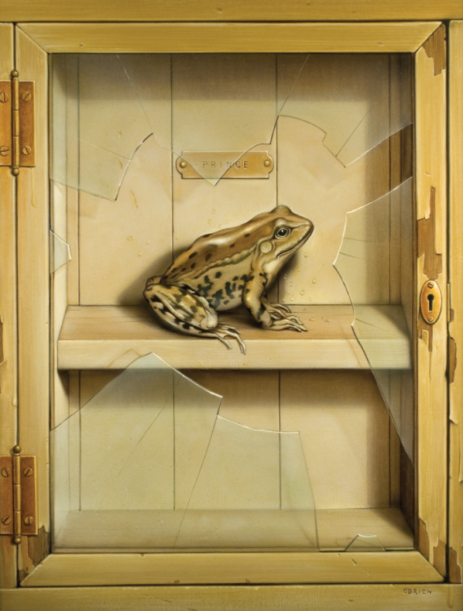

Topic- P.E

Get moving this afternoon by watching this PE video and joining in. Try and encourage the people in your house to join in too.

https://www.youtube.com/watch?v=EDC-plCTBbc&list=PLyCLoPd4VxBvPHOpzoEk5onAEbq40g2-k&index=13
Day 4
Phonics
Follow the link to take part in today’s phonics lesson all about to make the ‘ear’ sound. https://central.espresso.co.uk/espresso/primary_uk/subject/module/video/item111971/grade1/module63429/index.html
You will need to log in to Espresso using the log on details that you have been given. Once you have watched the video ask an adult to read these words for you to spell. Once you have written the words put them into a sentence.
deer | cheer | eerie | peer
tier | pierce | fierce

English
Now that you have finished the story ‘The Kiss That Missed’, I want you to write a book review to tell me if you enjoyed the book. Answer these questions in your exercise book to complete the book review. Remember to answer in a full sentence and try to extend your sentence with a joining word.
- What did you enjoy about the story?
- What did you not like about the story?
- Who was your favourite character?
- What was your favourite part?
- Would you change anything about the story?
- Would you tell a friend to read the story? Why?
Maths
Yesterday you learnt about lines of symmetry in 2D shapes. Today I want you to follow the link to complete an activity on Purple Mash all about lines of symmetry.
https://www.purplemash.com/#app/maths/2CaS_fractions_week6_y2_q1 You will need to log in using the details you have been given.
Reading
Find worksheet R4 in your learning pack, this is a poem called ‘My Castle’. Read the poem carefully and ask an adult if you need help. Once you have read the poem answer these questions in your exercise book. Remember to answer in a full sentence.
1. Some words in the poem rhyme, make a list of rhyming words you can find.
2. What adjectives does the poet use to describe the castle walls?
3. Why does the girl build the castle walls ‘as thick as castle walls must be’?
4. Where will the prisoners go?
5. Why is the girl worried about going to bed?

Topic- Computing
Follow the link for today’s computing lesson all about coding. https://www.purplemash.com/app/code/chimp/princessfrog
The link is for Purple Mash so you will need to log in using the details you have been given. Follow the instructions to complete the lesson.

Day 5
Phonics
Today you are going to practice all of your phase 5 sounds by playing a phonics game. Follow the link to play the game. Make sure you select phase 5 when you play. https://www.phonicsplay.co.uk/resources/phase/2/buried-treasure

English
Today in English I would like you to answer the question ‘If you could be any character from a fairytale, who would you be and why?’

In your exercise book I would like you to draw a picture of the character you would choose and then write some sentences about them. Think about why you would like to be that character and the things you would do if you were them. You can think about what happens in their story to help you. What would be the good things about being that character? What would be the bad things about being that character?
Here is an example:
I would like to be Cinderella so I could go to the magical ball and dance with a handsome prince. I wouldn’t like having to sweep the filthy floors or scrub the dirty dishes but I would like having cute mice as friends.
Maths
You have worked so hard in maths for the last two weeks. Today you can have some fun! Follow the link to play the maths games!

https://www.bbc.co.uk/bitesize/topics/zjkphbk

Reading

Follow the link to the Oxford Owl reading site. https://www.oxfordowl.co.uk/
Use helpsheet R2 which will explain how to access the texts.
Choose a text which matched the coloured book band you are on. It is your choice which book you would like to choose. Use your phonics to read the text then complete the activities.

Topic- British Values.
This term one of our school values is teamwork. I want you to think about a time when you think you have worked well in a team with others. This could be a time in school, at home or even in a sports team.
Write some sentences to describe how you worked well in a team and what you achieved together. Then draw a picture to show what happened.

Well done for completing two weeks of home learning! Your teachers can’t wait to see you back in school!

