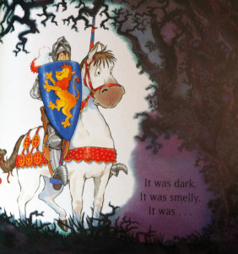
THE KISS THAT MISSED
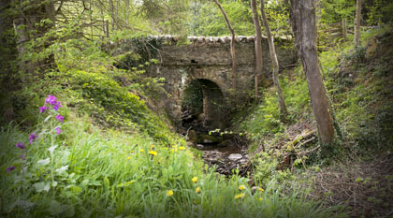
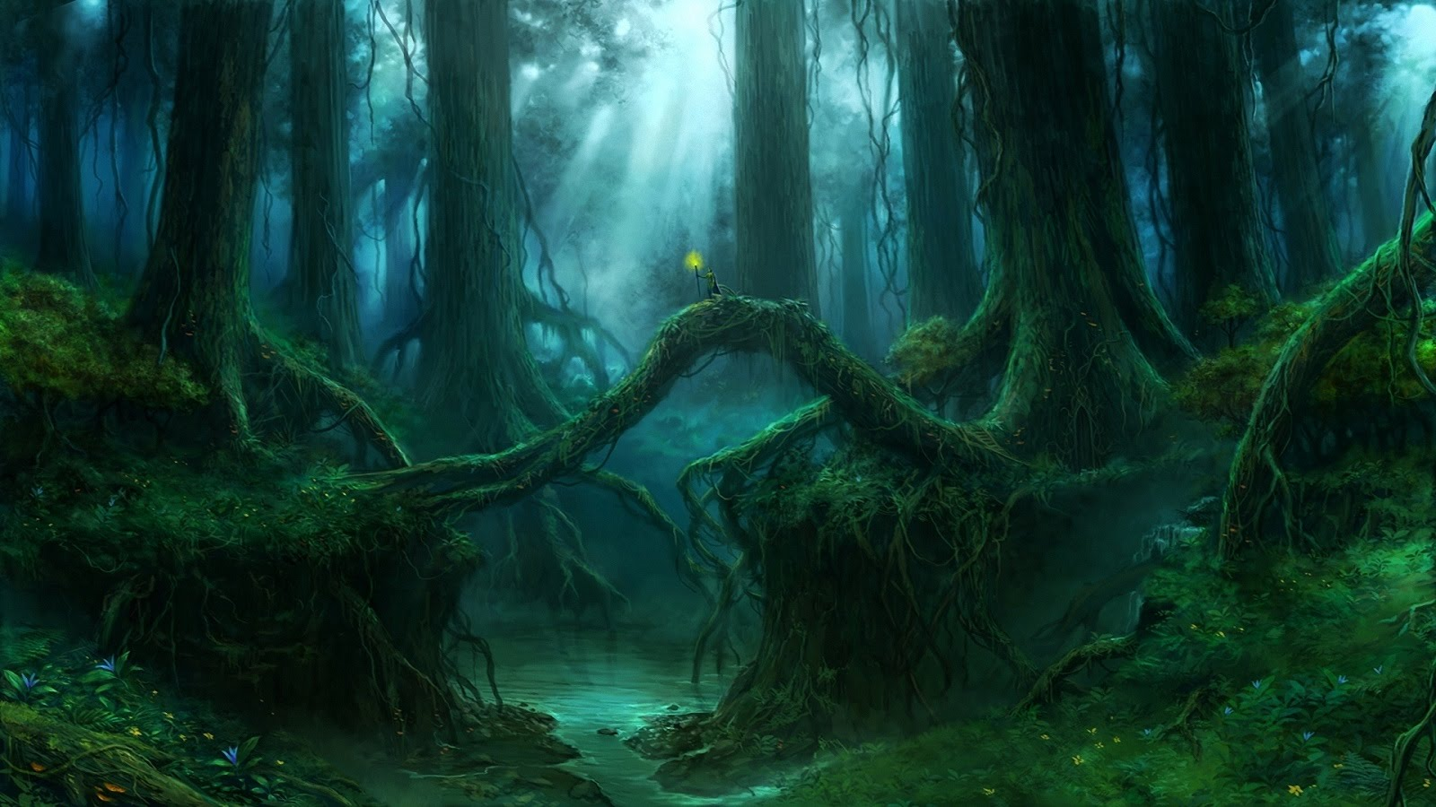
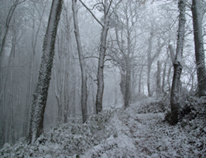
E3
forest wild woods knight
deep in the forest in the heart of the forest
trees logs bridge grass snow flowers wolves
bears owls branches ground river
dark gloomy shadowy misty murky eerie
sharp thorny spikey prickly tangled
scared trembled shivered shuddered quaked
huge enormous immense gigantic towering

