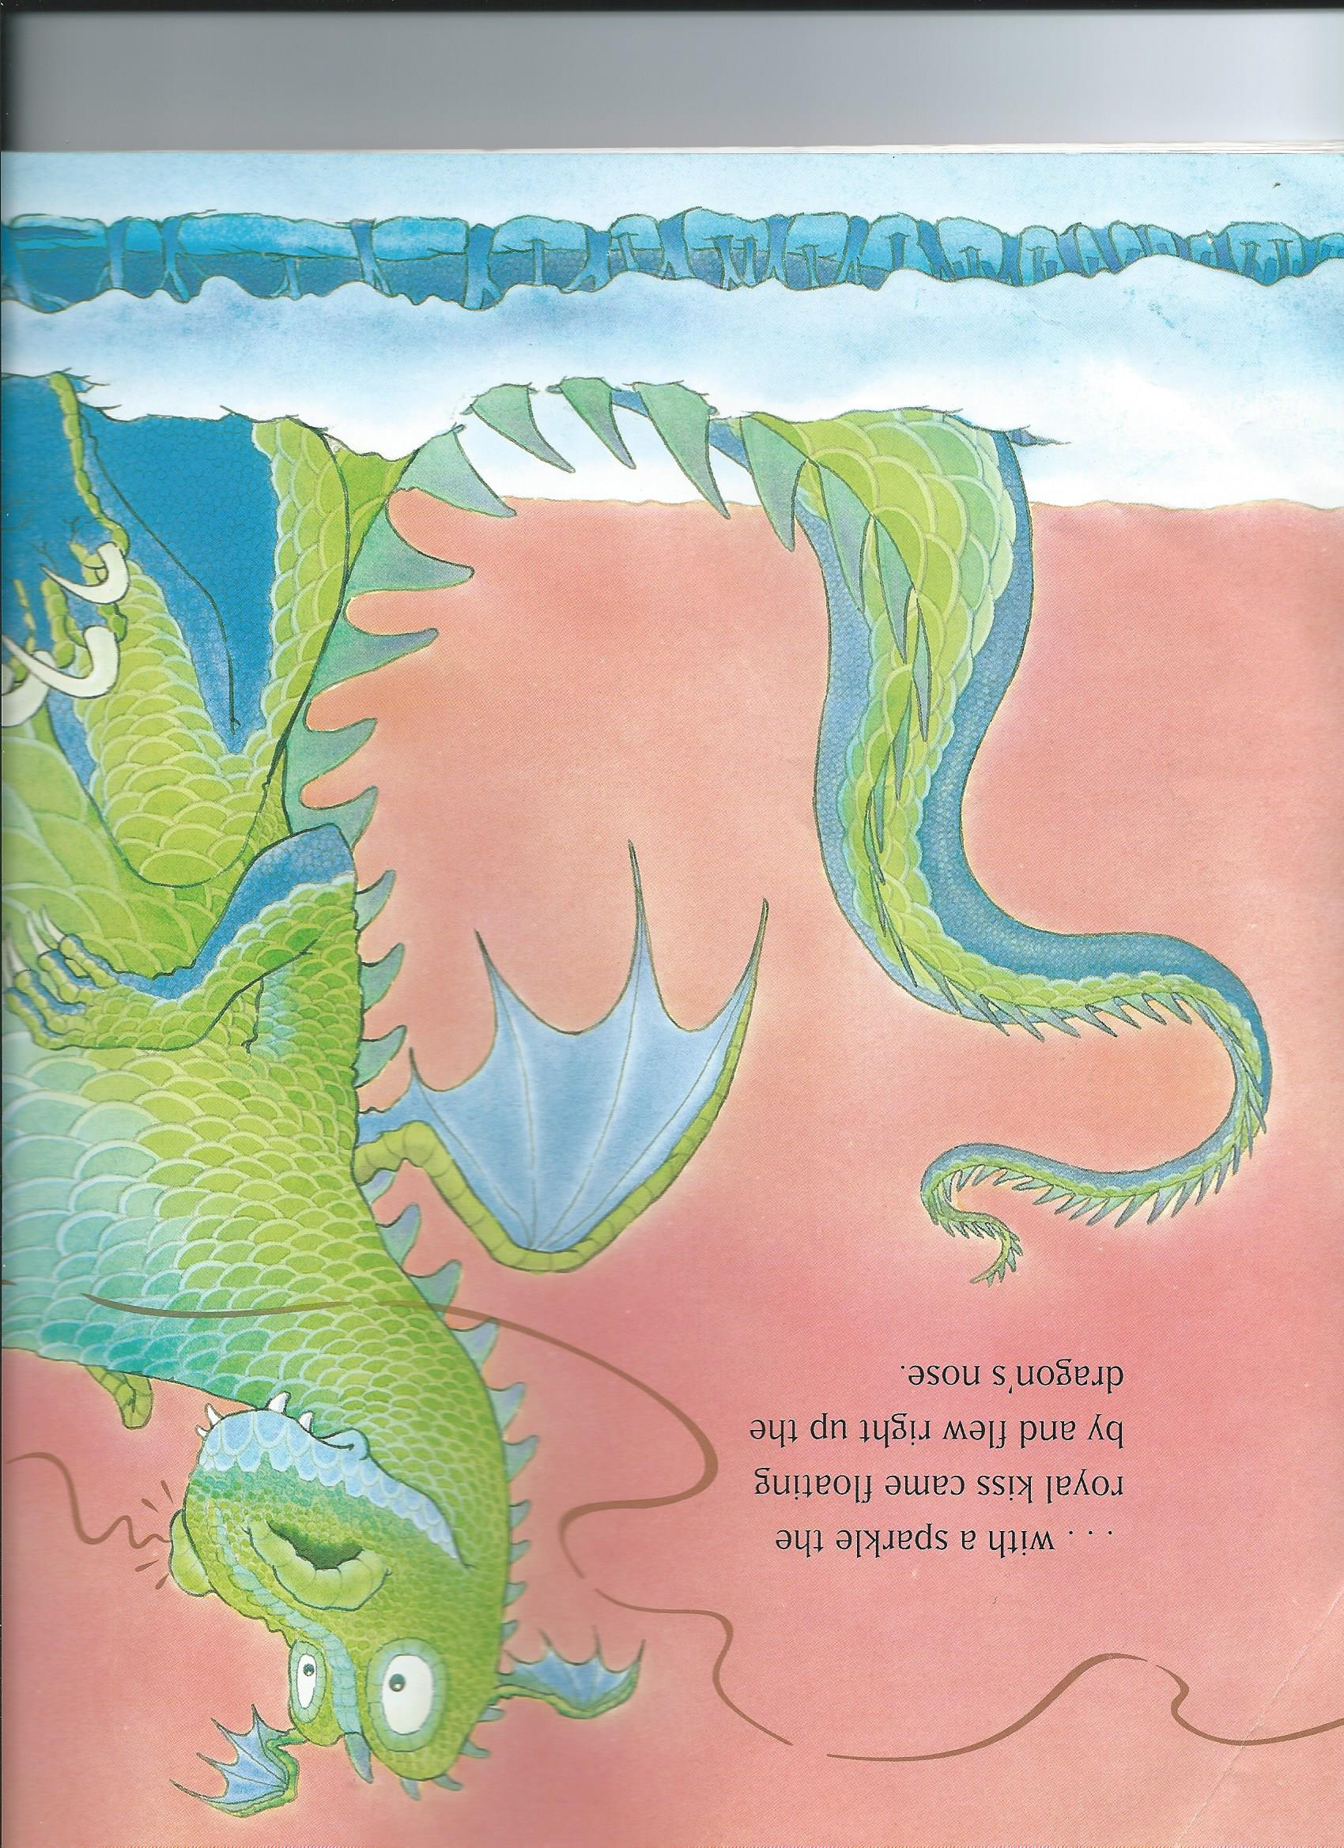
swooped
soared
flew
shot
floated
drifted
tumbled
twisted
swirled
twirled
danced
glided
lights
holly
candles
burrow
sledge

