Number bonds
M6
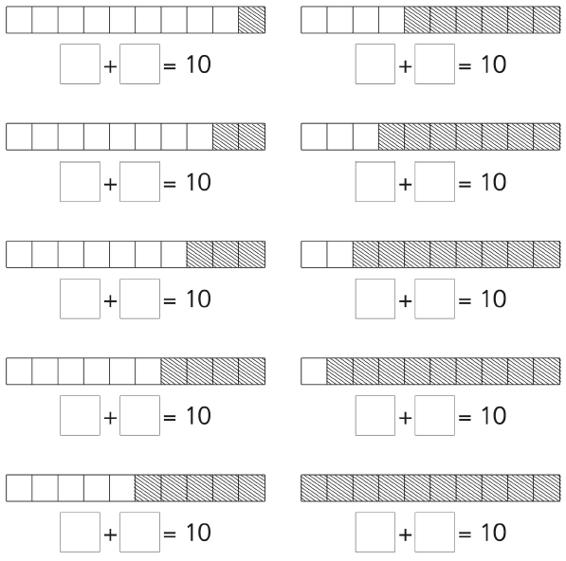
Can you look at the ten stick and write the number sentence it represents?
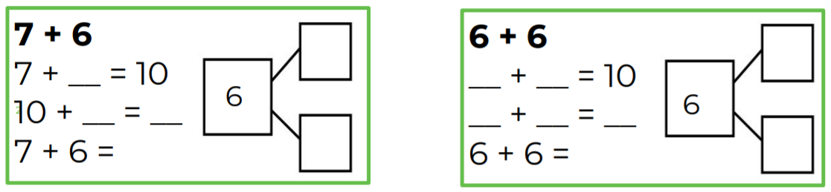
Can you now use your number bonds to 10 knowledge to help you solve these tricky problems?

