Whitefield Infant School
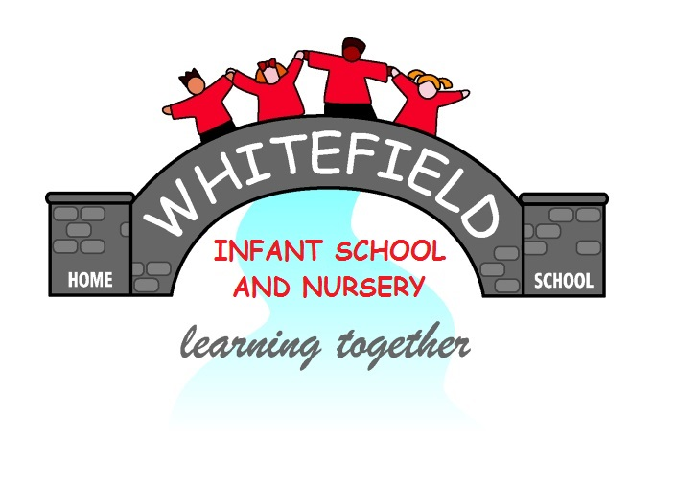

Year 2
Remote Learning Pack

Week 1
(Week beginning 22nd February 2021)
Year 2
Maths Learning
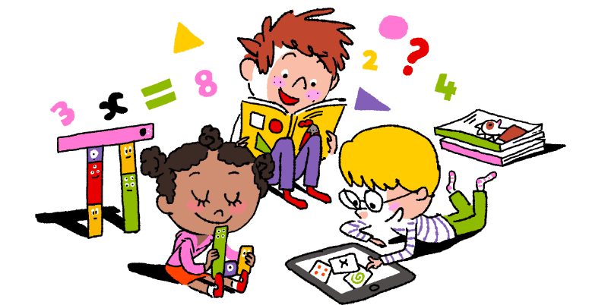

Week 1

This week we are going to learn how to add 9, 19, 29 and 39 to a number.
To add 9 to a number
- First add 10
- Then take away 1
Like this
37 + 9 = 46
First add 37 and 10. That makes 47. Then take 1 away from 47. That makes 46.
+ = - 1 = 46

To add 19 to a number
- First add 20
- Then take away 1
Like this
56 +19 = 75
First add 56 and 20. That makes 76. Then take 1 away from 76. That makes 75.
+ = - 1 = 75

To add 29 to a number
- First add 30
- Then take away 1
Like this
45 + 29 = 74
First add 45 and 30. That makes 75. Then take away 1 from 75. That makes 74.

+ = - 1 = 74

To add 39 to a number
- First add 40
- Then take away 1
Like this
34 + 39 = 73
First add 34 and 40. That makes 74. Then take away 1 from 74. That makes 73.

+ = - 1 = 73

Adding 9 to a number
24 + 9 =

35 + 9 =

47 + 9 =

26 + 9 =

58 + 9 =

48 + 9 =

63 + 9 =

74 + 9 =

76 + 9 =

82 + 9 =

86 + 9 =

84 + 9 =

90 + 9 =

+ 9 = 44

N

Adding 19 to a number
23 + 19 =

36 + 19 =

45 + 19 =

28 + 19 =

57 + 19 =

49 + 19 =

64 + 19 =

67 + 19 =

69 + 19 =

73 + 19 =

76 + 19 =

78 + 19 =

72 + 19 =

+ 19 = 67

N

Adding 29 to a number
45 + 29 =

47 + 29 =

52+ 29 =

56 + 29 =

66+ 29 =

64 + 29 =

+ 29 = 72

N
12 + 29 =

15 + 29 =

18 + 29 =

22 + 29 =

26 + 29 =

33 + 29 =

38 + 29 =

Adding 39 to a number
41+ 39 =

43 + 39 =

48+ 39 =

50 + 39 =

52 + 39 =

54 + 39 =

+ 39 = 59

13 + 39 =

15 + 39 =

19 + 39 =

20 + 39 =

23 + 39 =

36 + 39 =

39 + 39 =

N

Year 2
English Learning
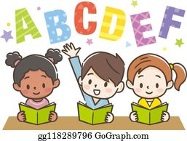

Week 1

This term in English we will be learning all about the Great Fire of London. This is something that happened in London hundreds of years ago. This week we are going to have to do some research to find out what happened!

- Use the Great Fire of London fact book in your pack
- If you struggle to read the fact book, you can listen to Miss Stott read it on the remote learning section of your class page
- If possible, you could also use the internet to research about the Great Fire of London, with support from an adult

Day 1 | Spelling, punctuation and grammar Lesson  Find the sheet titled ‘Day 1’ and see how many of the tasks you can complete.  Key skill: Today you need to use your spelling, punctuation and grammar skills. These definitions below might help you with your learning today.  A question- For example, What is the weather like today? A questions ends with a question mark.  A statement- For example, It is sunny today. A statement ends with a full stop.  An exclamation- For example, What a beautiful day it is! An exclamation ends with an exclamation mark.
Day 2 | Research about the Great Fire of London  Over the next two days you are going to research and find out all about the Great Fire of London. Today you are going to find out the answers to the questions on the sheet titled ‘Day 2’. To find out the answers you can use the copy of the Great Fire of London Fact Book in your pack.  Key skill: Today you are going to use your reading skills and history skills to find out information about the past.
Day 3 | Continue to research about the Great Fire of London  Today you will use the sheet titled ‘Day 3’ to continue to find out all about the Great Fire of London. Remember you can use the copy of the fact book in your pack to find out the answers to the questions.  Key skill: Today you are going to use your reading skills and history skills to find out information about the past.
Day 4 | Create a timeline of events, of the Great Fire of London  A timeline tells us the order in which something has happening from start to finish. Today you are going to create a timeline of events to show how the fire started and what happened. Can you put the events in the correct order, using the sheet titled ‘Day 4’ and add pictures to your timeline.  Key skill: Today you are going to put events into chronological order.  Chronological means the order in which something happened, from the first thing that happened to the last thing that happened.
Day 5 | Write the events of the Great Fire of London, in chronological order  Using your timeline that you created yesterday you are going to do some writing to show the events that happened in the correct order. Use words like First, Next, Then, After that and Finally to show the order in which it happened.  Key skill: Today concentrate on using the correct punctuation, a capital letter at the start of your sentence and a full stop at the end of your sentence. Also try to use your best handwriting!

English- Day 1
Spelling, punctuation and grammar lesson

English- Day 2
The Great Fire of London Research
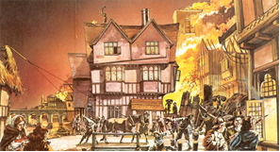
Use ‘The Great Fire of London Fact Book’ in your pack to help you research and find the answers to these questions. Make some notes in the boxes below.

When did the fire start?
See page 1 of your fact book
Where did the fire start?
See page 1 of your fact book
How did the fire start?
See page 2 of your fact book

English- Day 3
The Great Fire of London Research
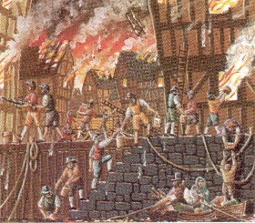
Use ‘The Great Fire of London Fact Book’ in your pack to help you research and find the answers to these questions. Make some notes in the boxes below.

Why did the fire spread so quickly?
See page 3 and 4 of your fact book
How did they try to put the fire out?
See page 5 and 6 of your fact book
Are there any other interesting facts you have found out?
See page 7, 8 and 9 of your fact book

English- Day 4
Timeline of the Great Fire of London

The events below are in the wrong order! Can you use your knowledge of days of the week and time, to put them in the correct order? Number the pictures from 1-6, then use this to help you create a timeline on the next sheet.

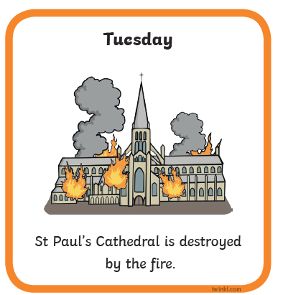 | 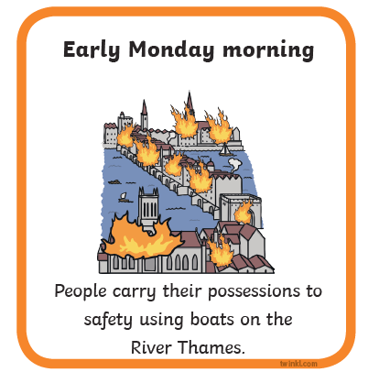
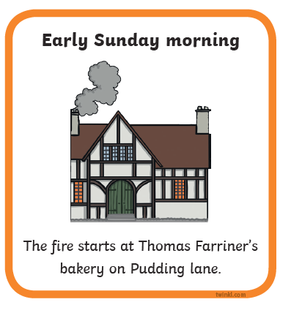 | 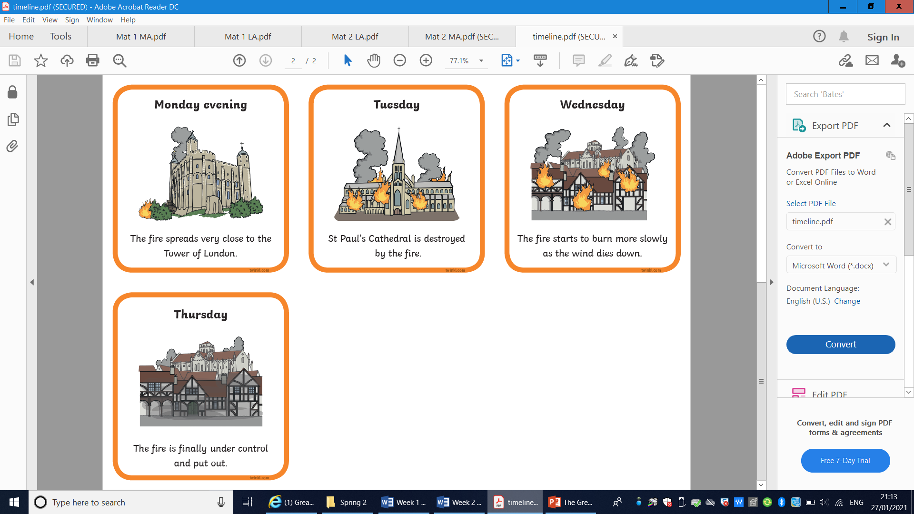
 | 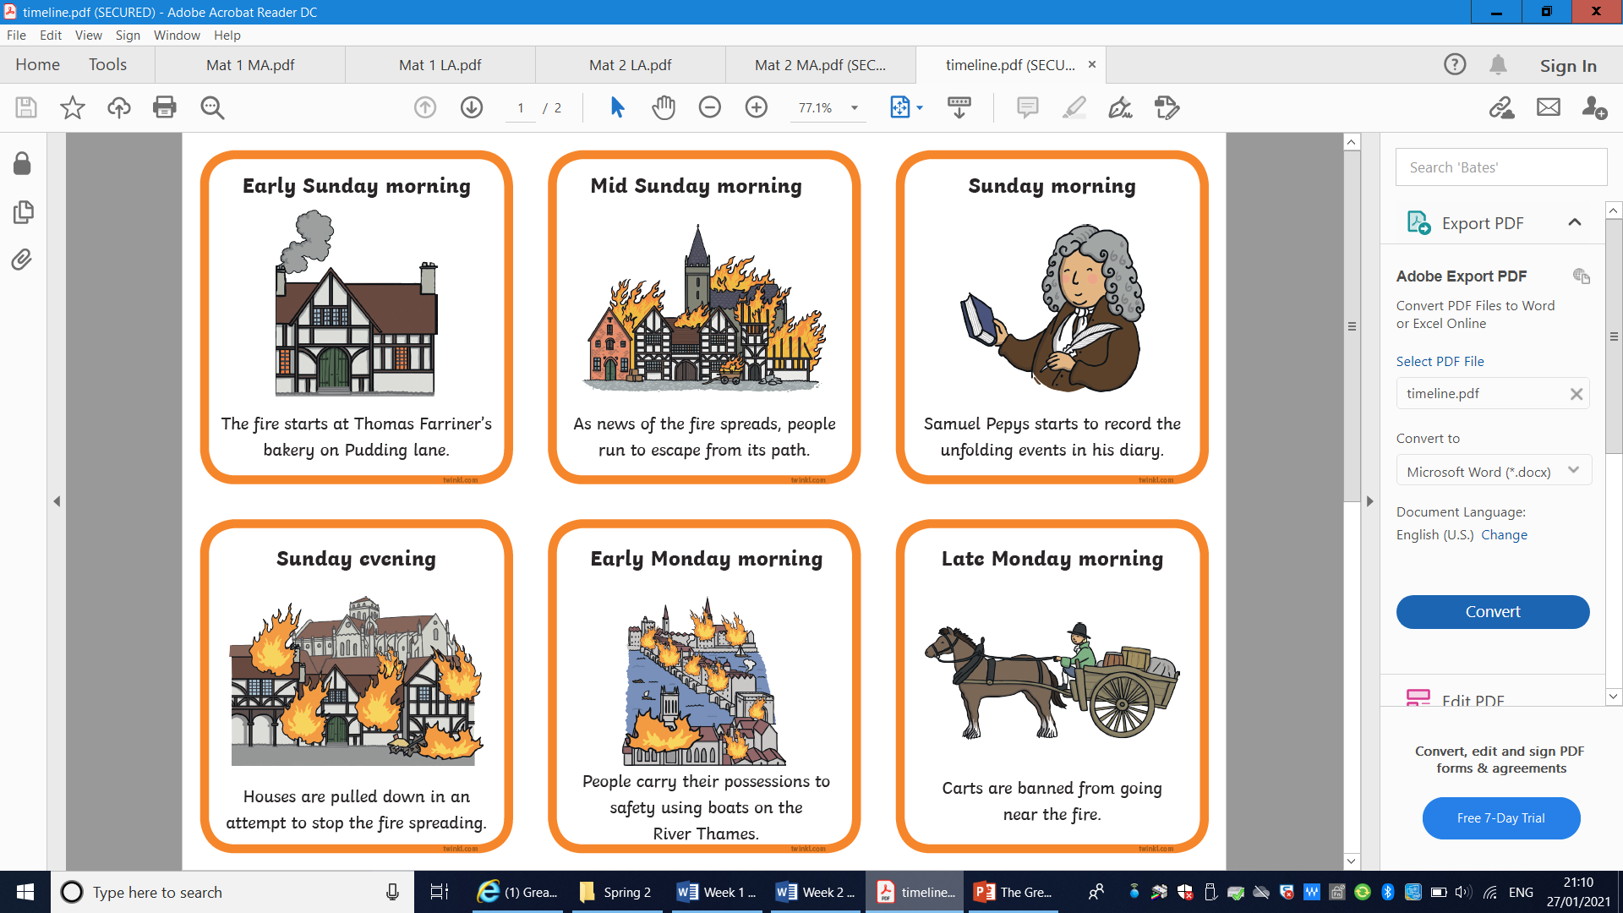

English- Day 4
Timeline of the Great Fire of London

Draw pictures to create your own timeline of the Great Fire of London.
5. The next day
3. Then
- First

2. Next
6. Finally
4. After that

English- Day 5
Write the events of the Great Fire of London

First _________________________________________________________

_________________________________________________________________

Next ________________________________________________________

_________________________________________________________________

Then _________________________________________________________

_________________________________________________________________

After that ________________________________________________

_________________________________________________________________

The next day ____________________________________________

_________________________________________________________________

Finally ______________________________________________________

_________________________________________________________________

Year 2
Science and Topic Learning


Week 1

Science Learning
This week we will be learning the names of animals and their offspring. Offspring means a human’s baby or the babies and young of animals.
- Look at the pictures on your sheet.
- Cut them out.
- Put the pictures in to 2 piles.
- Adult animals will go in one pile. Babies and eggs will go in another pile.
- Spread out both sets of pictures.
- Pick a picture of an adult animal
- Find the picture that shows their young.
- Do this until all your pictures have been matched.
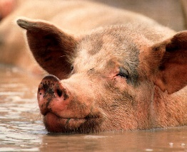
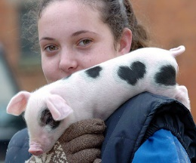
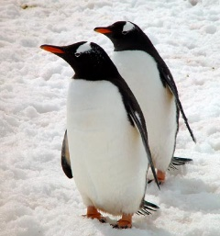
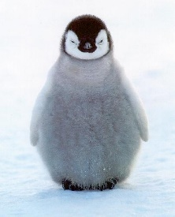

Now complete the table in your pack.
- Draw the adult animal in the correct column
- Draw their baby in the next column
- Label your drawings
- Do this for as many animals as you can
Play a matching game with a grown up
- Shuffle the pictures well
- Spread them out, making sure the picture is face down
- Take turns to turn over 2 cards.
- If you have found mother and baby you keep those cards
- The next person does the same
- Keep playing until all the cards have been used
- Count to see who has the most cards.


