Whitefield Infant School
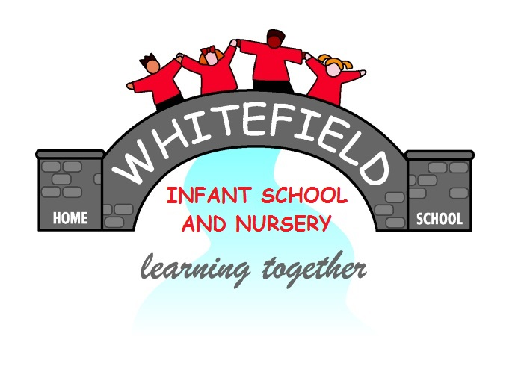

Year 2
Remote Learning Pack

Week 2
(Week beginning 1st March 2021)
Year 2
Maths Learning
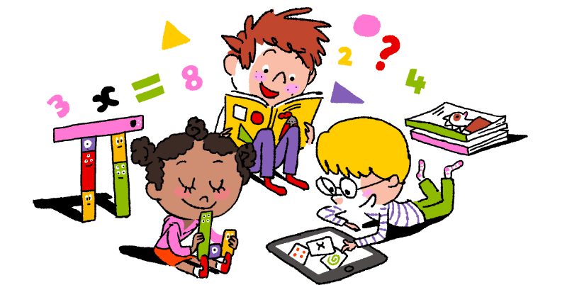

Week 2

This week we are learning how to take away 9, 19 and 29 from a number.
When you take 9 away from a number
- First take away 10 from the number
- Then add 1 to that number
Like this
27 – 9 = 18
- First take 10 away from 27. That makes 17
- Then add 1 to 17. That makes 18

- 10 = + 1 = 18

When you take 19 away from a number
- First take away 20 from the number
- Then add 1 to that number
Like this
48 – 19 =
- First take 20 away from 48. That makes 28
- Then add 1 to 28. That makes 29

- 20 = + 1 = 29
When you take 29 away from a number
- First take away 30 from the number
- Then add 1 to that number
Like this
67 –29 = 38
- First take 30 away from 67. That makes 37
- Then add 1 to 37. That makes 38

- 30 = + 1 = 38

Take away 9 from a number
22- 9 =

34 - 9 =

45 - 9 =

25 - 9 =

54 - 9 =

42 - 9 =

62 - 9 =

71 - 9 =

74 - 9 =

82 - 9 =

99 - 9 =

85 - 9 =

100 - 9 =

- 9 = 50

N

Takeaway 19 from a number
74 - 19 =

76 - 19 =

81 - 19 =

86 - 19 =

84 - 19 =

90 - 19 =

- 19 = 79

N
27 - 19 =

33 - 19 =

46 - 19 =

26 - 19 =

58 - 19 =

44 - 19 =

63 - 19 =

Takeaway 29 from a number
72 – 29 =

76 - 29 =

83 – 29 =

89 - 29 =

96 - 29 =

99 - 29 =

- 29 = 70

30 - 29 =

33 - 29 =

45 - 29 =

28 - 29 =

57 - 29 =

44 - 29 =

68 - 29 =

N
Year 2
English Learning
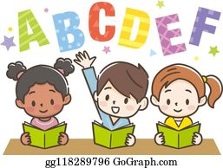

Week 2

This week in English we will continue to learn all about the Great Fire of London. This week we are going to compare how things have changed over time and think about how we can keep safe.

- Use the Great Fire of London fact book in your pack
- If you struggle to read the fact book, you can listen to Miss Stott read it on the remote learning section of your class page
- If possible, you could also use the internet to research about the Great Fire of London, with support from an adult

Day 1 | Spelling, Grammar and Punctuation Lesson  Find the sheet titled ‘Day 1’ and see how many of the tasks you can complete.  Key skill: Today you need to use your spelling, punctuation and grammar skills. These definitions below might help you with your learning today.    A comma- separates items in a list, it looks like this  A prefix- comes at the start of a word
Day 2 | Compare firefighting then and now  Many things have changed since the Great Fire of London. Today you are going to learn about firefighting in 1666 and firefighting in the present.  Key skill: Today you are going to use your reading and phonics skills to read the statements, then you are going to use your history skills and knowledge to decide whether that happened in 1666 or in the present.
Day 3 | Create a poster about fire safety  Today I would like you to talk to the adults in your house about fire safety in the home. Discuss these questions with an adult at home:  - Do you have fire alarms in your house?  - If so, where are they and why do you think they are in those rooms?  - Who would you ring if there was a fire?  - Where is a safe place for your family to meet in case of a fire?  Can you come up with some important rules that everyone needs to follow to keep safe in case of a fire? Use the sheet titled ‘Day 3’ to record your rules on a poster.
Day 4 | Inside the bakery  The Great Fire of London started in a bakery. What items of food can you buy in a bakery? Can you make a list of all the foods sold? If you are able to, choose an item off your list to make at home with an adult.  Key skill: Today you will use your phonics to read and spell correctly. If you are able to bake something at home you will be using verbs to follow instructions.  A verb- is a doing word, for example, mix, stir, bake, cook
Day 5 | The Great Fire of London Quiz  Please visit the Remote Learning area of your class page on the school website, where you will find a video of The Great Fire of London Quiz. Take the quiz and see how many points you score. Email your teacher with your score from the quiz then we can see how much you have learnt! If you are unable to access the school website, you will find the quiz questions at the end of the pack.

English- Day 1
Spelling, punctuation and grammar lesson
English- Day 2
Firefighting Then and Now

Read these statements carefully then write them in the correct box on the next page.

They used leather buckets filled with water.

Fire-fighters have fire engines which have hoses to put out the fire.

If there is a fire you can call 999 and fire-fighters will come to help you.

They collected water from the River Thames to put out the fire.

Fire-fighters wear a uniform to protect their body.

They did not have a uniform to wear.

English- Day 2
Firefighting Then and Now

1666 | Present

English- Day 3
FIRE SAFETY

Rule 1: If you find a fire…

Rule 2: If you find a fire…

Rule 3: If you find a fire…

Rule 4: If you find a fire…

English- Day 4
Inside the bakery

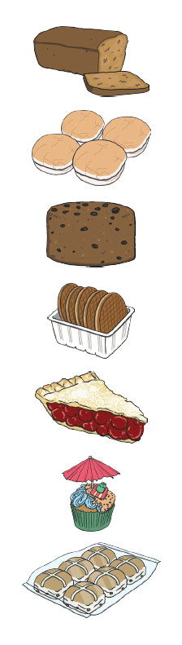
cupcakes buns fruit cake

pie loaf biscuits bread roll

English- Day 5
The Great Fire of London Quiz!

You will find this interactive quiz on the Remote Learning area of your class page on the school website. If you are not able to access the school website you can do the quiz here.

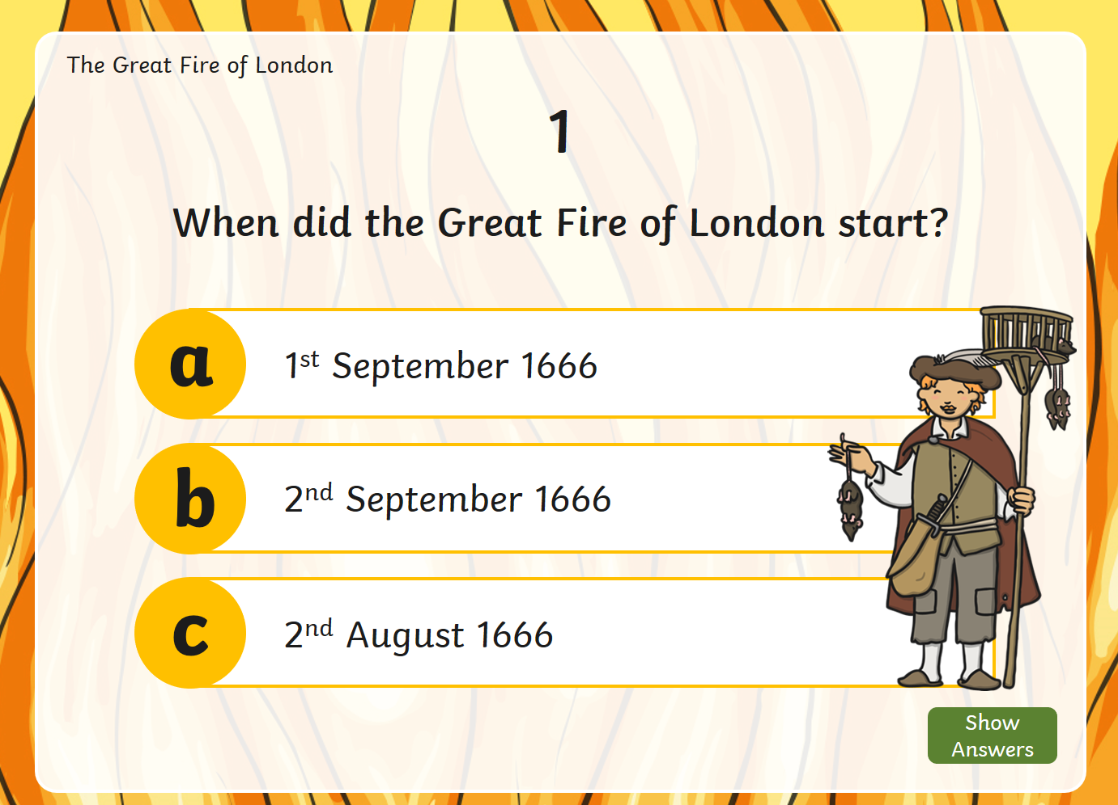 | 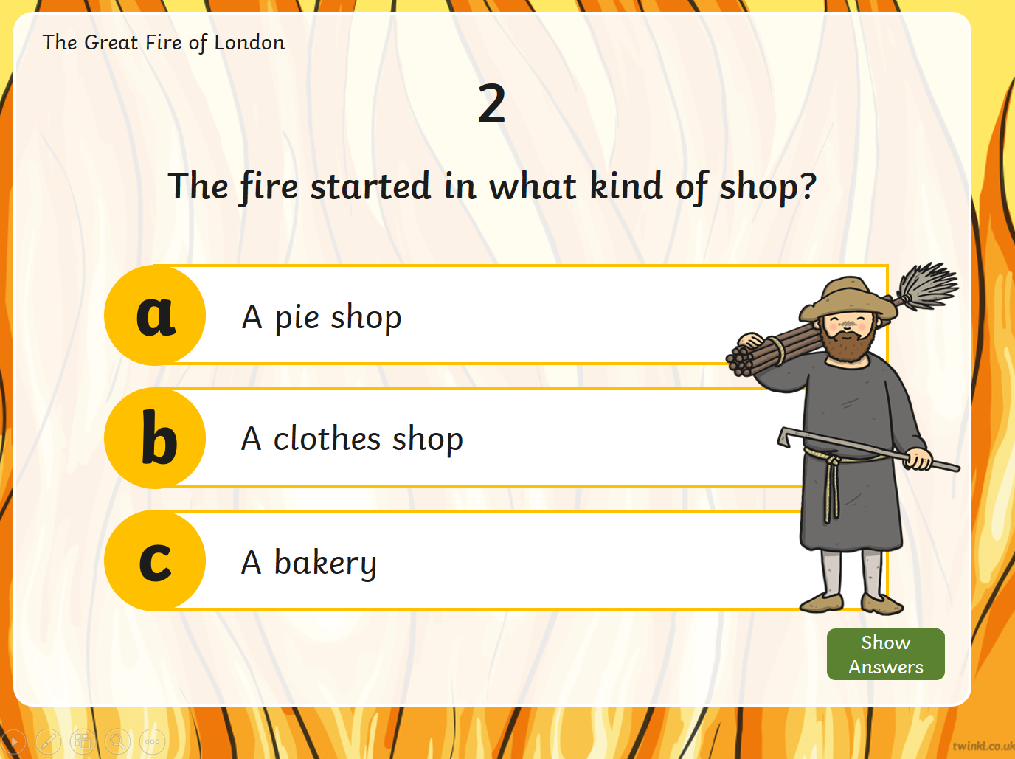
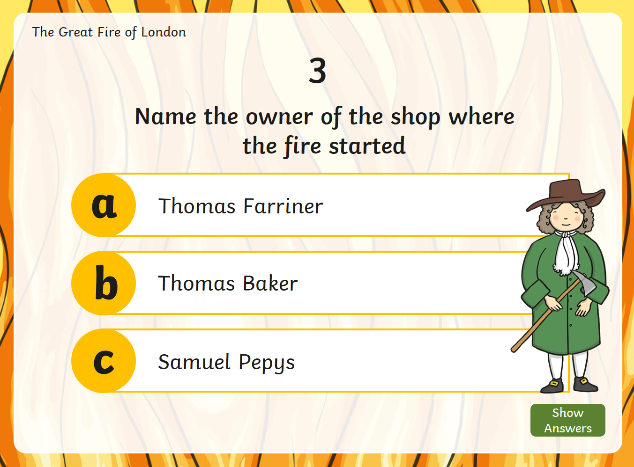 | 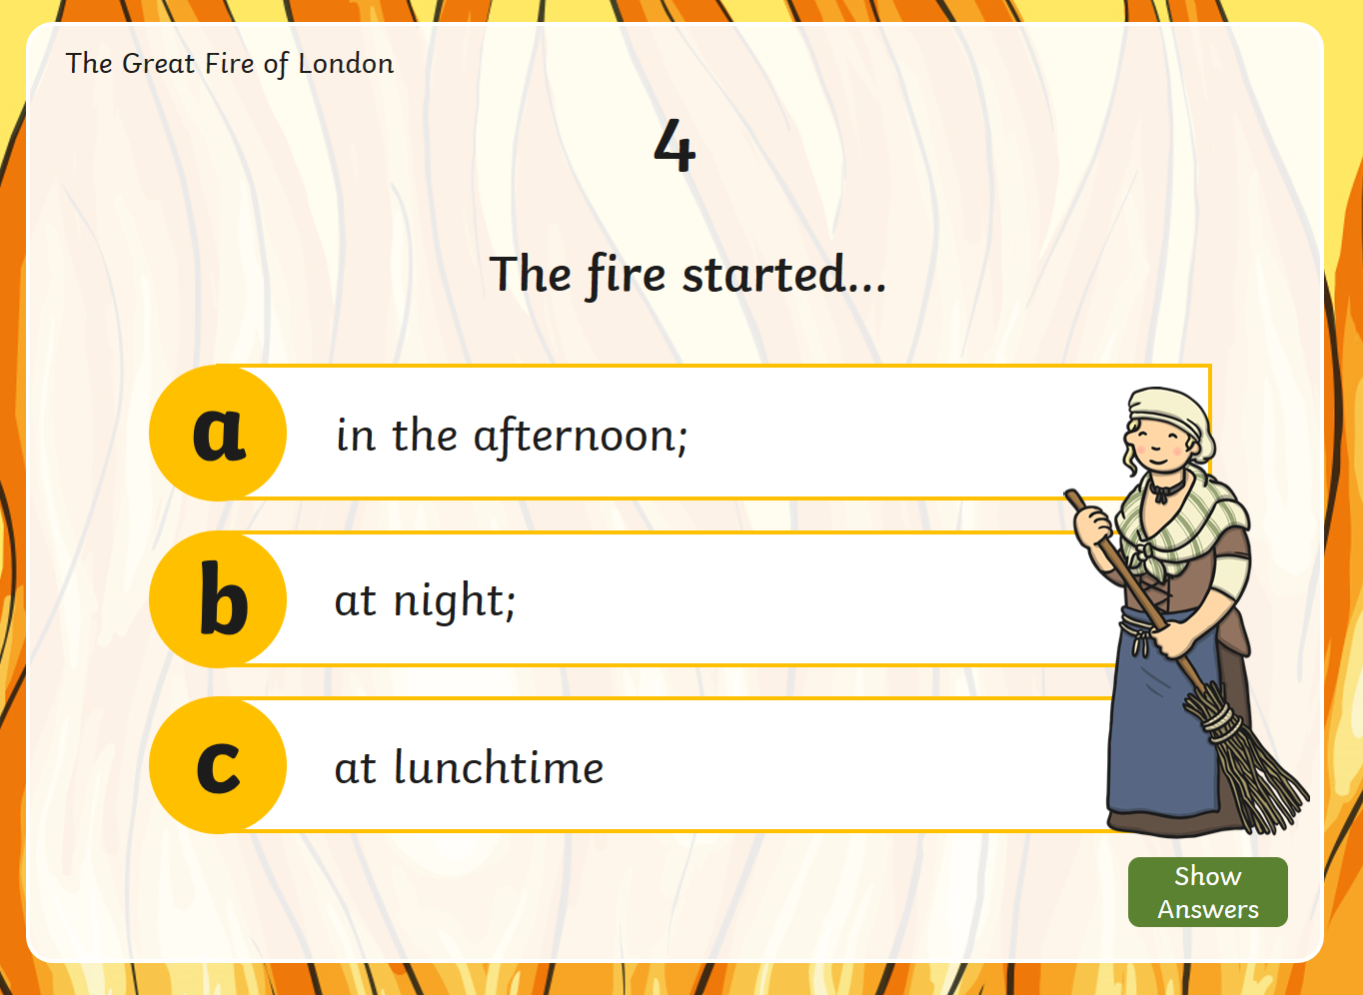
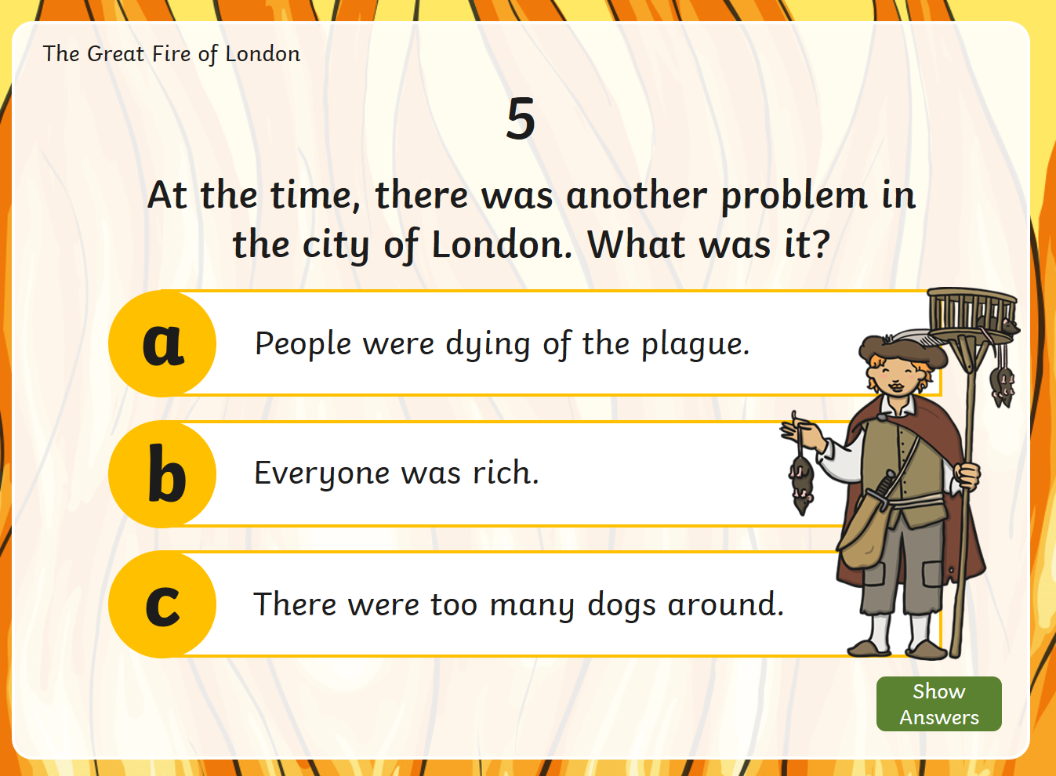 | 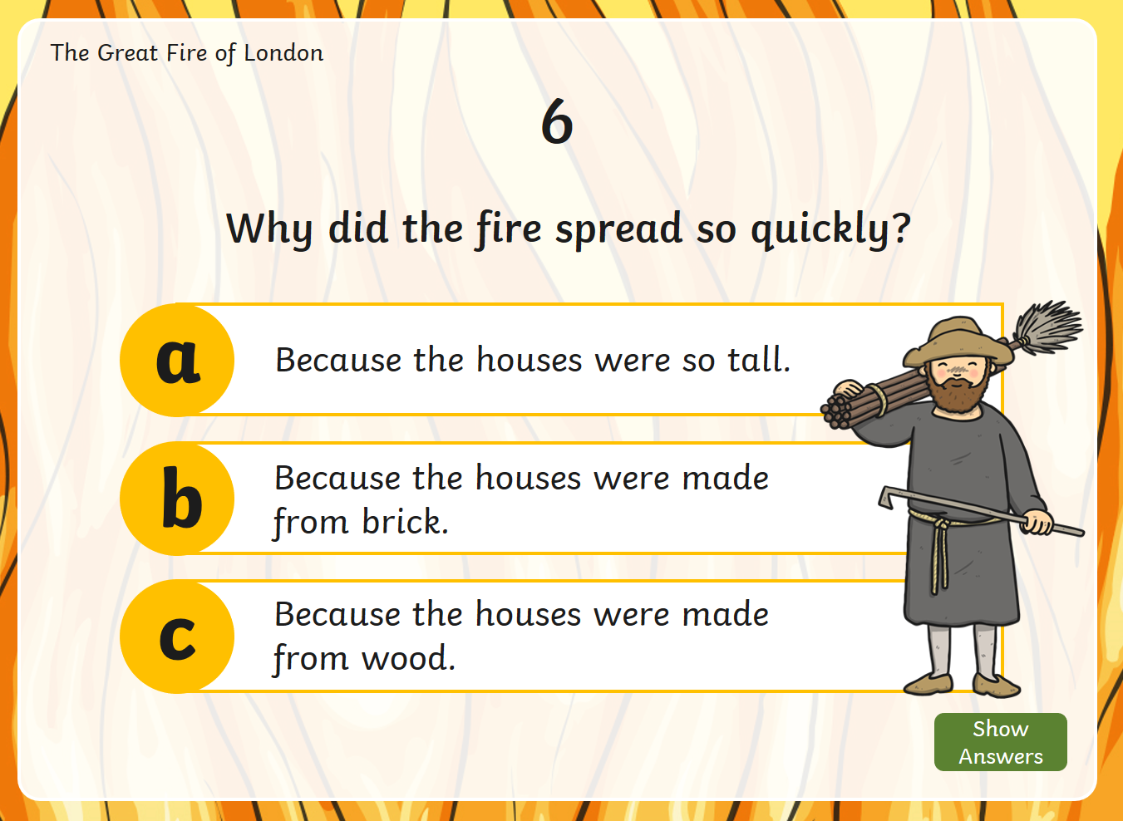

Answers:
- B 2. C 3. A 4. B 5. A 6. C

Year 2
Science and Topic Learning


Week 2

Science Learning
This week we want to know how much you have remembered about animals and their offspring. First of all explain to a grown up what offspring means.
- Look at the 3 pictures below.
- All of the creatures have offspring
- Which one is the odd one out?
- Explain your answer, using some super scientific vocabulary
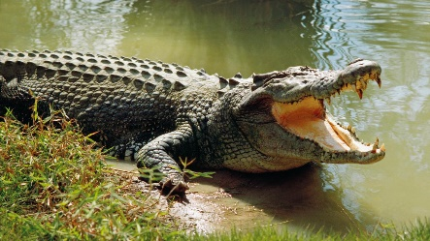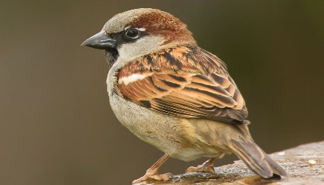

Now have a try at these 3 creatures
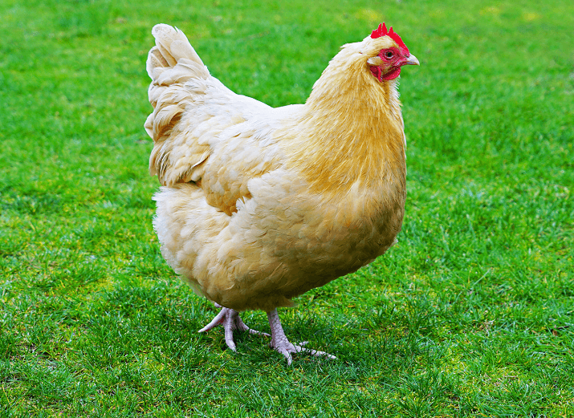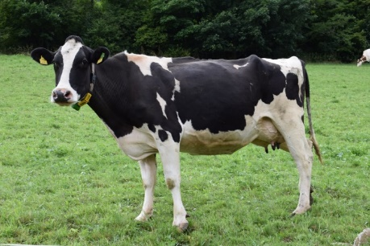
Follow the instructions just like you did before. Remember to write your explanation using super scientific vocabulary.

N. Draw a picture of some animals who lay eggs. Label your drawings.
Draw pictures of animals that give birth to live young. Label your drawings.

N Make up your own ODD ONE OUT game. Ask a grown up to tell you which is the odd one out.

Topic Learning
Geography
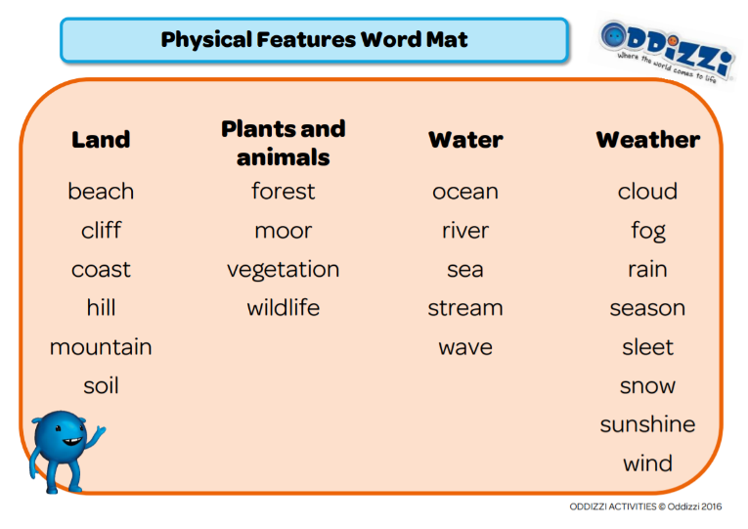
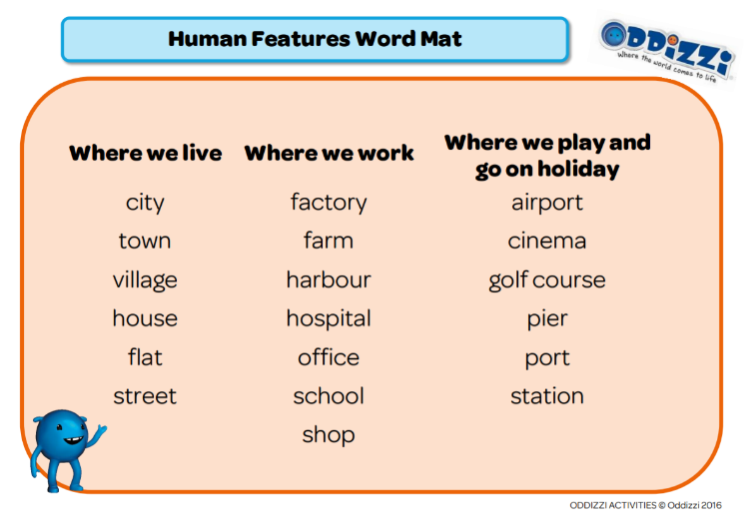
Today, I want you to find out about England. Please find the ‘England’ sheet in your pack. You will need an adult to help you to research. Your job is to find out the names of some of England’s major cities, list some human and physical features (use the word mats below), and add any other interesting facts that you find out.
PE
Continuing last week’s sock theme, this week’s activity is a sock-throw challenge. Follow the link to find out how to set it up. Don’t forget to challenge the people in your house!
https://youtu.be/JfSl3G0p4u0

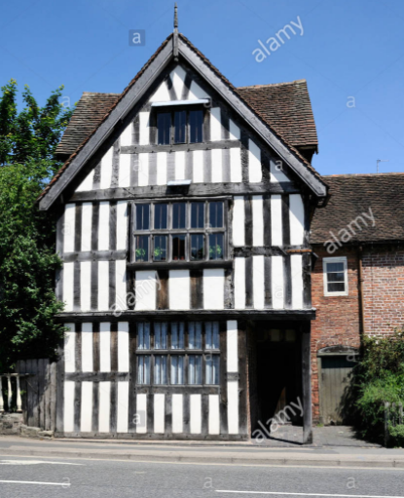
Art
At the time of the Great Fire of London, many buildings looked like this (we call them ‘Tudor buildings’). I want you to create your own Tudor house using an old cereal box. There are lots of examples of Tudor buildings online that you can use as inspiration or you can use the picture here. Follow the link for a simple tutorial. Remember to send in your creations to your teacher.
https://www.youtube.com/watch?app=desktop&v=i0Kjzviprwk

