Whitefield Infant School


Year 2
Remote Learning Pack

Week 1
(Week beginning 22nd February 2021)
Year 2
Maths Learning
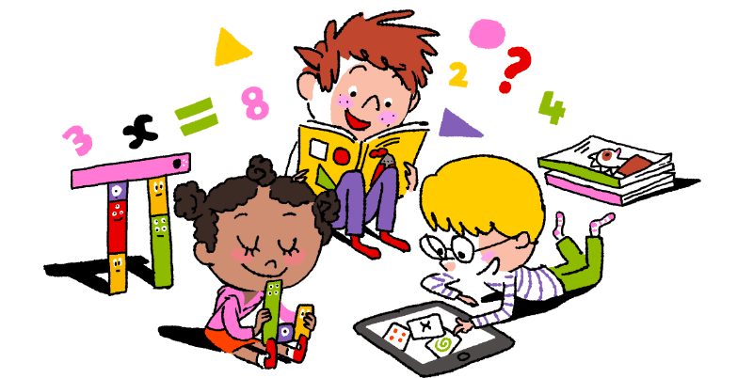

Week 1

Adding 1 digit numbers
Concrete – This means using objects.
Objects you could use at home:
buttons, stones, sticks, beads, lolly sticks, Lego blocks, pencils, small toys, pom poms

Steps to success:
- Collect some objects from home that you can use.
- Write numbers 1-9 on small squares of paper.
- Choose 2 numbers.
- Choose the correct number of objects to match each number.
- Count the total of your objects.
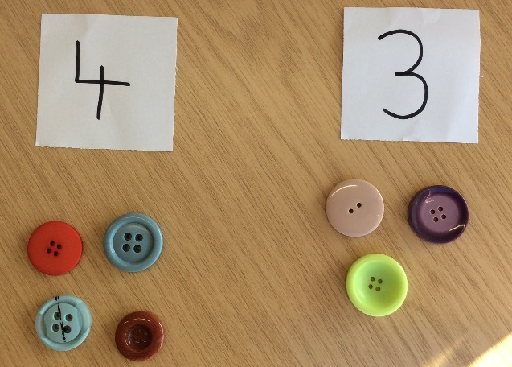
An example for you:
The total number of objects is 7.

Pictorial – This means using drawings or representations.
Steps to success:
- Find your exercise book.
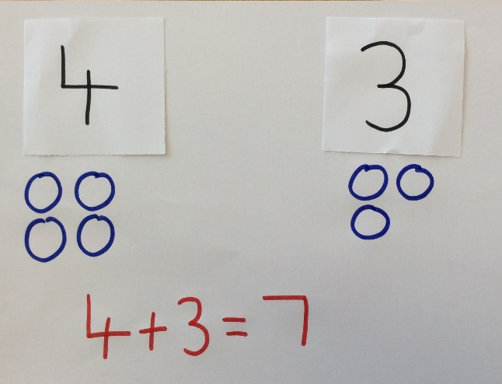
- Choose 2 numbers.
- Draw spots or pictures to represent each number.
- Count the total number of spots.
- Represent this as an addition number sentence.
An example for you:

Abstract – This means doing the calculation mentally in your head.
Steps to success:
- Find your exercise book.
- Choose 2 numbers and write them in an addition number sentence.
- Draw or use a number line to add the numbers together.
- Or add the numbers in your head by counting on
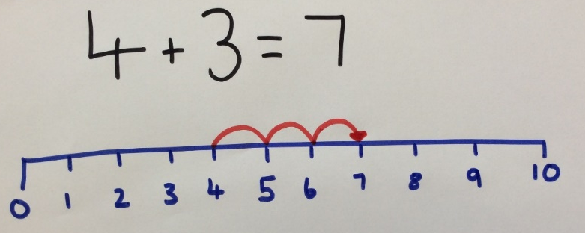
An example for you:

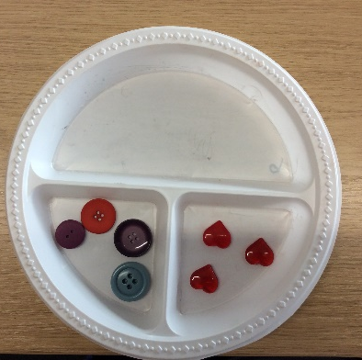
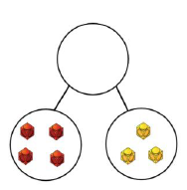
Other ways to represent adding 1 digit numbers.
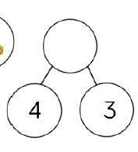
7
7
A part whole model using pictures or numbers.

You can use paper plates or dishes to make your own part whole model.
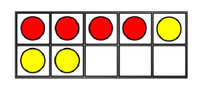
Tens frame.
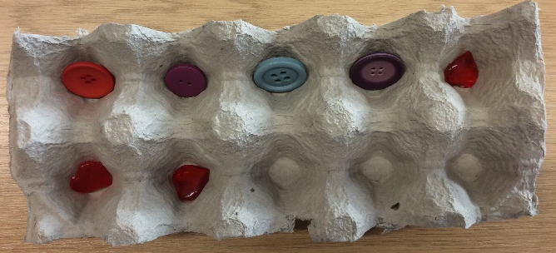
You can make your own ten frame using an egg box with 10 spaces. Then use objects to fill your egg box. I used 4 buttons and 3 beads.

Try these yourself. What will you use to help you?
7 + 2 =
5 + 4 =

Adding a 1 digit number to a 2 digit number
Concrete – This means using objects.
Objects you could use at home:
buttons, stones, sticks, beads, lolly sticks, Lego blocks, pencils, small toys, pom poms

Steps to success:
- Collect some objects from home that you can use.
- Write down the numbers from your number sentence.
- Choose the correct number of objects to match each number. When you are representing a 2 digit number use objects to represent the tens and the ones. You could use a longer object like a stick, pencil or lolly stick to represent the tens and smaller objects for the ones.
- Count the total of your objects. Remember to count the tens first and then the ones
I have represented the number 12 using tens and ones. 12 has one ten so I used one lolly stick and I used two beads to show the ones.
I represented the number 5 using beads.
The total number being represented is 17. Altogether I have 1 ten and 7 ones.
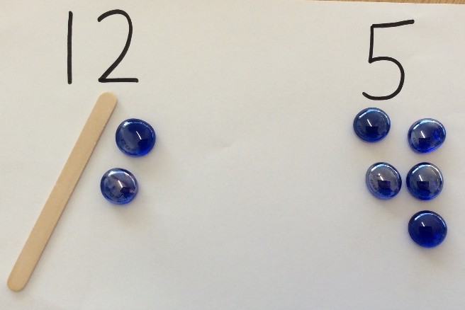
An example for you:

Pictorial – This means using drawings or representations.
Steps to success:
- Find your exercise book.
- Write down the numbers from your number sentence.
- Represent each number using jottings. Remember to draw the tens and ones for a 2 digit number.
- Count the total. Remember to count the tens first.
- Represent this as an addition number sentence.

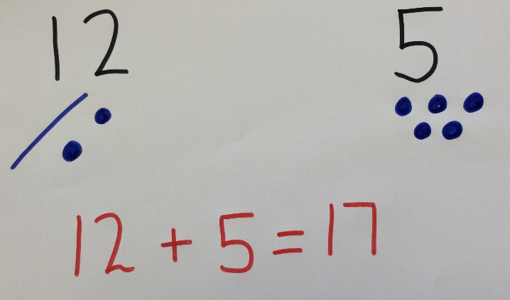
An example for you:

Abstract – This means doing the calculation mentally in your head or using number facts you know already.
Steps to success:
- Find your exercise book.
- Write down your number sentence.
- Use a number line or hundred square to add the numbers.
- Or add the numbers in your head by counting on from the greatest number.
An example for you:
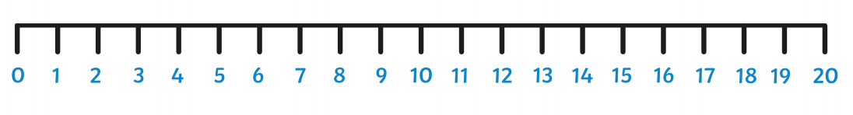

Other ways to represent adding a 1 digit number to a 2 digit number.
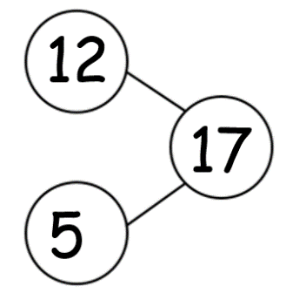
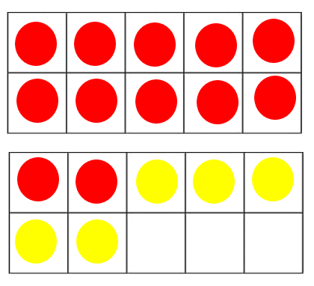

Tens frame. 1
A part whole model.

Try these yourself. What will you use to help you?
13 + 3 =
11 + 8 =

Day 1- Fill in the missing number
N
6 + 2 =

3 + 4 =

5 + 2 =

8 + 2 =

3 + 6 =

2 + 4 =

+ 3 = 5

4 + 5 =

6 + 4 =

5 + 3 =

8 + 1 =

6 + 3 =

2 + 5 =

3 + 7 =

Day 2- Fill in the missing number
N
2 + 13 =

12 + 4 =

16 + 3 =

13 + 2 =

15 + 3 =

20 + 0 =

+ 5 = 8

7 + 5 =

7 + 4 =

8 + 3 =

13 + 1 =

9 + 3 =

15 + 5 =

12 + 7 =

Day 3 – Adding 3 single digit numbers
N
6 + 4 + 1 =

2 + 4 + 2 =

3 + 2 + 4 =

9 + 2 + 1 =

4 + 4 + 2 =

2 + 3 + 2 =

6 + + 2 = 10

3 + 5 + 2 =

3 + 6 + 1 =

5 + 1 + 3 =

10 + 1 + 2 =

5 + 3 + 2 =

3 + 3 + 3 =

6 + 2 + 2 =

Day 4 – Fill in the missing number

+ 5 = 8 + 2 =10

+ 6 = 10 + 6 = 8

+ 4 = 8 + 4 = 5

+ 6 = 9 + 3 = 6

+ 3 = 5 + 2 = 5

+ 2 = 6 +5 = 9

+ 5 = 10 + 9 = 10

Day 5 – Fill in the missing number

+ 1 = 9 + 5 = 8

+ 3 = 6 + 3 = 5

+ 2 = 7 + 2 = 9

+ 4 = 9 + 4 = 5

+ 1 = 10 + 2 = 3

+ 4 = 6 + 7 = 9

+ 8 = 9 + 8 = 10

Year 2
English Learning
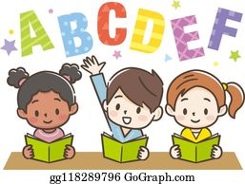

Week 1

This term in English we will be learning all about the Great Fire of London. This is something that happened in London hundreds of years ago. This week we are going to have to do some research to find out what happened!

- Use the Great Fire of London fact book in your pack
- If you struggle to read the fact book, you can listen to Miss Stott read it on the remote learning section of your class page
- If possible, you could also use the internet to research about the Great Fire of London, with support from an adult

Day 1 | Spelling, punctuation and grammar Lesson  Find the sheet titled ‘Day 1’ and see how many of the tasks you can complete. You do not have to complete them all, just try your best.  Key skill: Today you need to use your spelling, punctuation and grammar skills. These definitions below might help you with your learning today.  A question- For example, What is the weather like today? A questions ends with a question mark.  An exclamation- For example, What a beautiful day it is! An exclamation ends with an exclamation mark.
Day 2 | Research about the Great Fire of London  Over the next two days you are going to research and find out all about the Great Fire of London. Today you are going to find out the answers to the questions on the sheet titled ‘Day 2’. To find out the answers you can use the copy of the Great Fire of London Fact Book in your pack.  Key skill: Today you are going to use your reading skills and history skills to find out information about the past.
Day 3 | Continue to research about the Great Fire of London  Today you will use the sheet titled ‘Day 3’ to continue to find out all about the Great Fire of London. Remember you can use the copy of the fact book in your pack to find out the answers to the questions.  Key skill: Today you are going to use your reading skills and history skills to find out information about the past.
Day 4 | Create a timeline of events, of the Great Fire of London  A timeline tells us the order in which something has happening from start to finish. Today you are going to create a timeline of events to show how the fire started and what happened. Can you put the events in the correct order, using the sheet titled ‘Day 4’ and add pictures to your timeline.  Key skill: Today you are going to put events into chronological order.  Chronological means the order in which something happened, from the first thing that happened to the last thing that happened.
Day 5 | Write the events of the Great Fire of London, in chronological order  Using your timeline that you created yesterday you are going to do some writing to show the events that happened in the correct order. Use words like First, Next, Then and Finally to show the order in which it happened.  Key skill: Today concentrate on using the correct punctuation, a capital letter at the start of your sentence and a full stop at the end of your sentence. Also try to use your best handwriting!

English- Day 1
Spelling, punctuation and grammar lesson

English- Day 2
The Great Fire of London Research
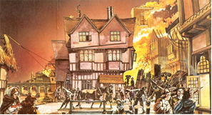
Use ‘The Great Fire of London Fact Book’ in your pack to help you research and find the answers to these questions. Make some notes in the boxes below.

When did the fire start?
See page 1 of your fact book
Where did the fire start?
See page 1 of your fact book

English- Day 3
The Great Fire of London Research
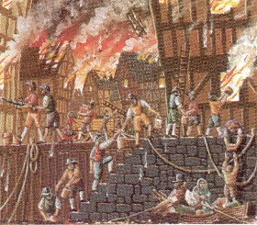
Use ‘The Great Fire of London Fact Book’ in your pack to help you research and find the answers to these questions. Make some notes in the boxes below.

Why did the fire spread so quickly?
See page 3 of your fact book
How did they try to put the fire out?
See page 4 of your fact book

English- Day 4
Timeline of the Great Fire of London

The events below are in the wrong order! Can you use your knowledge of days of the week and time, to put them in the correct order? Number the pictures from 1-5, then use this to help you create a timeline on the next sheet.

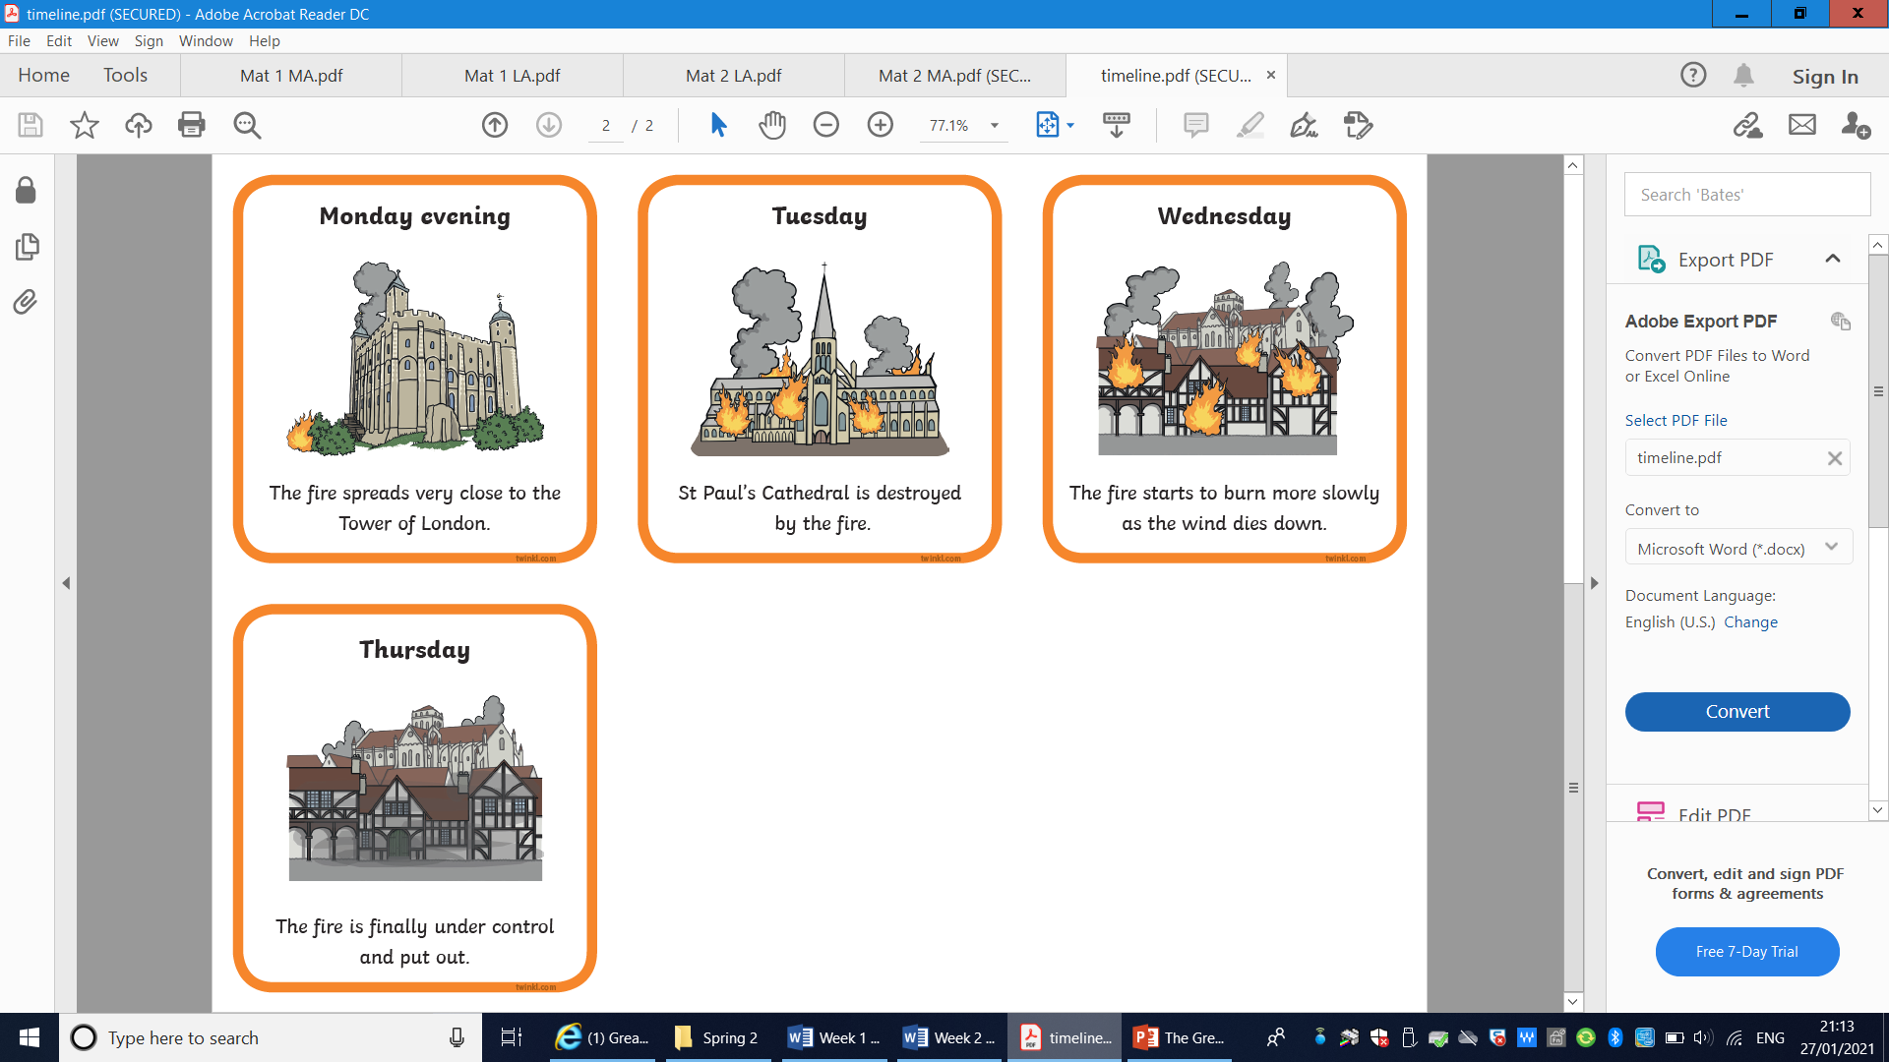 | 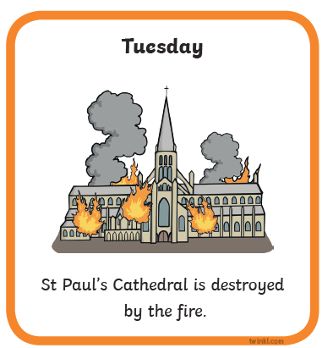
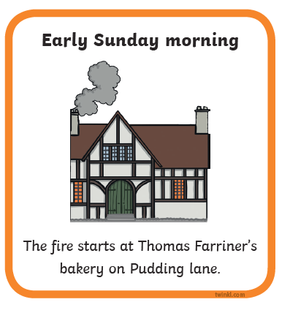

English- Day 4
Timeline of the Great Fire of London

Draw pictures to create your own timeline of the Great Fire of London.
- First
3. Then

2. Next
6. Finally

English- Day 5
Write the events of the Great Fire of London

First _________________________________________________________

_________________________________________________________________

Next ________________________________________________________

_________________________________________________________________

Then _________________________________________________________

_________________________________________________________________

Finally ______________________________________________________

_________________________________________________________________

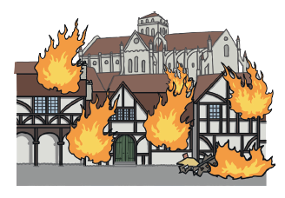
Year 2
Science and Topic Learning


Week 1

Science Learning
This week we will be learning the names of animals and their offspring. Offspring means a human’s baby or the babies and young of animals.
- Look at the pictures on your sheet.
- Cut them out.
- Put the pictures in to 2 piles.
- Adult animals will go in one pile. Babies and eggs will go in another pile.
- Spread out both sets of pictures.
- Pick a picture of an adult animal
- Find the picture that shows their young.
- Do this until all your pictures have been matched.
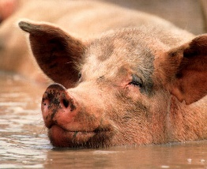




Now complete the table in your pack.
- Draw the adult animal in the correct column
- Draw their baby in the next column
- Label your drawings
- Do this for as many animals as you can
Play a matching game with a grown up
- Shuffle the pictures well
- Spread them out, making sure the picture is face down
- Take turns to turn over 2 cards.
- If you have found mother and baby you keep those cards
- The next person does the same
- Keep playing until all the cards have been used
- Count to see who has the most cards.
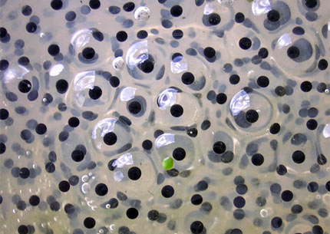



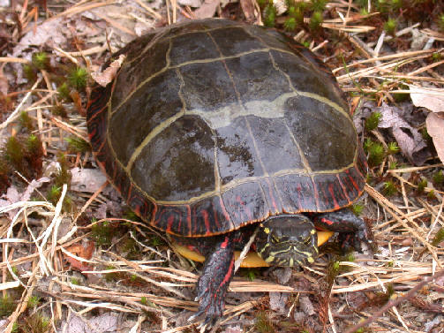
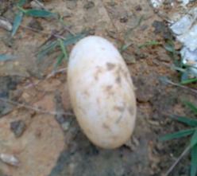
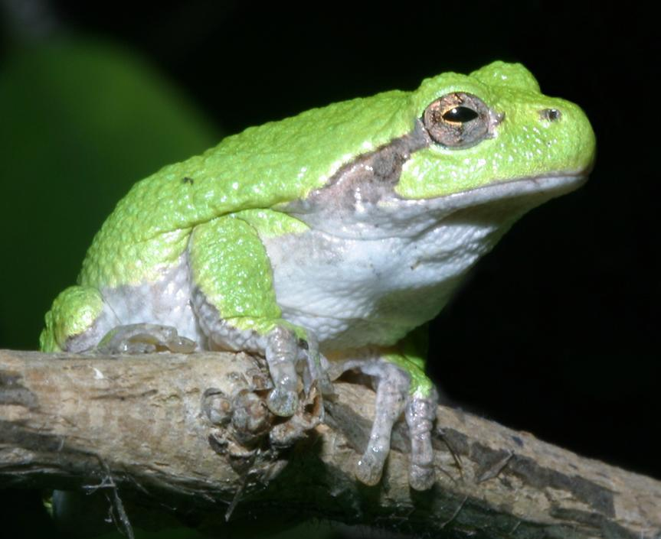

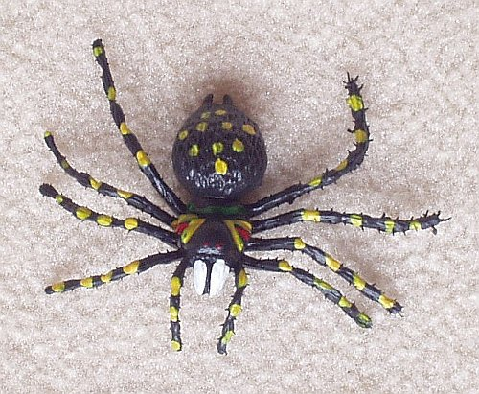
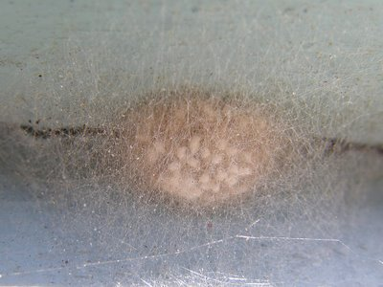


Topic Learning

