Whitefield Infant School
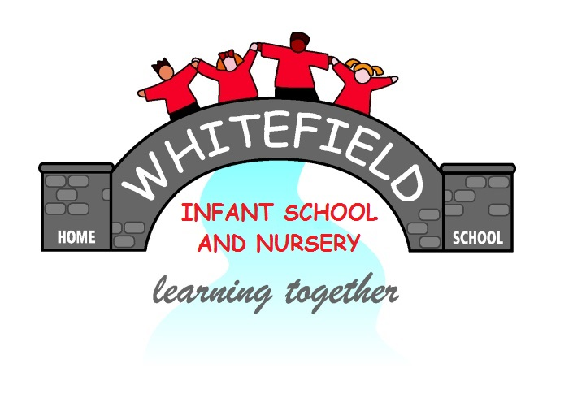

Year 2
Remote Learning Pack

Week 2
(Week beginning 1st March 2021)
Year 2
Maths Learning
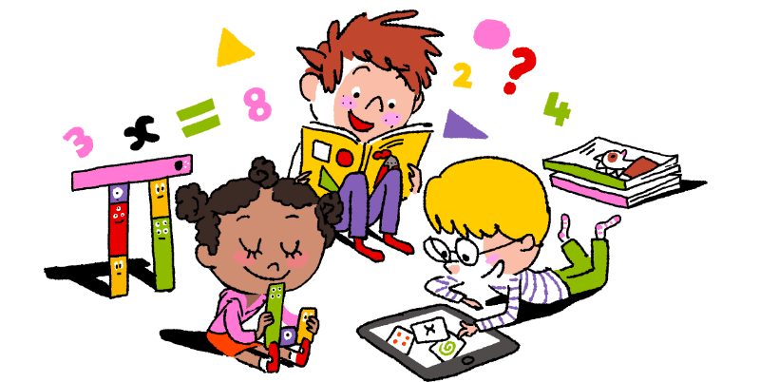

Week 2

Subtracting a 1 digit number from a 1 digit number.
Concrete – This means using objects.
Objects you could use at home:
buttons, stones, sticks, beads, lolly sticks, Lego blocks, pencils, small toys, pom poms

Steps to success:
- Collect some objects from home that you can use.
- Look at your subtraction number sentence.
- Choose the correct number of objects to make the greater number.
- Take away the right amount of objects.
- Count how many objects you have left.
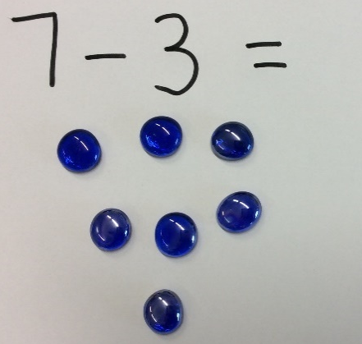
An example for you:
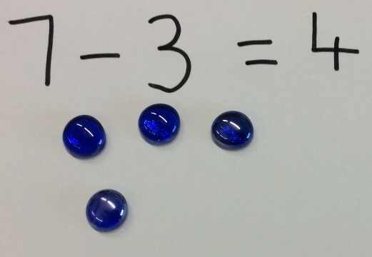
I started with 7 objects. I took away 3 objects and now I have 4 objects left.

Pictorial – This means using drawings or representations.
Steps to success:
- Find your exercise book.
- Write down your subtraction number sentence.
- Draw the correct number of spots to make the greater number.
- Take away the right amount of spots by crossing them out.
- Count how many spots you have left.
An example for you:
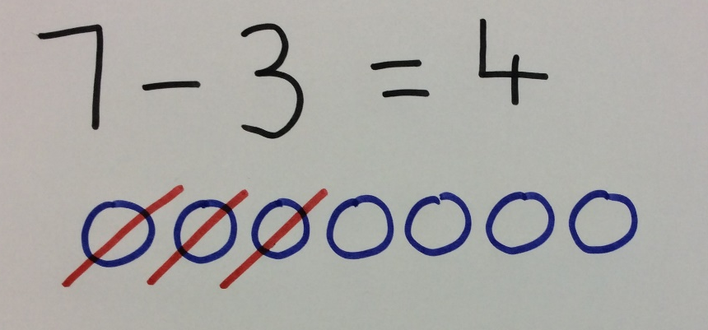

Abstract – This means doing the calculation mentally in your head.
Steps to success:
- Find your exercise book.
- Write down your subtraction number sentence.
- Draw or use a number line to subtract the smaller number from the greater number.
- Or subtract the numbers in your head by counting back.
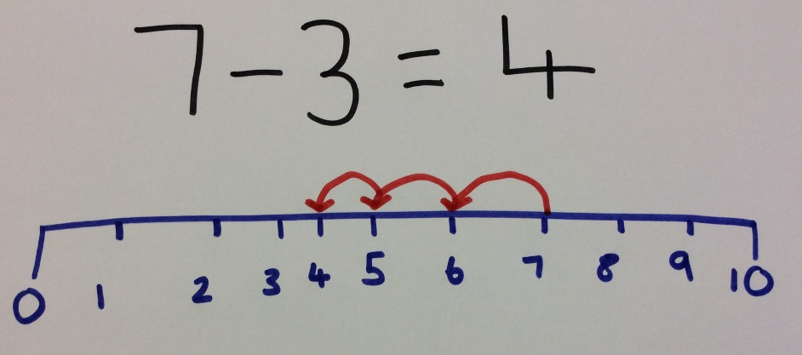
An example for you:

Other ways to represent subtracting a 1 digit number from a 1 digit number.
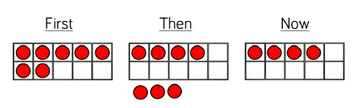
Tens frame.

Try these yourself. What will you use to help you?
7 - 2 =
9 - 4 =

Takeaway within 10
10 - 9 =

9 - 5 =

8 - 3 =

7 - 2 =

6 - 5 =

8 - 4 =

7 - 6 =

6 - 4 =

9 - 4 =

5 - 4 =

10 - 8 =

7 - 3 =

10 - 8 =

- 6 = 3

N

Takeaway within 20
20 - 5 =

18 - 4 =

17 - 3 =

16 - 2 =

13 - 2 =

10 - 4 =

17 - 6 =

14 - 4 =

16 - 5 =

15 - 4 =

19 - 8 =

17 - 6 =

20 - 8 =

- 8 = 12

N

Subtraction from counting back

1 2 3 4 5 6 7 8 9 10 11 12 13 14 15 16 17 18 19 20
Start at 15. Jump back 3.
15 – 3 =
12

1 2 3 4 5 6 7 8 9 10 11 12 13 14 15 16 17 18 19 20
Start at 17. Jump back 4.
17 – 4 =

1 2 3 4 5 6 7 8 9 10 11 12 13 14 15 16 17 18 19 20
Start at 18. Jump back 9.
18 – 9 =

1 2 3 4 5 6 7 8 9 10 11 12 13 14 15 16 17 18 19 20
Start at 15. Jump back 7.
15 – 7 =

1 2 3 4 5 6 7 8 9 10 11 12 13 14 15 16 17 18 19 20
Start at 13. Jump back 5.
13 – 5 =

1 2 3 4 5 6 7 8 9 10 11 12 13 14 15 16 17 18 19 20
Start at 19. Jump back 8.
19 – 8 =

1 2 3 4 5 6 7 8 9 10 11 12 13 14 15 16 17 18 19 20
Start at 16. Jump back 12.
16 – 7 =

N

1 2 3 4 5 6 7 8 9 10 11 12 13 14 15 16 17 18 19 20
Start at 16. Jump back 12.
16 – 12 =

Can you count back?
Ask a grown up to listen to you count back.

I can count back from 10

I can count back from 20

I can count back from 30

I can count back from 40

I can count back from 50

Draw a smiley face in the box if you counted back correctly!

Year 2
English Learning
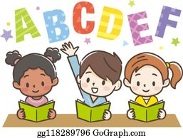

Week 2

This week in English we will continue to learn all about the Great Fire of London. This week we are going to compare how things have changed over time and think about how we can keep safe.

- Use the Great Fire of London fact book in your pack
- If you struggle to read the fact book, you can listen to Miss Stott read it on the remote learning section of your class page
- If possible, you could also use the internet to research about the Great Fire of London, with support from an adult

Day 1 | Spelling, Grammar and Punctuation Lesson  Find the sheet titled ‘Day 1’ and see how many of the tasks you can complete. You don’t need to complete them all, just try your best.  Key skill: Today you need to use your spelling, punctuation and grammar skills. These definitions below might help you with your learning today.    A comma- separates items in a list, it looks like this  A prefix- comes at the start of a word
Day 2 | Compare firefighting then and now  Many things have changed since the Great Fire of London. Today you are going to learn about firefighting in 1666 and firefighting in the present.  Key skill: Today you are going to use your reading and phonics skills to read the statements, then you are going to use your history skills and knowledge to decide whether that happened in 1666 or in the present.
Day 3 | Create a poster about fire safety  Today I would like you to talk to the adults in your house about fire safety in the home. Discuss these questions with an adult at home:  - Do you have fire alarms in your house?  - If so, where are they and why do you think they are in those rooms?  - Who would you ring if there was a fire?  - Where is a safe place for your family to meet in case of a fire?  Can you come up with some important rules that everyone needs to follow to keep safe in case of a fire? Use the sheet titled ‘Day 3’ to record your rules on a poster.
Day 4 | Inside the bakery  The Great Fire of London started in a bakery. What items of food can you buy in a bakery? Can you make a list of all the foods sold? If you are able to, choose an item off your list to make at home with an adult.  Key skill: Today you will use your phonics to read and spell correctly. If you are able to bake something at home you will be using verbs to follow instructions.  A verb- is a doing word, for example, mix, stir, bake, cook
Day 5 | The Great Fire of London Quiz  Please visit the Remote Learning area of your class page on the school website, where you will find a video of The Great Fire of London Quiz. Take the quiz and see how many points you score. Email your teacher with your score from the quiz then we can see how much you have learnt! If you are unable to access the school website, you will find the quiz questions at the end of the pack.

English- Day 1
Spelling, punctuation and grammar lesson
English- Day 2
Firefighting Then and Now

Read these statements carefully then write them in the correct box on the next page.

They used buckets filled with water.

Fire-fighters use hoses filled with water.

Fire-fighters wear a uniform to protect their body.

They did not have a uniform to wear.

If there is a fire call 999 for help.

There were no phones to call for help.

English- Day 2
Firefighting Then and Now

1666 | Present

English- Day 3
FIRE SAFETY

Rule 1: If you find a fire…

Rule 2: If you find a fire…

Rule 3: If you find a fire…

Rule 4: If you find a fire…

English- Day 4
Inside the bakery

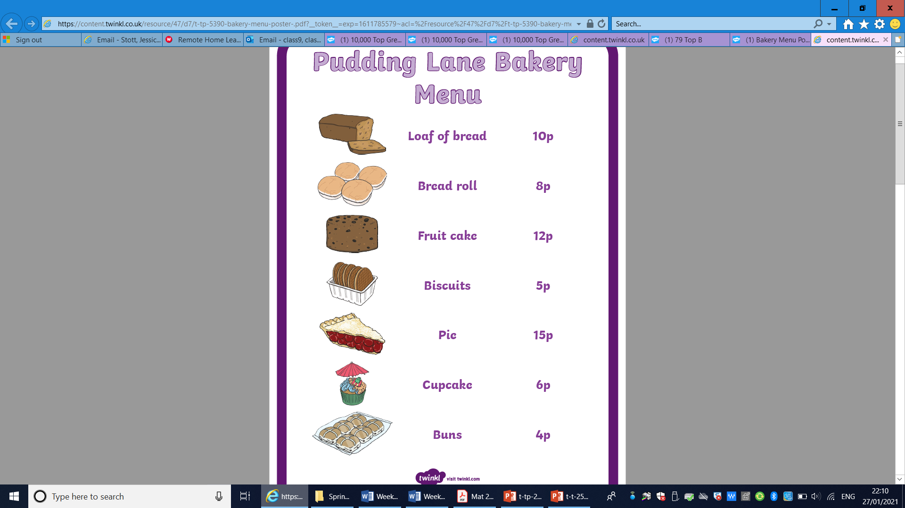

cupcakes buns

pie loaf bread roll

English- Day 5
The Great Fire of London Quiz!

You will find this interactive quiz on the Remote Learning area of your class page on the school website. If you are not able to access the school website you can do the quiz here.

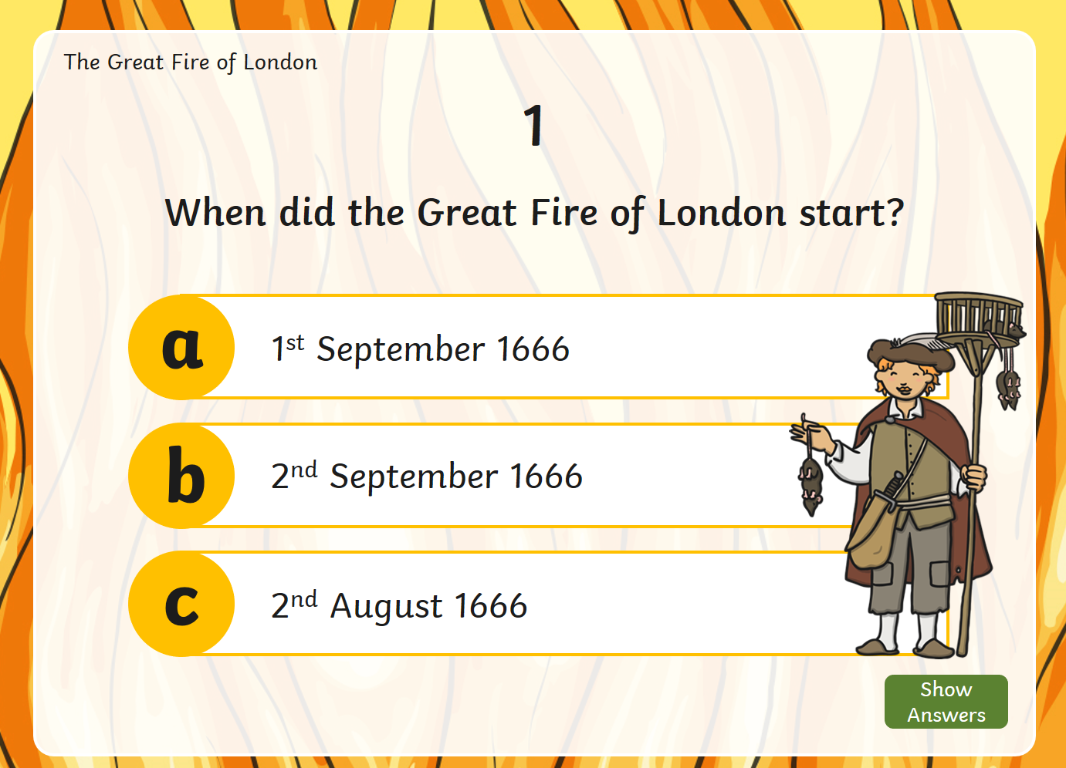 | 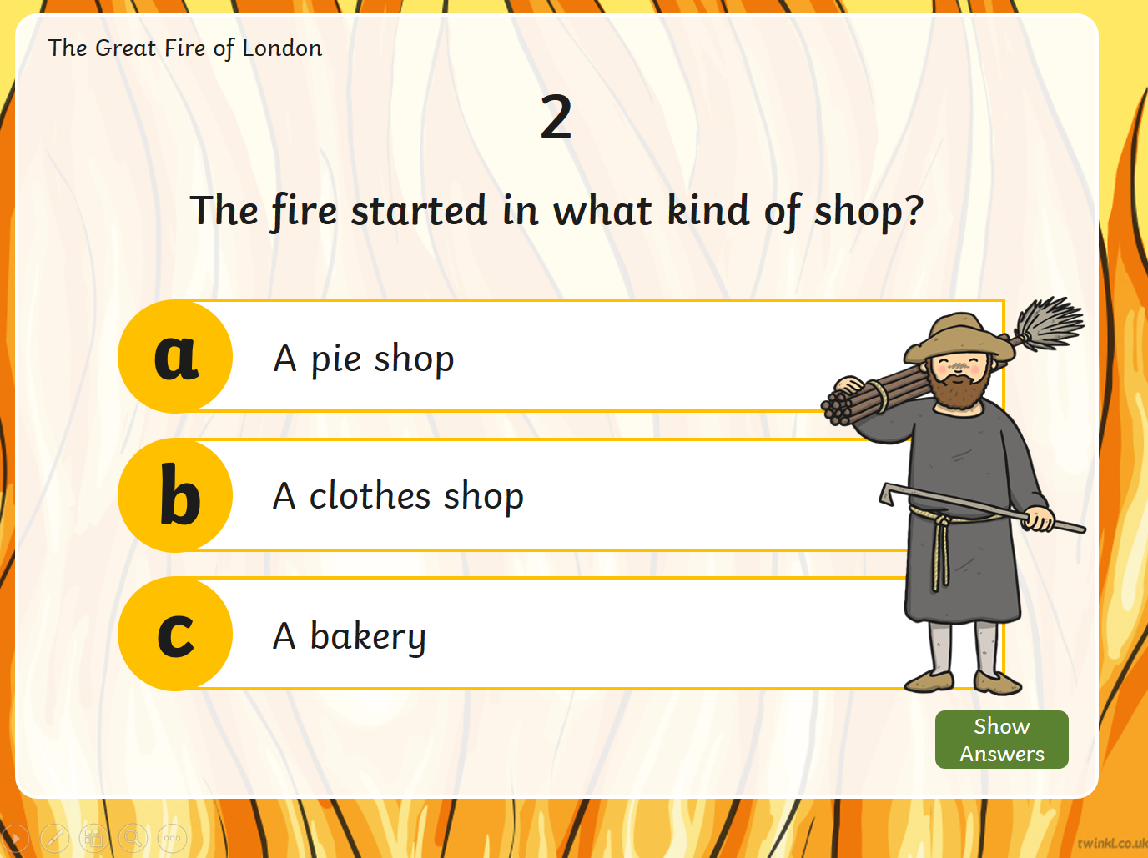
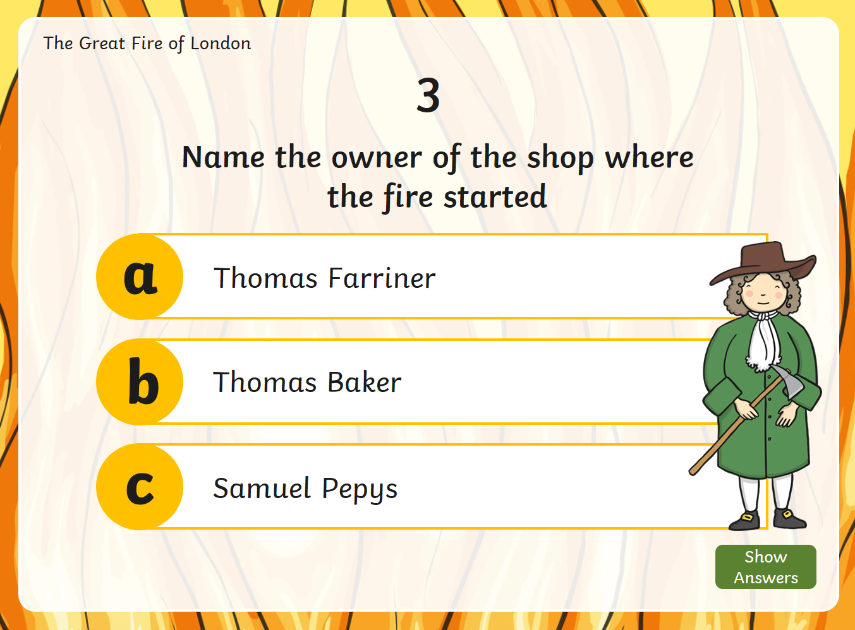 | 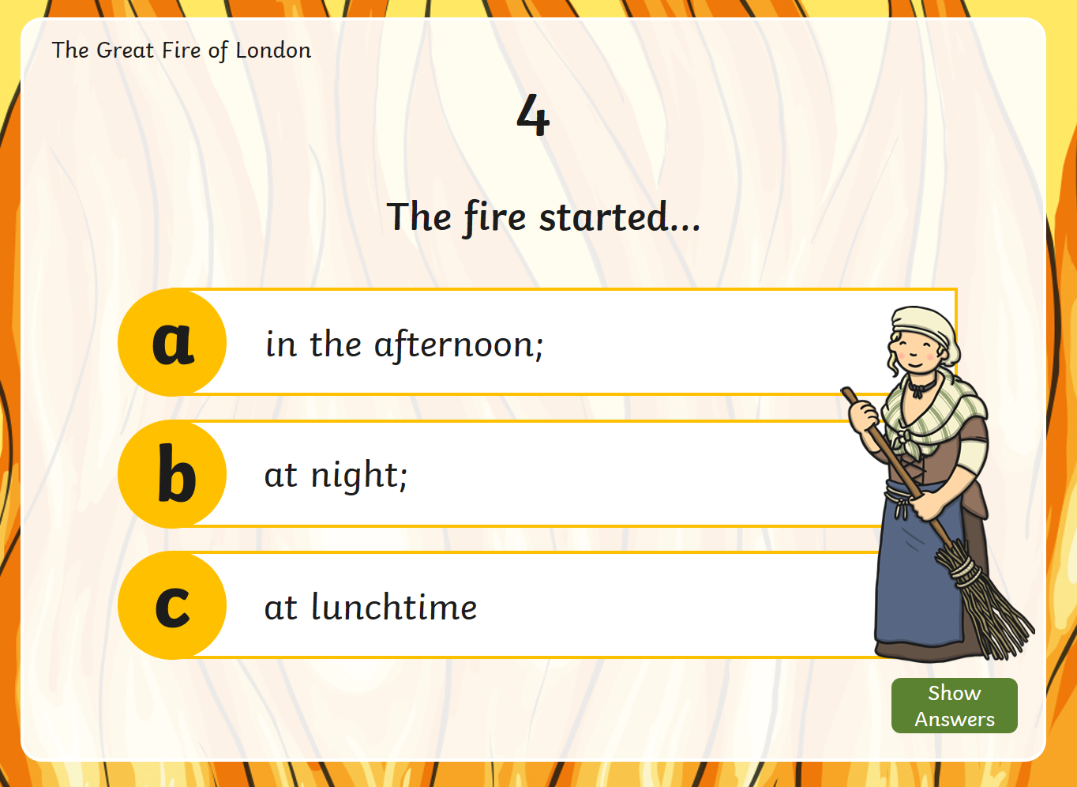
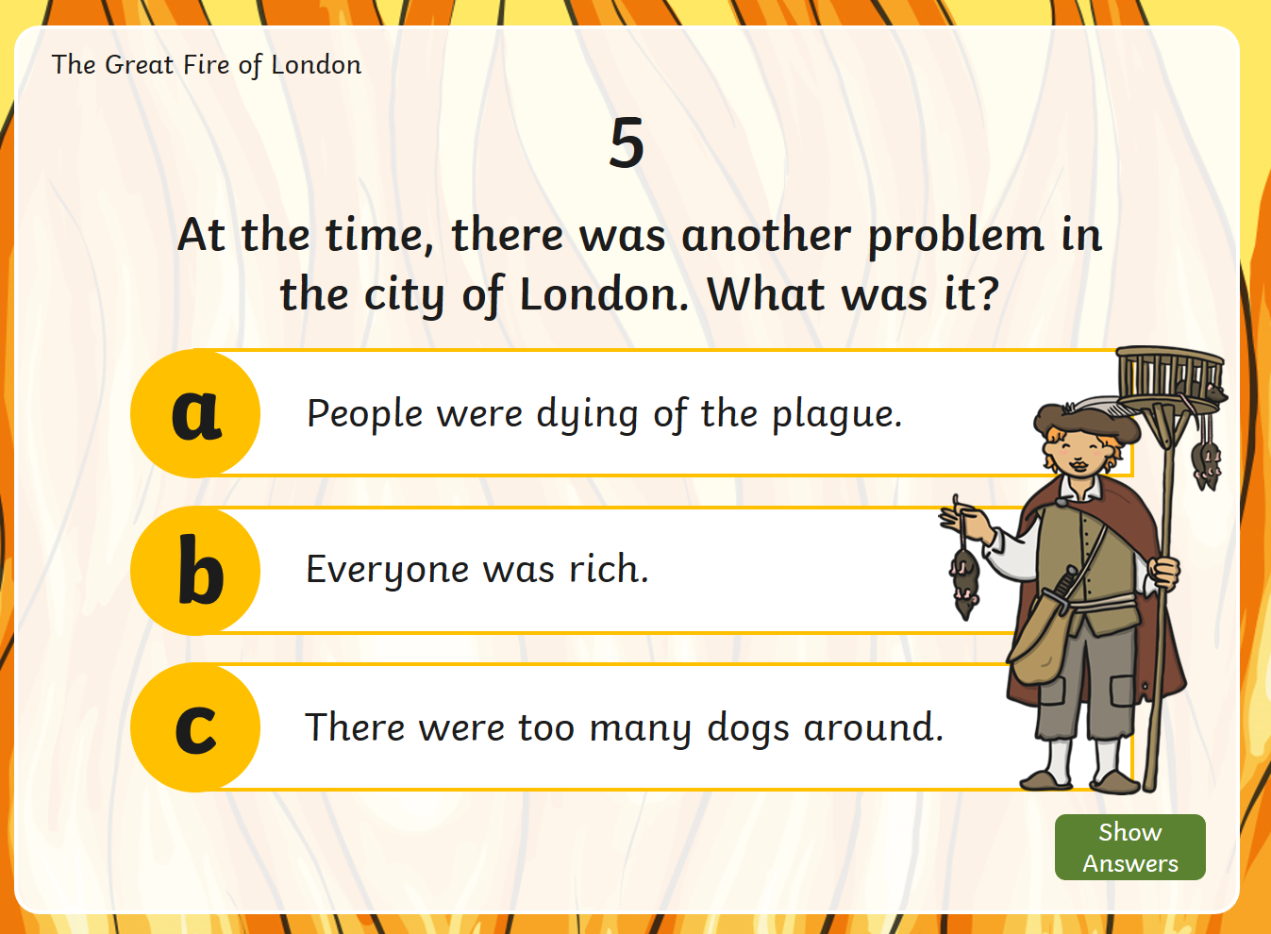 | 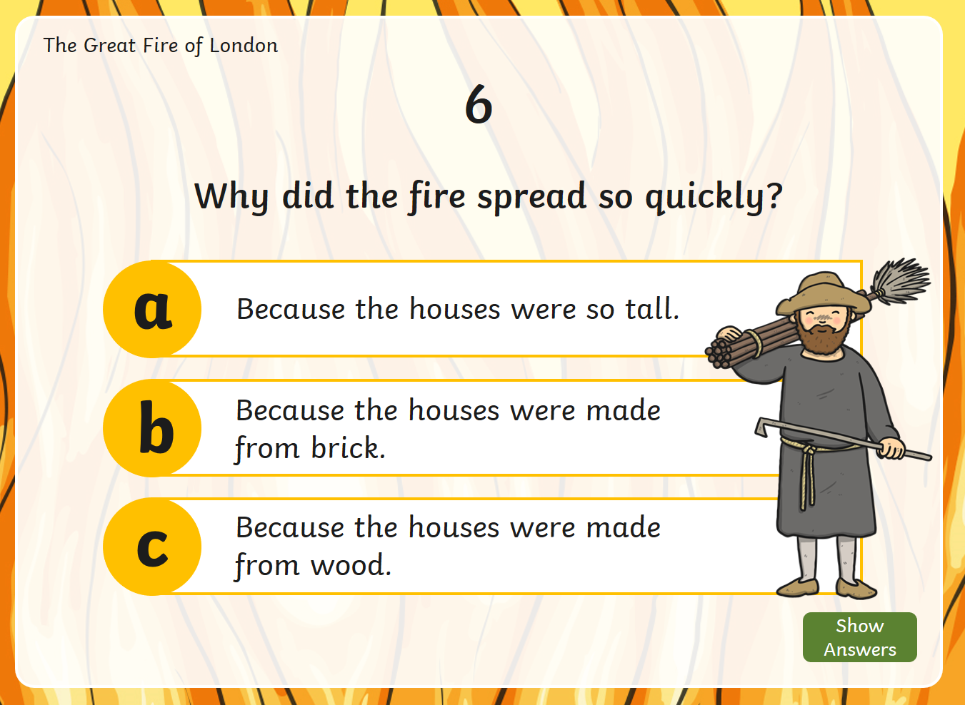

Answers:
- B 2. C 3. A 4. B 5. A 6. C

Year 2
Science and Topic Learning
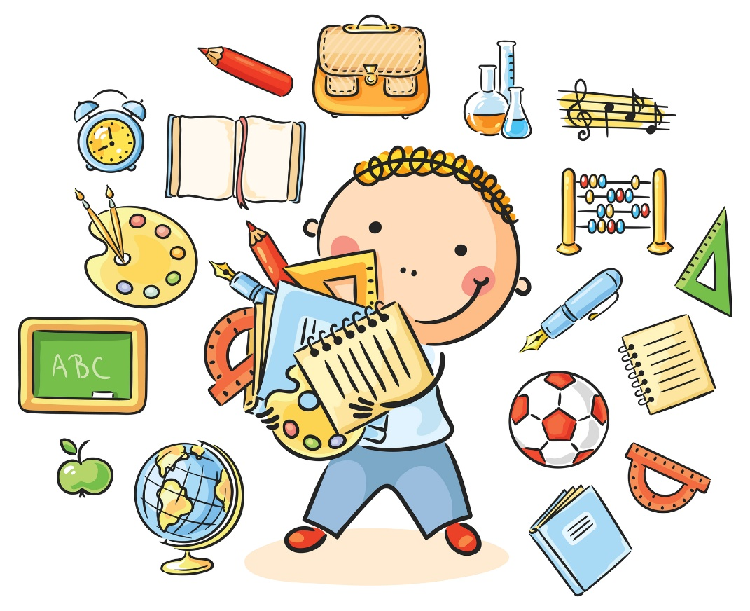

Week 2

Science Learning
This week we want to know how much you have remembered about animals and their offspring. First of all explain to a grown up what offspring means.
- Look at the 3 pictures below.
- All of the creatures have offspring
- Which one is the odd one out?
- Explain your answer, using some super scientific vocabulary
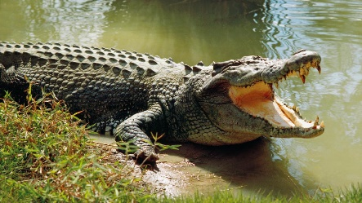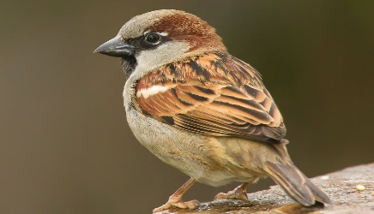

Now have a try at these 3 creatures
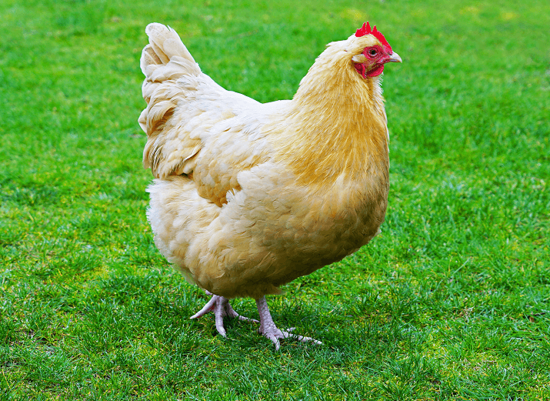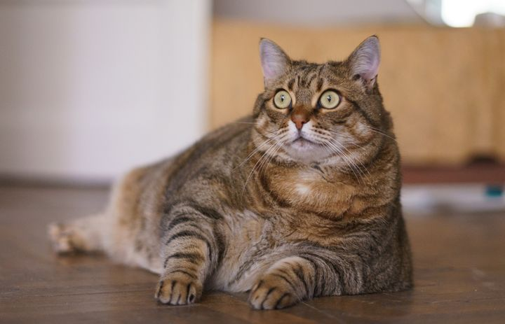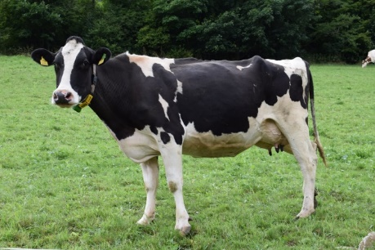
Follow the instructions just like you did before. Remember to write your explanation using super scientific vocabulary.

N. Draw a picture of some animals who lay eggs. Label your drawings.
Draw pictures of animals that give birth to live young. Label your drawings.

N Make up your own ODD ONE OUT game. Ask a grown up to tell you which is the odd one out.

Topic Learning
Geography
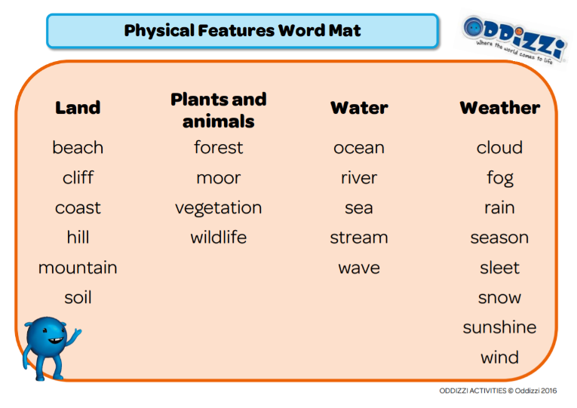
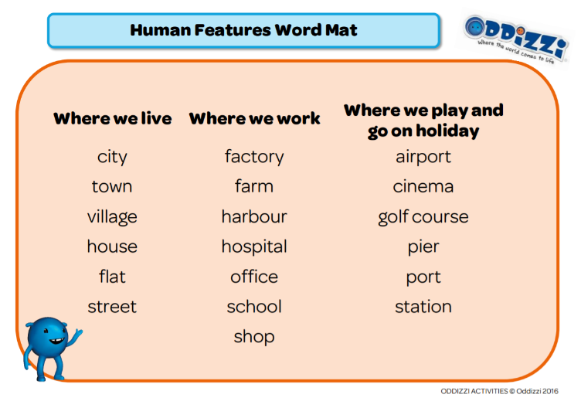
Today, I want you to find out about England. Please find the ‘England’ sheet in your pack. You will need an adult to help you to research. Your job is to find out the names of some of England’s major cities, list some human and physical features (use the word mats below), and add any other interesting facts that you find out.
PE
Continuing last week’s sock theme, this week’s activity is a sock-throw challenge. Follow the link to find out how to set it up. Don’t forget to challenge the people in your house!
https://youtu.be/JfSl3G0p4u0

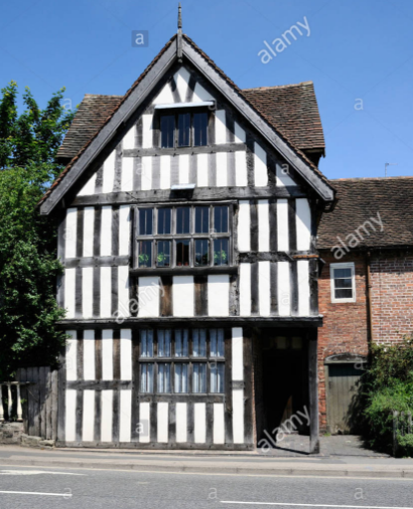
Art
At the time of the Great Fire of London, many buildings looked like this (we call them ‘Tudor buildings’). I want you to create your own Tudor house using an old cereal box. There are lots of examples of Tudor buildings online that you can use as inspiration or you can use the picture here. Follow the link for a simple tutorial. Remember to send in your creations to your teacher.
https://www.youtube.com/watch?app=desktop&v=i0Kjzviprwk

