Using different subtraction strategies
M8
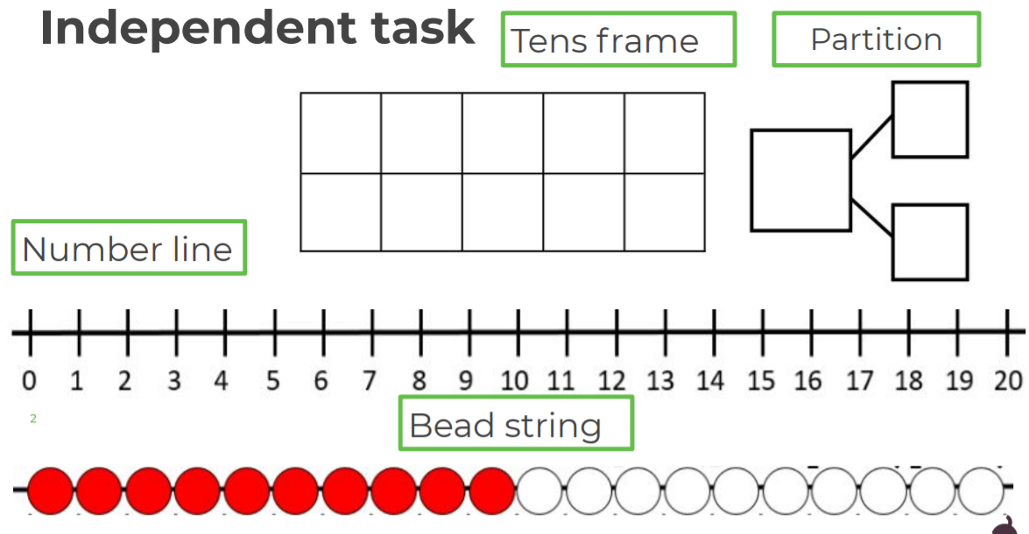
Choose your favourite subtraction strategy to solve these number sentences. How many different ways can you do it?

