Reception Home Learning - Week 1

Day 1
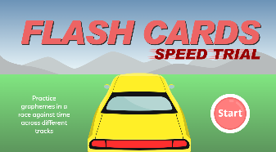  Phonics: | Log onto Phonics Play. Can you play the ‘Flashcards Speed Trial’ game? Remember to choose the Phase 2 option for the game.
https://www.phonicsplay.co.uk/resources/phase/2/flashcards-speed-trials

Literacy:  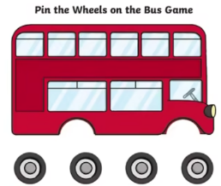 | Follow the link to re-watch the story The Naughty Bus. Then have a go at re-telling the story. What happened at the beginning of the story, middle and end?  Use the bus picture provided to cut out and add on the wheels on the bus. Then have a go at labelling your naughty bus e.g. wheels, door, windows etc. Remember to use your phonics!  Complete Literacy: Week 1 – Day 2 activity sheet.
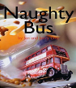
https://www.youtube.com/watch?v=sqQ1BAEj1oE&ab_channel=WideFrameUK

Maths:
In this lesson, children will explore finding one more than a number within 10.

In this lesson we will be focussing on the Oak National Academy Maths: Lesson 6 – Exploring one more within 10

If you do not have any objects to help you with counting at home don’t worry, you can still listen and join in.

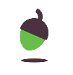
Exploring one more within 10 (thenational.academy)

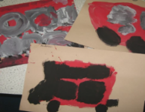  Topic – Expressive Art and Design: | Use paper and paints to paint the naughty bus. Can you count out how many windows and doors to add when painting the naughty bus?

Day 2
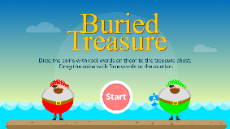  Phonics: | Log onto Phonics Play. Can you play the ‘Buried Treasure’ game? Remember to choose the Phase 2 option for the game.
https://www.phonicsplay.co.uk/resources/phase/2/buried-treasure

Literacy:  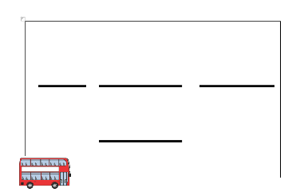 | Follow the link to watch the story ‘The Naughty Bus’. Then have a go at re-telling the story.  What happened at the beginning of the story, middle and end?  Complete Literacy: Week 1 – Day 2 activity sheet.  Ask your child to use their phonics and have a go at writing a simple sentence about the naughty bus; a big red bus.
https://www.youtube.com/watch?v=sqQ1BAEj1oE&ab_channel=WideFrameUK

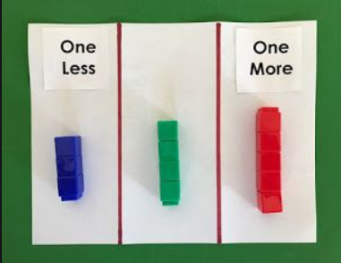  Maths: | In this lesson we will be focussing on the Oak National Academy Maths: Lesson 7 – Exploring one less within 10  Can you practically find one more and one less for numbers within 10? You could use Lego or toys to help you.
https://classroom.thenational.academy/lessons/exploring-one-less-within-10-cgtk0c

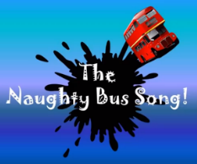  Topic - Music: | Listen to the naughty bus song. Then have a go at singing the song. Can you come up with actions and perform the song in front of your family?
https://www.youtube.com/watch?v=jwYU3aQ3tHc&ab_channel=SingKids%21songsbySueBleazard

Day 3
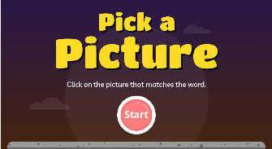  Phonics: | Log onto Phonics Play. Can you play the ‘Pick a Picture’ game? Remember to choose the Phase 2 option for the game.
https://www.phonicsplay.co.uk/resources/phase/2/pick-a-picture

Literacy:  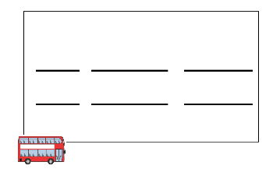 | Can you remember what happened in the story ‘The Naughty Bus’. Think about your favourite part of the story and have a go at writing a simple sentence what happened e.g. a big mess  a bad bus  Complete Literacy: Week 1 – Day 3 activity sheet.
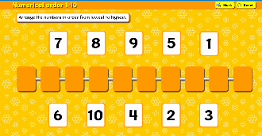  Maths: | Log onto Busy Things and complete the ‘Numerical order 1-10’ activity.  Busy Things
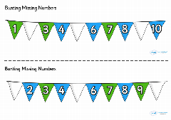 | Complete Maths: Week 1 – Day 3 activity sheet.
Topic – Physical Development:  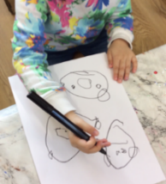 | Use thick / chunky felt tips – can you draw and colour in your naughty bus. Does it look like the naughty bus from the story? Does it make a lot of mess just like it does in the story? What adventure does your naughty bus go on?

Day 4
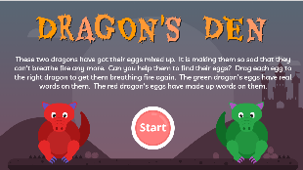  Phonics: | Log onto Phonics Play. Can you play the ‘Dragon’s Den’ game? Remember to choose the Phase 2 option for the game.
https://www.phonicsplay.co.uk/resources/phase/2/dragons-den

Literacy:  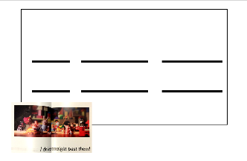 | Can your child re-tell the story of the Naughty Bus verbally?  Ask your child to write about how the characters on the bus stop feel when the naughty bus drove straight past them. Can you write two sentences explaining how the passengers felt as the bus drove past them?  I am mad  a bad bus  Complete Literacy: Week 1 – Day 4 activity sheet.
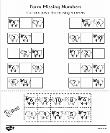  Maths: | Keep practising counting to and from 10 (forwards and backwards.)  Complete Maths: Week 1 – Day 4 activity sheet.
Topic – CAL / EAD:  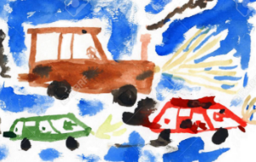 | Choose a vehicle or transport and have a go at painting it or you can be as creative as you like! You could paint a bus, car, aeroplane, boat etc. Talk about the all the different vehicles and how they are similar and different.

Day 5
Phonics:  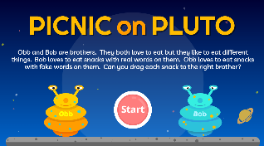 | Log onto Phonics Play. Can you play the ‘Picnic on Pluto’ game? Remember to choose the Phase 2 option for the game.
https://www.phonicsplay.co.uk/resources/phase/2/picnic-on-pluto

Literacy:  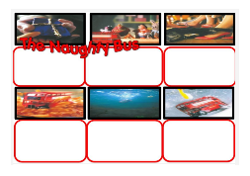 | Watch the story one more time this week!  Can your child join in with the story? No writing today children – oral retelling focus.  Complete Literacy: Week 1 – Day 5 activity sheet.
https://www.youtube.com/watch?v=sqQ1BAEj1oE&ab_channel=WideFrameUK

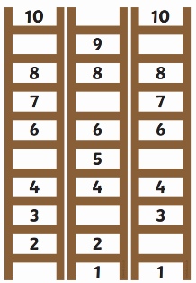  Maths: | Keep practising counting to and from 10 (forwards and backwards.)  Complete Maths: Week 1 – Day 5 activity sheet.
Topic – CAL / EAD:  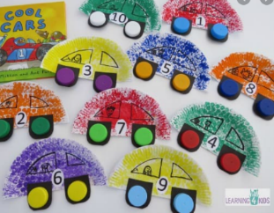 | Using a paper plate have a go at making your own car. You can decorate it however you like. Then have a go at telling a journey your car went on. Where did your car go on an adventure?

