Literacy: Week 1 – Day 1

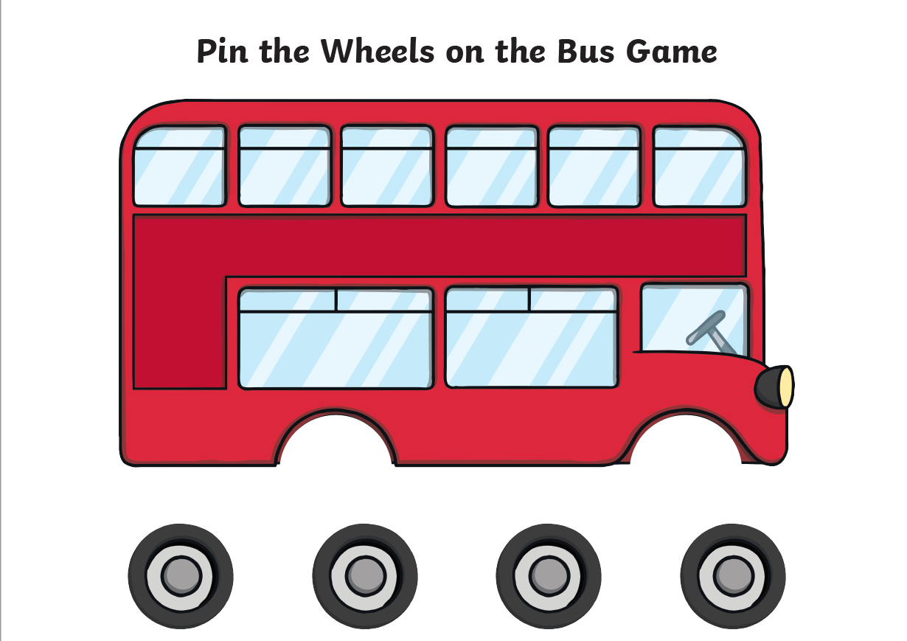

Literacy: Week 1 – Day 2

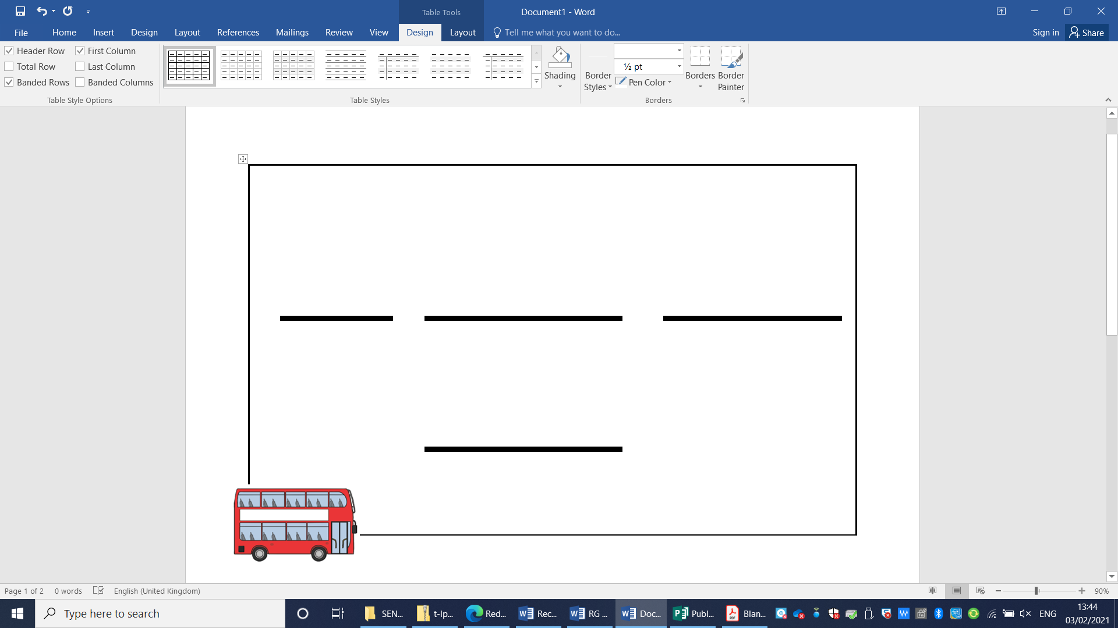

Literacy: Week 1 – Day 3

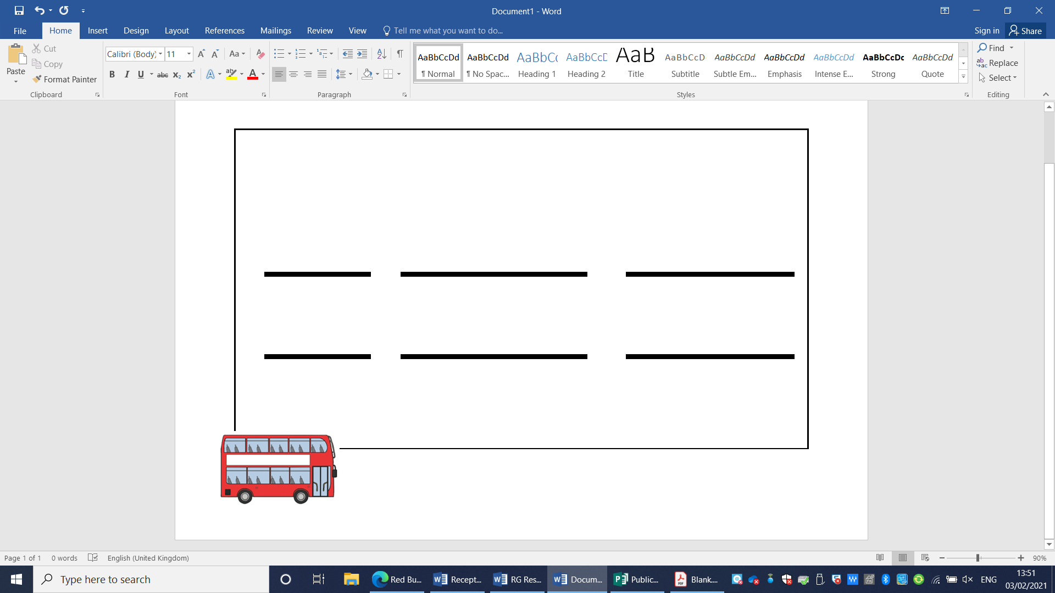

Maths: Week 1 – Day 3

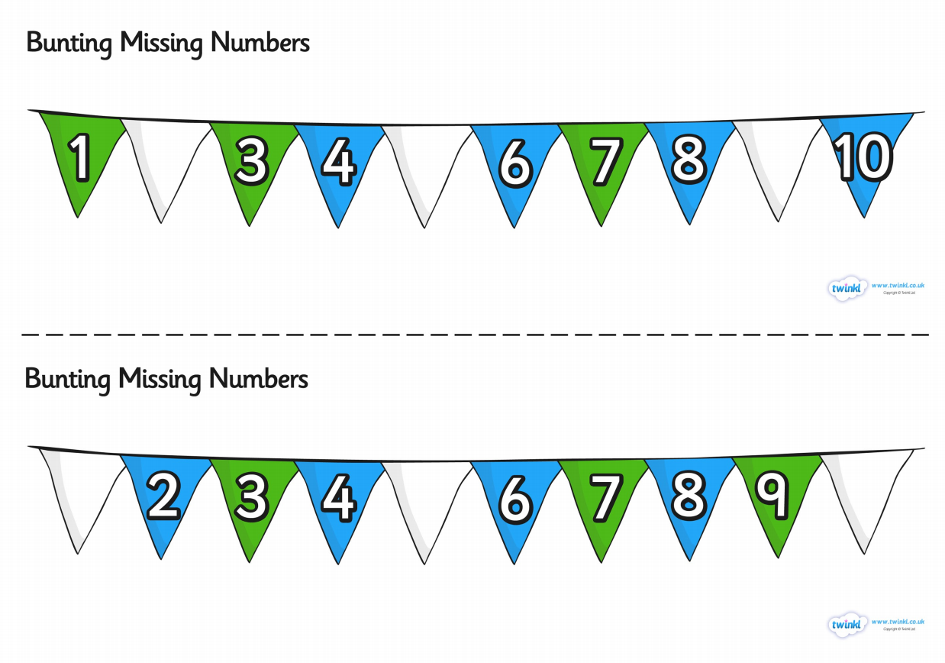

Literacy: Week 1 – Day 4

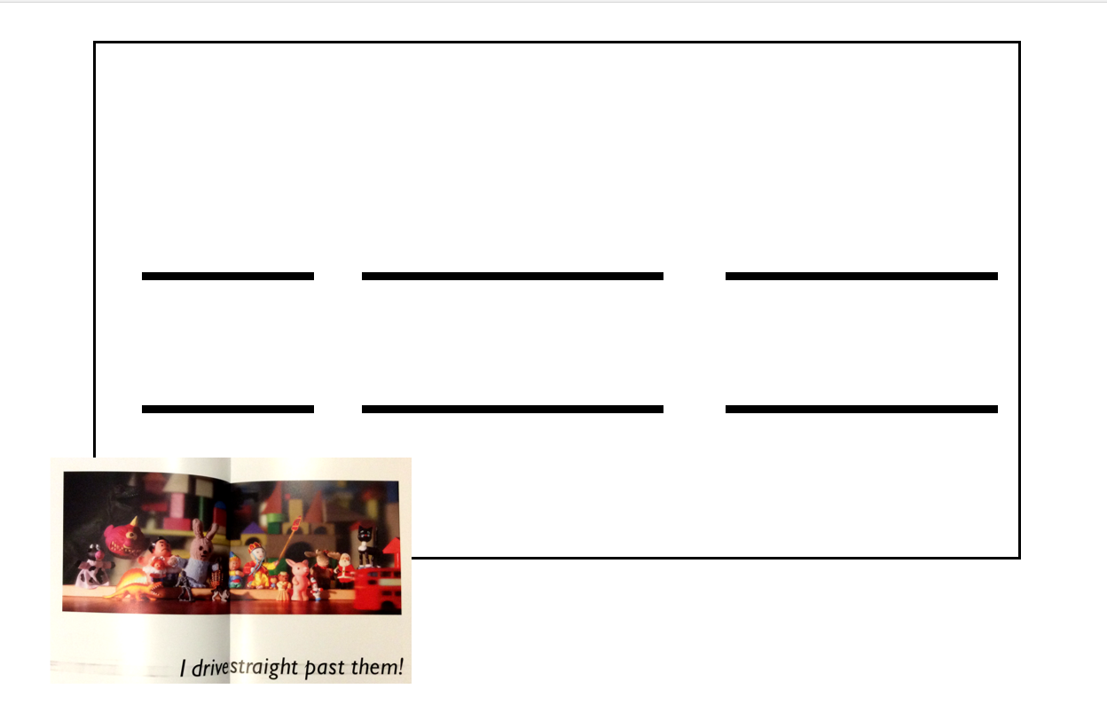

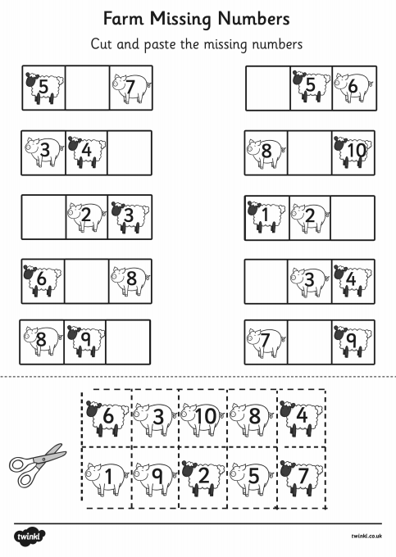
Maths: Week 1 – Day 4

Literacy: Week 1 – Day 5

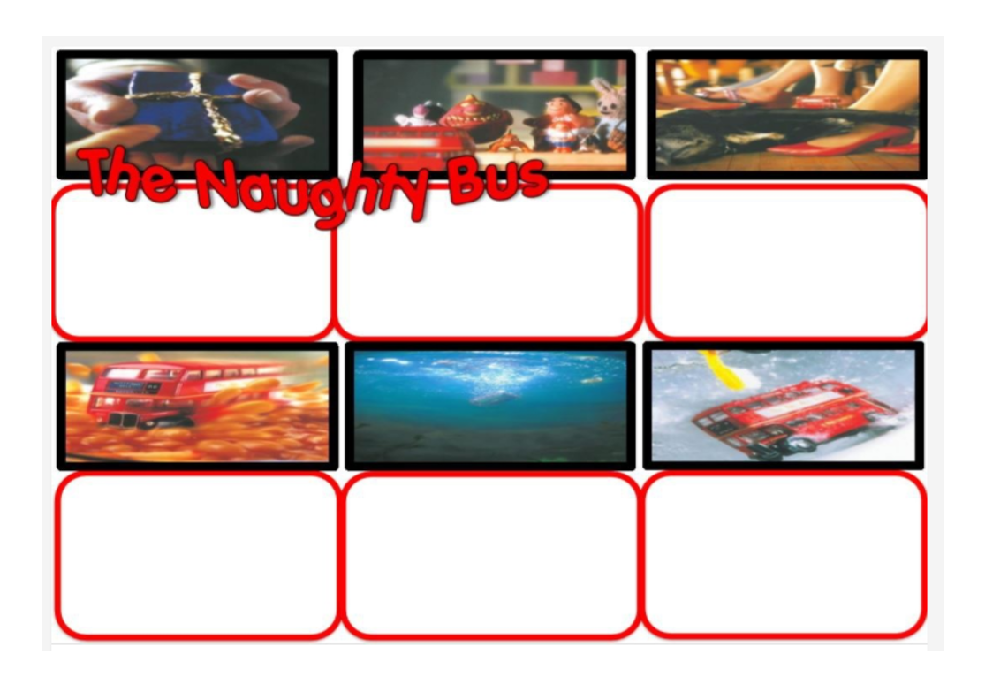

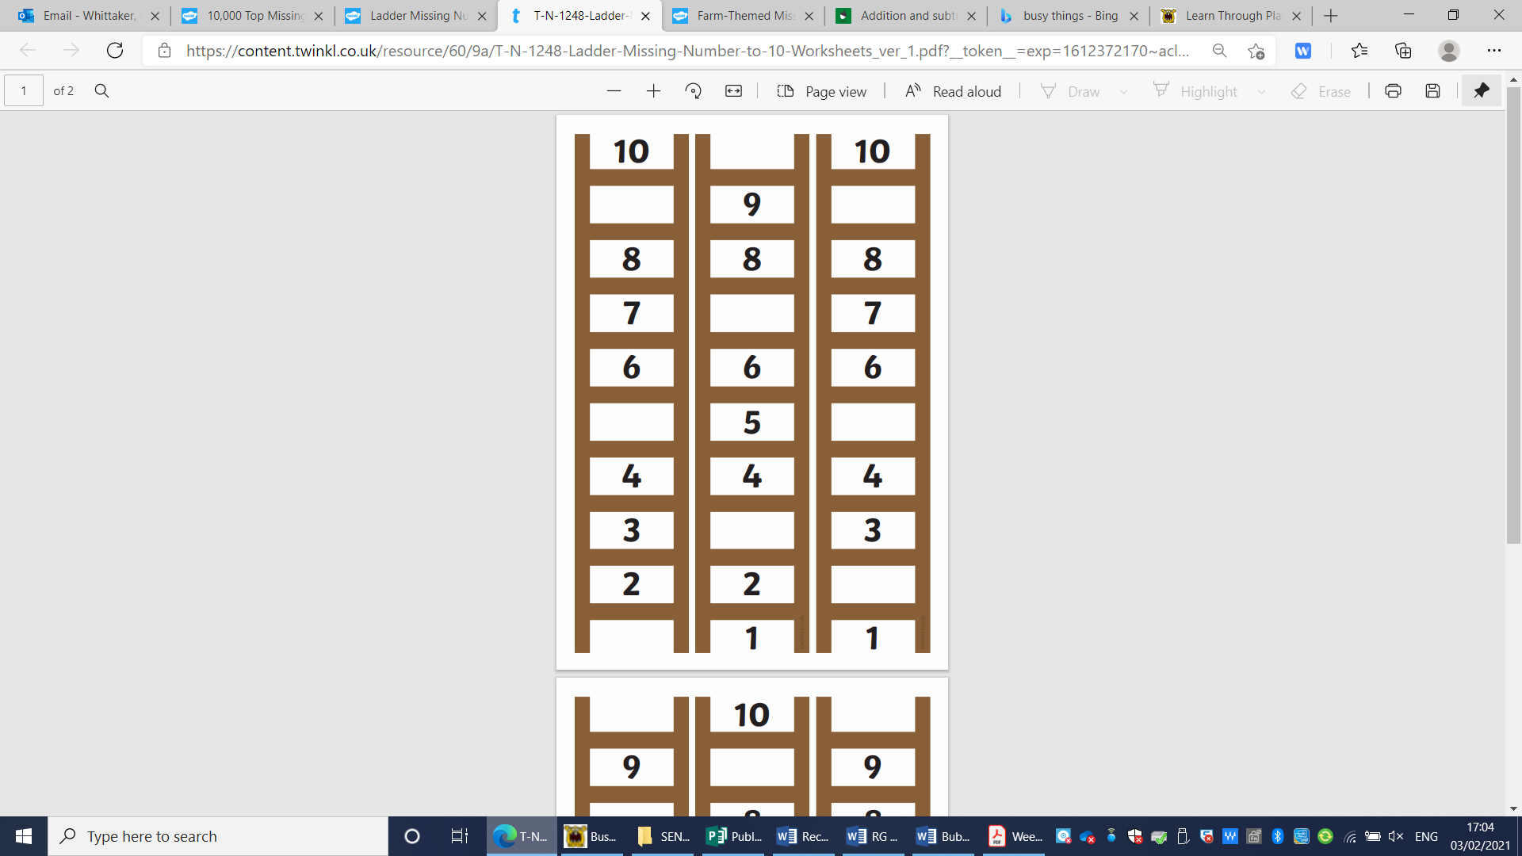
Maths: Week 1 – Day 5

