Reception Home Learning - Week 2

Day 1
Phonics:  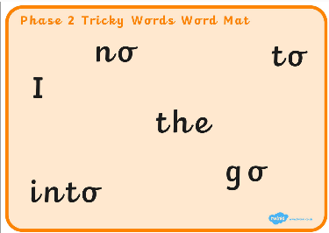 | Recap all the Phase 2 sounds that you have learnt.  This week, for Phonics, we are going to learn our Phase 2 ‘Tricky Words’. Now remember, these words are trying to ‘trick’ you! We can’t segment them and use our Robot Arms to help us. We have to learn the word by sight.  Using the ‘Phase 2 Tricky Words Word Mat’, can you recognise the tricky words? You could play ‘Tricky Word’ splat. Get an adult to say a tricky word and you splat the word on the mat.
Literacy:  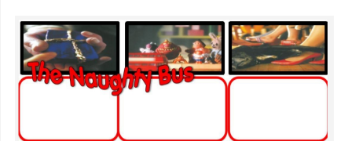 | Can you remember the story The Naughty Bus from last week? Listen to the story to recap what happens in the story. Use the resource sheet and have a go at writing a simple caption or label under the first 3 pictures. Remember to use your phonics to help you write. Don’t worry if your child struggles to spell some words correctly – the main thing is that they use their phonic knowledge – so it might look like this: For eg; a pst (a present etc)  Complete Literacy: Week 2 – Day 1 activity sheet.
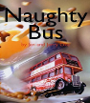
https://www.youtube.com/watch?v=sqQ1BAEj1oE&ab_channel=WideFrameUK

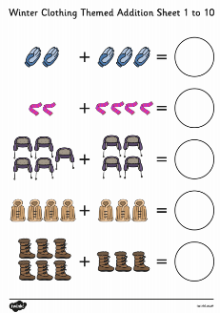  Maths: | In this lesson we will be focussing on the Oak National Academy Maths: Lesson 1 – Using manipulatives to count on when adding  Complete Maths: Week 2 – Day 1 activity sheet.
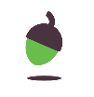
Using manipulatives to count on when adding (thenational.academy)

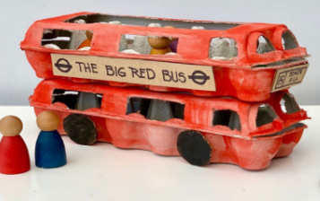  Topic – EAD / DT:  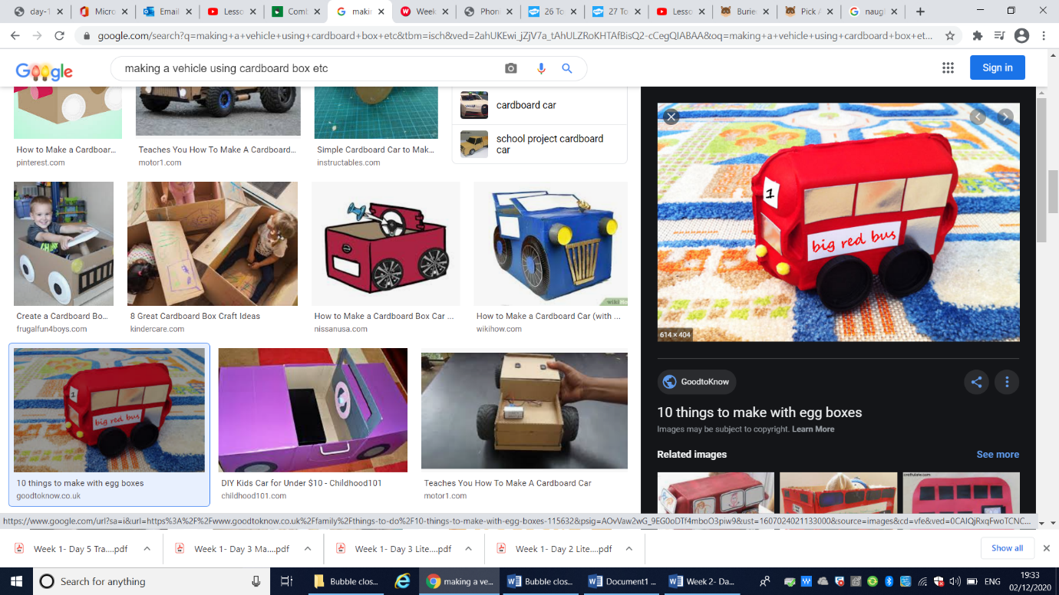 |  | Use cardboard boxes, egg cartons and cardboard cylinders from kitchen roll to design and make a vehicle. Focus on joining skills e.g. what could we use to join? Sellotape, split pins / masking tape etc / whatever you can find in the house. Decorate your vehicle with milk top lids/ colour/ paint etc.
Day 2
Phonics:  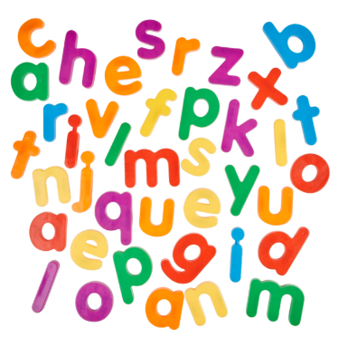 | Recap all the Phase 2 sounds that you have learnt.  This week, for Phonics, we are going to learn our Phase 2 ‘Tricky Words’. Now remember, these words are trying to ‘trick’ you! We can’t segment them and use our Robot Arms to help us. We have to learn the word by sight.  Using magnetic letters, can you make some tricky words? You can use the mat from yesterday to help you.
Literacy:  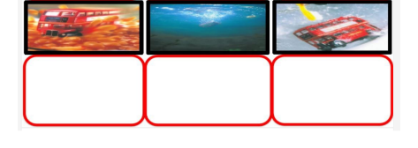 | Continue to complete writing simple sentences re-telling the story The Naughty Bus. Complete the bottom row of pictures. Don’t forget to use your phonics to have a go at writing a caption or a label.  Complete Literacy: Week 2 – Day 2 activity sheet.
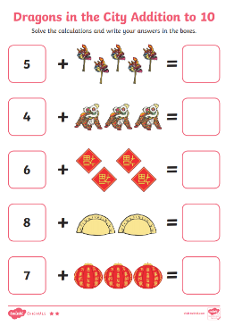  Maths: | In this lesson we will be focussing on the Oak National Academy Maths: Lesson 2 – Adding two numbers using a number track to count on  Complete Maths: Week 2 – Day 2 activity sheet.
Adding two numbers using a number track to count on (thenational.academy)
Topic – EAD / Music:

In this lesson we will be focussing on the Oak National Academy Music: Lesson 2 – Sitting on the Bus

Beep-Beep! Time to get on board the big red bus. Our bus journey will take us on a musical adventure through the streets of London. We will use singing games to explore note duration and improvise rhythms with a rapping bus driver. This lesson's imaginative listening will take us on a bus tour through the Queen's neighbourhood, as we listen to Eric Coates' Knightsbridge Suite.
https://classroom.thenational.academy/lessons/sitting-on-the-bus-c4t64d

Day 3
Phonics:  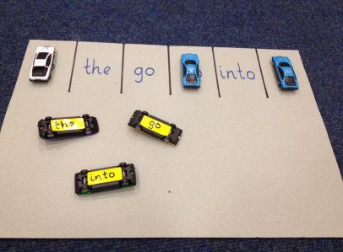 | Recap all the Phase 2 sounds that you have learnt.  This week, for Phonics, we are going to learn our Phase 2 ‘Tricky Words’. Now remember, these words are trying to ‘trick’ you! We can’t segment them and use our Robot Arms to help us. We have to learn the word by sight.  Can you park the tricky word cars in the matching parking space?
Literacy:  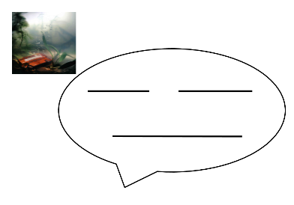 | Use the speech bubble template to complete your writing task.  Don’t worry if your child struggles to spell some words correctly –  the main thing is that they use their phonic knowledge – so it might look like this:  in the pd (pond)  Please encourage your child to spell the tricky word ‘the’ correctly  Complete Literacy: Week 2 – Day 3 activity sheet.
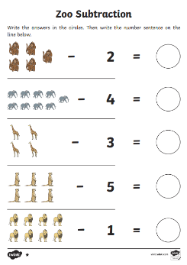  Maths: | In this lesson we will be focussing on the Oak National Academy Maths: Lesson 3 – Understanding the concept of subtraction as take away (Part 1)  Complete Maths: Week 2 – Day 3 activity sheet.
Understanding the concept of subtraction as take away (Part 1) (thenational.academy)

Topic:

In this lesson we will be focussing on the Oak National Academy Music: Lesson 5 – Sailing on a Boat

It's time to jump on board and come sailing with us! We will be singing a song in French, with movement to mirror the rocking of a boat and making up some rhythmic rhymes in Ally Ally O.

https://classroom.thenational.academy/lessons/sailing-on-a-boat-6gwkjt

Day 4
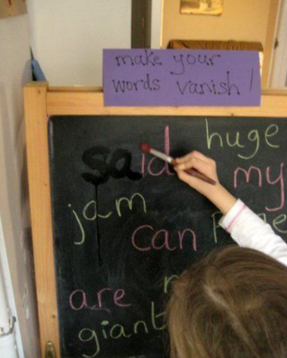  Phonics: | Recap all the Phase 2 sounds that you have learnt.  This week, for Phonics, we are going to learn our Phase 2 ‘Tricky Words’. Now remember, these words are trying to ‘trick’ you! We can’t segment them and use our Robot Arms to help us. We have to learn the word by sight.  Can you ask an adult to write the Phase 2 tricky words on a chalkboard / whiteboard? Using either water or your finger, can you make the tricky words disappear?
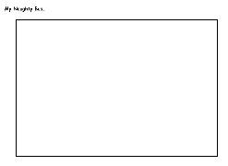  Literacy: | Design and draw your very own naughty bus. It can be any colour you like and even have some patterns on it! After designing it, can you have a go at labelling your bus? Use your phonics to help you. You could write ‘f’ for fast etc.  Complete Literacy: Week 2 – Day 4 activity sheet.
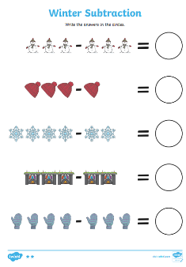  Maths: | In this lesson we will be focussing on the Oak National Academy Maths: Lesson 4 – Understanding the concept of subtraction as take away (Part 2)  Complete Maths: Week 2 – Day 4 activity sheet.
Understanding the concept of subtraction as take away (Part 2) (thenational.academy)
Topic:
In this lesson we will be focussing on the Oak National Academy Understanding the World: Lesson 2 – Transport Model

In today's lesson, we are going to be thinking about different modes of transport, and then we are going to have a go at creating our own aeroplane! Where is your aeroplane going to fly? The three key areas that this lesson links to are expressive arts and design, understanding the world and communication and language.
https://classroom.thenational.academy/lessons/transport-model-60wpat

Day 5
Phonics:  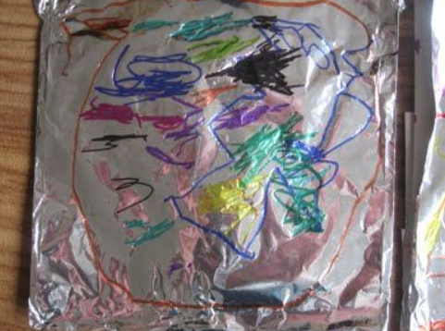 | Recap all the Phase 2 sounds that you have learnt.  This week, for Phonics, we are going to learn our Phase 2 ‘Tricky Words’. Now remember, these words are trying to ‘trick’ you! We can’t segment them and use our Robot Arms to help us. We have to learn the word by sight.  Can you write the Phase 2 tricky words on a piece of tinfoil? You can use felt tips for this.
Literacy: | Using your naughty bus model that you made earlier in the week. Can you take your naughty bus around house and take photographs of where your bus went?  Did it go …  In the bath  In your bed  In the fridge etc.
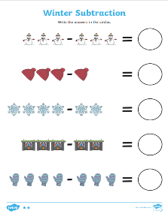  Maths: | In this lesson we will be focussing on the Oak National Academy Maths: Lesson 5 – Adding and subtracting using a number track  Complete Maths: Week 2 – Day 4 activity sheet.
Adding and subtracting using a number track (thenational.academy)
Topic:
In this lesson we will be focussing on the Oak National Academy Understanding the World: Lesson 3 – To explain features of different modes of transport

In this set of lessons, we learn about different modes of transport. In this lesson with Miss Hughes, we look at the features of different modes of transport and end the lesson by designing our own. Think carefully about how you would like your vehicle to move and what features it needs. You can bring the lesson to life by building your transport after the lesson.
https://classroom.thenational.academy/lessons/to-explain-features-of-different-modes-of- transport-chjk0c

