Phonics: Week 2 – Day 1

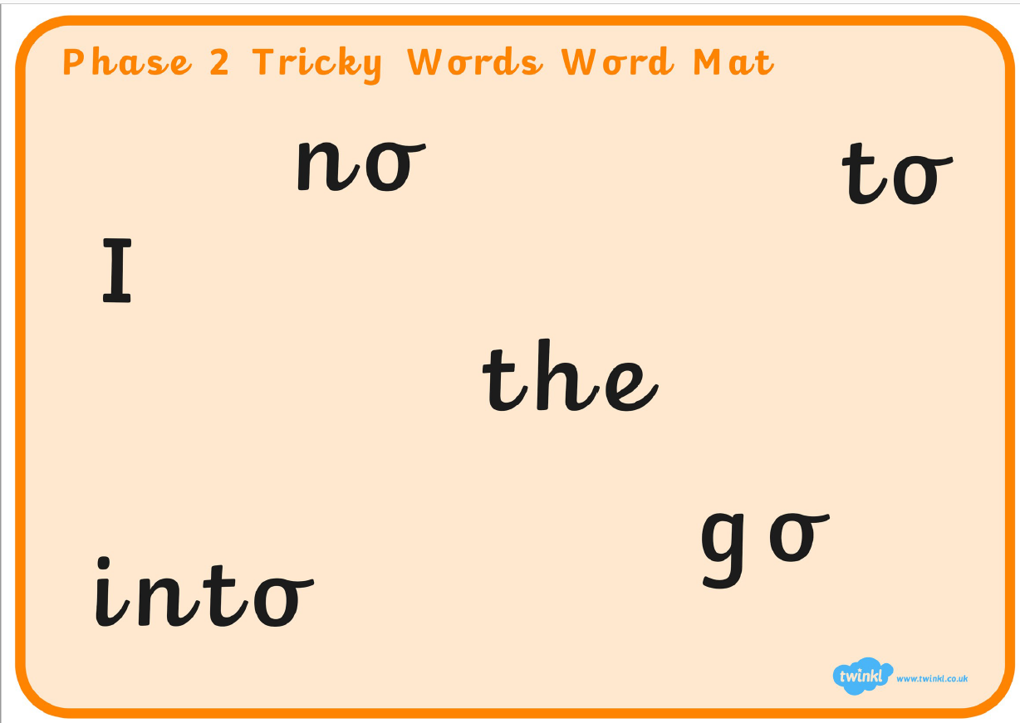

Literacy: Week 2 – Day 1

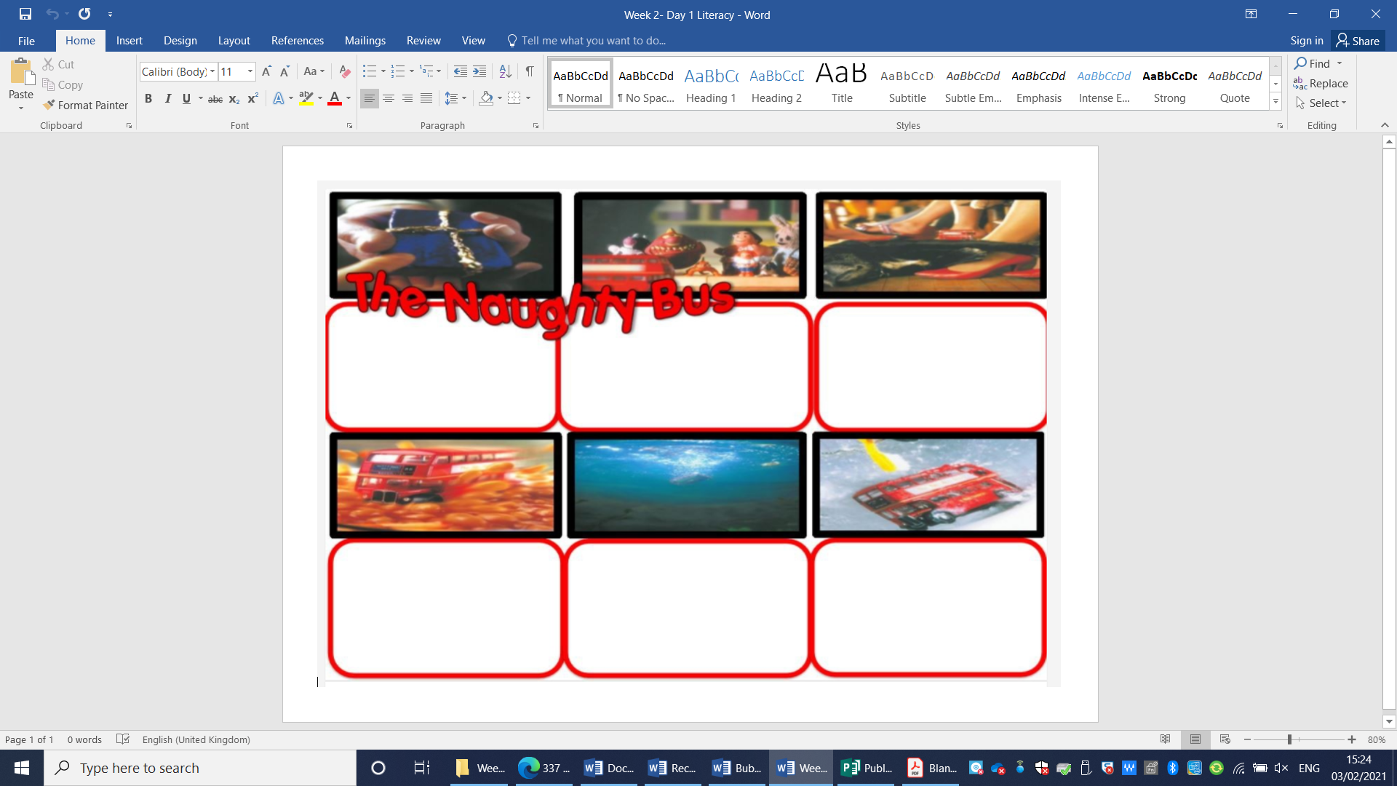

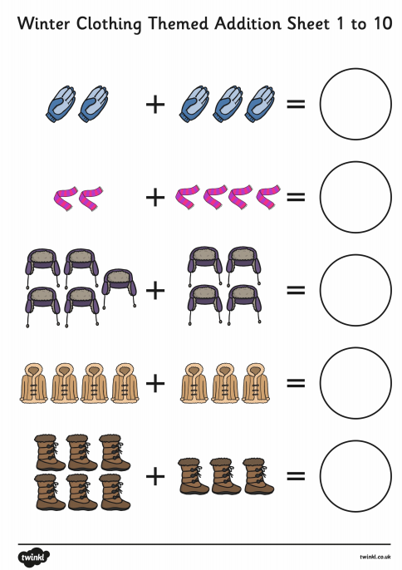
Maths: Week 2 – Day 1

Literacy: Week 2 – Day 2

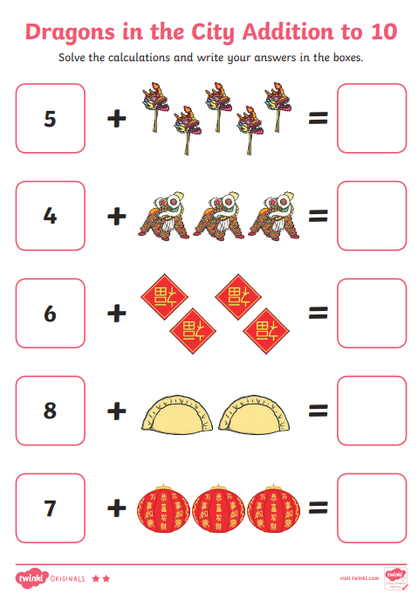
Maths: Week 2 – Day 2

Literacy: Week 2 – Day 3

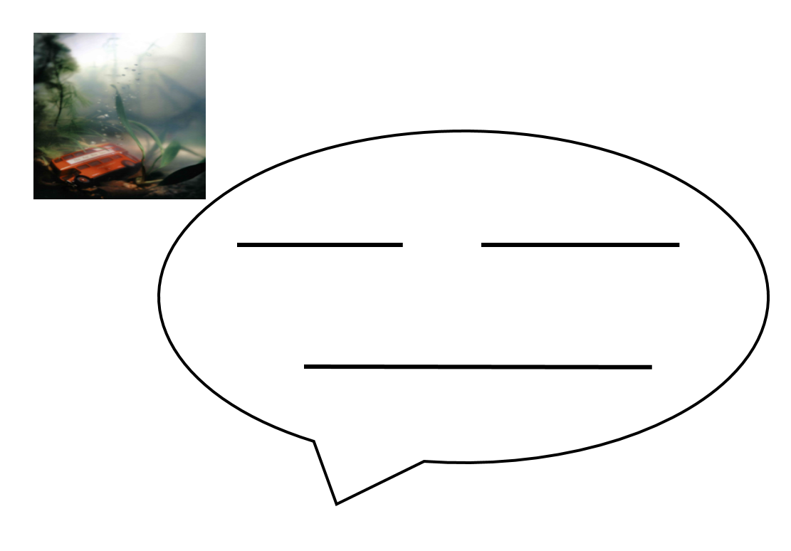

Maths: Week 2 – Day 3
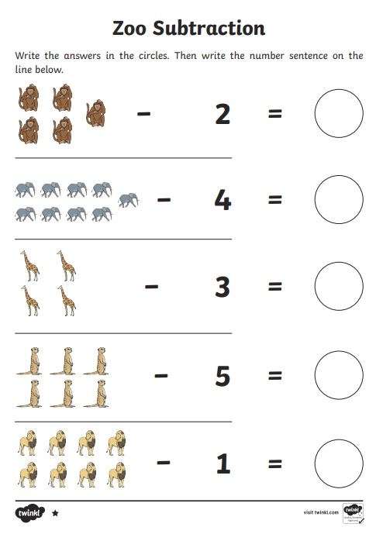

Literacy: Week 2 – Day 4

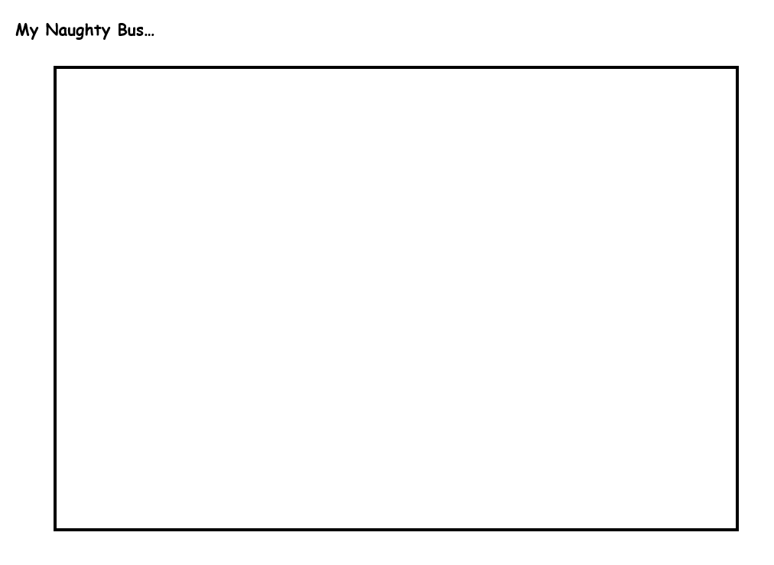

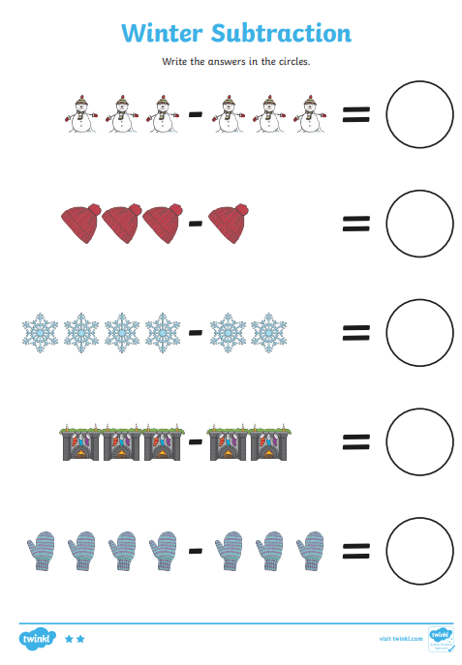
Maths: Week 2 – Day 4

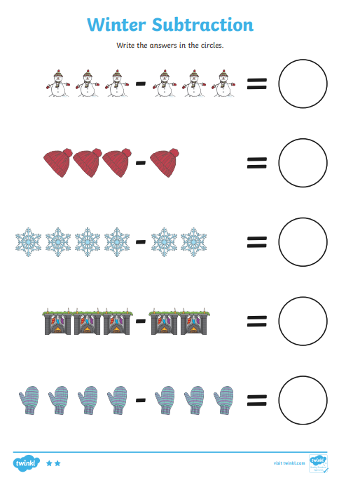
Maths: Week 2 – Day 5

