P2
The ‘ee’ sound family
Can you read the text and circle any words that have these sounds in
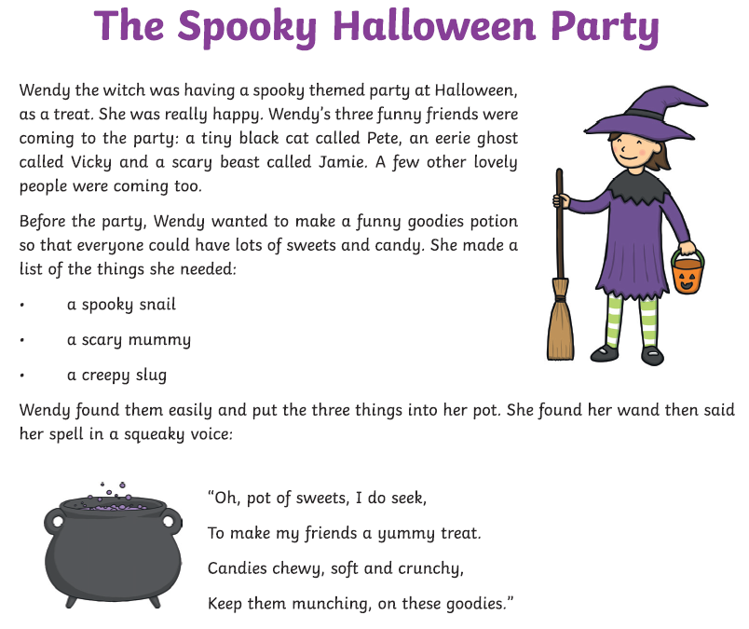
ee e_e ea y ie
Can you write down some of the words you found?
________________________________________________________________________________________________

