Alternative spellings for ‘ue’
P5
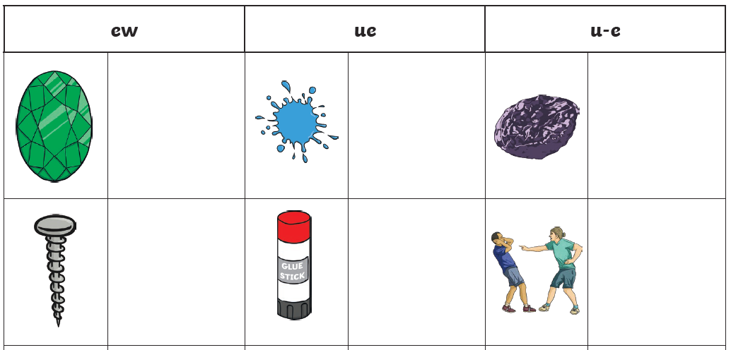
Use the word bank to write the correct word next to the picture
Word Bank
jewel | prune | rude
glue | screw | blue
Can you put one of the words into your own sentence?
_________________________________________________________________________________________________________________________________________________________

