ea
Write a label for each picture
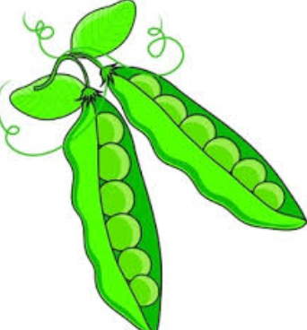
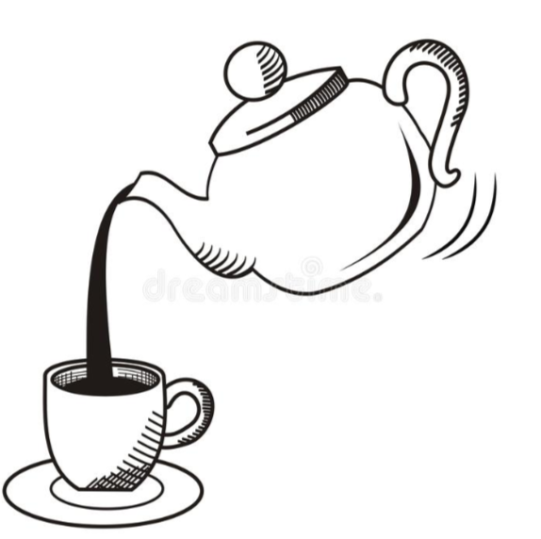
_______________________________ ____________________________
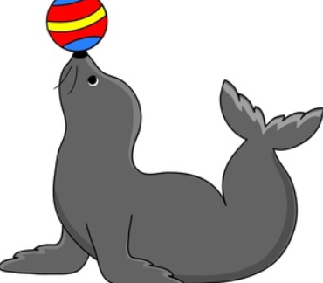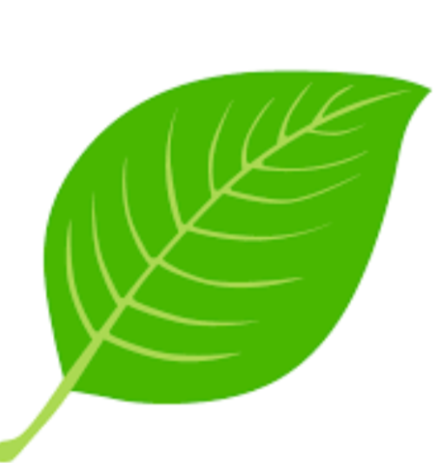

_______________________________ ____________________________

Can you think of a sentence to write about the picture below?







