oy
Draw a line to match each picture to the correct sentence?
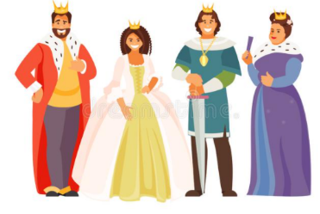
I enjoy going to the park to play.

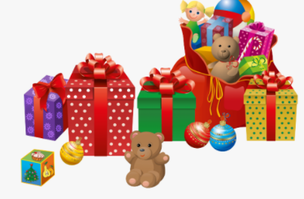
The queen is part of the royal family.

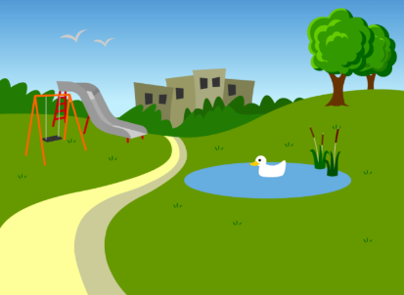
I got lots of toys for my birthday.

Can you think of a sentence to write about the picture below?







