ey

Read the sentences below and draw a circle around all the words you can find with the ey sound.
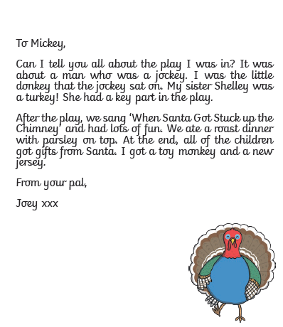
Can you think of a sentence to write about the picture below?








