o-e
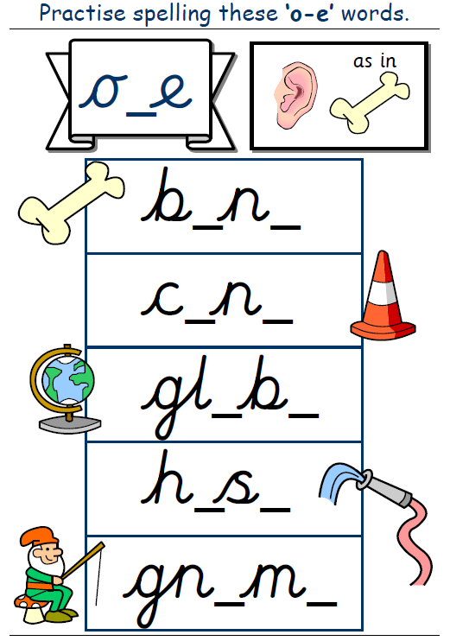

Have a go at writing some sentences using the words above.

