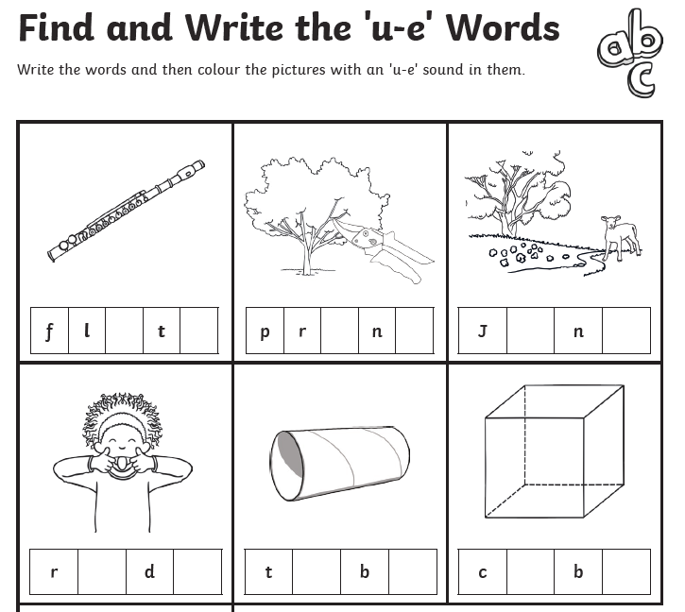
u-e
Have a go at writing some sentences using the words above.

