Tricky Words
P7
Can you read the tricky words and colour them using the key?
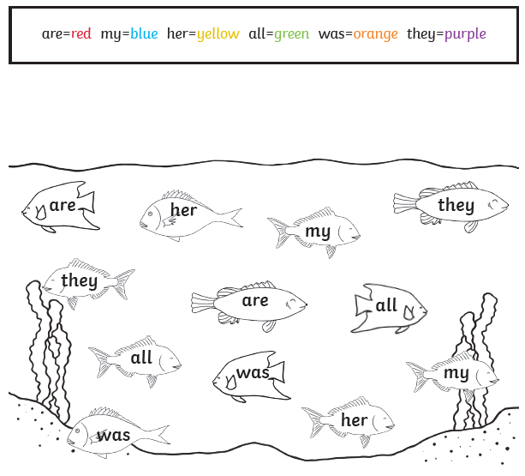

Can you put a tricky word in a sentence?
E.g. My friend is kind, she gave me all her sweets.
____________________________________________________________________________________________________________________________________________________________________________________________________________

