Think about the materials hunt you did and the suitability of the materials. Now decide which material you think would be most suitable to make each object.

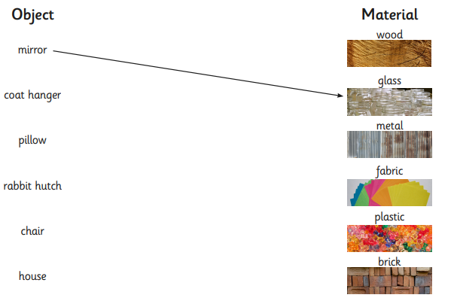

Challenge-
Write a few sentences to tell me about the choices you made and why you think the material is suitable. Use the properties vocabulary on the next page.
________________________________________________________________________________________________________________________________________________________________________________________________________________________________________________________________________________________________________________________________



