Tricky Words
P9
Can you read the tricky words, cover them and write them?
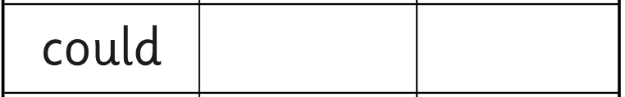
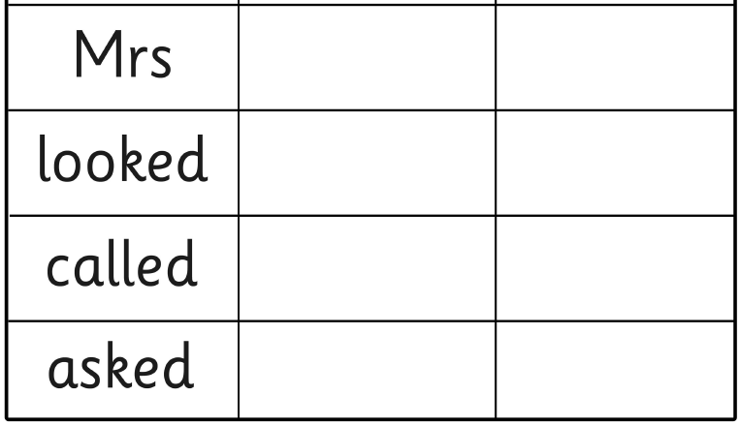
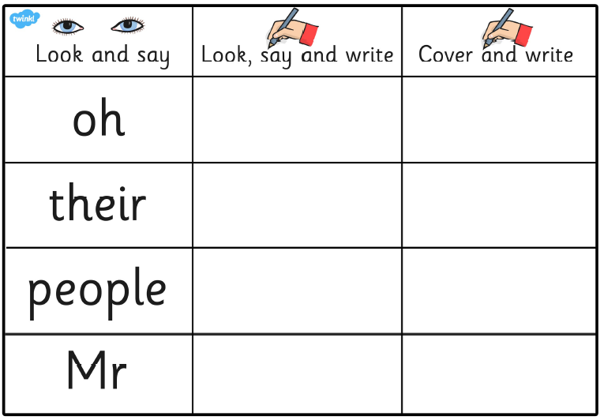
Can you say a sentence with a tricky word in?

