Year 1 Week 1
Day 1
Phonics
This week in phonics we are going to be continuing your learning on phase 4 phonics. You are going to use the sounds you already know from phase 2 and 3 to help you read and spell.
Today you are going to read the words and draw a line to the matching picture.
Find worksheet P1 in your workbook and complete the activity.
English
In your English lessons this week, you will be using the ‘Knights and Dragons Unite’ text.
Today, you are going to draw a picture of and tell an adult what you think will happen in the story using the front cover. Find worksheet E1 in your workbook. Use the opener “I think that…” when saying your simple sentence.
Maths
This week in maths we are going to be learning about division. Today we are going to start with finding half of an even number. Click on the link and watch the short video explaining how to find half by sharing into 2 equal groups.
https://www.whitefield-inf.lancs.sch.uk/division/
Then find worksheet M1 in your workbook and complete the task.
Reading
Follow the link to the Oxford Owl reading website https://www.oxfordowl.co.uk/
You will find the class login for Oxford Owl in your online login books which will explain how to access the texts. Choose a text which matches the coloured book band you are on.
Find worksheet R1 in your workbook. Draw a picture of your favourite part of the book and tell an adult why using the opener “I liked it when…”.
Topic – computing
Today you are going to practise you’re mouse skills. Click on the link and use the mouse to fill in the castle template.
https://www.purplemash.com/#tab/pm-home/topics/history
Think carefully about what materials are used to build a castle.

Day 2
Phonics
Today in phonics you need to use your phonics knowledge to look at the picture and then read all the words and circle the one that matches.
Find worksheet P2 in you workbook and complete the activity.
English
Today, you are going to think of questions about what you want to find out in the story using the front cover. Follow the link to watch a video about ‘How to write questions’ https://www.bbc.co.uk/bitesize/topics/zrqqtfr/articles/z2xdng8
Find worksheet E2 in your workbook. Remember to use the question hand resource to help think of your questions. Say these to an adult and ask them to write them down for you.
Who is the dragon? How did they get there? What is the name of the castle?

Maths
Today in maths we are going to be learning about dividing by sharing into equal amount. Click on the link and watch the short video explaining how to divide by sharing into equal parts.
https://www.whitefield-inf.lancs.sch.uk/division/
Find worksheet M2 in your workbook and complete today’s activities.

Reading
Follow the link to listen to the ‘A Monster Surprise’ story
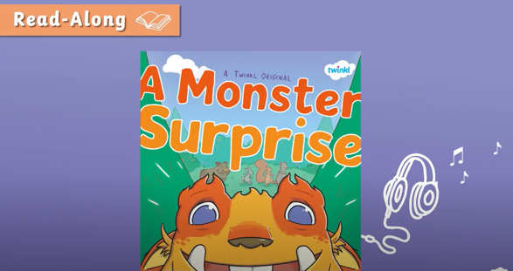
https://www.youtube.com/watch?v=Qe7G_ipEukU

Find worksheet R2 in your workbook and complete the character description for the monster. Remember to use the word bank to help with your labelling.
Topic - PE
Today in PE you are going to be going ‘Into the Wild’ for a movement lesson. You are going to be learning about different ways to travel and jump. You will need to make sure you have a big clear space for your PE lesson today.
https://www.youtube.com/watch?v=DtfvUedMTDA
I wonder what animals you will find in the wild.
Day 3
Phonics
Today in phonics you are going to use your phonics knowledge to read the captions and match them to the correct picture.
Find worksheet P3 in your workbook and complete the activity.
English
Today, you are going to label parts of a setting using a picture from the book.
Find worksheet E3 in your workbook and complete the task. Remember to use the word bank to help with your labelling.
Maths
Today you are going to continue your learning on dividing by sharing into equal groups.
Click on the link and re- watch the video from yesterday to refresh your mind.
https://www.whitefield-inf.lancs.sch.uk/division/
Today you are going to draw your own groups and share the amount equally. Find worksheet M3 in your workbook and complete today’s activities.
Reading
Follow the link to listen to the ‘A Monster Surprise’ story
https://www.youtube.com/watch?v=Qe7G_ipEukU
Find worksheet R3 in your workbook and complete the reading comprehension. An adult will need to help you read the questions.
Topic- history
Today in history we are going to be learning all about the parts of a castle. Have you seen a castle before? Now click the link and watch the video all about the parts of the castle. https://www.youtube.com/watch?v=ZZtWmElqPpU Find worksheet T1 in your workbook and label the castle using the glossary below.
Arrow loops – Slim opening inside the walls for archers to fire arrows.
Bailey – This is a courtyard inside the outer wall of the castle.
Barbican – This is a fortified gateway which is near a gate or bridge and is used to defend the castle.
Battlements – A wall around the top of the castle with square spaces for people in the castle to shoot through.
Drawbridge – A bridge that can be lowered and raised.
Moat – A deep ditch filled with water to protect the castle.
Portcullis – A strong metal gate that can be lowered to protect the castle from enemies.
Tower – A tall narrow building that stands alone or as part of the castle.

Day 4
Phonics
Today you are going to use your phonics knowledge to read and spell words with the ‘mp’ consonant cluster.
Find worksheet P4 in your workbook and complete the activity.

English
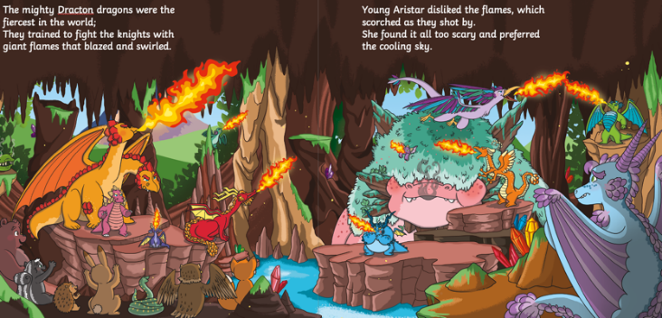
Today, you are going to label a character description for Aristar the dragon. Follow the link to listen to the story and pause it at 0.54 seconds https://www.youtube.com/watch?v=hOcCl0jKwvU

Find worksheet E4 in your workbook and complete the task. Remember to use your word bank to help label the character.
Maths
Today you are going to learn about dividing by making equal groups. Click on the link to watch the short video explaining how to divide by grouping.
https://www.whitefield-inf.lancs.sch.uk/division/

After watching the video, find worksheet M4 in your workbook and complete the division sums.
Reading
Follow the link to listen to the ‘A Monster Surprise’ story
https://www.youtube.com/watch?v=Qe7G_ipEukU
Find worksheet R4 in your workbook and complete the story sequencing map. Think carefully about the order of the events that took place. You will need a pair of scissors and a glue stick. If you don’t have them at home don’t worry you can draw the pictures yourself to sequence the story.
Topic- Science
Today in science you are going to continue your learning about materials. Today you are going to learn about the properties of materials and if they are suitable. Click on the link and watch the video.
https://central.espresso.co.uk/espresso/primary_uk/subject/module/video/item1134428/grade1/module1128907/index.html
You may need to login to discovery espresso using the details below.
Username: student18029
Password: nwi123
After watching the video you are doing to test some materials to see if they are absorbent. Find worksheet T2 in you workbook and complete your investigation.
Day 5
Phonics
Today you are going to read and write phase 4 words using your prior phonics knowledge. This will include real and nonsense words.

Find worksheet P5 and complete the activities.

English
Today, you are going to rewrite the opening part of the story. Follow the link to listen to the story and pause it at 1.12 minutes https://www.youtube.com/watch?v=hOcCl0jKwvU
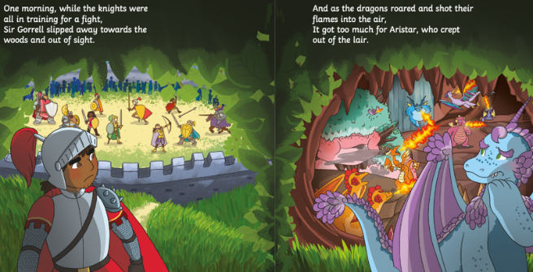
Find worksheet E5 in your workbook and complete the task. Remember to use your word bank to help write your simple sentences.

The dragon is scared.
A knight lives in a castle.
The flames are hot.
Maths
Today you are going to continue learning about dividing by making equal groups. Click on the link to watch the short video to refresh your memory on how to divide by grouping.

https://www.whitefield-inf.lancs.sch.uk/division/

Then find worksheet M5 in your workbook and complete the activities.
Reading
Follow the link to listen to the ‘A Monster Surprise’ story

https://www.youtube.com/watch?v=Qe7G_ipEukU

Find worksheet R5 in your workbook. Cut out the pictures of the food items and stick them onto the plate. Explain to an adult which animal the monster took them from in the story. You will need a pair of scissors and a glue stick. Don’t worry if you don’t have scissors and glue, you can draw the items of food and colour them in instead.

Topic- PSHE
Today you are going to be learning about ‘Living in the wider world’
Click the link and watch the lesson about ‘Local Heroes’

https://classroom.thenational.academy/lessons/local-heroes-cmw66c

Then find worksheet T3 in your workbook and draw a picture of a local hero you might see in Nelson and write who they are.

Year 1 Week 2
Day 1
Phonics
This week in phonics you are going to continue your learning on phase 4. Remember you are going to use your phase 2 and phase 3 knowledge to help you read and spell phase 4 words.

Find worksheet P6 in your workbook and complete today’s activity.

English
Today, you are going to write about what you think is going to happen next in the story.

Follow the link to listen to the story https://www.youtube.com/watch?v=hOcCl0jKwvU
pause the video at 1:25 minutes.

Find worksheet E6 in your workbook. Read the next part of the story and write a simple sentence.

The dragon will eat him.
He will run away.

Maths
This week in maths you are going to be learning about time.
Today you are going to begin learning reading and writing the time to o’clock. Click on the link to watch today’s lesson.

https://classroom.thenational.academy/lessons/reading-and-writing-the-time-to-oclock-part-1-69jk6t

Then find worksheet M6 in your workbook, read the clocks and write the correct time.

Reading
Follow the link to the Oxford Owl reading website https://www.oxfordowl.co.uk/

You will find the class login for Oxford Owl in your online login books which will explain how to access the texts. Choose a text which matches the coloured book band you are on.

Find worksheet R6 in your workbook. Draw a picture of your favourite character from the book. Then tell an adult why you like that character.

Topic- Design technology
This week in design technology we are going to be designing and making a healthy fruit salad.
Today you will think about fruits that you like and dislike and then you will design your fruit salad.

Find worksheet T4 in your workbook and complete the task.

Day 2
Phonics
Today in phonics you are going to read the words and then circle the word that matches the picture.
Find worksheet P7 in your workbook and complete the activity.
English
Today, you are going to write some thought bubbles to show what the characters are thinking. Follow the link to listen to the story and pause it at 2.03 minutes https://www.youtube.com/watch?v=hOcCl0jKwvU
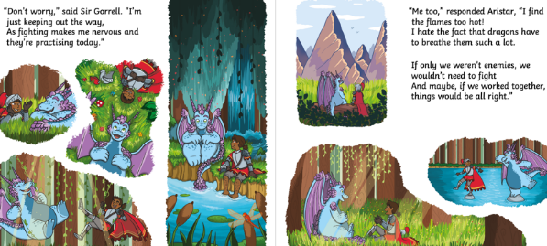

Find worksheet E7 in your workbook and write some simple sentences about how they are both feeling.

I am sad.
I want to be friends.
Maths
Today you are going to continue learning to read and write the time to o’clock.
Click on the link to watch today’s lesson.
https://classroom.thenational.academy/lessons/reading-and-writing-the-time-to-oclock-part-2-cnj6ar
Then find worksheet M7 in your workbook, today you are going to draw the minute and hour hands on the clock to show the correct time. To help you, you could use a blue pencil for the minute hand and a red pencil for the hour hand.
Reading
Follow the link to listen to the ‘Knights and Dragons Unite’ story https://www.youtube.com/watch?v=hOcCl0jKwvU

Find worksheet R7 in your workbook and complete the reading comprehension. An adult will need to help you read the questions.

Topic- Design technology
Today you are going to make the fruit salad that you previously designed, taste it and evaluate it.
Find worksheet T5 in your workbook and follow the instructions to make your healthy fruit salad.

Remember to take a picture and send it to your teacher and tell them what you liked, if there was anything you didn’t like, if you made it again what would you change.

Day 3
Phonics
Today in phonics you need to use your phonics to read the phase 4 words and draw a picture of them.
Find worksheet P8 in your workbook and complete the activity.
English
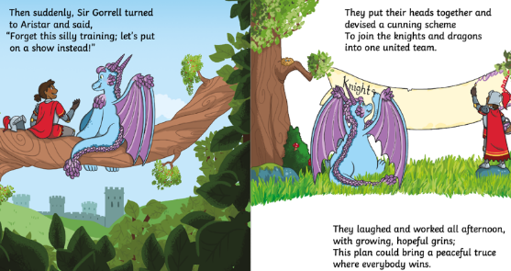
Today, you are going to create an invitation for the talent show. Follow the link to listen to the story and pause it at 2.29 minutes https://www.youtube.com/watch?v=hOcCl0jKwvU

Find worksheet E8 in your workbook and complete the task.
Maths
For today’s maths lesson you are going to begin to learn how to read and write the clock to o’clock and half past.
Click on the link to watch today’s lesson.
https://classroom.thenational.academy/lessons/reading-and-writing-the-time-to-oclock-and-half-past-part-1-6wwpat
Now find worksheet M8 in your workbook, read the clocks and write the correct times.

Reading
Follow the link to listen to the ‘Knights and Dragons Unite’ story https://www.youtube.com/watch?v=hOcCl0jKwvU
Find worksheet R8 in your workbook and complete the story sequencing map. Think carefully about the order of the events that took place. You will need a pair of scissors and a glue stick. Don’t worry if you don’t have scissors and glue, you can draw the pictures to sequence the story instead.

Topic- P.E
Today in PE you are going to be going ‘Under the Sea’ for a movement lesson. You are going to be learning about different ways to travel and roll. You will need to make sure you have a big clear space for your PE lesson today.
https://www.youtube.com/watch?v=a78-VKcdNNc
I wonder animals you will find in the ocean!

Day 4
Phonics
Today you are going to begin to look at phase 4 tricky words. Click on the link below to watch the video for today’s phonics lesson all about tricky words.
https://central.espresso.co.uk/espresso/primary_uk/subject/module/video/item82659/grade1/module63423/index.html
Find worksheet P9 in your workbook and complete the activity.
English
Today, you are going to write a list of things that they will need for the talent show. Follow the link to listen to the story and pause it at 3.34 minutes https://www.youtube.com/watch?v=hOcCl0jKwvU
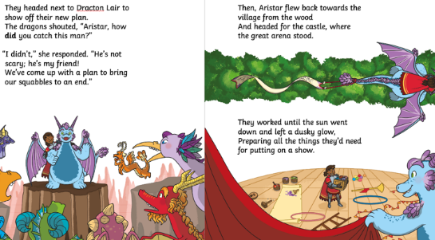

Find worksheet E9 in your workbook and complete the task. Remember to use your word bank to help write your list.
Maths
Today in maths you are going to continue learning to read and write the time to o’clock and half past.
Click on the link to watch today’s lesson.
https://classroom.thenational.academy/lessons/reading-and-writing-the-time-to-oclock-and-half-past-part-2-c4wkjr
Then find worksheet M9 in your workbook and write the time each clock shows.

Reading
Follow the link to listen to the ‘Knights and Dragons Unite’ story https://www.youtube.com/watch?v=hOcCl0jKwvU
Find worksheet R9 in your workbook and complete the book review.
Topic- History
In your history learning today you are going to be learning about Knights and their armour.

You will find the PowerPoint on the remote learning webpage of your class page.

Find worksheet T6 in your workbook and read all about the different parts of a Knights armour and then label the different parts on your worksheet.

Day 5
Phonics
Today you are going to continue learning phase 4 tricky words. If you need a refresher watch the video from yesterday.

Then complete worksheet P10 in your workbook.

English
Today, you are going to write a rhyming poem about a knight. Follow the link to listen to the rest of the story https://www.youtube.com/watch?v=hOcCl0jKwvU
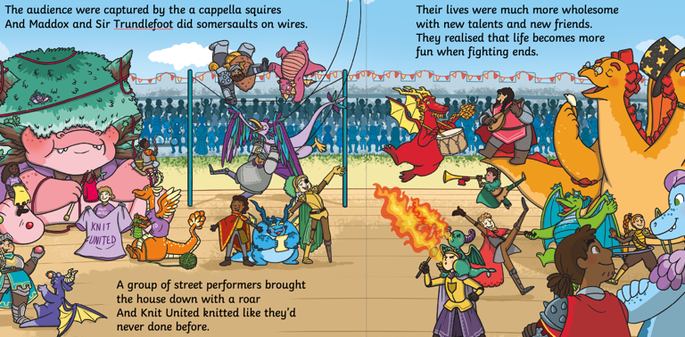
Find worksheet E10 in your workbook. Remember to use your word bank to complete the poem.
Maths
In today’s maths lesson you are going to learn to read and write the time to o’clock and half past in words.
Click on the link to watch today’s lesson.
https://classroom.thenational.academy/lessons/reading-and-writing-the-time-to-oclock-and-half-past-in-words-6xj3ac
After watching the lesson find worksheet M10 in your workbook and write what time each clock shows in words.

Reading
Follow the link to listen to the ‘Knights and Dragons Unite’ story https://www.youtube.com/watch?v=hOcCl0jKwvU
Find worksheet R10 in your workbook and draw a picture to show what Aristar and Sir Gorrell did next.
Topic- Outdoor learning
Today you are going to be making a simple bird feeder. You can hang this outside and encourage the birds to come. I wonder what birds come and feed on your feeder. The best time to catch them is in a morning.
Click on the link and watch the video about birds. https://central.espresso.co.uk/espresso/primary_uk/subject/news/video/item765757/grade1/index.html?source=search-all-KS1-all-all&source-keywords=birds
Find worksheet T7 in your workbook for instructions on how to make a bird feeder.

