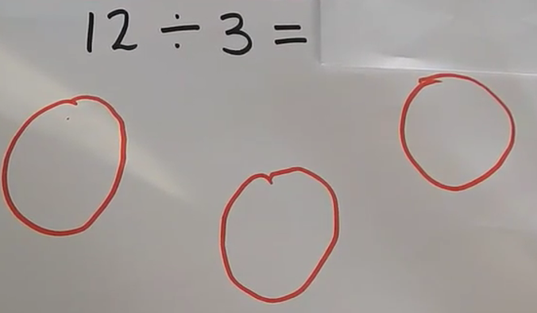
The amount to share
How many equal groups

Use your jottings to solve the division number sentences
8÷2=

10÷2=

6÷3=

9÷3=

4÷2=

