The amount to share
How many in each group
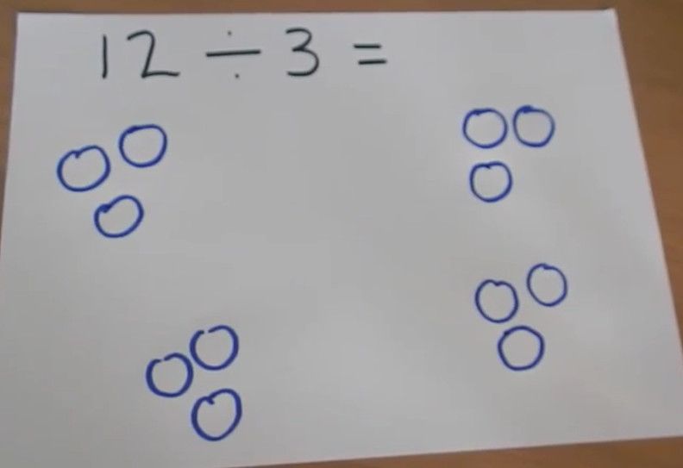

Use your jottings to solve the division number sentences
6÷2=

10÷5=

8÷4=

9÷3=

12÷4=

