Half past
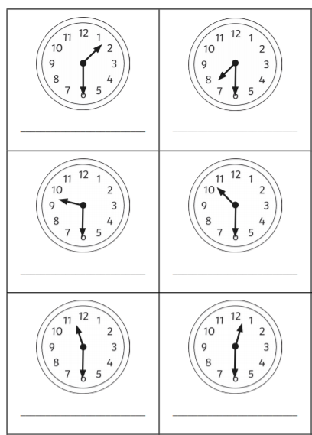
Look carefully at the clocks and write the time each clock is showing underneath.
half past
half past
half past
half past
half past
half past

