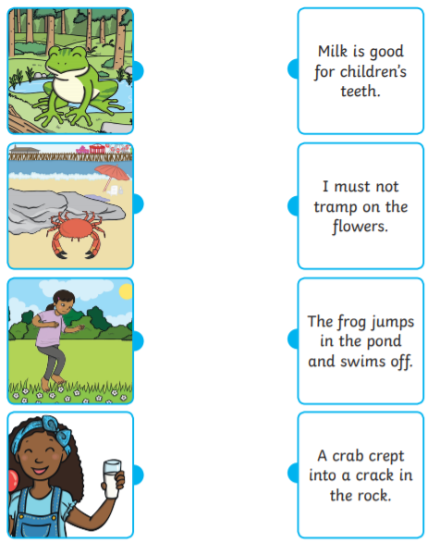
Read the sentences and match it to the correct picture.

