Today you are going to make your healthy fruit salad you have designed. You might need an adult to help you with this activity today.
Before you start you need to gather your ingredients and any tools you might need. You might need a peeler, knife and a chopping board depending on what fruit you chose.
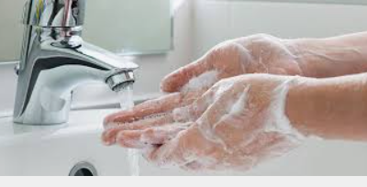
First – wash your hands with warm soapy water for at least 20 seconds.

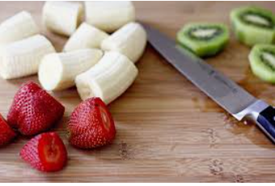
Next – peel, cut or chop your fruit. Remember to ask an adult to help you if you need to. Be careful of any sharp knives!

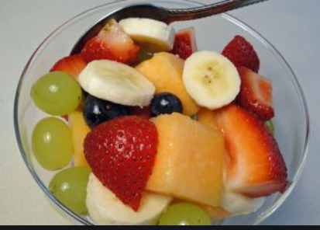
Then – carefully place your fruit in a bowl. You might like to add a little fresh juice to help keep it fresh.

Finally – enjoy your fruit salad. Take a picture and send it to your teacher. Tell them what you liked about it. Is there anything you would change?

