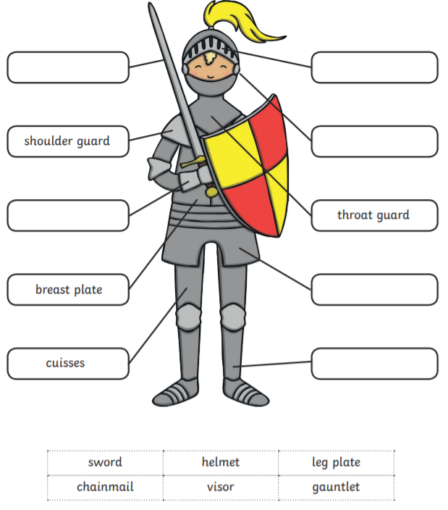
A Knight’s armour has many different parts. Use the PowerPoint to help you label the rest of the Knight’s armour.
g_
c_
h_
v_
l p
s_

