Bird Feeder
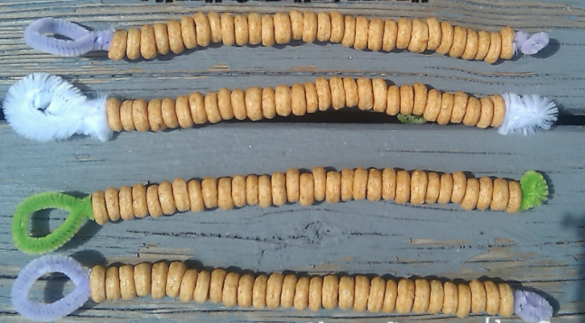
Today you are going to make a simple bird feeder. Follow the instructions and hang it outside for the birds.
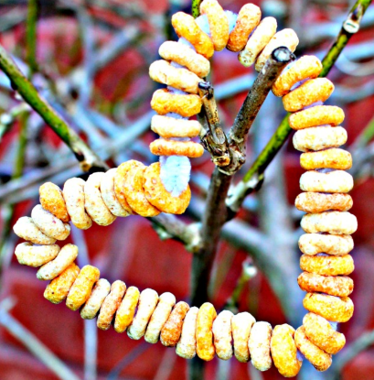
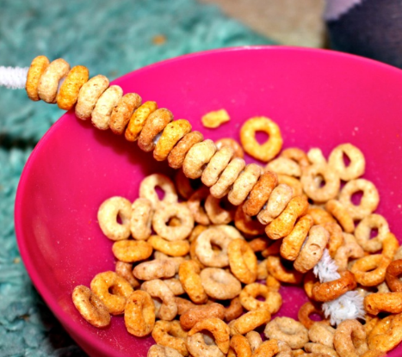
You will need:
- Pipe cleaners or string
- Cheerios
First get your pipe cleaner or string and make a small loop at the end to stop the cheerios falling off.
Next thread your cheerios on until it is full.
Then twist the ends of the pipe cleaner/tie the two string ends together.
Finally hang your bird feeder outside and wait for the birds to come.

